

Faculty of Mathematical, Physical and Natural Sciences
Master Degree Course in Particle and Astroparticle Physics

STUDY OF MAGNETIC RECONNECTION PHENOMENA ON THE PROTO-SPHERA EXPERIMENT THROUGH THE ANALYSIS OF FAST CAMERAS DATA

Degree Dissertation

Internal rapporteur:
Giovanni Montani
External rapporteur:
Franco Alladio

Candidate:
Yacopo Damizia
Serial: 1388631

Academic year 2018/2019

To my family

SUMMARY
INTRODUCTION 5
CHAPTER 1: COMPACT TOROIDS 8
Spheromak 10
Field Reverse Configuration 12
Spherical Tokamak 14
CHAPTER 2: PROTO-SPHERA PHYSICAL PRINCIPLES 15
Toroidal Plasma Formation 16
Magnetic Helicity 16
Relative Magnetic Helicity 18
Magnetic Reconnection 20
DC Helicity Injection 21
CHAPTER 3: MAGNETOHYDRODYNAMICS 23
Two-fluid model 25
Single fluid model 27
Ideal MHD 33
Balance in presence of magnetic forces 35
θ-Pinch 36
Z-Pinch 37
Screw-Pinch 38
CHAPTER 4: CHANDRASEKHAR-KENDALL-FURTH 40
CKF Force-Free Fields 41
Ideal MHD Stability of CKF Force-Free Fields 43
Unrelaxed CKF Configurations 44
CHAPTER 5: MECHANIC DESIGN OF PROTO-SPHERA 45
Vacuum Vessel 46
Electrodes 48
Poloidal Field Coils 49
Divertor 50
Assembly and Maintenance 51
CHAPTER 6: DIAGNOSTICS 52
Fast Cameras 53
Camera Calibration and 3D Reconstruction 54
CHAPTER 7: EXPERIMENTAL SEQUENCE AND DAQ 57
Frameworks 58
CHAPTER 8: DATA ANALYSIS 61
Tomography Errore. Il segnalibro non è definito.
Zernike Polynomials 61
Mathematical basis 62
Tomographic inversion of Zernike 63
Analyse technique Errore. Il segnalibro non è definito.
Hydrogen 66
Argon 68
Results and further development 69
CONCLUSIONS 71
REFERENCES 72

INTRODUCTION
In the field of nuclear fusion the most commonly used machines for the study of magnetic confinement fusion reactions are the tokamaks. A tokamak is an experimental toroidal-shaped machine designed by Russian physicists in the 1950s, which through the magnetic confinement of hydrogen isotopes in the plasma state creates the conditions for the thermonuclear fusion to occur in a controlled manner. The main magnetic field in the tokamak is the toroidal field$B_{Ф}$, but this alone cannot confine the plasma, because to have an equilibrium in which the plasma pressure is balanced by the magnetic force it is also necessary to have a poloidal magnetic field$B_{p}$. This field is mainly produced by the current flowing in the plasma itself along the toroidal direction. The poloidal magnetic fields are generally an order of magnitude lower than the toroidal field. The combination of these two fields generates field lines that have a helical trajectory around the torus.
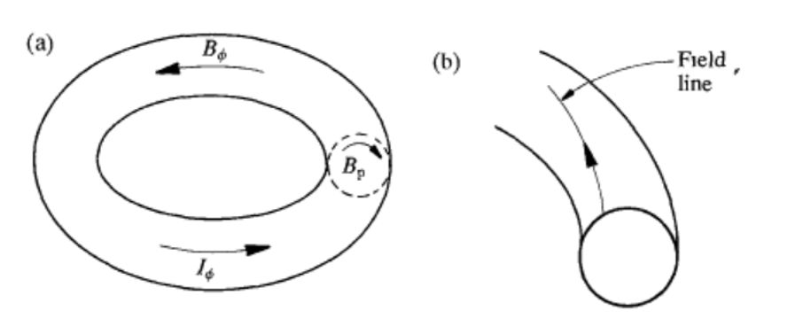
Figure 1: Toroidal magnetic field $B_{Ф}$ poloidal magnetic field $B_{p}$ b) The combination of $B_{Ф}$ and $B_{p}$ generates lines of field that wrap around the plasma
In the tokamaks, there is a central pole, containing the inner part of the toroidal magnet and the ohmic transformer, which produces and maintains the toroidal plasma current. The plasma pressure is the product of particle density and temperature. The fact that the reactivity of the plasma increases with both these quantities implies that the pressure must be high enough in a reactor. The plasma pressure is determined by stability considerations obtained through the equations of MagnetoHydroDynamics (MHD), and increases with the strength of the applied magnetic field. However, the magnitude of the toroidal field is limited by technological factors. For example in laboratory experiments with copper coils, both the cooling requirement and the magnetic forces impose a limit to the magnetic field that they can produce. Moreover, it is necessary to take into account the energy losses due to the Joule effect and today therefore, superconducting coils are envisaged which have a field limit lower than that of copper. In this case, there is the risk of a loss of superconductivity beyond a certain critical field. Currently, at least 4-5 MA of current are needed to confine alpha particles and thus obtain an ignited plasma, but advances in technology and better understanding of plasma dynamics could lead to lower values ​​in the future. The processes that limit plasma confinement in tokamaks are not well understood. However, the improvement of confinement with dimensions is found experimentally. The plasmas in the tokamak are heated to temperatures of a few keV by ohmic heating of the plasma current. The temperatures required to obtain a fusion plasma are around 10 keV and are reached by supplementary heating using particle beams or electromagnetic waves. Current tokamak plasmas typically have a particle density of about${ 10}^{-20 }m^{-3}$, a factor of ${10}^{6 }$lower than atmospheric pressure. The plasma is contained in a toroidal vacuum chamber and to minimize the presence of impurities it is necessary to maintain low base pressures. The presence of impurities in the plasma causes radiation losses and also dilutes the fuel causing inefficiencies in the reaction. The restriction of their entry into the plasma therefore plays a key role in the success of the operation of a tokamak. This therefore requires a separation of the plasma from the vacuum chamber. There are two techniques to do this: the first is to define an external limit of the plasma with a material limiter, the second is to keep the particles away from the walls of the machine by means of a modification of the magnetic field to produce a magnetic diverter. The PROTO-SPHERA (Spherical Plasma for HElicity Relaxation Assessment) experiment in the ENEA Frascati laboratories is dedicated to demonstrating the feasibility of a spherical torus, where the central conductor pole is replaced by a plasma current discharge, which is flowing between electrodes, and takes the form of a magnetic screw pinch. The main advantages of this configuration compared to a tokamak are:
- In a Tokamak configurations the plasma can disappear on the timescale of milliseconds (disruption) due to instabilities that can cause electromechanical damage to the vacuum chamber. After a disruption the only way to reform the confinement configuration is to restart the discharge of the plasma from the beginning. In the case of PROTO-SPHERA the tori so far obtained are immune to disruptions.
- The central conductor of a tokamak is the most fragile components of the machine. In PROTO-SPHERA the problem of the damaging the central conductor is removed.
- The current that flows through the electrodes along the lines of force of the screw pinch, allows to maintain the torus configuration through the direct injection of toroidal current for undefined times.
- Much easier access to the internal components of the machine thanks to the cylindrical geometry.
- A spherical configurations could enable the creation of fusion reactors able to exploit the confining magnetic fields better.
The accurate study of a laboratory plasma like that of PROTO-SPHERA could also provide useful information on some astrophysical phenomena. In some astrophysical systems unstable magnetic flux tubes are able to produce toroidal and helical plasmas through the phenomenon of magnetic reconnection. The configuration that forms the basis of this experiment is also present in the cosmos in the Crab Nebula, a magnetized configuration produced by the explosion of a supernova. From the point of view of nuclear fusion research with magnetic confinement, the PROTO-SPHERA project is part of the research on compact toroid (Spherical Tokamak, Spheromaks, Field Reversed Configurations) and has the ability to explore the connections between these three concepts. It is not only a sort of Spheromak formed and sustained with a new technique, but it is a magnetic configuration was designed with the objective of a safety factor profile similar to those obtained in Spherical Tokamaks with the central metal conductor. To the extreme compressions of its central screw pinch discharge it could also lead to the formation of Field Reversed Configurations with a new process.
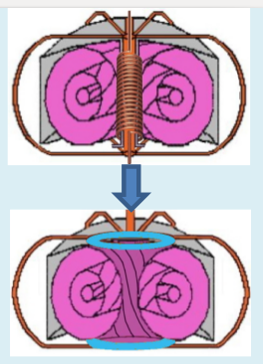
Figure 2: Differences between Tokamak on the top, and PROTO-SPHERA experiment.

CHAPTER 1: COMPACT TOROIDS
After more than thirty years of development, the tokamak concept has come very close to achieving break-even conditions in controlled thermonuclear fusion, and some proposed new generation experimental devices could provide a true fusion plasma. However, the tokamak is a very large, complex and expensive machine. The tokamak machine, although continuously improved by the evolution of plasma technology and knowledge, may not overcome its shortcomings such as: low power density, high construction complexity, large unit size and high development costs. It is therefore important to develop alternatives to conventional tokamaks with optimized and simpler designs. During the 1980s, researchers at the Oak Ridge National Laboratory (ORNL) were studying tokamak operations while reducing the aspect ratio,$A=R/a$. They demonstrated, based on MagnetoHydroDynamic considerations, that tokamaks were inherently more stable at low $A$ ratios. In particular, the classic kink instability is strongly suppressed. Other groups expanded on this theory, and discovered that the same thing was also true for the ballooning instability of high-order. This suggested that a low $A$ machine, would not only be less expensive to build, but would also have better performance.
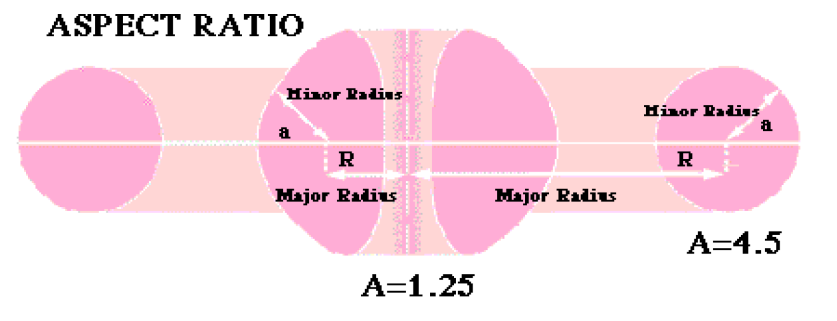
Figure 3: Aspect Ratio
There are three alternative projects mainly studied in the world, the Spherical Tokamak (ST), the Spheromak and the Field Reverse Configuration (FRC). These projects are in very different stages of development but have in common the small size and low cost. The ST is a modification of the conventional tokamak and differs by having much smaller aspect ratio. The Spheromak are low $β$ toroidal confinement configurations where the currents flowing in the plasma almost completely produce the magnetic field of the configuration. Inside, they have a toroidal magnetic field which is due to a plasma current along the symmetry axis which is terminating on an enclosing conductive vessel and therefore there aren't external field coils. FRCs are high $β$ toroidal confinement configurations with poloidal magnetic field but with a toroidal magnetic field equal to zero and therefore, in opposition to Spheromaks, they have external poloidal field coils around the plasma. One measure that is widely used in the field of magnetic fusion is the $β$ number. Each machine containing magnetically confined plasma can be compared using this number which represents the ratio of plasma pressure $p$ to magnetic field pressure${ p}_{M}=\frac{B^{2}}{8π}$, and$β=\frac{p}{p_{M}}=\frac{8πp}{B^{2}}$. Improving the$β$ parameter means that less energy must be used in relative terms to generate magnetic fields for any plasma pressure (or density). The fusion power output it scale like${ β}^{2}B^{4}$, and the price of magnets varies approximately with $B^{2}a^{2}R$ so reactors operating at higher $β$ are also less expensive at the technological level. Traditional tokamaks operate at relatively low $β$ values, with unique record of just over 12%, but various calculations show that practical designs would need to operate up to 20%.
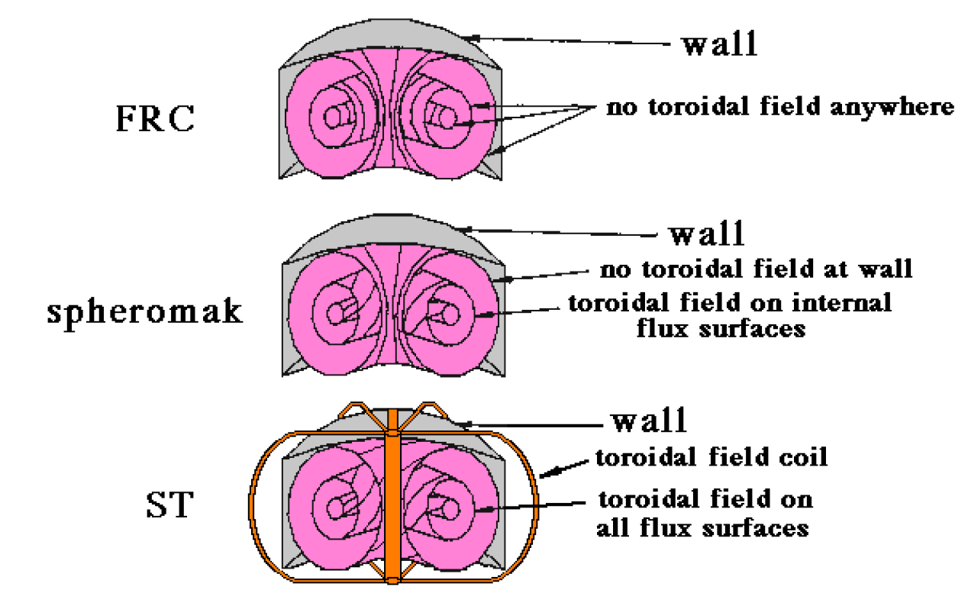
Figure 4: FRC, Spheromak and Spherical Tokamak differences

Spheromak
The Spheromak is a compact magneto fluid configuration with a simple geometry and several interesting attributes for a possible fusion reactor. It contains large internal electric currents and their associated magnetic fields are arranged so that the Magneto Hydrodynamic forces within the configuration are almost balanced. This allows the achievement of sub-millisecond magnetic confinement times without external fields. The physics of Spheromak and collisions between Spheromaks, is similar to a variety of astrophysical events, such as loops and coronal filaments, relativistic jets and plasmoids. The Spheromaks are particularly useful for studying magnetic reconnection events, when for example two or more Spheromaks collide. They usually generated using a "gun" that ejects the Spheromaks from the end of an electrode into a zone that allow the expansion of the volume, surrounded by a conducting flux conserver. This has made them useful in the laboratory environment and Spheromak guns are relatively common in astrophysics laboratories. Spheromaks were proposed as a project to produce magnetic fusion energy for their confinement times, which was in the same order as the best tokamaks when they were first studied. Although they had some successes during the 70's and 80's, these devices had limited performance and most Spheromak research ended when funding for fusion was drastically reduced in the late 1980s.
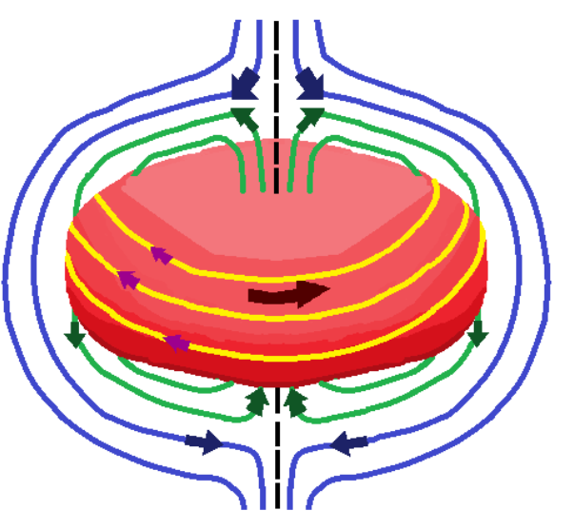
Figure 5: Spheromak magnetic configuration
However, in the late 1990s researchers produced Spheromaks that could reach higher temperatures with better confinement times, and this led to a second generation of these machines. This device is also a candidate for liquid metal walls to absorb neutrons and heat with minimal damage in a possible high power density reactor. The geometry is simple, can incorporate a diverter, and the toroidal and poloidal fields have comparable strength. The Spheromaks do in fact not use a central transformer as in the tokamaks to generate the poloidal fields for confinement, but exploit a self-reorganisation of the natural instabilities of the MHD. This phenomena allows therefore to obtain a Spheromak with different methods.

Field Reverse Configuration
A Field Reversal Configuration (FRC) is a device that contains a toroidal plasma on closed magnetic field lines that is created in an impulsive manner. In a FRC, the plasma has the shape of a self-stable torus, similar to a smoke ring, it is usually quite elongated and contained in a magnetic field that is produced by a cylindrical solenoid. In this configuration the plasma has a$β∼1$. The coils and the very simple and compact geometry makes it the least complex configuration. It is formed using high pressure plasmas in θ-pinch configurations. A toroidal electric current is induced inside a cylindrical plasma, creating a poloidal magnetic field, inverted in relation to the direction of a magnetic field applied externally. Typically it is used a structure of quartz outside of which there are coils that generate impulsive fields of about 1 Tesla for a few$ms$. If not supplied by an external current unit, these current rings decay in a very short time, less than a millisecond. After the impulsive formation, the FRC configuration shifts along a guide field to a metal container in which a mirror field keeps it in the centre of the machine. The electronic density in these cases is about $n_{e}=5⋅{10}^{21}m^{-3}$ and the increase of this quantity is proportional to the average lifetime of the magnetic configuration. The maximum values of $β$ have been reached in FRC machines with coils with a radius of more than 15 cm, with temperatures in the order of keV. The formation technique with θ-pinch is limited to a magnetic flux of a few$mWb$. For a fusion reactor several Webers would be necessary so alternative methods are being studied. One of these for example is a slow formation of FRC using two Spheromak with opposite helicity. A potentially promising approach to support an FRC configuration is the application of a Rotating Magnetic Field (RMF), using large antennas. An interesting observation about the FRC plasmas produced in all experiments is that they are globally more stable than the ideal MHD theory predicts, and this is thought to be due to kinetic or to rotational effects.
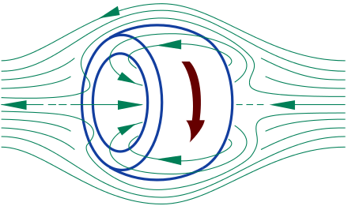
Figure 6: FRC magnetic configuration
In addition, there is some theoretical and experimental evidence that FRCs may be minimum rotationally stabilized energy states, similar to Spheromak and Reverse Field Pinch (RFP), when total helicity and angular momentum are preserved. FRC probably offers the best reactor potential due to the high power density obtained from simple structural and magnetic topology. As a consequence of its very high $β$ and the potential for direct electrical conversion of the exhaust, the FRC is particularly interesting as a candidate for burning aneutronic fuels. The magnetic configuration of the FRC has an ideal geometry for future fusion propulsion using D-3He as the fuel. The null field region and high beta indicate low synchrotron radiation and moderate field requirements even at high plasma temperatures. In addition, linear geometry and unimpeded magnetic flux seem to point to a natural direct conversion of energy to obtain a space engine.

Spherical Tokamak
A Spherical Tokamak is a type of fusion device based on the tokamak principle. A traditional tokamak has a toroidal confinement area which gives it an overall shape similar to a large donut with a hole. The spherical tokamak reduces the size of the hole as much as possible, resulting in an almost spherical plasma shape. The spherical tokamak is sometimes referred to as a spherical toroid and often abbreviated to ST. ST uses a D-shaped plasma cross-section. If one considers a D on the right side and an inverted D on the left, when the two approach each other (as A is reduced) at the end the vertical surfaces touch each other and the resulting shape is a circle. In 3D, the outer surface is approximately spherical. These studies have suggested that the ST layout includes all the qualities of a compact tokamak, strongly suppresses different forms of turbulence, reaches a high$β$, and is less expensive to build. In an ST the poloidal field $B_{p}$ is comparable to the toroidal field$B_{T}$, while in a tokamak${ B}_{p}≪B_{T}$. ST uses a modest toroidal field, but has great values of the ratio between the plasma current $I_{p}$ and the toroidal field current${ I}_{tf}$. In this configuration a large plasma current can be carried within a low toroidal field and therefore with very simple windings compared to conventional tokamaks. This corresponds to a high ohmic power density and allows to work with high density plasmas.
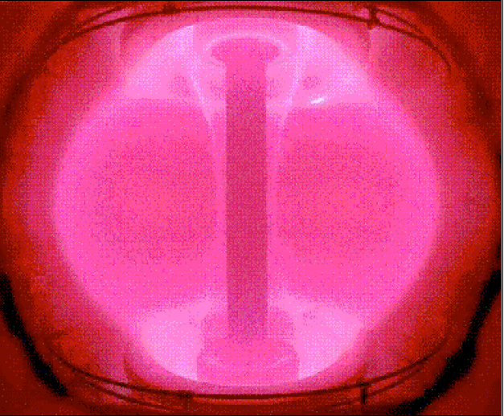
Figure 7: Plasma inside the spherical tokamak START

CHAPTER 2: PROTO-SPHERA PHYSICAL PRINCIPLES
The purpose of this section is to clarify the physics underlying the PROTO-SPHERA experiment, which can be summarized as magnetic helicity injection. Magnetic helicity,$K=\int{\overline{A}⋅}\overline{B}$ is an ideal invariant that slowly decaying and controls to a certain extent the formation of a relaxed MHD state in laboratory plasmas. Helicity integrals measure topological properties of field lines. If the electric current is forced to flow along the magnetic field lines, a perpendicular magnetic flux is generated which causes the field lines to bend towards a helical model. In simple geometric circumstances, such as closed-field line structures, magnetic helicity can be interpreted as the product of two connected magnetic fluxes. When dissipation phenomena are taken into account, magnetic energy decays much faster than magnetic helicity, provided that the length of the scale of dissipative phenomena is much shorter than the size of the system. Any initial configuration will self-organize into a relaxed state$\overline{ ∇}x\overline{B}=μ\overline{B}$, with $μ=$ relaxation parameter, and $μ=cost$ over the entire plasma. Since $\overline{∇}μ=0$ in a relaxed state, this state can be considered as the cessation of kink instabilities, the nonlinear saturation of a kink instability is the process through the PROTO-SPHERA configuration is formed. In a more realistic physical situation of a domain containing a magnetized plasma, with open field lines passing through the boundary, compels to define a relative helicity that is gauge invariant and physically meaningful, because it is independent of the properties external to the domain. In this situation, if the magnetic helix can be injected across the boundary (leading the current along the force lines) more quickly than is dissipated inside the domain by the resistive processes, there is an opportunity to renew the helicity content of the magnetized plasma. The magnetic energy can therefore be injected together with the helicity and the reconnection processes then convert part of the magnetic energy into the kinetic energy of the magnetized plasma. In the case of PROTO-SPHERA, the source of the helicity is the discharge of the screw pinch, which is physically separated from the spherical torus. In this case a gradient of the relaxation parameter $\overline{∇}μ≠0$ appears, so the resistive instabilities of the MHD produce a helical flow that moves from regions of higher µ to regions of lower$μ$.

Toroidal Plasma Formation
The formation of toroidal plasma is obtained by destabilizing the screw pinch by increasing the longitudinal arc current. The PROTO-SPHERA experiment aims to support the toroidal plasma after its formation through the injection of DC helicity (Fig.8). The physical scheme of the helicity injection can be summarized as follows:
- Plasma with open field lines that intersect the electrodes has$B\sim 0$ , thereby$J‖B$.
- As a result of the twisting of the field lines, the current between the electrodes moves in the toroidal direction close to the surfaces of the closed magnetic flux.
- Resistive MHD instabilities convert, through magnetic reconnections, open current/field lines into closed current/field lines, winding on the closed magnetic flux surfaces.
- Magnetic reconnections through helical perturbations break the axial symmetry.
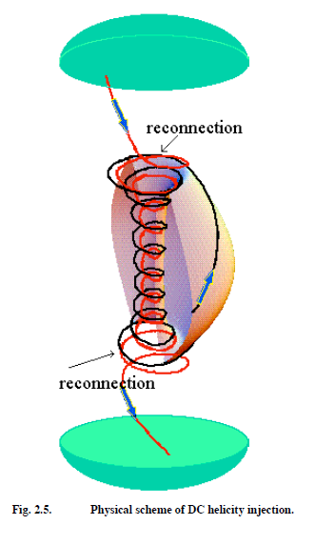
Figure 8: Physical scheme of DC helicity injection

Magnetic Helicity
Magnetic Helicity quantifies various aspects of magnetic field structure. Examples of field possessing helicity include twisted, kinked, knotted or linked magnetic flux tubes, sheared layers of magnetic flux, and force-free fields. Helicity thus allows us to compare models of fields in different geometries, avoiding the use of parameters specific to one model. The helicity of a uniform vector field defined on a domain in 3D space is the extent to which field lines wind and roll over each other. As for magnetic helicity, this vector field is a magnetic field. It is a generalisation of the topological concept of the number of connections of the differential quantities required to describe the magnetic field. Like many quantities in electromagnetism, magnetic helicity (which describes the magnetic field lines) is closely related to the mechanical helicity of fluids (which describes the fluid flow lines). If the magnetic field lines follow the wires of a twisted string, this configuration would have a non-zero magnetic helicity; the left strings would have negative values and the right strings would have positive values. The idea of applying helicity injection to magnetic configurations can be traced back to J.B. Taylor, a British physicist known for his contributions to plasma physics and their application in the field of fusion energy. In a perfectly conductive plasma, i.e. with resistivity$η=0$, we will have:
$$\frac{∂\overline{A}}{∂t}= \overline{∇}x\overline{B}+ \overline{∇}χ$$
Where $χ$ is an arbitrary gauge, $\overline{A}$ is the potential magnetic vector. The parallel component of $\overline{A}$ satisfies the differential magnetic equation:
$$\overline{B}⋅\overline{∇}χ=\overline{B}⋅\frac{∂\overline{A}}{∂t}$$
To have a single value of χ it is necessary that the following equations are equal to zero on any closed field line and magnetic surface, this last one described by the closed poloidal flux ($ψ_{p}$), or toroidal flux ($ψ_{T}$).
$\oint{\frac{∂l}{B} \overline{B}⋅\frac{∂\overline{A}}{∂t}}=0$ $∯{\frac{∂S}{\left|\overline{∇}ψ\right|} \overline{B}⋅\frac{∂\overline{A}}{∂t}=0 }$
In this way, for each flow tube it is possible to express a constant value as a function of two variables$\left(α,β\right)$. This value, which is called magnetic helicity, is an invariant, and can be interpreted as a measure of how much the lines of force of the field are curved: $K\left(α,β\right)$ =$\int{\overline{A}⋅}\overline{B}dV$. Minimizing the magnetic energy$W=\frac{1}{2μ_{0}}\int{{\left(\overline{∇}x\overline{A}\right)}^{2}}dV$ under the restriction that$K=cost$, the Euler’s equation of the motion is modified:
$$\left\{\begin{aligned}\overline{∇}x\overline{B}=μ\left(α,β\right)\overline{B} \\ \left(\overline{B}⋅\overline{∇}\right)μ=0\end{aligned}\right.$$
These equations describe a forceless magnetic field. The physical meaning of the magnetic helicity is a measure of how much the lines of force are interlinked, kinked or twisted. For two flow tubes individually connected with flows $Φ_{1}$ and${ Φ}_{2}$, integrating with the Stokes theorem on the two volumes $V_{1}$ and $V_{2}$ , it is obtained$K =2Φ_{1}Φ_{2}$. The magnetic helicity is a quantity conserved in ideal Magneto Hydrodynamics, and still remains preserved in a good approximation even with a little but finished resistivity, in which case the magnetic reconnection dissipates energy. Its importance derives from two basic properties:
- Magnetic helicity typically better preserved than magnetic energy.
- The magnetic energy associated with a fixed amount of magnetic helicity is minimized when the system relaxes this helical structure to the largest scale available.
- The magnetic helicity is not localized in some points of the flux tubes, but can be thought of as a distributed property.
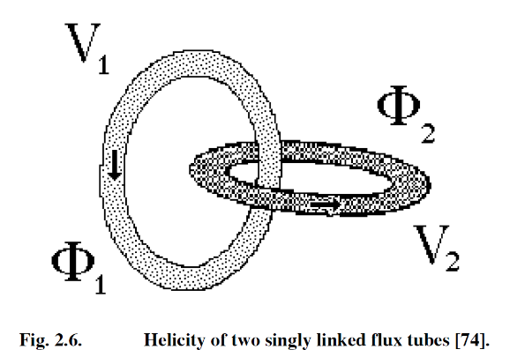
Figure 9: Helicity of two singly linked flux tubes

Relative Magnetic Helicity
In a simply connected volume delimited by a magnetic surface, the integral $K\left(α,β\right)$ = $\int{\overline{A}⋅}\overline{B}dV$ is invariant under transformation of gauge$\overline{ A}=\overline{A}+\overline{∇}χ$. However, in a multiple connected volume such as a torus, there are special gauge transformations that correspond to the change in magnetic flux through the hole. In addition, if the volume of interest is not limited by a magnetic surface, the field lines will have closing points on the boundary, and the connection numbers will no longer define. The definition of magnetic helicity becomes more complicated in these cases then the relative magnetic helicity is used. In the case of two simply connected regions $V_{a}$ e $V_{b}$, separated by a surface $S$, if $\overline{B_{a}}$ and $\vec{B_{a}}'$ are fields with the same boundary conditions and differ only in $V_{a}$, then:$\overline{B}=\left(\overline{B_{a}},\overline{B_{b}}\right)$ and $\overline{B}'=\left(\overline{B_{a}}',\overline{B_{b}}\right)$, it may be demonstrated that:
$ⵠK$ =$\int_{V_{a}+V_{b}}{\overline{A}⋅}\overline{B}dV-\int_{V_{a}+V_{b}}{\overline{A}'⋅}\overline{B}'dV$
Is independent of the field in${ V}_{b}$. It is therefore possible to define a relative magnetic helicity $ⵠK$ in${ V}_{a}$:
$ⵠK$ =$\int_{V_{a}}{\overline{A}⋅}\overline{B}dV-\int_{V_{a}}{\overline{A}'⋅}\overline{B}'dV$
A particularly simple choice is the vacuum potential field in${ V}_{a}$, ${\overline{B_{a}}}^{'}=\overline{B_{V}}$ the vacuum potential field in $V_{a}$ is determined by $\overline{∇}x\overline{B_{V}}=0$ with boundary conditions $\overline{B_{V}}⋅\overline{n_{a}}=\overline{B_{a}}⋅\overline{n_{a}}$ it is assigned zero helicity and gives as a definition of relative magnetic helicity:
$ⵠK$ =$\int_{V_{a}}{\left(\overline{A}+\overline{A_{V}}\right)⋅}\left(\overline{B}-\overline{B_{V}}\right)dV$
This generalized magnetic helicity can be checked to be gauge invariant in almost any situation, the exceptions being magnetic monopole fields and periodic geometry with a mean field.
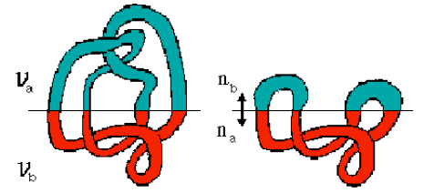
Figure 10: The difference in total magnetic helicity of the two configurations is independent of the field in$V_{b}$

Magnetic Reconnection
Magnetic reconnection is a physical process that takes place in highly conductive plasma, with resistivity$η≠0$ , in which the magnetic topology is rearranged and the magnetic energy is converted into kinetic energy, thermal energy and particle acceleration. The time scale at which the phenomena occurs is intermediate between the rather slow scale of magnetic field diffusion and the much faster scale of Alfvén waves. In the reconnection process, the magnetic field lines of the magnetic domains (defined by the connectivity of the field lines) are connect to each other, changing the connectivity sequences in respect to their sources. It can be considered as a violation of the (not rigorous) law of conservation of plasma physics, called Alfvén's theorem, and can concentrate mechanical or magnetic energy both in space and time. A number of integral quantities are preserved from magnetic reconnections and can be expressed as $K_{α}\left(α,β\right)$ = $\int{\left(\overline{A}⋅\overline{B}\right)χ^{α}⋅}dV$ where $χ^{}$ is the helical flux of the resonant surface on which the magnetic reconnection occurs. However, the helicity$K_{0}$, is the only invariant common to all the winding numbers and hence to all the resonance surfaces. By comparing the decay time of the magnetic energy and the decay time of Taylor's invariant, is observed that the dissipation of the magnetic helicity is a factor $η^{\frac{1}{2}}$ less strong than the dissipation of magnetic energy. In a plasma, the magnetic helicity is not conserved exactly, but is only dissipated at a lower rate than the magnetic energy. MHD plasma spontaneously relaxes to the lowest magnetic energy state consistent with the initial helicity inventory. The relaxation process typically involves magnetic reconnection, as flux tube linkages are broken on the microscopic scale and then re-established in a manner consistent with helicity conservation. This corresponds to a form of current drive because a configuration that initially had zero toroidal current relaxes to a state with a finite toroidal current. The effective electric field driving this current is called a dynamo field and results from the non-linear interaction of fluctuating velocities and magnetic fields. Now these processes are reasonably understood in an average global sense, but there is very little understanding of the microscopic dynamics. It would be useful to demonstrate why helicity is conserved during small-scale reconnection processes. The dynamo model shows how fluctuating velocities and currents provide an effective electric field. A magnetic reconnection model can prescribe these fluctuations. The actual dynamics of reconnection are very complex and bring together many of the most difficult concepts in plasma physics. Furthermore, this process involves parallel electric fields, precisely the area where MHD is most suspect. Moreover, non-axisymmetric magnetic fluctuations tend to degrade confinement. All relevant instabilities grow on a time scale intermediate between the Alfvén time $τ_{A}$and the resistive diffusion time$τ_{R}$. It is therefore necessary to produce plasma pulses that are longer than the resistive time$τ_{R}={μ_{0}a^{2}}/η$. Standard reconnection theories treat reconnection as an exponentially growing process, whereas in the experiments the magnetic relaxation is observed to involve cyclic or periodic oscillations.

DC Helicity Injection
The dynamics of the relative magnetic helicity in a domain can be expressed through a Poynting's theorem:
$$\frac{∂(ⵠK)}{∂t}=-2\int{ϕ_{E}}\overline{B}⋅\overline{n}dS-2\int{\overline{A}}x\frac{∂\overline{A}}{∂t}⋅\overline{n}dS-2\int{(\overline{E}⋅\overline{B})dV}$$
Where:
- $2\int{ϕ_{E}}\overline{B}⋅\overline{n}dS$ dS represents the DC helicity injection and $ϕ_{E}$ is the electrostatic potential on the boundary;
- $2\int{\overline{A}}x\frac{∂\overline{A}}{∂t}⋅\overline{n}dS$ represents the AC helicity injection and includes the inductive helicity injection;
- $2\int{(\overline{E}⋅\overline{B})dV}$ is the total helicity dissipation.
The DC helicity injection is obtained by driving current along the lines of force which cross the boundary of the domain. This is performed through electrodes placed where $\overline{B}⋅\overline{n}=0$.The electrodes must be electrically insulated from the rest of the boundary, upon which$\overline{B}⋅\overline{n}=0$. If an MHD equilibrium with $β≪1$ is obtained, then the current density $\overline{J}$ is approximately parallel to the magnetic field$\overline{B}$. As a result, the current enters and exits the electrodes at the points where the magnetic field enters and exits the electrodes. The injection rate is $\left|\frac{∂(ⵠK)}{∂t}\right|=2V_{e}ϕ_{e}$ ; where${ V}_{e}$, is the electrostatic potential difference between the two electrodes and $ϕ_{e}=0.5\int{\left|\overline{B}⋅\overline{n}\right|dS}$ is the magnetic flux which enters and exits both electrodes, see next Fig.
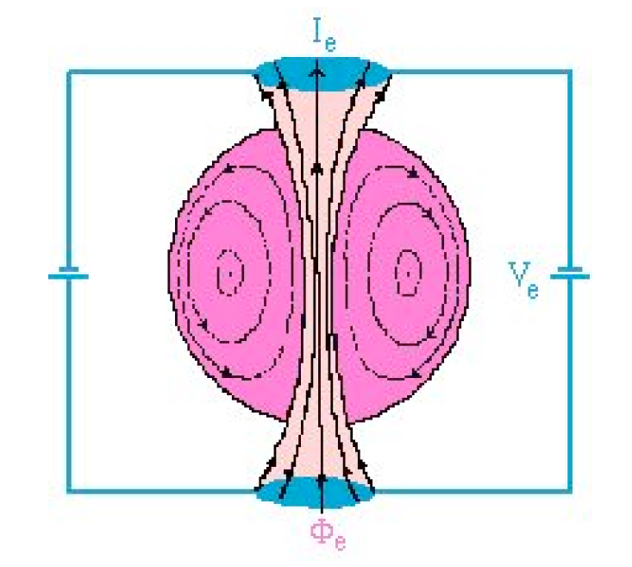
Figure 11: Scheme of DC helicity injection in PROTO-SPHERA
To inject$\frac{∂(ⵠK)}{∂t}>0$ :
- The electrostatic potential must be $V_{e}<0$, where $\overline{B}⋅\overline{n}dS>0$
- The electrostatic potential must be $V_{e}>0$, where $\overline{B}⋅\overline{n}dS<0$
The total current $I_{e}$ which flows through the electrodes is$I_{e} =\frac{μϕ_{e}}{μ_{0}}$, in the case of a relaxed state with$μ=μ_{0}\frac{\overline{J}⋅\overline{B}}{B^{2}}=cost$. The direction of $\overline{J}$ in the plasma torus: opposite to direction of $\overline{J}$ in equatorial PFExt coils:
Sign of $\overline{J}$<$\overline{B}$ is negative in the Plasma-Centerpost
Sign of $\overline{J}$<$\overline{B}$ is negative as well in the plasma torus
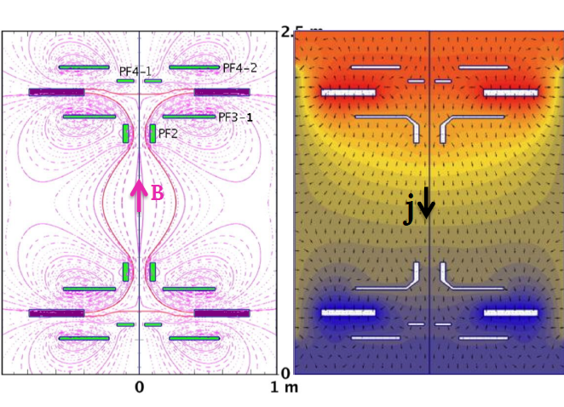
Figure 12: Magnetic Field and current inside PROTO-SPHERA

CHAPTER 3: MAGNETOHYDRODYNAMICS
Magnetohydrodynamics (MHD) is the discipline that studies the dynamics of a globally neutral flux, formed by charged particles in motion. It was studied by Hannes Alfvén, for whom it received the Nobel Prize in 1970, and by Jean-Pierre Petit in the 1960s. The set of equations describing MHD is a combination of Navier-Stokes' equations, from Fluid Dynamics, and Maxwell's equations, from electromagnetism. These differential equations must be solved simultaneously. This task is impossible to carry out symbolically, except in the simplest cases. MHD treats the plasma as a continuous medium, associating to a suitable portion of plasma the same properties typical of a fluid element. The fluid contains currents and electromagnetic fields are produced. One can distinguish two fluids having opposite charge density in relative motion: for the plasma one has the electronic fluid and the ion fluid. We speak of the so called "two-fluids model", according to which each fluid of different species is treated separately as an ideal fluid combining together the relations of the Fluid Dynamics and the Maxwell’s equations for the ionic fluid and the electronic one. A system of equations coupled with partial derivatives is obtained, a closed system for the two fluid model. Resolving a system of this type is complex, given the presence of numerous coupled equations. The problem can be simplified with the assumptions underlying MHD. In the MHD theory a plasma is represented as a single globally neutral fluid in which currents flow and the charges mentioned above are electrons and ions "single fluid model". In this chapter, after having illustrated the system of equations governing the two-fluid model, the simplicity and elegance of the single-fluid model are studied, the basic equations are obtained and, at the same time, the reasonableness of the hypotheses underlying the MHD and their implications are evaluated and argued.

In the following discussion is used the Gauss system of units of measure, generally used in MHD, please note that in such a system:
$ϵ_{0}\overset{⇒}{}\frac{1}{4π}$ $μ_{0}\overset{⇒}{}\frac{4π}{c}$ ; $4πϵ_{0}\overset{⇒}{}1$ $ϵ_{0}μ_{0}\overset{⇒}{}\frac{1}{c}$
The Maxwell equations in the Gauss system become:
- $\overline{∇}⋅\overline{E}=4πρ_{q}$ Eq. of Gauss
- $\overline{∇}⋅\overline{B}=0$ Eq. of Gauss magnetic
- $\overline{∇}x\overline{E}=-\frac{1}{c}\frac{∂\overline{B}}{∂t}$ Eq. of Faraday-Neumann-Lenz
- $\overline{∇}x\overline{B}=\frac{4π}{c}\overline{J}+\frac{1}{c}\frac{∂\overline{E}}{∂t}$ Eq. of Ampere-Maxwell
(3. 1)
The generalised strength of Lorentz become:
$\overline{F}=m\frac{∂\overline{v}}{∂t}=q(\overline{E}+\frac{\overline{v}}{c}x\overline{B})$ $\left\{\begin{aligned}{\overline{F}}_{e}=m_{e}\frac{∂{\overline{v}}_{e}}{∂t}=(\overline{E}+\frac{{\overline{v}}_{e}}{c}x\overline{B}) \\ {\overline{F}}_{i}=m_{i}\frac{∂{\overline{v}}_{i}}{∂t}=(\overline{E}+\frac{{\overline{v}}_{i}}{c}x\overline{B})\end{aligned}\right.$
(3. 2)
Taking advantage of the I eq. of Maxwell (3.0), we obtain a continuity equation:
$$\frac{∂ρ_{q}}{∂t}+\overline{∇}⋅\overline{J}=0$$
(3. 3)
Which expresses the law of conservation of the electric charge. The four fundamental equations of ideal fluid dynamics are shown below:
Continuity equation $\frac{∂ρ}{∂t}+\overline{∇}⋅\left(ρ \overline{v}\right)=0$
Euler equation $ρ\left[\frac{∂\overline{v}}{∂t}+\left(\overline{v}⋅\overline{∇}\right)\overline{v}\right]=-\overline{∇}p$
Temperature equation $\frac{∂T}{∂t}+\overline{v}⋅\overline{∇}T+\frac{2}{3}T\left(\overline{∇}⋅\overline{v}\right)=0$
Pressure equation $\frac{∂p}{∂t}+\overline{v}⋅\overline{∇}p+\frac{5}{3}p\left(\overline{∇}⋅\overline{v}\right)=0$
(3. 4)

Two-fluid model
Plasma is considered to be composed of two ideal fluids, ionic fluid (indicated by the subscript i) and electronic fluid (subscript e). Ions have mass $m_{i}$ and charge$Ze$, while electrons mass $m_{e}$ and charge$-e$. The two fluids are each characterized by a speed ranges${\overline{v}}_{i,e}$, particle number density$n_{i,e}$ , mass density${{ ρ}_{i,e}=m}_{i,e}n_{i,e}$, pressure$p_{i,e}$, and temperature${ T}_{i,e}$. The distribution of charges in the two fluids generates electric fields $\overline{E}$ in the plasma, while the motion of the two charged fluids generates currents and, therefore, magnetic fields$\overline{ B}$. The sources of the fields $\overline{E}$ and $\overline{B}$ are respectively the total charge density $ρ_{q}$ and the current density $\overline{J}$, each of which has a contribution from the electronic fluid and one from the ion fluid.
$ρ_{q}=e(Zn_{i}-n_{e})$ ; $\overline{J}=e(Zn_{i}{\overline{v}}_{i}-n_{e}{\overline{v}}_{e})$
(3. 5)
The fields $\overline{E}$ and $\overline{B}$ are described by the Maxwell equations (3.0) replacing for the sources $ρ_{q}$ and$\overline{ J}$. In addition to the equations for electromagnetic fields, the two-fluid model also uses the relations of the ideal fluids, applied to the electronic and ion fluids. Assuming that no chemical or nuclear reactions occur in the plasma, the law of conservation of the number of particles for ions and electrons, is expressed by the:
$$\frac{∂n}{∂t}+\overline{∇}⋅\left(n \overline{v}\right)=0$$
(3. 6)
For each of the two charged fluids, moreover, the dynamic equation is expressed by the Euler equation:
$$nm\left[\frac{∂\overline{v}}{∂t}+\left(\overline{v}⋅\overline{∇}\right)\overline{v}\right]=-\overline{∇}p+qn(\overline{E}+\overline{v}x\overline{B})$$
(3. 7)
Taking into account the electromagnetic forces, the equations governing the two-fluid model are:
Conservation of particle numbers $\frac{∂n_{i,e}}{∂t}+\overline{∇}⋅\left(n_{i,e} {\overline{v}}_{i,e}\right)=0$
Euler electronic fluid equation $m_{e}n_{e}\left[\frac{∂{\overline{v}}_{e}}{∂t}+\left({\overline{v}}_{e}⋅\overline{∇}\right){\overline{v}}_{e}\right]=-\overline{∇}p_{e}-n_{e}e(\overline{E}+\frac{{\overline{v}}_{e}}{c}x\overline{B})$
Euler ionic fluid equation$m_{i}n_{i}\left[\frac{∂{\overline{v}}_{i}}{∂t}+\left({\overline{v}}_{i}⋅\overline{∇}\right){\overline{v}}_{i}\right]=-\overline{∇}p_{i}+n_{i}Ze(\overline{E}+\frac{{\overline{v}}_{i}}{c}x\overline{B})$
Status equation $p_{i,e}= p_{i,e}\left( ρ_{i,e}\right)=> p_{i,e}= p_{i,e}( n_{i,e})$
Faraday-Neumann-Lenz equation $\overline{∇}x\overline{E}=-\frac{1}{c}\frac{∂\overline{B}}{∂t}$
Ampere-Maxwell equation $\overline{∇}x\overline{B}=\frac{4π}{c}e(Zn_{i}{\overline{v}}_{i}-n_{e}{\overline{v}}_{e})+\frac{1}{c}\frac{∂\overline{E}}{∂t}$
Temperature equation $\frac{∂T_{i,e}}{∂t}+{\overline{v}}_{i,e}⋅\overline{∇}T_{i,e}+\frac{2}{3}T_{i,e}\left(\overline{∇}⋅{\overline{v}}_{i,e}\right)=0$
Pressure equation $\frac{∂p_{i,e}}{∂t}+{\overline{v}}_{i,e}⋅\overline{∇}p_{i,e}+\frac{5}{3}p_{i,e}\left(\overline{∇}⋅{\overline{v}}_{i,e}\right)=0$
(3. 8)
The system of equations that describes the plasma as a two-fluid model is a closed system: 16 equations and 16 scalar unknowns. In particular, if the two charged fluids can be treated as ideal and adiabatic gases, the temperature or pressure equations are used in conjunction with the status equation. The complexity of solving the two-fluid model is enormous, given the presence of many coupled equations. In the rest of the chapter, the problem is simplified with the approximation MHD.

Single fluid model
To describe better the hypothesis behind the MHD it is appropriate to define the concept of regime. Define the characteristic length and time scales for electromagnetic fields. Let $L$ be the spatial scale on which there is a sensitive variation of the fields, $τ$ the corresponding time scale and $U$ a typical value of the fluid velocity. The MHD regime is defined by the relationships; $U=\frac{L}{τ}$ and$U≪c$. The first expresses the concept that the typical speed of electromagnetic phenomena (identified with$\frac{L}{τ}$ ), is of the same order as the typical speed of hydrodynamic phenomena, defined by$U$. In this situation, the two classes of phenomena go at the same speed and this maximizes the interaction between them. The second relation tells us that we limit ourselves to non-relativistic situations. Indicating with $\overline{E},\overline{B},ρ_{q} ,\overline{J}$ respectively the characteristic values of the electric field, magnetic field, charge density and current density. The ideal MHD theory assumes the plasma as a single fluid and is based on the following hypothesis:
- Plasma transport processes are non-relativistic, that is:$\frac{L}{τ}≪c$, with L lenght scale and τ time scale (the displacement currents in the plasma are omitted).
- The inertia of the electrons is neglected and the balance of the total force (per unit volume) applied to the electronic fluid along the direction parallel to the magnetic field $B$ is assumed to be satisfied at each moment.
- The relative velocity module between ionic and electronic fluid is much lower than both fluid velocities $\left|{\overline{v}}_{e}-{\overline{v}}_{i}\right|≪{\overline{v}}_{i,e}$ or in other words,${\overline{ v}}_{i}≈{\overline{v}}_{e}$.
- For each plasma species, force of pressure is neglected in relation to electromagnetic force.
- The plasma system is approximately neutral: $ρ_{q}≈0.$
These are not crude ad hoc approximations, but they are well verified hypotheses for a plasma in nature and in the laboratory. The resulting model has found clear astrophysical evidence and was awarded the Nobel Prize in 1970 to Hannes Olof Gösta Alfvén. For plasmas that are not neutral, or that do not satisfy the previous hypotheses, MagnetoHydroDynamics cannot be used, but there are theories modified and supplementary to this one.

Analysing the reasonableness of the hypotheses underlying the MHD, one considers the implications in the representation of the plasma as a single fluid maintaining the previous numbering of the hypotheses:
1)
It is assumed that the time it takes for light to pass through the system is much shorter than any time scale. If a generic plasma transport process occurs with non-relativistic speeds$\frac{L}{τ}≪c$ , then in the Maxwell equations one can neglect the displacement currents$\frac{1}{c}\frac{∂\overline{E}}{∂t}$ , which are related to variations in the time of the electric field. In fact, starting from Maxwell's equations, the following considerations can be made:
$$\overline{∇}x\overline{E}=-\frac{1}{c}\frac{∂\overline{B}}{∂t} \underset{⇒}{} \frac{E}{L}≈\frac{1}{c}\frac{B}{τ} \underset{⇒}{} \frac{E}{B}≈\frac{1}{c}\frac{L}{τ}≪1$$
$$\overline{∇}x\overline{B}=\frac{4π}{c}\overline{J}+\frac{1}{c}\frac{∂\overline{E}}{∂t} \underset{⇒}{} \frac{\frac{1}{c}\frac{∂\overline{E}}{∂t}}{\overline{∇}x\overline{B}}≈\frac{\frac{1}{c}\frac{B}{τ}}{\frac{B}{L}} =\frac{1}{c}\frac{LE}{τB}= {\left(\frac{1}{c}\frac{L}{τ}\right)}^{2}≪1$$
Therefore, displacement currents can be omitted. The law of Ampere in this way becomes:
$$\overline{∇}x\overline{B}=\frac{4π}{c}\overline{J}$$
(3. 9)
Currents occur if $\overline{B}$ varies in space, i.e. if the plasma is not homogeneous. If the currents are known, the magnetic field is obtained and the other way around. Note that for this approximation $\overline{J}$ is a solenoid field:
$$\overline{∇}⋅\left(\overline{∇}x\overline{B}\right)=0=\frac{4π}{c}\overline{∇}⋅\overline{J} \underset{⇒}{} \overline{∇}⋅\overline{J}=0$$
In addition, the density of charge $ρ_{q}$ does not change over time, as evidenced by the law of conservation of the electric charge (3.3).
2)
To neglect the inertia of the electrons means to consider approximately null the acceleration of the electronic fluid$\frac{∂{\overline{v}}_{e}}{∂t}≈0$.
$$m_{e}{\overline{v}}_{e}\left[\frac{∂{\overline{v}}_{e}}{∂t}+\left({\overline{v}}_{e}⋅\overline{∇}\right){\overline{v}}_{e}\right]≪-\overline{∇}p_{e}-n_{e}e(\overline{E}+\frac{{\overline{v}}_{e}}{c}x\overline{B})$$
$$0≈≪-\overline{∇}p_{e}-n_{e}e(\overline{E}+\frac{{\overline{v}}_{e}}{c}x\overline{B})$$
To justify the balancing of the forces exerted on the electronic fluid in the parallel direction of the magnetic field$\overline{ B}$, it better decomposes the motion of the electronic fluid along the parallel and the perpendicular component of$\overline{B}$. The vector quantities contained in the (3.8) it rewrite for the two orthogonal directions:
$$\overline{E}=E_{||}\hat{t}+E_{⊥}\hat{n} ; \overline{v}=v_{||}\hat{t}+v_{⊥}\hat{n} ; \overline{B}=B\hat{t}$$
With $\hat{t}$ (tangent) and $\hat{n}$ (normal) respectively parallel and perpendicular directions to the magnetic field lines. The term $\overline{∇}p_{e}$ it scompose along these directions of $\overline{B}$ using the scalar product for obtained the projection:
$$\overline{∇}p_{e}={\left(\overline{∇}p_{e}\right)}_{||}\hat{t}+{\left(\overline{∇}p_{e}\right)}_{⊥}\hat{n}$$
Rewrite the Euler equation (3.7) along the two direction$\hat{t}, \hat{n}$:
$$\left\{\begin{aligned}\hat{t}: {\left(\overline{∇}p_{e}\right)}_{||}={{-n}_{e}E}_{||}………………….. \\ \hat{n}: {\left(\overline{∇}p_{e}\right)}_{⊥}= {-n}_{e}e\left[E_{⊥}+{\left(\frac{{\overline{v}}_{e}}{c}x\overline{B}\right)}_{⊥}\right]\end{aligned}\right.$$
Looking at the first equation obtained, there is no dependence on the speed of the electronic fluid and therefore always applies during the motion. According to hypothesis 2, in the parallel direction at$\overline{B}$, the balance between the force due to the pressure gradient and the electric force applied to the electronic fluid (per unit volume) is verified.
3)
Ions and electrons by electrostatic attraction tend to remain in mutual proximity along the motion, so their drift velocities are comparable. A volume element of the fluid (ionic or electronic) contains a large number of particles and it is assumed that their average speeds, the speeds of the two fluids, are comparable as well:
$\left|{\overline{v}}_{e}-{\overline{v}}_{i}\right|≪{\overline{v}}_{i,e}$ ${\overline{v}}_{i}≈{\overline{v}}_{e}$
4)
The forces due to the partial pressure gradient are neglected compared to the electromagnetic forces for the two species of fluid in the plasma:
$$\left\{\begin{aligned}\left|\overline{∇}p_{e}\right|≪ \left|n_{e}e(\overline{E}+\frac{{\overline{v}}_{e}}{c}x\overline{B})\right| \\ \left|\overline{∇}p_{i}\right|≪ \left|n_{i}Ze(\overline{E}+\frac{{\overline{v}}_{i}}{c}x\overline{B})\right|\end{aligned}\right.$$
This condition allows to obtain a limitation on the direction of the electric field $\overline{E}$ in the plasma. From the balancing of the parallel forces for the hypothesis 2, one must necessarily have$E_{||}=0$, the electric field has no parallel component to the magnetic field. Therefore, in the following, with $\overline{E}$ it will be implicitly meant always the electric field with only the perpendicular component$\overline{E}=E_{⊥}\hat{n}$. The Euler equation is simplified and the equation of electronic balancing is obtained:
$$\overline{E}+\frac{{\overline{v}}_{e}}{c}x\overline{B}=0$$
(3. 10)
From the vector product occurs again that $\overline{E}$ is always orthogonal to $\overline{B}$ in the plasma. From the condition$E_{||}=0$, the parallel component at $\overline{B}$ of the total force that acts on an electronic fluid element is null; electrons moving along field lines magnetic $\overline{B}$ are not affected by the effect of any force. This property is used in laboratory applications of Plasma Physics, for example in Tokamak machines. In reality, even if ideally the particles in a Tokamak move according to a helical motion around the field lines of $\overline{B}$ (they spiral due to the combined effect of the Lorentz force), appears also a drift velocity, referred to the fluid element along the direction perpendicular to $\overline{B}$, which makes the plasma unstable.
5)
The fifth hypothesis is restrictive, because it places limits on the spatial and temporal scales for which the plasma can be considered globally neutral. A plasma is treated as globally neutral if the following two conditions are satisfied:
$L≫λ_{D}$ $τ≫τ_{p}$
- Where $L$ and $τ$ respectively scale length and scale time of a generic physical process that involves the plasma.
- $λ_{D}$, length of electrostatic screen (Debye length); is the distance beyond which the electrical potential produced by a charge is completely shielded from the surrounding charges. $λ_{D}=\sqrt{\frac{ϵ_{0}K_{B}T}{e^{2}n_{0}}}$
- $τ_{p}$, characteristic time of plasma fluctuations, linked to plasma pulsation by the relationship $τ_{p}=\frac{2π}{ω_{p}}$ where$ω_{p}=\sqrt{\frac{e^{2}n_{0}}{ϵ_{0}m_{e}}}$ . Indicating with time $τ$ the scale of the phenomenon studied in the plasma, the size $τ_{p}$ allows to obtain the time scale in which the plasma can be considered globally neutral.
There is an interesting relationship between Debye length and plasma pulsation:
$$λ_{D}ω_{p}=\sqrt{\frac{ϵ_{0}K_{B}T}{e^{2}n_{0}}}\sqrt{\frac{e^{2}n_{0}}{ϵ_{0}m_{e}}}=\sqrt{\frac{K_{B}T}{m_{e}}}≡v_{s}$$
Where $v_{s}$ is the sound velocity, so, $τ_{p}$ is the time it takes for the perturbation to travel a length of Debye $λ_{D}$ at the speed of sound$v_{s}$. The whole MHD theory is valid for these regimes; in this case, the total charge density $ρ_{q}$ of a portion of plasma is on average zero; but it doesn't mean that there can't be any electromagnetic fields inside the plasma. The hypothesis of quasi-neutrality of the plasma also implies a condition on the numerical densities:
$$ρ_{q}≈0 \overset{⇒}{} {Zn}_{i}≈n_{e}$$
Thanks to the above hypotheses, the plasma is treated as a single magnetized fluid, which is affected by the effects of a magnetic field. In general, the motion of the plasma is identified with the motion of the ionic fluid, since the centre of mass of the plasma system coincides substantially with that of the ions$({\overline{m}}_{e}≪{\overline{m}}_{i})$. The plasma quantities are introduced as a single fluid: the speed coincides with that of the ionic fluid, which is approximately equal to the speed of the electronic fluid; the pressure of the single fluid is expressed as the sum of the partial pressures of the electronic fluid and the ion fluid; the mass density $ρ$ is substantially reduced to the ionic mass density${ ρ}_{i}$. The quantities of the single fluid in MHD will be:
$$\overline{v}={\overline{v}}_{i}≈{\overline{v}}_{e}; {p=p}_{i}+p_{e} ; ρ≈ρ_{i}= m_{i}n_{i}; ρ_{q}≈0; Zn_{i}≈n_{e}$$
The charge density is approximately zero for hypothesis 5; current density is given by:
$$\overline{J}=e(Zn_{i}{\overline{v}}_{i}-n_{e}{\overline{v}}_{e})≈en_{e}({\overline{v}}_{i}-{\overline{v}}_{e})$$
(3. 11)
The electronic balance equation is rewritten in terms of the speed of the single fluid:
$$\overline{E}+\frac{\overline{v}}{c}x\overline{B}=0$$
(3. 12)
The charged particles in a plasma do not simply follow the magnetic field lines, but the single fluid always has a component of the velocity perpendicular to$\overline{B}$, the drift velocity${\overline{v}}_{\overline{E}x\overline{B}}$, therefore, the particles describe a helical motion around the magnetic field lines. Multiplying vectorally the 3.12 by$\overline{ B}$:
$$\overline{E}x\overline{B}=-\frac{\left(\overline{v}x\overline{B}\right)}{c}x\overline{B}$$
(3. 13)
Explicitly the double vector product, it is obtained the perpendicular component of the speed:
$$\overline{E}x\overline{B}=-\frac{1}{c}\left[\left(\overline{v}⋅\overline{B}\right)\overline{B}-\left(\overline{B}⋅\overline{B}\right)\overline{v}\right]=\frac{B^{2}\overline{v}}{c}$$
$${\overline{v}}_{\overline{E}x\overline{B}}=\frac{c}{B^{2}}\left(\overline{E}x\overline{B}\right)$$
(3. 14)
Since there is always a magnetic field in the plasma, the one generated by the currents caused by the motion of the particles, the velocity of the fluid always has a component orthogonal to$\overline{ B}$, and perpendicular to$\overline{E}$. The longitudinal velocity to the magnetic field, instead, is only the thermal one, because for the hypothesis 2 the particles do not suffer forces along the parallel direction. The presence of ${\overline{v}}_{\overline{E}x\overline{B}}$ leads to instability and obvious problems of magnetic confinement of the plasma in the laboratory, for example in a Tokamak. It is one of the main causes of the destruction of the plasma. In conclusion, the dynamics of the plasma are identified with those of the ionic fluid, while the electronic fluid contributes to the total pressure of the single fluid in MHD and makes the system quasi-neutral, thanks to the remarkable property of the electrons to move almost undisturbed through the plasma along the force lines of the magnetic field. Since now, in the validity regime of the hypothesis of the MHD, the model with two fluids will be definitively abandoned and it will be discussed of single magnetized fluid.

Ideal MHD
The equations that describe the ideal MHD plasma are simplified compared to those seen above and allow to obtain a simple and elegant system. The aim is to determine a complete set of equations to describe the plasma system only by the three parameters of the single fluid (speed$\overline{v}$, pressure$p$, density$ρ$) and the magnetic field$\overline{B}$.
The masses of the ionic fluid and the electronic fluid are preserved. Adding up the continuity equations of the two fluids, the continuity equation for the single fluid emerges:
$$\frac{∂}{∂t}\left(ρ_{i}+ρ_{e}\right)+\overline{∇}⋅\left(ρ_{i} {\overline{v}}_{i}+ρ_{e} {\overline{v}}_{e}\right)=\frac{∂}{∂t}\left(m_{i}n_{i}+m_{e}n_{e}\right)+\overline{∇}⋅\left(m_{i}n_{i} {\overline{v}}_{i}+m_{e}n_{e} {\overline{v}}_{e}\right)=0$$
$$\frac{∂}{∂t}\left(m_{i}n_{i}+m_{e}n_{e}\right)+\overline{∇}⋅\left(m_{i}n_{i} {\overline{v}}_{i}+m_{e}n_{e} {\overline{v}}_{e}\right)=\frac{∂ρ}{∂t}+\overline{∇}⋅\left(ρ \overline{v}\right)≈\frac{∂ρ_{i}}{∂t}+\overline{∇}⋅\left(ρ_{i} {\overline{v}}_{i}\right)=0$$
Having used$\overline{v}={ \overline{v}}_{i}≈{\overline{v}}_{e}$ , since the centre of mass of the system coincides substantially with that of the ions and therefore $ρ≈ρ_{i}= m_{i}n_{i}$ the continuity equation for the single fluid is referred to the ionic fluid.
The equation of Euler for the single fluid is obtained, exploiting the hypotheses of the MHD. Since there ${\overline{v}}_{i}≈{\overline{v}}_{e}$and$Zn_{i}≈n_{e}$, which means $n_{i}$ and $n_{e}$ are of the same order of magnitude, and that$m_{e}≪m_{i}$, it has:
$$m_{e}n_{e}\left[\frac{∂{\overline{v}}_{e}}{∂t}+\left({\overline{v}}_{e}⋅\overline{∇}\right){\overline{v}}_{e}\right]≪m_{i}n_{i}\left[\frac{∂{\overline{v}}_{i}}{∂t}+\left({\overline{v}}_{i}⋅\overline{∇}\right){\overline{v}}_{i}\right]$$
The equations of Euler for the ionic fluid and the electronic one are added up (3.8), obtaining:
${m_{i}n_{i}\left[\frac{∂{\overline{v}}_{i}}{∂t}+\left({\overline{v}}_{i}⋅\overline{∇}\right){\overline{v}}_{i}\right]+m}_{e}n_{e}\left[\frac{∂{\overline{v}}_{e}}{∂t}+\left({\overline{v}}_{e}⋅\overline{∇}\right){\overline{v}}_{e}\right]=-\overline{∇}p_{e}-\overline{∇}p_{i}+n_{i}Ze\left(\overline{E}+\frac{{\overline{v}}_{i}}{c}x\overline{B}\right)-n_{e}e\left(\overline{E}+\frac{{\overline{v}}_{e}}{c}x\overline{B}\right)$
Note that the forces due to the partial pressure gradients in this case are not negligible, since the total pressure of the fluid is being calculated.
$${m_{i}n_{i}\left[\frac{∂{\overline{v}}_{i}}{∂t}+\left({\overline{v}}_{i}⋅\overline{∇}\right){\overline{v}}_{i}\right]+m}_{e}≈-\overline{∇}\left(p_{i}+p_{e}\right)+\left[\left({Zn}_{i}-n_{e}\right)e\right]\overline{E}+\left[e\left(Zn_{i}{\overline{v}}_{i}-n_{e}{\overline{v}}_{e}\right)\right]\frac{1}{c}x\overline{B}$$
In the second member the total pressure${p=p}_{i}+p_{e}$, the loading density $ρ_{q}≈0,$ the current density$\overline{J}$, are recognized. The equation of Euler for the single fluid results:
$$nm\left[\frac{∂\overline{v}}{∂t}+\left(\overline{v}⋅\overline{∇}\right)\overline{v}\right]=-\overline{∇}p+\frac{1}{c}\overline{J}x\overline{B}$$
Where it remembers that $ρ≈ m_{i}n_{i}$ and$\overline{v}={\overline{v}}_{i}$. Replacing in $\overline{J}$ the expression given by the law of
Ampere (3.9):
$$ρ\left[\frac{∂\overline{v}}{∂t}+\left(\overline{v}⋅\overline{∇}\right)\overline{v}\right]=-\overline{∇}p+\frac{1}{4π}\left(\overline{∇}x\overline{B}\right)x\overline{B}$$
In this way the equation of plasma dynamics is expressed only in terms of $ρ,\overline{v},p,\overline{B}.$
The equation of electronic balancing and the law of Faraday-Neumann-Lenz or law of electromagnetic induction are used to get the induction equation:
$$\overline{∇}x\overline{E}=\overline{∇}x\left(-\frac{\overline{v}}{c}x\overline{B}\right)=-\frac{1}{c}\frac{∂\overline{B}}{∂t}$$
$$\frac{∂\overline{B}}{∂t}=\overline{∇}x\left(\overline{v}x\overline{B}\right)$$
(3. 15)
A relationship has been obtained that binds the magnetic field $\overline{B}$ to the velocity field of the plasma$\overline{v}$. At this point a complete dynamic theory is obtained. The final equations of the ideal MHD resulting can be summarized as:
Continuity equation $\frac{∂ρ}{∂t}+\overline{∇}⋅\left(ρ \overline{v}\right)=0$
Euler equation $ρ\left[\frac{∂\overline{v}}{∂t}+\left(\overline{v}⋅\overline{∇}\right)\overline{v}\right]=-\overline{∇}p+\frac{1}{4π}\left(\overline{∇}x\overline{B}\right)x\overline{B}$
Induction equation$\frac{∂\overline{B}}{∂t}=\overline{∇}x\left(\overline{v}x\overline{B}\right)$
Status equation $p= p\left( ρ\right)$
Electronic balance equation $\overline{E}+\frac{\overline{v}}{c}x\overline{B}=0$
Ampere law $\overline{∇}x\overline{B}=\frac{4π}{c}\overline{J}$
(3. 16)
For this reason the theory is called Magneto Hydrodynamics:$\overline{B}$,$\overline{v}$,$p$, are quantities indissolubly linked together. In particular, note that to represent the plasma in MHD no need to specify$\overline{ E}$, the motion of the single fluid is not affected by the electric field. In addition to the fundamental equations, the equations that allow to determine the current density$\overline{ J}$ and the electric field$\overline{E}$, use respectively the law of Ampere and the electronic balance equation. The theory is compact; now there is a limited number of partial differential equations, compared to the large number of coupled equations in the case of the two-fluid model. However, the physical content of the model is very complicated and deep compared to that of Eulerians ordinary fluids. Also note that in the equations of the ideal MHD there are terms that are not linear, such as the term adjective $\overline{v}⋅\overline{∇}$ and also$\left(\overline{∇}x\overline{B}\right)x\overline{B}$. MHD is a non-linear theory and this will lead to instability phenomena.

Balance in presence of magnetic forces
The MHD equations demonstrate in a self-consistent way that it is possible to confine a plasma using a magnetic field. If we consider general configurations, in which the magnetic force is not zero, the equation of equilibrium becomes:
$$\overline{∇}\left(p+\frac{B^{2}}{8π}\right)=\frac{1}{4π}\left(\overline{B}⋅\overline{∇}\right)\overline{B}$$
(3. 17)
Limited to a cylindrical case, a magnetic field $\overline{B}=\left[0,{B_{θ}\left(r\right),B}_{z}(r)\right]$ is reduced to:
$$\frac{∂}{∂r}\left(p+\frac{B_{θ}^{2}+B_{Z}^{2}}{8π}\right)=-\frac{1}{4π}\frac{B_{θ}^{2}}{r}$$
(3. 18)
Only one differential equation in the three unknown functions. There are infinite solutions, but there are particularly interesting cases for the magnetic confinement of plasmas. These configurations are referred to by the general term of pinches.

θ-Pinch
Let's consider the ideal case of a solenoid of infinite length that produces inside it, a constant magnetic field with rectilinear lines of force along the axis of the solenoid. In this configuration known as θ-pinch, in the absence of plasma, the magnetic field is uniform and equal to$B_{0}$. In the presence of plasma the self-consistent magnetic field is given by the relationship:$\overline{∇}\left(p+\frac{B^{2}}{2μ_{0}}\right)=0$, which means that the magnetic system can confine a plasma up to a maximum kinetic pressure of: $p_{max}=\frac{B^{2}}{2μ_{0}}$ .
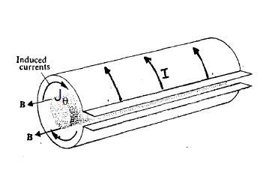
Figure 13: θ-pinch
In practice, a θ-pinch is a discharge tube inserted into a solenoid consisting of a series of coils. Inside the coil a rapidly variable axial magnetic field is generated $B_{z}$ which induces azimuth currents in the plasma$J_{θ}$. These currents flow in the opposite direction to those that flow through the coil. It may be useful to schematize the phenomena making the hypothesis that the plasma behaves as a perfectly conductive fluid with a constant kinetic pressure. The magnetic field produced by the loop is present only in the region between the plasma and the metal conductor, since it cannot penetrate the plasma, for the preservation of the magnetic flux inside the fluid. What happens is that an azimuthal diamagnetic current is generated on the surface of the fluid, which compresses the fluid until the magnetic and kinetic pressure equals the quantity:
$$β_{θ}=\frac{p}{\frac{B^{2}}{2μ_{0}}}=1$$
(3. 19)
Where quantity $β_{θ}$ is a measure of the system's ability to confine a plasma with a certain kinetic pressure. In reality when the conductivity is finite, the magnetic field penetrates (or spreads), to a certain extent, inside the plasma, and the plasma diffuses through the magnetic field lines. In a real case there will be a situation with diffused contours, with a generally increasing kinetic pressure and a decreasing magnetic pressure towards the centre of the solenoid.

Z-Pinch
Another linear configuration of MHD equilibrium is the Z-pinch which consists of a column of cylindrical fluid. Also in this case of infinite length, which leads currents in the direction of the z axis$J_{z}$. These currents create an azimuthal magnetic field $B_{θ}$ and therefore force lines of $\overline{J}$ and $\overline{B}$ are exchanged in respect to the configuration of θ-pinch. The force $\overline{J}x\overline{B}$ is radial, directed towards the axis. A Z-pinch is obtained by inducing a discharge in a low-pressure gas inside a glass tube, between two terminal electrodes, similar to those used for lighting. These are obviously in contact with the plasma and the total current flowing through the plasma is equal to the current of the external circuit that supplies the discharge. In cylindrical coordinate’s r, z e θ, since the coordinates z and θ are ignorable due to the symmetry of the problem, the equation for the pressure balance becomes:
$$\overline{∇}\left(p+\frac{B^{2}}{2μ_{0}}\right)=\frac{1}{μ_{0}}\left(\overline{B}⋅\overline{∇}\right)\overline{B}$$
(3. 20)
Is reduced to:
$$\frac{∂}{∂r}\left(p+\frac{B^{2}}{2μ_{0}}\right)+\frac{B^{2}}{2μ_{0}r}=0$$
(3. 21)
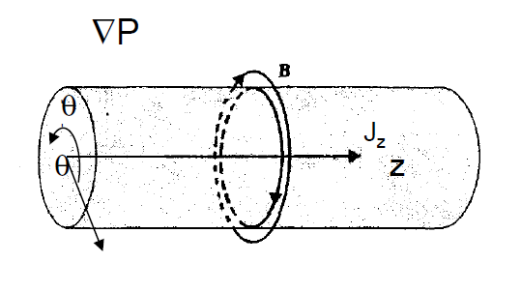
Figure 14: Z-Pinch
In this configuration, it is the plasma current itself that generates the magnetic field that confines the discharge. If the situation is schematically shown with a cylindrical fluid, crossed by a current flowing parallel to its axis, under the action of the force $\overline{J}x\overline{B}$ the plasma is compressed (pinch effect) in a filament along the axis of the cylinder, and this force is balanced by the gradient of pressure in the fluid. The surfaces with $p = cost$ are still concentric cylinders, but the pressure now varies with the radius of the cylinder. In this case the pressure of the plasma is balanced by the magnetic field through two mechanisms: by the effect of the magnetic pressure, similarly to the case of θ-pinch, and by the effect of the curvature of the field lines. The two effects are generally of the same order of magnitude. It can be shown that the MHD Z-pinch balance is not stable, and requires the addition of an axial magnetic field component to be stabilized. Moreover, in this configuration the plasma column is not confined to the ends but in thermal contact with the electrodes of the exciter circuit, therefore the Z-pinch has modest confinement capacity.

Screw-Pinch
In the PROTO-SPHERA experiment, a configuration called Screw-Pinch is created along the central symmetry axis, combining the stability aspects of θ-pinch and the confinement aspects of Z-pinch. Starting from Ampere's law, $∇xB=μ_{0}J$ in this scenario the magnetic field and the current density will have components along θ and Z:
$\overline{B}=B_{θ}\hat{θ}$+$B_{Z}\hat{z}$
$$μ_{0}J=\frac{1}{r}\frac{∂}{∂r}\left(rB_{θ}\right)\hat{z}-\frac{∂}{∂r}{(B}_{Z})\hat{θ}$$
The balance condition of the screw pinch will finally be given by$\overline{∇}p=\overline{J}x\overline{B}$, therefore:
$$\frac{∂}{∂r}\left(p+\frac{B_{θ}^{2}+B_{Z}^{2}}{{2μ}_{0}}\right)+\frac{B_{θ}^{2}}{μ_{0}r}=0$$
Though the momentum equation is non-linear the θ-pinch and Z-pinch forces ad as a linear superposition, a consequence of the high degree of symmetry.
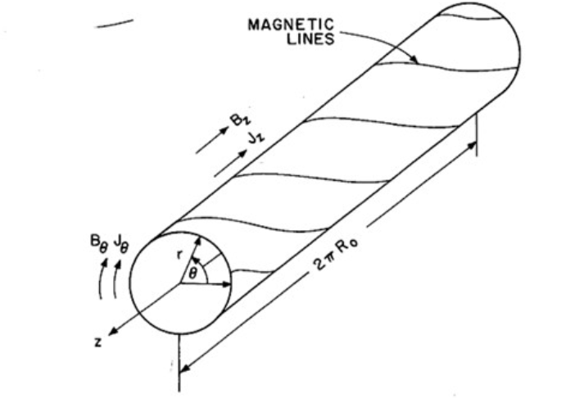
Figure 15: General screw-pinch geometry
In PROTO-SPHERA this configuration shapes the plasma like a disk near each electrode and applies a huge voltage to the central flow tube. From a balance point of view the configuration interfaces a spherical torus with a Screw-Pinch. The Screw-Pinch provides the field to stabilize the toroidal field which in return provides the longitudinal stabilization field to the Screw-Pinch.
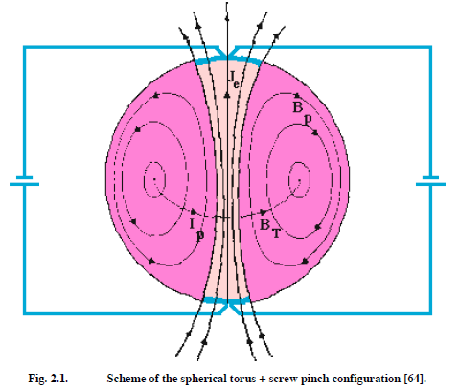
Figure 16: Scheme of the spherical torus and screw-pinch configuration

CHAPTER 4: CHANDRASEKHAR-KENDALL-FURTH
Chandrasekhar-Kendall-Furth (CKF) fields are simply connected plasma equilibria containing a magnetic separatrix, which divides a main spherical torus, two secondary tori on top and bottom of the main torus and a spheromak discharge surrounding the three tori. A separatrix is a boundary between domains with distinct dynamical behaviour (phase curves) in a dynamical system, in the case of a divertor configuration in tokamaks, or a similar situation in other devices: the separatix is the boundary between closed and open field lines, separating the toroidally confined region from the region where field lines connect to material surfaces. The CKF is the configuration that serves as the basis for the PROTO-SPHERA experiment. While forceless fields CKF have no pressure gradient $\overline{∇}p=0$ and a relaxation parameter $μ=μ_{0}\frac{\overline{J}⋅\overline{B}}{B^{2}}$ constant all over the plasma, unrelaxed CKF equilibria can be calculated with the boundary condition that $μ=μ_{0}\frac{\overline{J}⋅\overline{B}}{B^{2}}$ is constant only at the edge of the plasma. Unrelaxed CKF equilibria can be defined as spherical tori enclosed within spheromaks endowed with high elongation. This configuration has the advantage of being stable at all ideal MHD modes, up to the beta values$β∼1$. This high $β$ value opens the possibility that plasma motions, i.e. radial electric field, can sustain the magnetic field of CKF configurations. Unrelaxed CKF fusion reactors with the right helicity injection, $β$ limit and energy confinement, will allow an unimpeded outflow of high-energy fusion products, facilitating the direct conversion of energy and the use of the burner as a space propeller. Nevertheless, a method for injecting current into a CKF configuration still needs to be developed. PROTO-SPHERA can be seen as a preliminary experiment that will study the properties of an unrelaxed CKF configuration, where a Hydrogen force-free screw pinch, powered by electrodes, replaces the innermost part of the surrounding spheromak discharge, whereas the coils of the poloidal field replace the secondary tori.

CKF Force-Free Fields
A simply connected magnetic confinement scheme can be obtained superposing two axisymmetric homogeneous force-free fields, each with$\overline{∇}x\overline{B}=μ\overline{B}$, both having the same value of the relaxation parameter$μ$. The first is the Chandrasekhar-Kendall force-free field of order-1, the second is the Furth square-toroid force-free field. It possible write these two fields in spherical geometry as:
$$Ψ_{μ,1}^{CK}(r,θ)=-(μr)j_{1}(μr)\sin{θ}P_{1}^{1}\left(\cos{θ}\right)$$
$$Ψ_{μ,λ}^{F}(r,θ)=\sqrt{μ^{2}-λ^{2}}r\sin{θ}J_{1}(\sqrt{μ^{2}-λ^{2}}r\sin{θ})\cos{(λrcos{θ}})$$
Where $j_{1}$is the spherical Bessel function of order 1, $P_{1}^{1}$is the Legendre polynomial, $J_{1}$ is the cylindrical Bessel function. The superposition of the two force free-field is written:
$$Ψ\left(r,θ\right)=Ψ_{μ,1}^{CK}+{γΨ}_{μ,λ}^{F}$$
For value of the superposition constant$γ≥0.402$, of these two fields contains, in a simply connected region near the origin, a toroidal current density${\overline{J}}_{}$of the same sign and can be called a Chandrasekhar-Kendall-Furth force-free field (CKF). The Fig.16a shows the cross-section of the CKF force-free field with a parameter of superposition constant$γ=0.55$, and details its composition in terms of different plasma regions, divided by a magnetic separatrix. The main spherical torus (ST) has a safety factor which is $q_{0}^{ST}\sim 1.0$ on the magnetic axis and $q_{95}^{ST}\sim 1.5$ at the edge (95% of the poloidal flux of the magnetic separatrix). In a toroidal fusion device, the magnetic fields confining the plasma are formed in a helical shape, winding around the interior of the reactor. The safety factor, usually labelled $q$or $q(r)$, is the ratio of the times a particular magnetic field line travels around a toroidal confinement area's long way (toroidally) to the short way (poloidally). The term safety refers to the resulting stability of the plasma; plasmas that rotate around the torus poloidally about the same number of times as toroidally are inherently less susceptible to certain instabilities. The two secondary tori (SC), present on top and bottom of the main torus, also have $q_{0}^{SC}\sim 1.0$ on their magnetic axes and $q_{95}^{SC}\sim 1.5$ at their edges. The discharge surrounding the three tori, which will be dubbed as spheromak (P) has a larger safety factor, respectively $q_{0}^{P}\sim 1.5$ on the symmetry axis and $q_{95}^{P}\sim 3.7$ at the separatrix. When the superposition constant exceeds $γ=0.69$the secondary tori disappear.Fig 16b
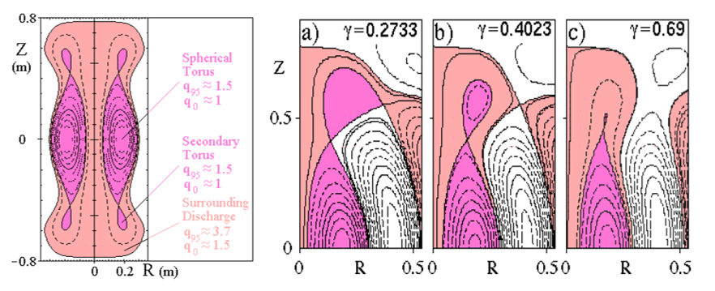
Figure 17: a) Contours of the poloidal flux function of the CKF Force-Free field with$γ=0.55$. b) Poloidal flux function countors of CKF Force-Free field.
Once a CKF force-free field is formed, if the surrounding spheromak discharge can be sustained by driving current on its closed flux surfaces, magnetic reconnections will occur at the X-points of the configuration, injecting magnetic helicity, poloidal flux and plasma current into the main spherical torus. Also the secondary tori will be a by-product of the same magnetic reconnections.

Ideal MHD Stability of CKF Force-Free Fields
The ideal MHD stability of the Chandrasekhar-Kendall-Furth (CKF) force-free fields has been studied by solving the eigenvalue problem: $\overline{W}⋅\overline{ξ}=ω^{2}\overline{K}⋅\overline{ξ}$ , where $\overline{W}$ is the plasma perturbed potential energy and $\overline{K}$ the plasma perturbed kinetic energy, associated with the perturbed plasma displacement$\overline{ξ}$ , and $ω^{2}$ is the eigenvalue. The expressions for the perturbed energies become simpler if the equilibrium is analysed in non-orthogonal periodical Boozer coordinates ($ψ_{T}$ radial, $θ$ poloidal, $φ$toroidal) that are a set of magnetic coordinates in which the diamagnetic $\overline{∇}ψ×\overline{B}$ lines are straight besides those of magnetic field$\overline{B}$. The periodic part of the stream function of $\overline{B}$ and the scalar magnetic potential are flux functions in this coordinate system. The radial variable $ψ_{T}$ is the toroidal flux divided by 2π, with $ψ_{T}=0$ on the magnetic axis of the main torus, $ψ_{T}={ψ_{T}}^{X}$ on the separatrix and $ψ_{T}={ψ_{T}}^{MAX}$ at the edge of the surrounding spheromak and on the symmetry axis. MHD global modes, which exist over the whole plasma, must have periodical perturbed displacements in terms of the Boozer poloidal angle θ. For these global modes the allowed poloidal mode numbers can be all the integers $m=…,-2,-1,0,1,2,3,…$ inside the main and the secondary tori. However other MHD internal modes can still exist if their radial extent is limited to the surrounding spheromak, where${ψ_{T}}^{X}≤ψ_{T}≤{ψ_{T}}^{MAX}$. The result of the ideal MHD stability calculations for low toroidal mode numbers (n=1, 2, 3), assuming fixed boundary conditions at the edge of the plasma is that the Chandrasekhar-Kendall-Furth force-free fields are stable when the value of the superposition parameter is greater than$γ=0.5$ .
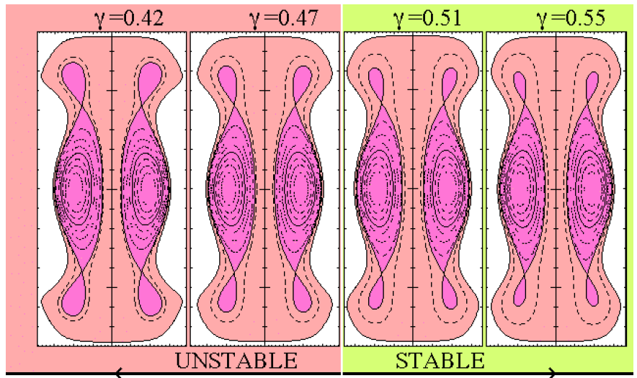
Figure 18: Sequence of CKF force-free fields with ideal MHD stability boundary as a function of the superposition parameter γ

Unrelaxed CKF Configurations
However force-free fields have $\overline{∇}p=0$ and are so unable to confine plasmas of fusion interest. Nevertheless a variety of unrelaxed ($\overline{∇}μ≠0$ ,$\overline{∇}p≠0$) MHD fixed boundary equilibria, similar in shape and topology to the CKF force-free fields, can be calculated. They have $μ=μ_{0}\frac{\overline{J}⋅\overline{B}}{B^{2}}$ constant only at the edge of the plasma ($ψ_{T}={ψ_{T}}^{MAX})$ as a boundary condition for the MHD equilibrium. Reactor extrapolations of unrelaxed CKF magnetic configurations, endowed with the right helicity injection, β limit and energy confinement, will allow for an unimpeded outflow of the high energy charged fusion products. The charged fusion products will drift across the magnetic separatrix, to the degenerate X-points ($\overline{B}=0$) on top/bottom of the configuration easing direct energy conversion and the use of the burner as a space thruster. An example of different case stable and an unstable CFK configuration with different beta of the main spherical torus$β_{ST}$:
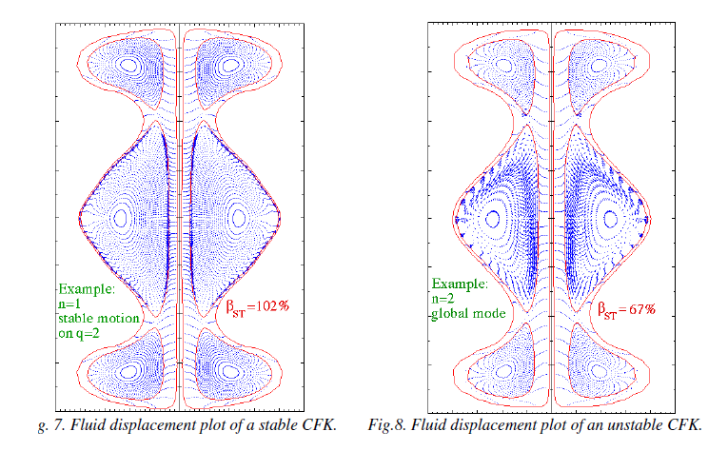
Figure 19: Fluid displacement of: a) stable CFK. b) Unstable CFK

CHAPTER 5: MECHANIC DESIGN OF PROTO-SPHERA
The PROTO-SPHERA machine consists of the following components: the vacuum vessel (VV), poloidal field (PF) coil system, the internal support, the anode, cathode, and the machine support (MS). In addition, there are divertor protection plates. The main parameters of the machine are given in Fig 18:
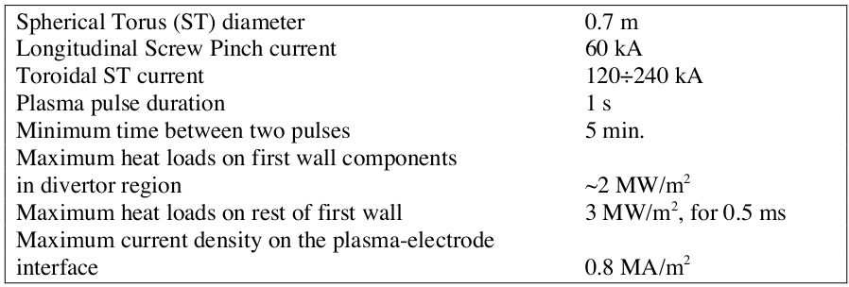
Figure 20: Machine Parameters
The basic principle of the mechanical engineering of PROTO-SPHERA is for a substantial VV, which provides both the high vacuum enclosure and contains the PF coils, the anode, the cathode and the other components. The PF coils are located very close to the plasma and therefore must be positioned inside the VV. The plasma arc inside the machine is produced by two electrodes, anode and cathode, which are (particularly the cathode) the most unconventional and technologically demanding components. The design is as simple as possible, easily assembled, with good access, particularly to anode and cathode, which are critical components and may require frequent maintenance/repair. In order to enhance the reliability and maintainability, all connections for the PF coils are external to the VV. All the feeds come from the top and bottom flanges, leaving space for diagnostic ports in the main body of the VV. Each coil has a separate feed connected to the access flange by a flexible bellows arrangement, in order to adjust its position, only the new PFInt-A coils do not have them because they are temporary. Provisions are made in the design to minimize the stray magnetic field, particularly in region near the spherical torus. Particular care has been exercised to keep each component floating, to avoid hot spots (90 °C) in the coils and to accommodate the electromagnetic stresses during plasma disruptions. Insulation plates are used where appropriate, while no coil can see directly the cathode. Now the machine is in the phase 1.5, with new internal and external PF coils plus other improvements to cathode and anode.
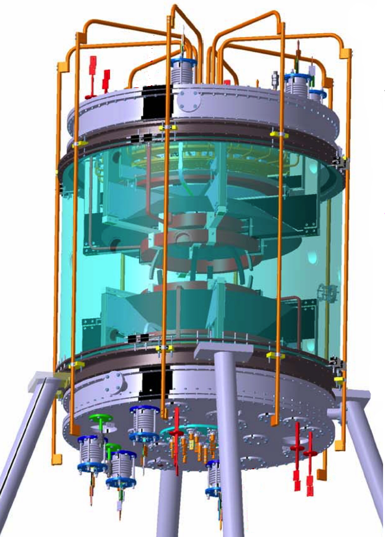
Figure 21: PROTO-SPHERA experiment phase 1.5

Vacuum Vessel
The old VV was an Aluminum vessel, 2 $m$ in diameter and 2 $m$ in height and 4 $cm$ thick; was START vacuum vessel, donated by Culham in 2004. In the May 2019 it was installed the new vacuum vessel consisting of an innovative polymer created from the Reynolds Company, the world’s leader in highly engineered acrylic and polymer material products. This particular VV is in polymethylmethacrylate (PMMA) very transparent to visible and to ultraviolet light. It was chosen because the field produced by the external coils had a skin-current delay in order to cross the thickness of Aluminum. The dimensions of the new VV are 1.7 $m$ in height, 2.0 $m$ in internal diameter, and a thickness of 90$mm$. In the cylinder there are 12 passing holes through the equatorial plane, with a diameter of 120$mm$ each, each hole is centered with respect to 2 flattened surfaces with a 152$mm$ diameter the external one and again 152 $mm$ the internal one, obtained on the PMMA cylinder. There are also four passing holes in the upper part of the cylinder and four passing holes in the lower part of the cylinder at a distance of 92 $mm$ from the cylinder extremities. Each hole is 96 $mm$ in diameter, and is centered with respect to two flattened surfaces with a 152 mm diameter the outer one and 128 $mm$ the internal one. The PMMA cylinder is also provided with two rounded grooves of 20$mm$ thickness and 16 $mm$ width, placed at 20$mm$ distance from both extremities of the cylinder: these grooves allow, through a clamping system, to fix the PMMA cylinder on two AISI 304 ferrules (with ferrules, seals and clamping system). Once the clamping system has been tightened at the extremities, and once the 20 holes have been closed with appropriate flanges, two flat gaskets of Viton FPM75, 1 cm thick, are compressed between the new cylinder and the lower and the upper ferrule, allow the cylinder itself to hold the vacuum. The VV is has withstood about 30 tons vertically, as well as the radial stress, and also supports the weight of the (existing) metal components, which is weighting (via the ferrule) from above upon the cylinder itself, with about 3 tons before the cylindrical chamber is vacuum pumped. A thin layer 2 $mm$ of polycarbonate has been inserted into the vacuum chamber to prevent any direct contact of the plasma with the PMMA and for protecting the cylinder from the UV radiation emitted by the plasma. A particular diaphragm are used to prevent a flow of plasma current in the outermost area of the vessel, and are in direct contact with the polycarbonate that protect the vacuum vessel. The vacuum inside the chamber is guarantee from a system of pump. Is used a rotative pump until a pressure of ${10}^{-3}mbar$, and there is in series a Roots pump ATB Kunden, which is a wall displacement vacuum pumps that work by dragging the gas through a pair of rotating lobes. Finally there are two turbo pumps which are axial drive pumps and bring the vacuum pressure until${ 10}^{-5}mbar$.
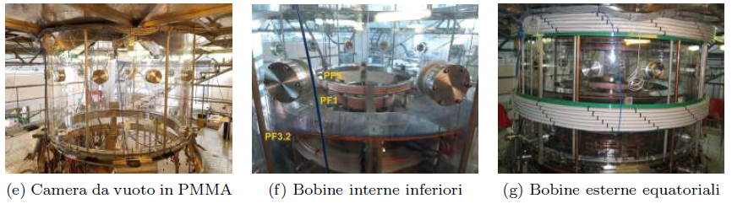
Figure 22: Vacuum Vessel, Internal PF coil, External PF coil

Electrodes
The anode and cathode electrodes supplying the pinch arc are placed on the vessel top and bottom, respectively. The arc current has a reclosing path outside the vacuum vessel through eight copper bars. The cathode consists of tungsten filaments having a special conic-spiral shape designed to optimize the thermionic effect while limiting the electromagnetic interferences. The cathode has 54 tungsten filaments in 18 modules. Each installed filament is heated by its nominal current (150$A$) and the average current density on the cathode is maybe$1{MA}/{m^{2}}$ , requiring a cathode heating power supply at 1.7 $kA$ $rms$ and 25$V rms$. The cathode power supply is designed to heat these filament up to about 2750$°C$. The electrons emitted by the filaments due to the thermionic effect produce the required plasma by ionizing the hydrogen injected from the top (in the anode region). The cylindrical component is made from 378 coils supported by a dispenser assembly, see Figs.19 which also feeds the current to the W coils. The dispensers are made from Molybdenum that is a very hard metal and among the elements is one of the highest melting points and is perfect for the cathode. In addition the cathode is composed from 6 sectors, each powered by a six-phased AC power supply. There are $3 x 7$dispensers form each sector, each carrying 3 coils of null field type. The design is such that each dispenser can be individually replaceable. The six-phased AC power supply gives 8 $MJ$ to the cathode. The heating time to the working temperature (2600$°C$) of the coil wires is 29 $s$ if the machine start from cold. As soon as the screw pinch plasma breaks down, the coil temperature increases to a maximum of 2750 $°C$ predicted stresses are much less than the ultimate W strength at 2750 $°C$ and result also in no creep at these temperatures for several thousand pulses. The anode is formed by six 60$°$ sectors, each with 5 modules each at the moment. Each module is made from OFHC Cu, with its surface, exposed to the plasma arc, protected by an alloy of W-Cu(5$\%$) to resist excessive transient temperatures (~1000 $°C$). Gas puff in each individual module, summing up to 30 $mbar •l/s$ l/s, is performed through 20, 10 $mm$ diameter holes, see Fig.22 to spread the arc energy and avoid melting. The modular design of the anode permits replacement of each module individually. The machine duty cycle is determined by the cooling time of the electrodes. The interpulse cooling of the anode and cathode is mainly done by radiation. In order to achieve a machine duty cycle of 5$min$, the global temperature (after a few successive pulses) must be 380 $°C$ for the anode and 450 $°C$ for the cathode. Thanks to the new transparent vacuum chamber, easy optical diagnostics are also possible to directly display most of the anode and cathode from the upper and lower flange, in order to monitor any degradation. The design of the electrodes is modular so that local replacements can be made at minimal cost. A secondary 2$mm$ thick Polycarbonate screen surrounds rear of both anode and catode. An axisymmetric high density confined torus is produced in absence of a toroidal magnet, but using only the external metal legs that connect anode and cathode for close the circuit.
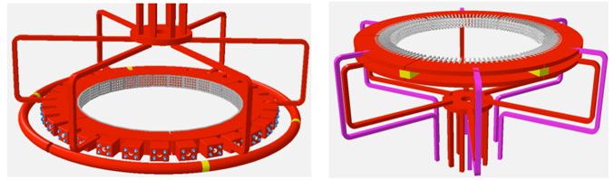
Figure 23: Outline of anode and cathode

Poloidal Field Coils
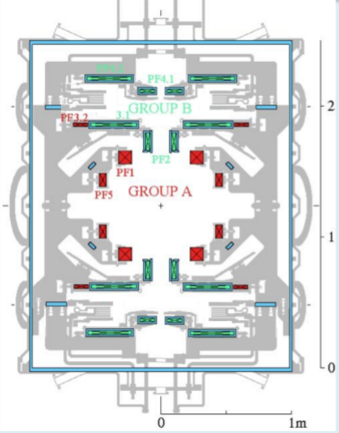
There are two sets of poloidal field coils in PROTO-SPHERA, all connected in series Fig.24: type B, the set of coils which shape the screw pinch and whose currents do not vary during the plasma evolution; type A, the set of coils which compress the ST and whose currents vary during the plasma evolution. The present provisional internal compression PFInt-A coils are made with Teflon shielded copper cable of $105 m^{2}$section, there are three pairs, powered in series by the Super Capacitor with a maximum current of 2000 A. In detail inside the vacuum chamber there are PF3.2 = 4 turns, PF5 = 6 turns and the PF1 = 10 turns. The coils are arranged coaxially and sustained by the support structure. The coils and their supports are designed to withstand electromagnetic forces during normal and fault conditions. They can also accommodate thermal expansion during the plasma operation. Outside the VV are present external PF coils: PFExt. Two PFExt of 8 turns on the top and the bottom of the vessel, and two PF of 12 turns consisting of copper cable of 240 ${mm}^{2}$, 2kA, 350 $V$ in DC current. In the 2 PFExt coils near equator the current flows in opposite direction to toroidal current inside the Plasma-Centerpost, whereas in the two PFExt coils on top and bottom in the same direction as in the Plasma-Centerpost.
Figure 24: Group of Poloidal Field Coils
External equatorial coils create a vertical magnetic field pointing from top to bottom. This magnetic field moves the plasma near the electrodes. For this reason, a top and a bottom coil (with currents circulating in the opposite direction to the equatorial currents) are used to return the plasma to the correct area. The central plasma column is autostabilized from electrostic phenomena.
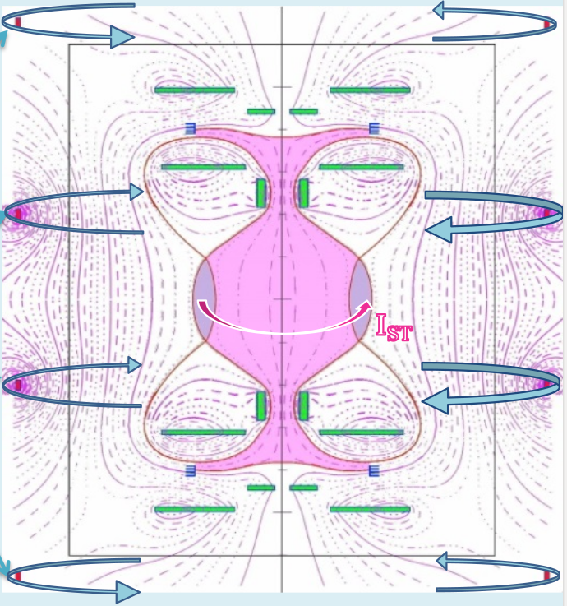
Figure 25: Magnetic field of external Poloidal Field Coils

Divertor
Among the coils of the poloidal system of PROTO-SPHERA, The PF2, PF1 and PF5 are very near and in direct view of the plasma and thus can be subjected to thermal loads. In addition the double X-point configuration requires target plates, where the thermal power diverted from the spherical torus can be dumped. The thermal flux impinging upon the divertor plates in the steady-state phase of the discharge is first evaluated, assuming that the spherical torus can be sustained for$1 s$. Based on the calculated equilibrium configurations, the position of the divertor protection plates have been chosen. The rationale of this choice is to provide a large enough separation from the plasma to the divertor plates and to allow for the positioning of the target at a sufficiently small angle with the projection of the separatrix on the poloidal cross-section. This thermal flux is easily manageable by any material we can think for the divertor plates, so that the choice of this material can be based on other issues. The machine use now a divertor of Stainless Steel, convenient and effective. It is to be noted that the divertor plates configuration just described is rather unconventional with respect to tokamak experiments, and it could offer some advantages:
- The wetted surface is quite far away from the plasma, so that the impurity flux to the plasma, due to generation at the plates, could be lower than in more conventional configurations.
- Also the recycling should be quite different: neutrals emitted from the target can reenter the plasma only after recirculation through the vacuum chamber volume. This could result into a very diffuse refuelling and into an effective recycling coefficient substantially smaller than 1.
- The target plates are accessible for optical, bolometric and thermographic diagnostics.
To avoid the flowing of plasma currents outside the desired path of the plasma centerpost two large insulating Polycarbonate diaphragm separators have been inserted near the divertor.
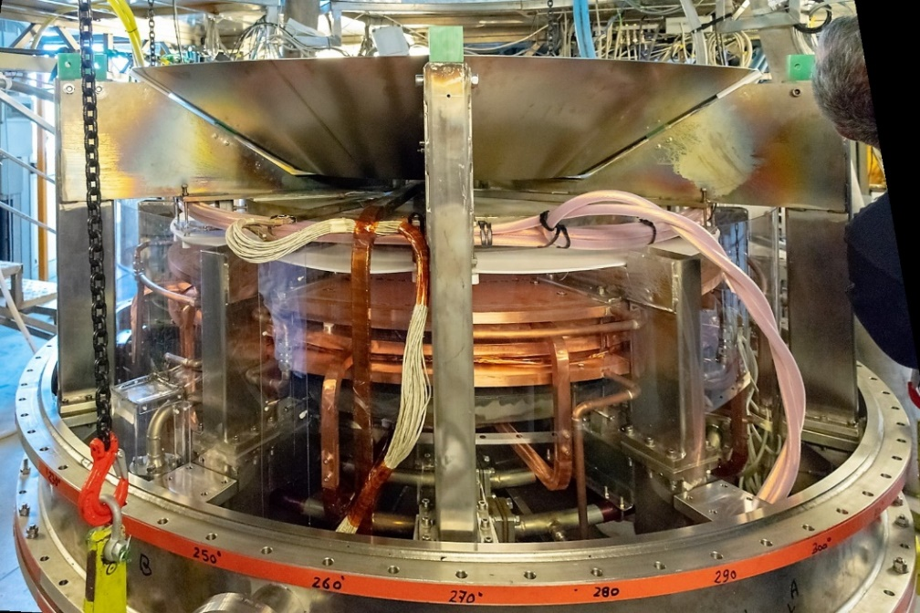
Figure 26: View of the cathode,the divertor is on the top

Assembly and Maintenance
To facilitate the assembly and maintenance, the machine services are routed through ports at the bottom and top flat flanges. Thus no internal, to the vacuum, connections to the services are needed. Furthermore the design of the coil feedthrough and of the other services is such as to avoid any cutting and re-welding when the machine is partially dismounted for access to the electrodes. The PF coils, anode, cathode and their support structure are pre-assembled on a customized jig outside the VV. The relative position of the coils are adjusted before the closure of the machine to guarantee the accuracy of the magnetic field. The magnetic field is measured with a magnetic probe system, which would record the value and direction of the field. In addition the position of the probe(s) in relation to datum points together with these of anode, cathode and PF Coil system are also carefully measured. Then the PF coils, anode, cathode and their supports are installed inside the VV, which is closed by the top and bottom flanges. These flanges can be removed in situ for repair of the anode or the cathode as required.

CHAPTER 6: DIAGNOSTICS
On the PROTO-SPHERA experiment are available different kind of diagnostic plasma diagnostic that allows to detect a different plasma parameters. The diagnostic are mounted inside the device (like magnetic measurement), and outside on the equatorial plane of the vacuum chamber.
For detect the optical emission from the PROTO-SPHERA device is present a compact spectrometer array. This instrument covering the range 235-790 nm, with the resolution from 0.09 nm in UV to 0.14 nm in IR. The light collected is carried by three quartz fibres. This spectrometer has two lenses, one fixed and the other mounted on a micrometric slide. This structure allows you to focus on the emission of plasma from different depths of the vacuum chamber.
Another diagnostic available is a Second Harmonic Interferometer (SHI). The SHI, developed by the Plasma Diagnostics & Technologies SRL of the University of Pisa, is a device insensitive to vibrations, which has allowed an easy installation on the machine, thanks to a compact modular design. The SHI it allows to detect the line-averaged electron density $〈n_{e}〉$
A radiation survey monitor has been used to verify the presence of hard x-rays radiation emission during the formation of the plasma arc and torus configuration. The monitor used was a Victoreen gamma x ray ionization chamber with an energy measuring range from about 20 keV up to 3 MeV. The integral of the total dose was measured during some pulses in a position near a glass window facing the plasma equator but signals above the background were never detected. This is consistent with the high density of the plasma produced by PROTO-SPHERA.
A large number of magnetic probes (about 70) are present near the anode and near the cathode plasma regions, but there are not magnetic measurements near the torus, however the distance between the two X-points of the divertor gives an accurate estimate of the current flowing inside the torus. The measurements of the original Rogowsky coils that measure the Plasma Centerpost currents that go through the two PF2 mirror coils have been doubly checked by two supplementary Rogowsky coils that have been built from the armoured cable kindly offered by the firm Axon Cable of Montmirail (France) and inserted inside the machine just before attempting the formation of the plasma torus.
Are present a visible light slow cameras acA640-90gm - Basler that capture the views of the plasma in different angulation for check his behaviour and the situation of the machine components. The Basler acA640-90gm GigE camera with the Sony ICX424 CCD sensor delivers 90 frames per second at VGA resolution. There are six of these cameras in different strategical position;
- Two cameras control the condition of the anode and the nozzles from where the gas is inserted.
- Another two are positioned on the cathode for check the reheat of the tungsten filaments.
- The last two are angulated for see the PF2 coils, bottom and top.
Is possible manage and change the acquisition parameters from two computers, where there are three cameras connected for each one.

Fast Cameras
Is was implemented a system of six fast visible light cameras was evenly spaced around the PROTO SPHERA experiment. Thanks to the new vacuum vessel in polymethylmethacrylate (PMMA), totally transparent to visible and to ultraviolet light; it is possible collocate the cameras outside the vessel leaving the existing ports available for other diagnostics. Is used the acA640-750um Basler ace USB 3.0 cameras with an ON Semiconductor PYTHON 300 mono CMOS sensor, that delivers 751 frames per second at VGA resolution and use Basler Lens C125-0418-5M(f/1.8 / 4mm). All Basler ace USB 3.0 cameras are equipped with separate input/output ports for triggered image acquisition. This kind of camera has a resolution of 640 x 480. The Pixel Size (H x V) are 4.8 $μm$ x 4.8$μm$. The camera is interfaced to external circuitry via two connectors:
- A USB-3.0 Micro-B connector to transmit image data, control signals, and configuration commands. The connector is used to provide power to camera.
- A 6-pin connector used for access to the camera’s I/O lines. Don’t use the I/O connector to provide power to the camera. The attached cable plug must have 6 female pins.
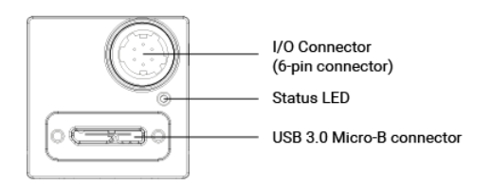
Figure 27: Connector scheme
The cameras are positioned on the equatorial plane of the vessel, separated by 60 degree around the circumference of the experiment and are able to cover all the volume of the central plasma. During the positioning of the cameras is used the vacuum vessel like a referent system for centred all the cameras each other with their opposite camera. Two PCs equipped with two dedicated USB3 controllers manage the cameras, three for each of them. An Arduino Nano, plugged to one of the two Pc, generates the pulse train for the frames acquisition as soon as the experiment trigger arrives. By varying the pulses duty cycle allows to control the exposure time for each frame. The configuration of the number of pulses and their duty cycle can be changed before each experiment. The cameras aim to detect the axial symmetric brightness profile as well as the not-axisymmetric helical instability phenomena in the plasma. However, the problem of visible tomography of the plasma will require a method of reversing the brightness, since the cameras will observe not the precise brightness of the plasma, but its integrated brightness on the lines of sight. A fast and effective method to invert the quantities integrated on the lines of sight through a plane disk is that of the polynomials of Zernike, angular index $m$ and radial index$l$ that will be discussed in the chapter of data analysis.

Camera Calibration and 3D Reconstruction
The geometry of the system has been analysed creating a program Proto_Sphera_3D.py that recreate in 3D: the vacuum vessel, the cameras and the ports using the optics geometry, and the lines of view for each pixel. For the first approach it was used the pinhole camera model. The pinhole camera model describes the mathematical relationship between the coordinates of a point in three-dimensional space and its projection onto the image plane of an ideal pinhole camera, where the camera aperture is described as a point and no lenses are used to focus light. The model does not include, for example, geometric distortions or blurring of unfocused objects caused by lenses and finite sized apertures. It also does not take into account that most practical cameras have only discrete image coordinates. This means that the pinhole camera model can only be used as a first order approximation of the mapping from a 3D scene to a 2D image. Its validity depends on the quality of the camera and, in general, decreases from the centre of the image to the edges as lens distortion effects increase. Some of the effects that the pinhole camera model does not take into account can be compensated, for example by applying suitable coordinate transformations on the image coordinates; other effects are sufficiently small to be neglected if a high quality camera is used. The next relations are derived based on the assumption that the cameras can be approximated by the pinhole camera model. In this model, a scene view is formed by projecting 3D points into the image plane using a perspective transformation.
$$sm^{'}=A[R|t] M^{'}$$
Or,
$$s\left[\begin{matrix}u \\ v \\ 1\end{matrix}\right]=\left[\begin{matrix}f_{x} & 0 & c_{x} \\ 0 & f_{y} & c_{y} \\ 0 & 0 & 1\end{matrix}\right]\left[\begin{matrix}r_{11} & r_{12} & r_{13} & t_{1} \\ r_{21} & r_{22} & r_{23} & t_{2} \\ r_{31} & r_{32} & r_{33} & t_{3}\end{matrix}\right]\left[\begin{matrix}X \\ Y \\ Z \\ 1\end{matrix}\right]$$
Where:
- (X, Y, Z) are the coordinates of a 3D point in the world coordinate space
- (u,v) are the coordinates of the projection point in pixels
- A is a camera matrix, or a matrix of intrinsic parameters
- (cx, cy) is a principal point that is usually at the image centre
- (fx, fy) are the focal lengths expressed in pixel units.
Thus, if an image from the camera is scaled by a factor, all of these parameters should be scaled (multiplied/divided, respectively) by the same factor. The matrix of intrinsic parameters does not depend on the scene viewed. So, once estimated, it can be re-used as long as the focal length is fixed (in case of zoom lens). The joint rotation-translation matrix [R|t] is called a matrix of extrinsic parameters. It is used to describe the camera motion around a static scene, or vice versa, rigid motion of an object in front of a still camera. That is, [R|t] translates coordinates of a point (X, Y, Z) to a coordinate system, fixed with respect to the camera. The transformation above is equivalent to the following (when$z≠0$):
$$\left[\begin{matrix}x \\ y \\ z\end{matrix}\right]=R\left[\begin{matrix}X \\ Y \\ Z\end{matrix}\right]+t$$
$$\left\{\begin{aligned}x^{'}=\frac{x}{z} \\ y^{'}=\frac{y}{z} \\ u=f_{x}*x^{'}+c_{x} \\ v=f_{y}*x^{'}+c_{y}\end{aligned}\right.$$
The following figure illustrates the pinhole camera model.
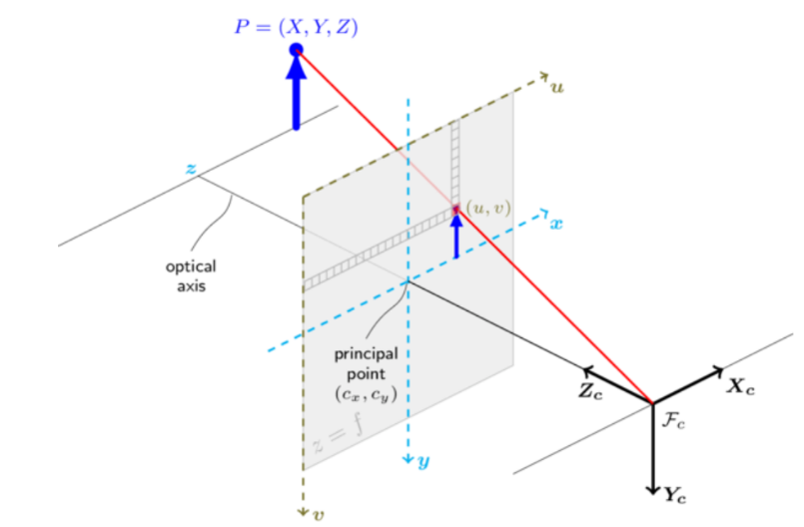
Figure 28: Pinhole camera model
Using this model it was possible create the program that rebuild the lines of view from each pixel using the previos equation and the camera matrix obtained from a camera calibration. The process of determining the camera matrix is the calibration. Calculation of these parameters is done through basic geometrical equations. The equations used depend on the chosen calibrating objects. For calibrate the camera it was use a simple program OpenCV where basically, it is necessary take snapshots of a classical black-white chessboard with the camera. To solve the equation there is need at least a predetermined number of pattern snapshots to form a well-posed equation system. This number is higher for the chessboard pattern. In theory the chessboard pattern requires at least two snapshots. However, in practice it has a good amount of noise present in the input images, so for good results it was used at least 10 good snapshots of the input pattern in different positions. At the end, it was created the lines of view of all the cameras using the coordinates of them and of the image plane from the pinhole model. Is possible create 640x480 lines of view in 3D.
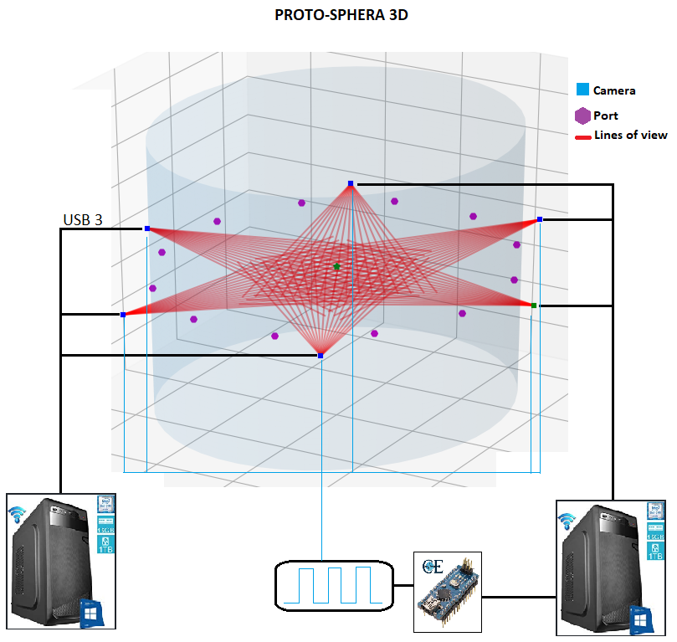
Figure 29: System layout of PROTO-SPHERA and fast cameras

CHAPTER 7: EXPERIMENTAL SEQUENCE AND DAQ
Like in other tokamak machines both the PROTO-SPHERA experimental sequence and the data acquisition system (DAQ) rely on the MDSPlus and MARTe frameworks. The first step of the experimental campaign it was recreate a central column of plasma inside the machine using Argon gas. The Argon is choose for first because is a noble gas, high atomic weight and it reaches a less temperature and major density of the Hydrogen plasma, these characteristics make it better for the preliminary test and check the functionality of the machine upgrades without big risk of damage the dispositive. For a typical shot is reaches current for the pinch from $1 – 10 kA$ and for the internal and external coils a max current of $2 kA$. Usually a discharge lasts 250 milliseconds but, modifying the delay of the pinch current is possible extend the discharge of plasma until 1 second. The procedure follow for a typical experimental session is the sequent:
- Before all the shots the cathode is alimented for 29 seconds for allows the correct reheat of the tungsten filaments up to about 2750 degree.
- The gas is inserted inside the vacuum chamber from the anode for ten second, the armoured internal coils are fed, which in about 50 milliseconds stabilise the magnetic field inside the vacuum chamber.
- By switching on the potential difference between cathode and anode, the discharge is created, and the central plasma column is formed.
- For manage the shape of the column the PF-Int have a current that flow in anti-clockwise direction.
- It was used first Argon and after Hydrogen gas.
- In the case of the Argon gas is observe a thin column, and for obtain the torus is necessary use the PF-Ext togheter the PF-Int with current in anti-clockwise verse, the field in this mode enlarges the column and create the torus around them.
- In the case of the Hydrogen is observe a large column, for obtain the torus is necessary use the PF-Ext and the PF-Int with current in clockwise verse. The magnetic field in this mode has a total effect that compress the column, and finally the torus start to appear.
- It is possible to manage the current direction in a decoupled way for PF-Ext and the PF-Int, in particular for the PF-Ext is possible also choose how many windings activate of the total 12 for manage the intensity of the magnetic field. This property allows to search the best combination of the current for obtain a large tori.
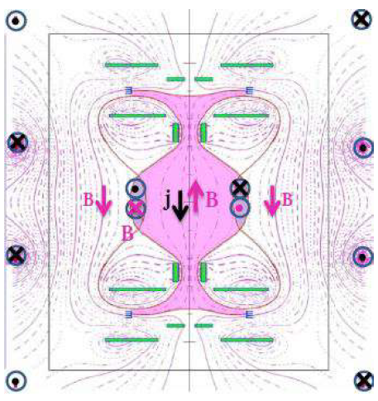
Figure 30: PFext magnetic field
During the firsts experimental week there's been an incident, the plasma has damage the cooling system and the water was poured into the cathode. It was necessary open the bottom and the top ports and using a heating installation for dry the machine for maybe three days. The cooling system ducts have been closed with vacuum for continue the experimental campaign also because the temperature for this phase 1.5, are not so higher to require the water cooling for now.
The data acquisition system of the experiment is managed from a frameworks MDSPlus and MARTe, that allows to control the sequence of the shot from the control room synchronising the trigger for all the diagnostics, include the fast cameras.

Frameworks
The MARTe software framework is a C+ modular and multi-platform framework for the development of real-time control system applications. The previous version of the framework (aka MARTe1) was deployed in many fusion real-time control systems, particularly in the JET tokamak. One of the main advantages of the MARTe architecture is the bold separation between the platform specific implementation, the environment details and the real-time algorithms (i.e. the user code). The platform is defined by the target processor and the operating system, while the environment encapsulates all the interfacing details which are related to the peculiarities of the location where the final system is to be deployed. This includes both the interfacing with the hardware platform and the binding to the services that allow to configure and retrieve data from the system. This clear separation of concern has allowed to reuse many components inside the same environment (e.g. all the systems deployed at JET share the same services for parameter configuration and data retrieval) and to develop and test the user algorithms in non-real-time operating systems and to later deploy the same exact code in a previously tested platform. As more systems started to use MARTe1, the number of supported environments and platforms has grown considerably. This has leveraged the exposure of the same core code to different environment configurations, thus increasing the confidence on its quality and robustness. Having the same infrastructure being used inside a community has also had the advantage of sharing and recycling knowledge about the framework and its architecture. One of the main objectives of the MARTe2 version was to develop a software Quality Assurance (QA) strategy that is appropriate for the development of real-time applications that required the integration of contributions from a large and heterogeneous development community, which includes developer profiles both from the scientific community and from the industry.
MDSplus is a set of software tools for data acquisition and storage and a methodology for management of complex scientific data. MDSplus allows all data from an experiment or simulation code to be stored into a single, self-descriptive, hierarchical structure. The system was designed to enable users to easily construct complete and coherent data sets. The MDSplus programming interface contains only a few basic commands, simplifying data access even into complex structures. Using the client/server model, data at remote sites can be read or written without file transfers. MDSplus includes x-windows and java tools for viewing data or for modifying or viewing the underlying structures. Developed jointly by the Massachusetts Institute of Technology, the Fusion Research Group in Padua, Italy (Istituto Gas Ionizzati and Consorzio RFX), and the Los Alamos National Lab, MDSplus is the most widely used system for data management in the magnetic fusion energy program. It is currently installed at over 30 sites spread over 4 continents. MDSplus was designed to give researchers the ability to produce complete, coherent, self-descriptive data sets and to provide tools for efficient access to that data in a distributed computing environment. The result was a system with sufficient flexibility and extensibility that ALL information associated with an experiment (or simulation) can be stored in the same structure and accessed through the same set of simple calls. By unifying setup, calibration, geometry and so forth with task descriptions, scheduling, status and all raw and processed data, MDSplus makes it easy to share data and tools across applications, facilitating collaborative research and reducing duplication of efforts. With MDSplus, it becomes practical to remove data entirely from codes and move them into the data structures. This approach allows highly flexible applications to be created whose operation can be modified easily without re-writing code. For example, a routine can create a menu of signals for display or processing by interacting with the data. New signals appear automatically in the application when they are added to the data structure - no new programming is required. Similarly, the names of routines for analysis and the parameters to control their operation can be specified as MDSplus data. Steps used during interactive processing can be saved for future reference or used as a script to "replay" the analysis. Perhaps the most important data driven application supported by MDSplus is data acquisition. Composite structures called DEVICES are defined which contain all the setup parameters, task descriptions, scheduling information and raw data which are associated with each physical data acquisition module on an experiment. Tools for scheduling and dispatching the data acquisition and analysis tasks are also part of MDSplus.
It was develop a program in C+ language that grab and process images from multiple cameras using the CInstantCameraArray class. The CInstantCameraArray class represents an array of instant camera objects and main purpose is to simplify waiting for images and camera events of multiple cameras in one thread. The program loads a configured file that comes from the Basler PylonViewer software that allow to modify all the features of the cameras for grab images like, analog control, acquisition control, image format, etc. An external trigger setup is used to cause all cameras to grab images synchronously using a NANO Arduino connect to one PC. Is possible manage the exposure time by software directly modifying the part of the code that manage the Arduino. After the acquisition phase, are created a folder for each cameras, and all the image are stored inside. For see instantly the behaviour of the column of plasma, it was implemented a script that create video for each cameras, send them to the main computer in the control room and generate a mosaic of all six videos. After each shot is possible check all the video of the experiment in slow motion, if is necessary is also available the single frames. To manage the acquisition system of the fast cameras was implemented the MARTe2 software.

CHAPTER 8: IMPLEMETATION OF OPTICAL TOMOGRAPHY
Tomography is imaging by sections or sectioning, through the use of any kind of penetrating wave. The method is used in radiology, archaeology, biology, atmospheric science, geophysics, oceanography, plasma physics, materials science, astrophysics, quantum information, and other areas of science. In many cases, the production of these images is based on the mathematical procedure tomographic reconstruction, such as X-ray computed tomography technically being produced from multiple projectional radiographs. Many different reconstruction algorithms exist. Most algorithms fall into one of two categories: filtered back projection (FBP) and iterative reconstruction (IR). These procedures give inexact results: they represent a compromise between accuracy and computation time required. FBP demands fewer computational resources, while IR generally produces fewer artifacts (errors in the reconstruction) at a higher computing cost. Tomographic images are 2-D representations of structures lying within a selected plane in a 3-D object. Modern computed tomography (CT) use detector systems placed or rotated around the object so that many different angular views (also known as projections) of the object are obtained. Mathematical algorithms then are used to reconstruct images of selected planes within the object from these projection data. Note that the data collected correspond to a slice through the object perpendicular to the Z axis of the chamber and that this is called the transverse or transaxial direction. The direction along the z axis, which defines the location of the slice, is known as the axial direction.

Zernike Polynomials
The Zernike polynomials are a sequence of polynomials that are continuous and orthogonal over a unit circle. A large fraction of optical systems in use today employ imaging elements and pupils which are circular. As a result, Zernike polynomials have been adopted as a mathematical description of optical wavefronts propagating through such systems. An optical wavefront can be thought of as the surface of equivalent phase for radiation produced by a monochromatic light source. For a point source at infinite distance this surface is a plane wave. The mathematical description, offered by Zernike polynomials, is useful in defining the magnitude and characteristics of the differences between the image formed by an optical system and the original object. These optical aberrations can be a result of optical imperfections in the individual elements of an optical system and/or the system as a whole. The Zernike polynomials are but one of infinite number of complete sets of polynomials, with two variables, that are orthogonal and continuous over the interior of a unit circle. The condition of being continuous is important to note because, in general the Zernikes will not be orthogonal over a discrete set of points within a unit circle. However, Zernike polynomials offer distinct advantages over other polynomial sequences. Using the normalized Zernike expansion to describe aberrations offers the advantage that the coefficient or value of each mode represents the root mean square (RMS) wavefront error attributable to that mode. The Zernike coefficients used to mathematically describe a wavefront are independent of the number of polynomials used in the sequence. This condition of independence or orthogonality, means that any number of additional terms can be added without impact on those already computed. Coefficients of larger magnitude indicate greater contribution of that particular mode to the total RMS wavefront error of the system and thus greater negative impact on the optical performance of the system.

Mathematical basis
In general, the function describing an arbitrary wavefront in polar coordinates$(r, θ)$, denoted by$W(r, θ)$, can be expanded in terms of a sequence of polynomials Z that are orthonormal over the entire surface of the circular pupil:
$$W\left(r, θ\right)=\sum_{n,m}{C_{n}^{m}Z_{n}^{m}\left(r, θ\right)}$$
Where C denotes the Zernike amplitudes or coefficients and Z the polynomials. The coordinate system is shown in figure:
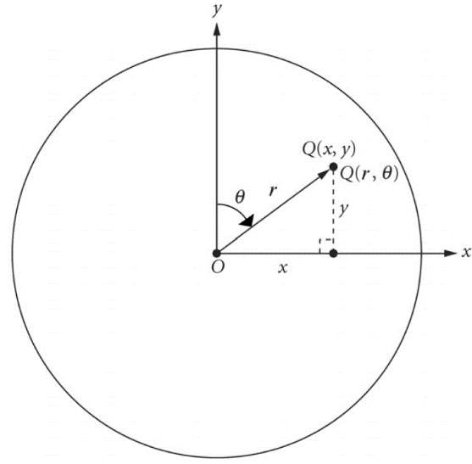
Figure 31: Cartesian (x, y) and polar (r,θ) coordinates of a point Q in the plane of a unit circle representing the circular exit pupil of an imaging system
The Zernike polynomials expressed in polar coordinates$(X=r\sin{θ}$,$Y=r\cos{θ})$, are given by the complex combination:
$$Z_{n}^{m}\left(r, θ\right)±iZ_{n}^{-m}\left(r, θ\right)=V_{n}^{-m}\left(r\cos{θ},r\sin{θ}\right)=R_{n}^{m}\left(r\right)exp⁡(±imθ)$$
There are odd and even Zernike polynomials. Even polynomials are defined as:
$$Z_{n}^{m}\left(r, θ\right)=R_{n}^{m}\left(r\right)\cos{mθ}$$
and odd-numbered ones like:
$Z_{n}^{-m}\left(r, θ\right)=R_{n}^{m}\left(r\right)\sin{mθ}$
Where $m$ and $n$ are non-negative integers with $n$ radial number, $m$ angular number with$n ≥ m$; $r$ is restricted to the unit circle ($0≤r≤1)$ meaning that the radial coordinate is normalized by the semi-diameter of the pupil, and $θ$ is the azimuth angle measured clockwise from the y-axis. Zernike polynomials have the property of being limited to a range from -1 to +1 $\left|Z_{n}^{m}\left(r, θ\right)\right|≤1.$This is consistent with aberration theory definitions, but different from the conventional mathematical definition of polar coordinates. The convention employed is at the discretion of the author and may differ depending on the application. The radial function$R_{n}^{m}\left(r\right)$, is described by:
$$R_{n}^{m}\left(r\right)=\sum_{l=0}^{(n-m)/2}{\frac{{\left(-1\right)}^{l}\left(n-l\right)!}{l!\left[1/2\left(n+m\right)-l\right]!\left[1/2\left(n-m\right)-l\right]!}r^{n-2l}}$$
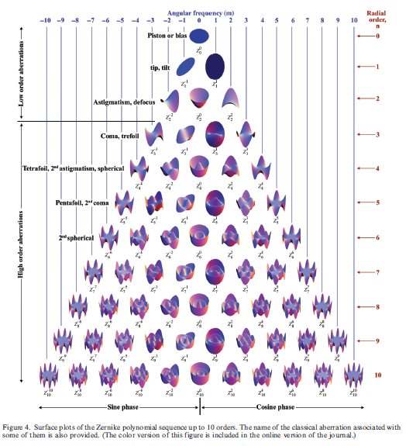
Figure 32: Surface plots of the Zernike polynomial sequence up to 10 orders

Tomographic inversion of Zernike
These polynomials are a good basis for comparing the point quantities $g(ρ, η)$ defined on a unitary circle (in cylindrical coordinate’s$(ρ, η)$) with their line integrals $f\left(p,ϕ\right)$(in azimuth coordinates $ϕ$ and impact parameter$p$) see next figure.
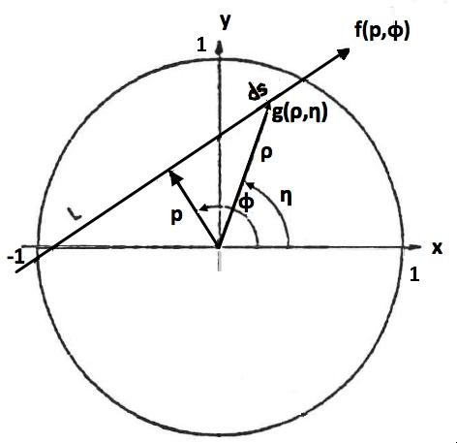
Figure 33: Coordinate system
If they expand according to Fourier, is possible write:
$$g\left(ρ, η\right)=\sum_{m=0}^{∞}{ \left[g_{m}^{c}\left(ρ\right)\cos{mη}+g_{m}^{s}(ρ)\sin{mη}\right] }$$
$$f\left(p, ϕ\right)=\sum_{m=0}^{∞}{ \left[f_{m}^{c}\left(p\right)\cos{mϕ}+f_{m}^{s}(p)\sin{mϕ}\right] }$$
Zernike polynomials establish a peculiar property of correspondence between the two sets of Fourier coefficients:
$$g_{m}^{\left\{\begin{aligned}c \\ s\end{aligned}\right.}\left(ρ\right)=\sum_{l=0}^{∞}{\left(m+2l+1\right)a_{m}^{l\left\{\begin{aligned}c \\ s\end{aligned}\right.}}Z_{m}^{l}(ρ)$$
$$f_{m}^{\left\{\begin{aligned}c \\ s\end{aligned}\right.}\left(p\right)=\sum_{l=0}^{∞}{a_{m}^{l\left\{\begin{aligned}c \\ s\end{aligned}\right.}\sin\left[\left(m+2l+1\right)\arccos\left(p\right)\right]}$$
Where the highest m-value that can normally be reconstructed is about equal to the number of detector arrays, and the maximum l-number which can be used it depends on the sampling density of the chords within a projection or an array, i.e. the chord spacing in the p coordinate. The highest Zernicke polynomial should have a node spacing about equal to the chord separation. The coefficients $a_{m}^{l\left\{\begin{aligned}c \\ s\end{aligned}\right.}$ are identical in both expansions they therefore lead to two orthogonal expansions of functions in both Radon's and Fourier's space. The procedure followed is analyse the $f\left(p, ϕ\right)$ according to Fourier on $p$ and $ϕ$ given, to derive the coefficients $a_{m}^{l\left\{\begin{aligned}c \\ s\end{aligned}\right.}$ with a given system in which the indices $l$ of the coefficients are exactly balanced by an equivalent number of impact parameters. This algorithm it was implemented in a code Tomography.py, using Python 3.7.

Data analyses
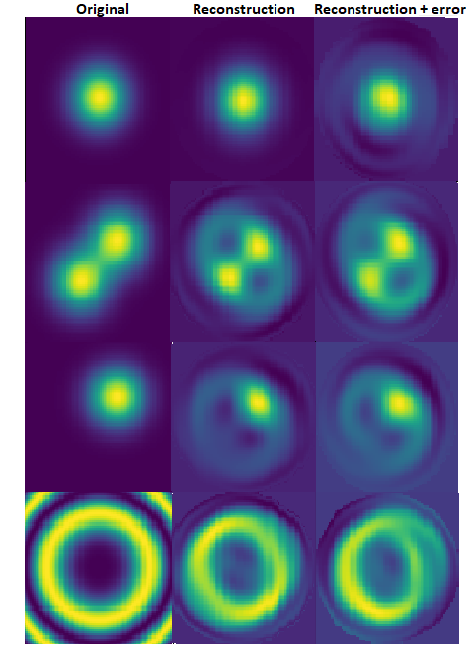
For the first approach, was calculate the lines of view only on the plane (x, y) analysing a 2D system. The program Proto_Sphera_3D.py, calculate the impact parameter and the angle of the line of view compared to the centre (0, 0). From the code is possible select the frames and the number of shot that want use to analyse, and using a function, is possible extract the data pixel from the frames. All these information are print on an output file. For the tomography analyse, it was used and modifying a code that is born for the tomography inside FTU renamed Tomograpy.py. From the output file, it recreate the lines of view and do it a tomography inversion using the Zernike polynomials. For the first trials it was used a phantom distributions for check the real potentiality of these configuration of cameras. Analysing a Gaussian distribution centred in (0, 0) it was observed that if add an error until 15% for simulate a real data from the cameras, the algorithm rebuilds a strange artefacts that no represent the realty. For obtain a fairly well reconstruction of the distribution it is necessary to force the reconstruction using a virtual chords that clamping the boundary of the zone under analysis to zero, improving a lot the reconstruction. Obviously the reconstructions depends also from the radius of the zone that is under study and is important manage the virtual line near the object. It was observed that if is select a radius too large compared to the maximum impact parameter of the actual configuration of the cameras that is 0.432 m, and the virtual chords don’t touch the boundary it obtain a reconstruction artefact. Several known distributions have been tested to verify the reliability of the algorithm and are shows in the figure: first column is the original distribution, the second the reconstruction with the virtual chord, and the last is the reconstruction with virtual chord plus an error of 15% for simulate data from real cameras. Before the analyses of the frames, has been taken into account that the precision of the positioning of the cameras around PROTO-SPHERA is about$1mm$. For this reason, and for obtain a better analyses, it was necessary check one frame without plasma for each camera, rotate and shift them slightly, for centred on the ports and get the same coordinates for the pixels. Several interesting shots were selected for the analyses from the experimental campaign of September-October 2019, are show in the next tab.
Figure 34: Phantom reconstruction from 1 meter, reconstruction with virtual chords, and with 15% of error
Shot | Gas | Pinch Current
1555 | Argon
1617 | Hydrogen
1618 | Hydrogen

For the analysis of the plasma’s frames it was used the data pixels extract from each frame selecting a slice of interest. From each pixel is possible extract three value that represent the colours red, green and blue. Each value is a number from 0 to 255. For the analyses is did it a norm of the three value of the RGB channel but it was analysed also the singularly channels for see the changes in the different tonality, for example in the shots with Hydrogen it dominated the RED channel, in Argon the BLUE channel. For each pixels this value represent the line integral along each line of view.

Hydrogen
For the Hydrogen are selected two session of experiments: 1617, 1618. Analysing 1618 is did it a tomography inversion on the central part of the plasma in the start phase. The slice of pixel under analysis is underlined from a red line. Using the virtual chords at 0,5m is appear a disk which is supposed to represent the little torus around the screw pinch. Through indirect measures, knowing the radius of the PF3 inside the machine, it is possible to trace the width of the plasma, and also the tomography analysis confirm the calculates, an external radius of about 20 cm. In the first frame is possible observe the homogeneity of the little torus visible in the tomography, is the ring that fades from the yellowest zone. In the shutoff phase a zone where the plasma is less brightness on one side respect the other is observable very well also in the tomography graph.
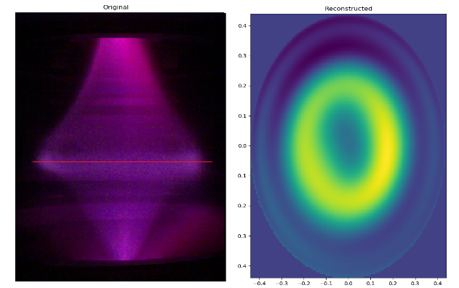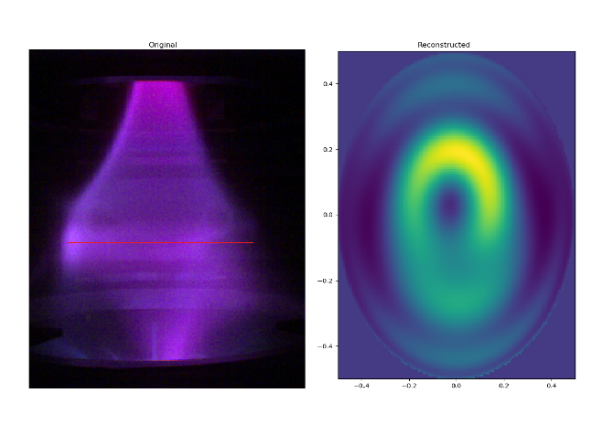
Figure 35: Tomography of the start frame and shutoff frame of 1618
Is show also a mosaic that represent the point of view of all the cameras from the two shots.
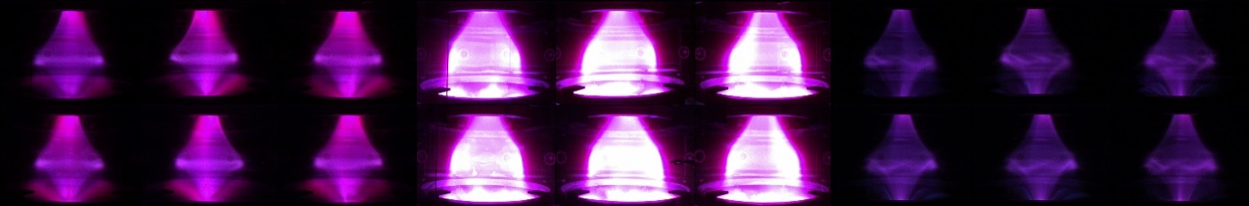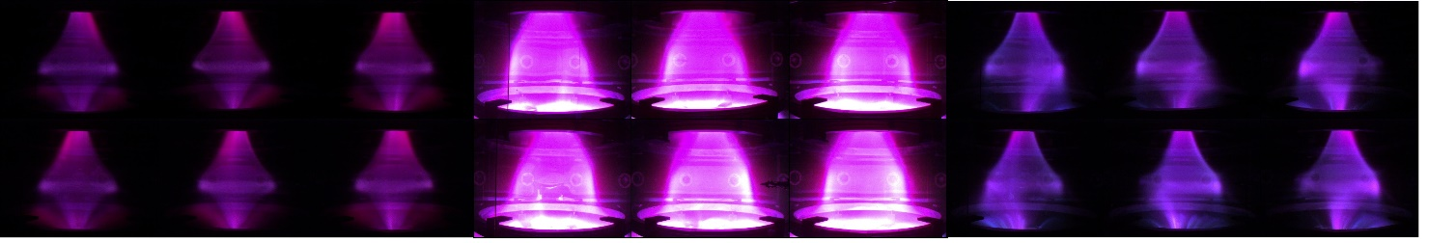
Figure 36: Mosaic frames 1617-1618; start, intermediate, shutoff
In the case of these frames, on the start the brightness was adequate to see little tori, but during the discharge, especially in shot 1617 there is a phenomena of overexposure. In the end of discharge is possible see the shutoff of the plasma configuration; in 1617 is visible a phenomena of kink instabilities inside the torus. An interesting osservation is that in the hydrogen gas the little tori result more brightenss of the central column; with argon, on the other hand, the opposite is noted. The program recreate for each analyses also the lines of view of the cameras plus the virtual chords, a graph with the distribution of the values of the pixels respect the impact parameter, the chord space that represent the area cover from the cameras, and the Zernike radial function.
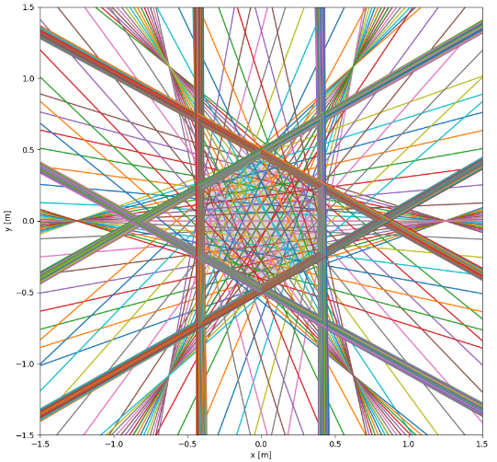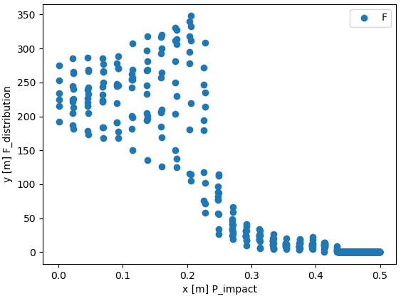
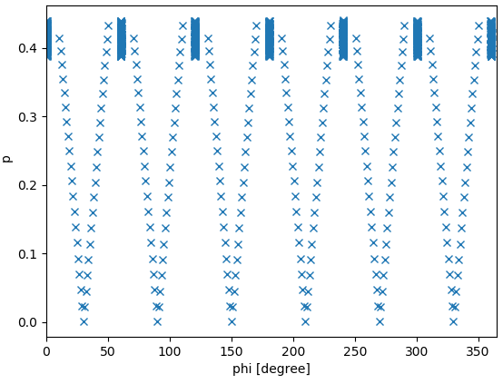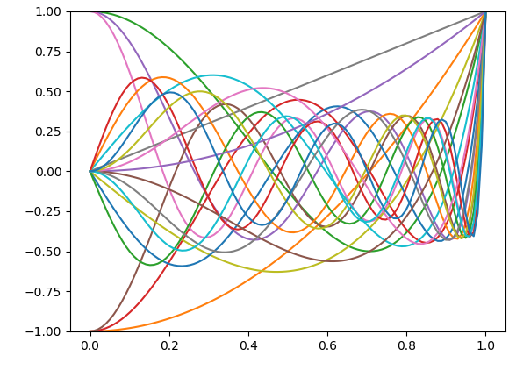
Figure 37:From the shutdown frame of 1618; PROTO-SPHERA chords(top left), Pixesl data distribution vs impact parameter(top right), Chords space(bottom left), Zernike radial function(bottom right)

Argon
In the case of Argon the situation is little different. The Argon gas present a most brightness from the central column and shows a torus like transparent respect the case of the Hydrogen. The Argon column start very narrow and the configuration of the field from the PFcoils is modified to try to enlarge the column. A good shot is 1555 where is report here a frame of the start phase where the reconstruction evidence very well the column.
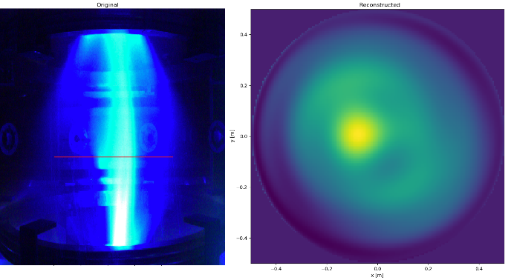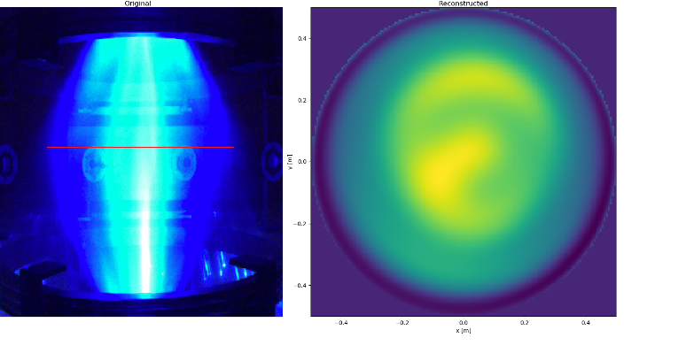
Figure 38: Start frame and intermediate frame with enlarge of the column, shot 1555
From the start to an intermediate state frames the column first is enlarge a lot, after when the extarnal coil turn on is possible see a compression around the central part of the column and a very large torus it seems appear. In this case the torus having a less brightess, in the tomography is represent from the darkness zone after the strong yellow ring. The Argon torus achieve the external radius of about 40 cm, more bigger respect the torus of the Hydrogen.
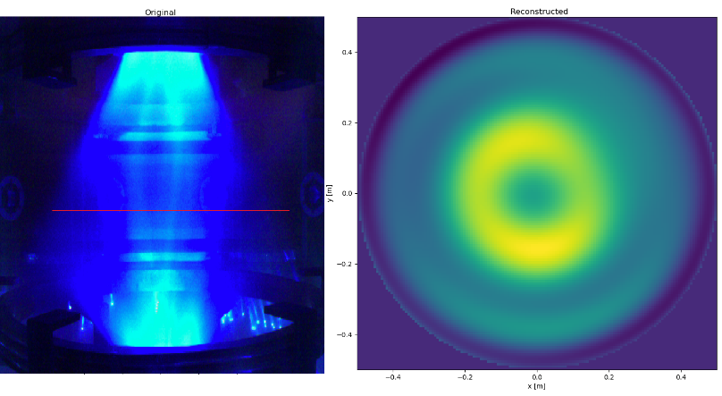
Figure 39: Large torus of the shot 1555

Results and further development
At the end of the analises it was obtained a good achieve. Now PROTO-SPHERA has a new efficent system of fast cameras that work sincronously and permit the view of the plasma of all the direction respect to the phase 1 of the experiment that was present only one camera. The new algorithm that recreates the geometry system of the cameras has the potentiality to excrat a lot of data useful for different kind of analysis, also a future tomography in 3D. Zernike polinomial are result efficent instrument for this study and probably it coulb be used also for a future 3D tomography, obviously this is a first approach to tomography in this experiment and the algorithm is in phase of optimization. The purpose of the tomography it was check the presence of the torus inside the configuration. See the ring in the tomography 2D has confirmed that something like a torus is there; anothers analyses could confirm or refute it. Several problems were found during the analysis and new ideas are proposed for improve the study:
- Cameras alignment is accurate to the millimetre, is necessary major precision. After an attention analyses it was observed that the cameras until 120 degree gives a relevant contribute to the tomographic reconstruction, but the other three cameras are a mirror respect the firsts three. This thing improve very little the resolution because there are an ambiguities of the data for impact parameter and angle because rotating of 180 degree respect the main cameras you obtain same value of impact parameter and angle with different sign. Probably a possible solution is try to change the disposition of the cameras around PROTO-SPHERA. For example three cameras spatiated of 60 degree and the other three of 45 degree in mode that change the cross of the lines of view and the sistem cover a greater region of the space without data ambiguity. Another idea to improve the analysis is to position the cameras a little further away to increase the impact parameter and cover a larger area where the plasma is generated.
- The creation of strange artefact during the tomography reconstruction is an interesting fact. Analasing the phantom distributions it seems that the code works well with this configuration of cameras. To a qualitative level the program Tomograpy.py reconstruct very well the position and the line of view of the cameras, but using the real data of the pixels, return some strange negative value for the integrals that the code create for to compel the reconstruction. It seems that the problem of the artifacts depends of the distance of the zone of study, and if is take a radius larger than the impact parameter maximum the alghorithm is not reliable in that range. A little negative value remain also if the zone under study is touched at the boundary of the impact parameter maximum from the virtual chords. One next step could be do it a tomography with another alghorithm like using the iterative method.
- Changing the pinch current influence the brightness of the column of the plasma, especially to high current over 8 kA the cameras go to saturation when region of the image become white. In this moments is difficult obtain a acceptable reconstruction because the channels RGB achieve the max value 255, and go into saturation. The pixel data distibution become incoherent with the real situation. Obviusly is possible manage the camera shutter for modify the quantity of light that enter in the cameras and also with the trigger sistem is possible control the exposure time, but sometimes the rapydly change of brightness of the plasma evades these controls.
- The future step is try a 3D reconstruction of the plasma, in fact since the geometry is known is possibile generete the lines of view in the space for each pixel 640x480, obtaining with the lines of view in the 3D model a pyramid with a rectangular base with apex in the camera. Exctracting the impact parameter and, in this case two angle for each lines (one for the horizontal plane and one for the vertical plane) is possible try an approach to 3D reconstruction. Exist also Zernike polinomials in 3D but is necessary develop a new code for use the alghoritm in this different setting. It may be possible try a stereography 3D reconstruction of the plasma with this configuration because the cameras view cover the plasma for 360 degree ad the geometry system is already note.

CONCLUSIONS
From the point of view of the researches on magnetic fusion energy, the PROTO-SPHERA project could explore the connections between other well-known approaches and configurations:
• The described set-up can form and sustain a flux-core spheromak with a new technique.
• The safety factor profile is similar to those obtained in standard spherical tokamaks with the metal central post.
• The compression of the screw pinch, while decreasing the longitudinal pinch current, could even lead to the formation of a field reversed configuration with a new technique.
• PROTO-SPHERA could be relevant for the mainstream tokamak line to investigate biased divertors and plasma sources for NBI injectors and for high current vacuum arcs in presence of guiding magnetic fields. As a possible far-future development, it is interesting to consider that a simply connected configuration is particularly suitable for magnetic fusion space propulsion. The availability of a laboratory plasma like that obtained in PROTO-SPHERA could provide useful information also on some astrophysical phenomena, mainly solar and protostellar flares. In fact, as a matter of fact, in several astrophysical (gravity-confined) systems, unstable twisted magnetic flux tubes are able to produce, through magnetic reconnection, helical twisted toroidal plasmoids. In particular, the relevance of compact configurations was emphasized by recent studies showing that the energy gain achievable in anuclear fusion device weakly depends on the device size, implying that useful performances can be obtained also in relatively small devices.

REFERENCES
Berger, M. A., n.d. Introduction to Magnetic Helicity. Plasma Physics and Controlled Fusion.
Blackman, E. G., 17 Mar 2014. Magnetic Helicity and Large Scale Magnetic Fields: APrimer. arXiv:1402.0933v2 [astro-ph.SR] .
Claudio Chiuderi, M. V., 2011. Fisica del Plasma. Firenze: Springer.
Cohen, S., 2012. First operation of the PFRC-2 device. 57(12).
Dolan, T., 2012. Magnetic Fusion Technology. New York City: Springer.
F. Alladio, A. M. a. P. M., 2005. Calculation of Boozer magnetic coordinates for multiple plasma regions„with either closed or open flux surfaces...connected by magneticseparatrices. PHYSICS OF PLASMAS, Volume 12.
F. Alladio, A. M. a. P. M., 2006. Behavior of perturbed plasma displacement near regularand singularX-points for compressible ideal magnetohydrodynamicstability analysis. PHYSICS OF PLASMAS, 13(082505).
F. Alladio, A. M. P. M. L. P., 2001. PROTO-SPHERA REPORT. CR-ENEA Frascati: s.n.
F. Alladio, P. C. A. M. P. M. S. P. a. F. R., 2006. Design of the PROTO-SPHERAexperiment and of its first step(MULTI-PINCH). Nucl. Fusion, 46(S613–S624).
F.Chen, F., 1974. Introduction to Plasma Physics and Controlled Fusion. Los Angeles: Springer.
G.Bosia, n.d. Equilibrio MHD in geometria lineare. Torino: s.n.
Hooper, E. B. & Barnes, C., (23 April 1996). . "The Spheromak – An Alternative MFE Concept and Plasma Science Experiment"., Chicago: s.n.
Lakshminarayanan, V., 10 April 2011. Zernike polynomials. Journal of Modern Optics, Vol. 58(No. 7), p. 545–561.
P. Micozzi, F. A. A. M. a. F. R., 14 June 2010. Ideal MHD stability limits of thePROTO-SPHERA configuration. IOP PUBLISHINGand INTERNATIONALATOMICENERGYAGENCY.
P. Micozzi, F. A. A. M. F. R., 2002. Chandrasekhar-Kendall-Furth Configurations for Magnetic Confinement. ResearchGate.
Simon R. Cherry, J. A. S., 2012. Physics in Nuclear Medicine. Philadelphia: Elseviers Saunders.
Sobehart, R. F. a. J. R., 1994. Minimum ohmic dissipation and DC helicity injection in tokamak-like plasmas. Plasma Physics and Controlled Fusion, 36(10).
Sykes, A., September 2008. The Development of the Spherical Tokamak. s.l.:s.n.
W Schuurman, C. B. a. R. F. d. V., June 1969. Stability of the screw pinch. Plasma Physics, 11(495).
Wesson, J., 2004, Third Edition. Tokamaks. Clarendon: PRESS-OXFORD.

