RUN 994: detection at point d=0 (center of the reactor)
The spectra show a presence of H, O, C, Cu and W, and in weak spectra there is also some detectable emission from OH, probably coming from the external plasma region. An example of the spectra acquired by the three channels and for delay of 765 ms is shown in Fig. 1.
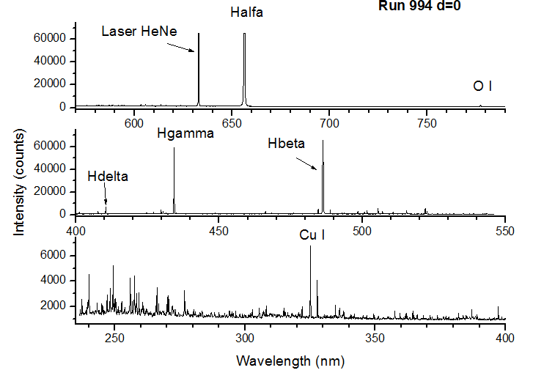
Figure 1
Note : HeNe line is saturated and it must be further attenuated in the next measurements

Time evolution of the plasma emission is shown in Figs. 2-3 for two H I lines, O I, Cu I and Cu II.
The peak emission from Cu I and Cu II occurs at 765 ms, followed by peaks of O I and H I at 770 nm. This might indicate that the Cu, with lower ionization energy than O and H, mainly contributes to the plasma formation and successive heating through acceleration of the free electrons.
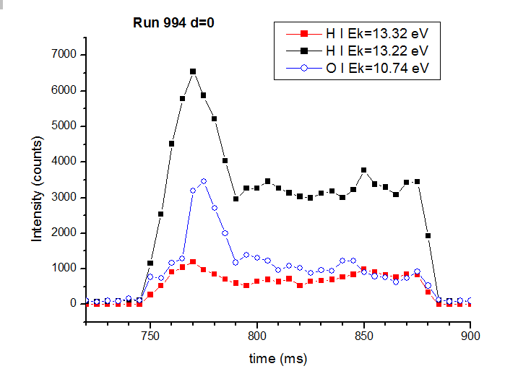
Figure 2
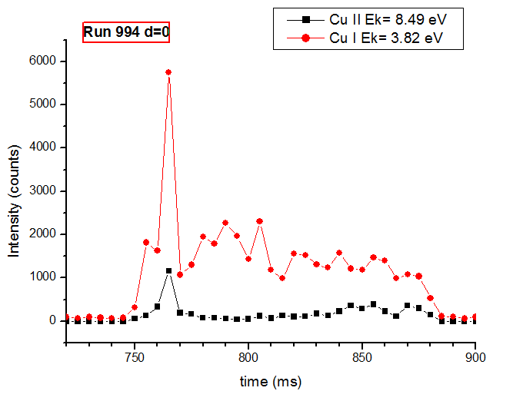
Figure 3
Ratio of the two H I lines is shown in Fig.4, and it is expected to increase with the plasma temperature. However, the measured line ratio does not exhibit important variations with time, and this could be explained both by the energy close levels and by a missing LTE in low density plasma. Indeed, the excitation temperatures (Texc) calculated from H I lines and for the Boltzmann distribution are below 1500 K, the values too low and incompatible with the occurrence of ionic Cu II and W II lines.
Note: in previous experiments the Texc measured from Ar II lines in visible spectral region was around 7000 K.
Cu I emission is always well detected in the spectra during the plasma discharge. Although the signal is collected along the observation axis and there is some contribution from the outer colder plasma, the largest portion of the signal comes from the focal volume, which extension is less than 10 cm. Basing on these considerations, probably the maximum plasma temperature is below the ionization energy of Cu I, i.e. less than 7.73 eV.
At this point, we can assume that the T evolution with time corresponds to the behavior of H I and O I lines, the species with high ionization energies (about 13.6 eV). Thus, the maximum plasma T is reached after 770 ms (Fig. 2) i.e. 20 ms from the beginning of the discharge. The T drops down to an almost stable value at about 790 ms until the plasma disappears at 885 ms. On the other hand, the ratio I(Cu II)/I(Cu I) has the minimum value in the interval 780-810 ms (Fig. 4), and later it starts to grow although the plasma T keeps stable. This means, basing on the Saha equation and assuming the partial LTE (p-LTE), that the electron density Ne is maximum for the interval 780-810 ms, and that it decreases later, causing a more intense Cu II emission. This hypothesis has been confirmed by observing the number of detectable hydrogen Balmer lines in the spectra (Fig. 5), where higher series of H I lines correspond to lower electron densities according the Inglis-Teller equation (Tab. 1).
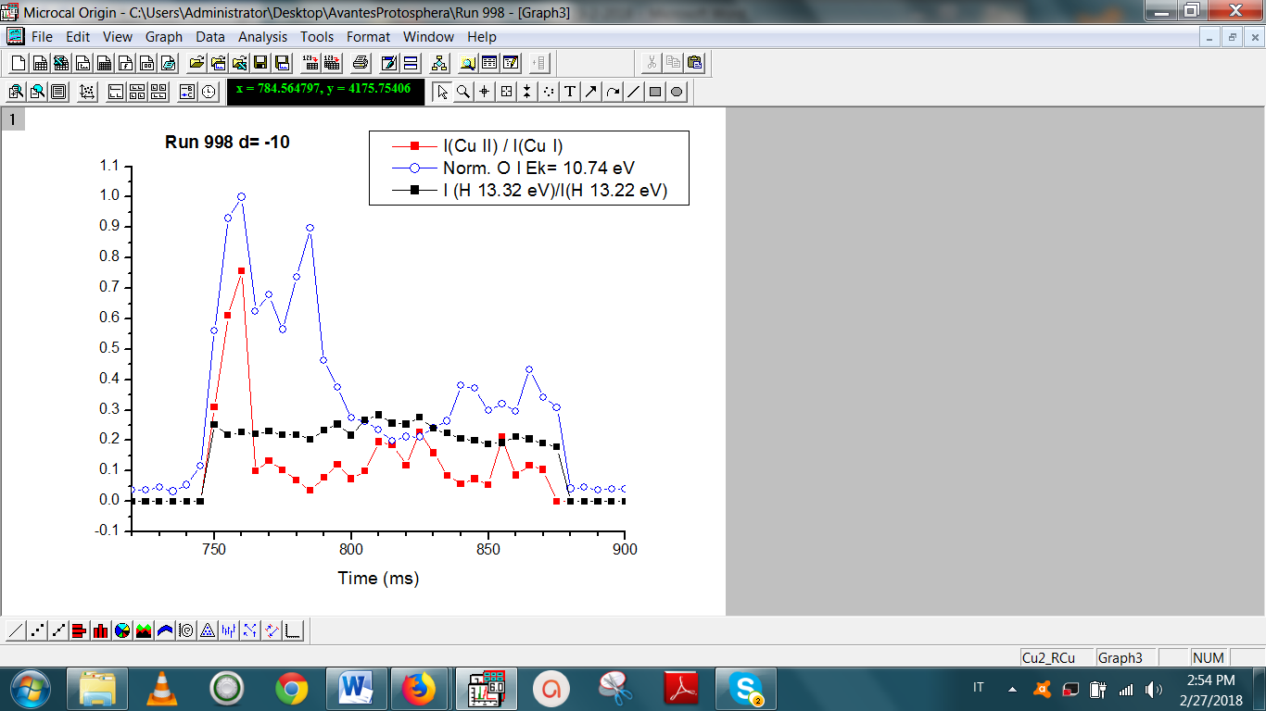
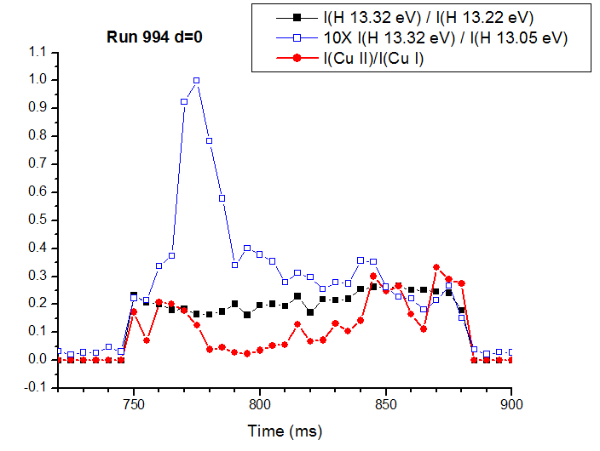
Figure 4
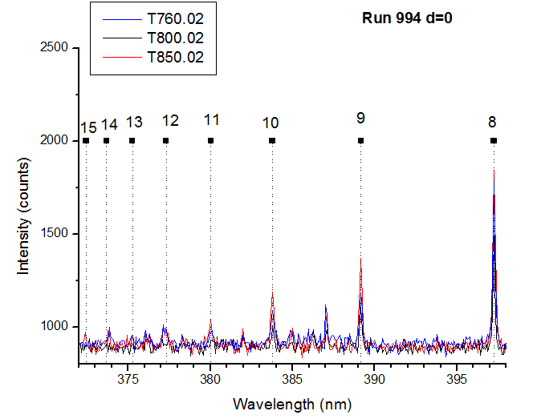
Figure 5

Figure 5 shows the comparative spectra acquired at delays of 760 ms, 800 ms and 850 ms, and the corresponding position of the Balmer transitions from the levels with different quantum numbers. Close to the plasma initiation (760 ms) the Balmer lines were detected up to the quantum number 14 while at delay of 850 ms the last n was 15. In a middle of the discharge duration (800 ms) the last detected Ballmer line corresponds to only n=10. In order to increase signal-to-noise ratio (SNR) of the H I lines, in following we summed the central spectrum at one delay (example at 760 ms) with the timely close spectra (example at 755 ms and 765 ms), and determined the number of the Ballmer lines. The results, and the corresponding Ne calculated from Inglis-Teller equation are given in Tab. 1.

Table 1
Delay (ms) | n Balmer | Ne (cm⁻³)
755, 760 | 12 | 7.4·10¹⁴
770, 780 | 11 | 1.4·10¹⁵
790, 810 | 10 | 2.9·10¹⁵
820, 850 | 12 | 7.4·10¹⁴
860 | 14 | 2.3·10¹⁴
870 | 15 | 8.5·10¹³

An attempt to measure the Ne through the Stark broadening of Hδ line did not produce the results consistent with the previous findings because, certainly, the line self-absorption occurs in plasma which main constituent is hydrogen.
Note: Self-absorption might also affect the detection of Balmer lines with low intensities; is such case the here estimated Ne would be higher than the true values.
Note: in the run 970, relative to hydrogen plasma, the spectra acquired with OceanOptics HR4000 spectrometer (390-800 nm) did not show any Cu I emission. Was the plasma temperature higher than now, or a significant erosion of the electrodes was not present before, or that happened just because of the lower overall signal?

RUN 998: detection at point d= -10 cm (from the center of the reactor)
The time evolution of some characteristic peaks is shown in Fig. 6, and the plasma initiates at delay of 745 ms and end at delay of 880 ms. Also here, the rapid growth of H I peak is anticipated by emission of Cu lines.
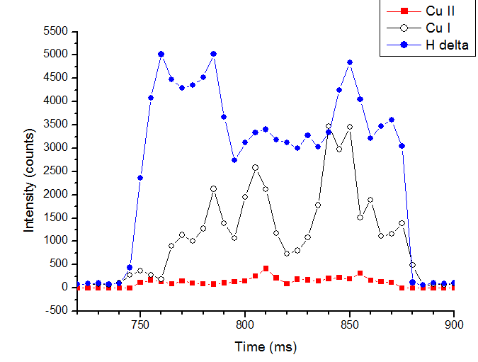
Figure 6
The ratio of the Cu II and the Cu I line (Fig. 7) is maximum in the early plasma (delay 760 ms), corresponding to the highest plasma temperature, seen also from the O I line, here normalized. The rapid drop of the ionic to atomic ratio although the T keeps high, is caused by an increase of Ne, which estimated values for some acquisition delays are given in Tab. 2.
Figure 7
Table 2
Delay (ms) | n Balmer | Ne (cm⁻³)
760 | 13 | 4.0·10¹⁴
780 | 11 | 1.4·10¹⁵
820 | 12 | 7.4·10¹⁴
850, 870 | 11 | 1.4·10¹⁵

RUN 997: detection at point d= -20 cm (from the center of the reactor)
The detectable plasma emission starts later, at delay of 755 ms, and ends at 890 ms (Fig. 8). This might indicate that the plasma volume at this position is a result of the expansion of the plasma core. Also, the position of the first emission peak of H I in the time scale is not delayed but it coincides with the peaks of Cu I and Cu II.
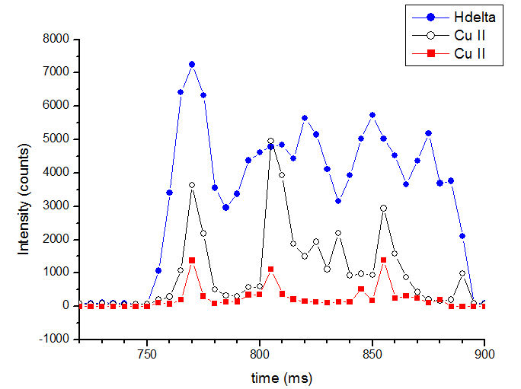
Figure 8
The plasma T, according both to H I (Fig. 8) and O I line peaks (Fig. 9) show some oscillations without a well distinguishable high value at the beginning followed by a decay to an almost stable value like it happens closer to the plasma core. The fluctuations of the ionic to atomic line ratio are also present. The estimated values of Ne for some acquisition delays are given in Tab. 3. Here, the detected Balmer lines are always between 12-13, the lower value was measured around the delay of 820 ms, corresponding to the lowest ionic to atomic ratio.

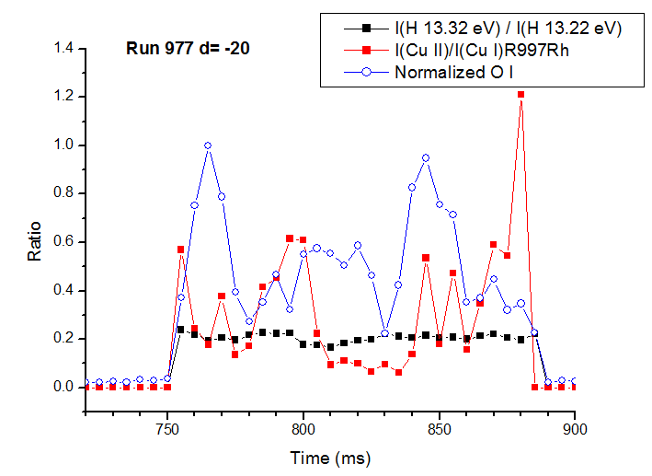
Figure 9

Table 3
Delay (ms) | n Balmer | Ne (cm⁻³)
765, 780, 795 | 13 | 4.0·10¹⁴
820 | 12 | 7.4·10¹⁴
870 | 13 | 4.0·10¹⁴

RUN 995: detection at point d= -30 cm (from the center of the reactor)
The plasma emission was detected only for the acquisition delays from 805 ms to 885 ms, where this delay is due to time necessary for the plasma expansion from the chamber center. The spectra from the channel 1 (UV) are dominated by Cu I emission from low excitation levels (Ek = 3.8 eV in Fig. 10) while the ionic emission, if present, is very weak and here shown multiplied by factor 10.
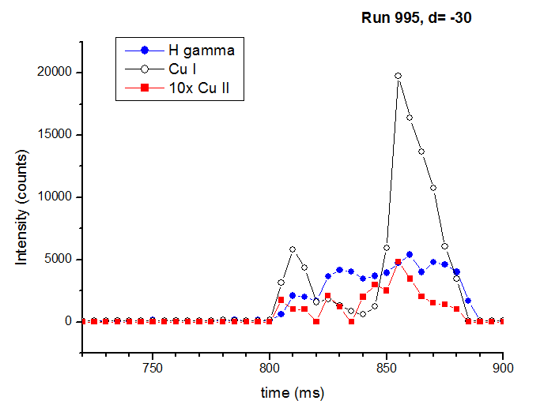
Figure 10

Around the acquisition delay of 850 nm the detected Ballmer lines are up to the quantum number 14, corresponding to Ne of 2.3·10¹⁴ cm⁻³.

Comparison of the plasma at different positions
The time evolution of O I intensity, considered here as an indicator of the plasma T, is shown in Fig. 11 for different distances from the chamber center. It seems that the highest plasma T is reached out of its center, but for confirming this, it would be necessary to calculate the effective focal volume (collected by the optical system) in all four cases i.e. the acquisition distances.

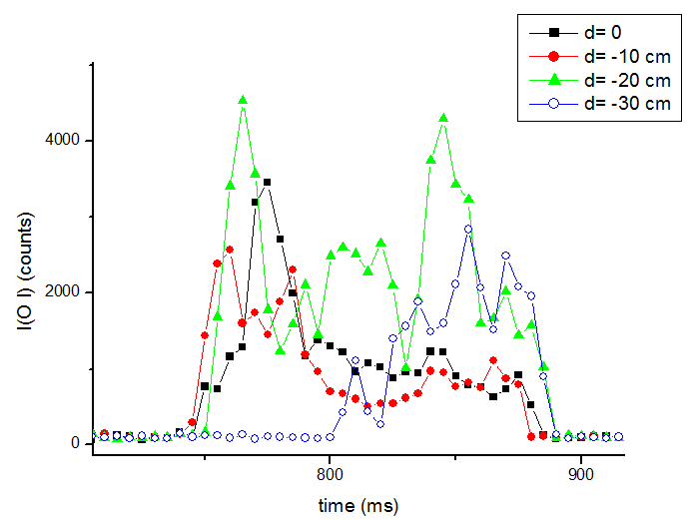
Figure 11

The Ne measured at different distances from the reactor center is shown in Fig.12 for some acquisition delays. It is evident that the highest Ne is present in the central plasma and it is reached 30 ms after the plasma ignition. Increasing the distance from the reactor center, the Ne becomes lower.

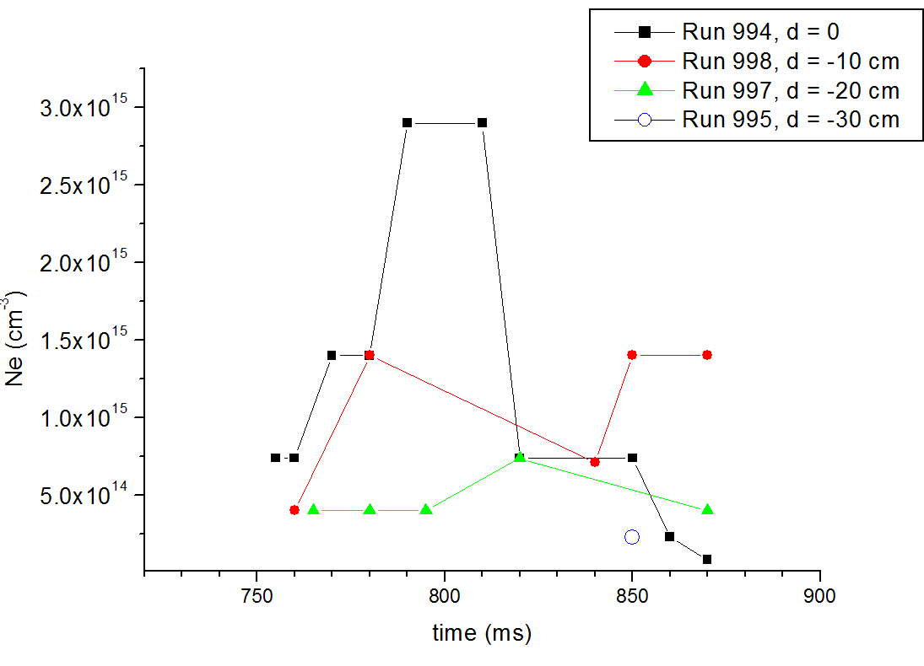

Figure 12

