Authors’ Response to Reviewers of
3D tomographic reconstruction of light emission density of plasma in the PROTO-SPHERA experiment
Manuscript ID MEAS-D-24-11112
Legend: Reviewer comment (RC), Authors’ response (AR) and changes to the text. In the revised version of the paper, all the changes are reported in bold fonts. At the end of the response to the Reviewers, five pictures are reported to better respond to the Reviewer’s comments.

AUTHORS’ RESPONSE TO REVIEWER #1
RC First and foremost, the validity of the Fourier slice theorem in higher dimensions is well known, and the proof can be found in computed tomography textbooks [1] (see Chapter 8), it is not a novel or original method
AR We sincerely thank the Reviewer for their insightful criticism and literature suggestions, which helped us to better place of our contribution within the framework of the scientific literature. We acknowledge that the validity of the Fourier slice theorem in higher dimensions is well known, and we had already cited Zosso’s work, where complete proof for arbitrary angles is not provided. In comparison with Buzug’s proof [1], we have resolved the ambiguity concerning the rotational degree of freedom about the detector’s normal (mentioned at the end of page 330 in Buzug’s book) in a different way. We attached the coordinate system to a plane tangent to a sphere, with coordinate axes aligned with the outward normal and the tangents to parallels and meridians (as shown in our Figure 3). The result is obviously the same, but in our view, this represents a small but meaningful step toward a clearer presentation, more obviously linked with the geometry of the problem.
In addition to adding Buzug’s book to the references, we have introduced a dedicated section discussing manuscripts related with our work. Consequently, the introduction has been revised to remove the part where related literature was originally presented. This new section explicitly clarifies our contribution.
RC the method is rarely used due to artefacts in back projections (visible in all reconstruction figures 15-17).
AR In fact, the complete suppression of artifacts in the reconstructed image cannot be guaranteed by any method [2], even for a perfectly calibrated, noiseless detection system. Moreover, we agree that the solution algorithms that work best in medical tomography do not necessarily are the most useful for tokamak plasmas. In tokamaks, X-ray emission is measured from pinhole cameras that are not equally spaced and do not provide views from the internal surface of the torus, which is not accessible. This makes the analytical methods less appropriate for image reconstruction than iterative finite element techniques.
However, the geometry of PROTO-SPHERA is rather different from that of a tokamak. In PROTO-SPHERA, visual access to the plasma is unhindered from any angle. The visible light emission is measured with regular cameras. In this case, 3D analytical methods can be a viable strategy for image reconstruction. While we acknowledge that our image reconstruction is not perfect and that several improvements could be made, this work represents a first step toward 3D reconstruction of the plasma visible light emission density, which has never been attempted before. Fusion plasma tomography, to the best of our knowledge, was only carried out on sections of the torus.
We would like to mention that the angle brilliance visible at the four corners, reported in Figure 1 a for the ease of review, is not an artifact, but it is due to the reflection of light from four metal columns supporting the vessel, shown in Figure 1 b. In addition, we managed to reproduce the presence of some real parts of the machinery whose presence is unquestionable. This is shown in Figure 2, which shows the image of external conducting copper bars (3 cm in diameter) that connect the two electrodes, as well as the Langmuir probe immersed in the plasma.
Some artifacts are certainly due to the use of a reduced number of cameras, a problem which will be addressed in future work. Anyway, the macroscopic phenomena that we observed are not affected by the artifacts.
In the new section concerning literature on plasma tomography, we better explained the difference of PROTO-SPHERA with respect to classical tokamaks and motivated the choice of the method. In the section “Results and discussion”, we mention the limits of the technique and added pictures showing the metal supports of the vessel, as well as a section displaying how we reconstructed the copper bars and the Langmuir probe.
RC The authors spend much of the introduction on the history of medical tomography and provided no reference to related fusion plasma tomography works, just to list a few [2-6].
References:
[1] Buzug T 2008 Computed Tomography (Berlin, Heidelberg: Springer)
[2] Granetz R S and Smeulders P 1988 X-ray tomography on JET Nucl. Fusion 28 457
[3] Mlynar J, Craciunescu T, Ferreira D R, Carvalho P, Ficker O, Grover O, Imrisek M, Svoboda J, and JET contributors 2019 Current Research into Applications of Tomography for Fusion Diagnostics J. Fusion Energy 38 458-66
[4] Anon 2017 Deep learning for plasma tomography using the bolometer system at JET Fusion Eng. Des. 114 18-25
[5] Anon 2012 Modern numerical methods for plasma tomography optimisation Nucl. Instrum. Methods Phys. Res. Sect. Accel. Spectrometers Detect. Assoc. Equip. 686 156-61
[6] Jardin A, Bielecki J, Mazon D, Peysson Y, Król K, Dworak D and Scholz M 2021 Implementing an X-ray tomography method for fusion devices Eur. Phys. J. Plus 136 706
AR Thank you for this comment. To improve completeness of the literature review, we introduced a section concerning fusion plasma tomography manuscripts where we have cited the manuscripts you suggest.
RC Secondly, the acquisition geometry is quite confusing, as the method requires parallel beams, but the actual camera acquisition is of cone beam geometry,
AR In cone beam X-ray tomography, the radiation source is acquired by pinhole cameras and captured by the detector. The image is formed without passing through lenses. In this case, acquisition indeed needs that cone beam geometry is used.
In the case of a traditional photographic or video camera, however, the acquisition geometry is not exactly conical. The light rays entering the lens are typically treated as if they are coming from a three-dimensional scene and are focused onto the sensor's surface. The camera lens, which is a curved lens, is designed to gather the light and focus it onto a single point on the sensor. The lens converts the rays coming from different directions so that they are correctly mapped onto the sensor to produce a sharp image. In practice, the lens compensates for the fact that the light rays are not parallel by focusing them so that the resulting image is correct and sharp. In our case, a small aperture was used to get a great depth of field, so that both the foreground and background appear in focus.
So, your point is correct for applications such as cone beam X-ray tomography, but it is not the exact description of how a traditional camera works, in which case, parallel projections can be used.
We better explained this point in Section 3.2.
RC and even more confusing is the placement of the cameras, which are all 180 degrees opposite to each other, providing essentially three views [1].
AR: While it is true that, in an ideal scenario free from errors, two cameras placed exactly 180 degrees apart would provide redundant information, real-world measurements are inevitably affected by several sources of error. These include, but are not limited to, slight misalignments in camera positioning, optical distortions, thermal expansion, structural vibrations, and electronic noise. In this context, having views from opposite sides of the plasma is rather advantageous, as it increases the robustness of the reconstruction and helps mitigate the effects of such errors.
We added an explanation in Section 3.2 where we motivated the choice for the camera arrangement.
RC Given such limited data and the method in the manuscript, it is highly unlikely that the reconstructed profile is accurate. Although the subject is interesting, the specific method used in this manuscript is not state of the art and should not be used. I recommend that the authors read related reactor tomography work and use another reconstruction method on the acquired images and resubmit the manuscript.
AR We thank the reviewer for the comments and would like to clarify some key aspects of our work. While we acknowledge that more advanced tomographic reconstruction techniques are available, our primary objective was not to develop a novel tomography method, but rather to investigate the plasma formation dynamics and the characteristics of its light emission. Despite the relatively simple reconstruction approach employed, the results are consistent with both theoretical predictions and experimental observations in the literature and are not affected by artifacts that could compromise their interpretation.
Our analysis shows that the plasma torus forms in approximately 8 milliseconds, evolving from a kinked filament generated by the destabilization of the central plasma column. The cross-sectional views reveal a previously unreported green light emission from the core, while equatorial sections enable a rough estimate of the torus thickness.
These findings align closely with predictions from magnetohydrodynamic (MHD) models, in particular those presented in the work by Garcia-Martinez, Lampugnani, and Farengo (Physics of Plasmas, 2014). Figure 3 of this letter compares Figure 12 of the manuscript with Figure 9 from Garcia-Martinez et al., which shows magnetic field lines at different Lundquist numbers. The topological similarity between the two sets of results is evident. Likewise, Figure 4 of this letter compares Figure 15 of the manuscript – depicting the emission density in the equatorial plane – with Figure 8(B) from the same reference, which shows the ratio between current density and magnetic field. Both figures display remarkably similar morphologies, featuring a centerpost around which a toroidal structure forms.
Further experimental confirmation comes from the PROTO-SPHERA research group, who obtained similar results using different reconstruction techniques. Specifically, Figure 5 of this letter shows plasma luminosity obtained through tomographic inversion using Zernike polynomials, as reported in the work by Damizia et al. (Optical Tomography of the Plasma on the PROTO-SPHERA Experiment, 2021), which is now cited in the revised manuscript. Although the data in this figure refer to earlier experiments conducted with Argon gas and are not shown in true color, they support the presence of the toroidal light emission structure and of the centerpost observed in our study. We would like to underline that these data were not used in the current manuscript under review, as they correspond to an earlier phase of the experimental campaign during which several setup details were still being finalized.
For the sake of completeness and comparison, we have also included Figure 8 from the work by Garcia-Martinez et al. and Figure 6 from the paper by Damizia et al. in the revised version of the manuscript. Should the manuscript be accepted, we will formally request permission from the respective publishers to reproduce these figures.
We would also like to stress that, to the best of our knowledge, this work represents the first attempt to reconstruct the three-dimensional visible light emission density of a cold plasma. Traditional approaches to plasma tomography have typically focused on cross-sectional reconstructions of toroidal structures. Only recently have studies emerged addressing 3D reconstructions of X-ray emission, achieved by combining views from different lines of sight. These more recent contributions have now been cited in the updated literature review section of the revised manuscript.
In conclusion, although we recognize that the reconstruction method used is not state of the art, we believe that the physical insights and experimental observations presented in our study are significant and well-supported. We hope that the reviewer will reconsider the value of our work in light of the arguments and evidence outlined above.

AUTHORS’ RESPONSE TO REVIEWER #2
RC The abstract would benefit from additional background information and a clearer articulation of the manuscript's contributions.
AR We thank the reviewer for this suggestion. In response, we have revised the abstract to include a brief but informative background that sets the context of the study. Additionally, we have clarified the main contributions of the manuscript to make them more explicit and easily identifiable.
RC Certain sections (e.g., around lines 16-17) are missing citations, and the discussion of related work should be organized into a dedicated section for better clarity.
AR To improve completeness of the literature review, we introduced a new section focused on plasma tomography. Consequently, the introduction has been revised to remove repetitions.
RC A detailed pipeline describing the methodology would help improve the transparency and comprehensibility of the process.
AR The methodology works as follows. The vertical projection of the points of the density function f(x, y, z) onto an arbitrarily angulated detector plane are obtained. The plane containing all line integrals perpendicular to the projection plane is the projection P_{θ,ϕ}(t,r). A two-dimensional Fourier transform from the plane (t,r) to the domain (μ, ν) yields [F₂P_{θ,ϕ}](μ,ν). This plane can be sorted into the (u,v,w) wavenumber space. If the projections have been measured for all angulations, then the object can finally be reconstructed by means of the inverse three-dimensional Fourier transform. In the case of a finite number of projections, we will obtain an approximation of the original density.
A picture describing schematically how the corollary of the Fourier theorem is applied to 3D-reconstruct the image is reported in Section 2.2. Some further explanations were added in Section 2.2.
RC Experimental comparisons with existing methods are necessary to validate the effectiveness of the proposed approach.
Experimental comparison comes from the PROTO-SPHERA research group, who obtained similar results using different reconstruction techniques. Specifically, Figure 5 of this response letter shows plasma luminosity obtained through tomographic inversion using Zernike polynomials, as reported in the work by Damizia et al. (Optical Tomography of the Plasma on the PROTO-SPHERA Experiment, 2021), which is now added among the references in the revised manuscript. Although the data in this figure were obtained in earlier experiments conducted with Argon gas and are not shown in true color, they support the presence of the toroidal light emission structure and of the centerpost observed in our study. These data were not used in the manuscript currently under review, as they correspond to an earlier phase of the experimental campaign during which several setup details were still being finalized.
For the sake of completeness and comparison, we have added Figure 6 from the paper by Damizia et al. in the revised version of the manuscript for comparison. Should the manuscript be accepted, we will formally request permission from the respective publishers to reproduce these figures.

FIGURES
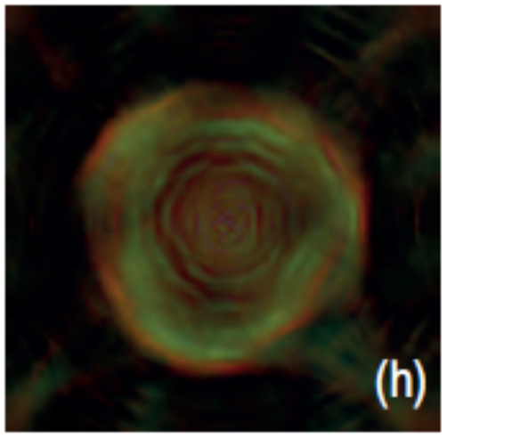a) | 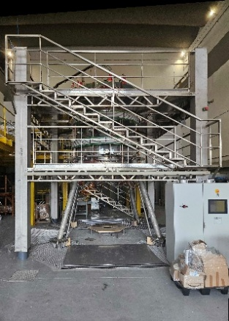  b)

Figure 1: Cross-section of plasma with angle reflections a) and structure supporting the vessel b)

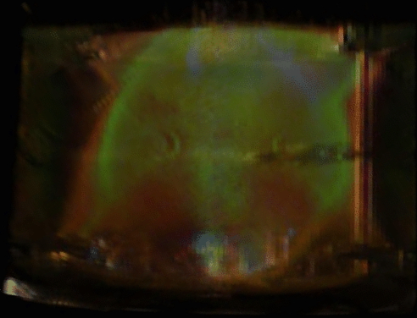
copper bars
Langmiur
probe
Figure 2: Vertical section of the plasma displaying the Langmuir probe and the copper bars
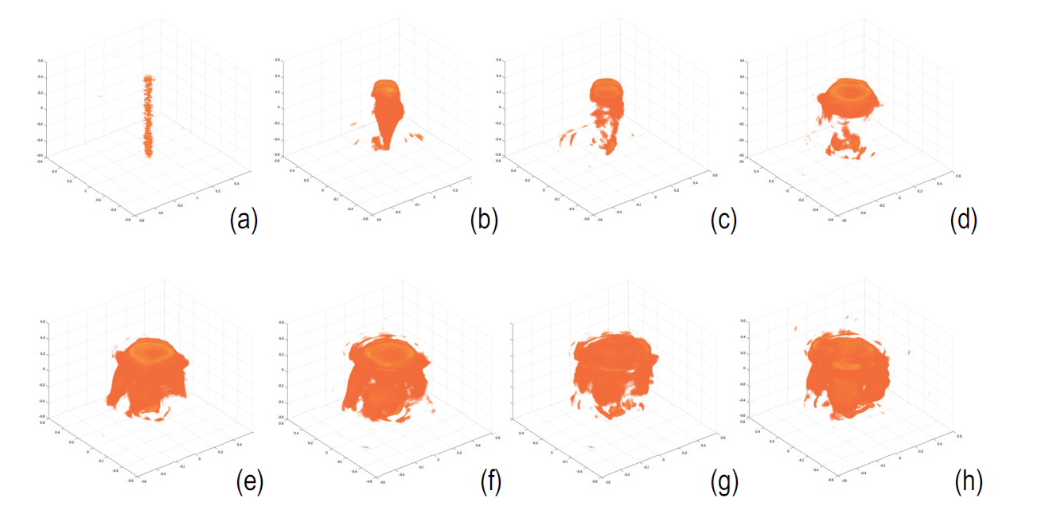(A)
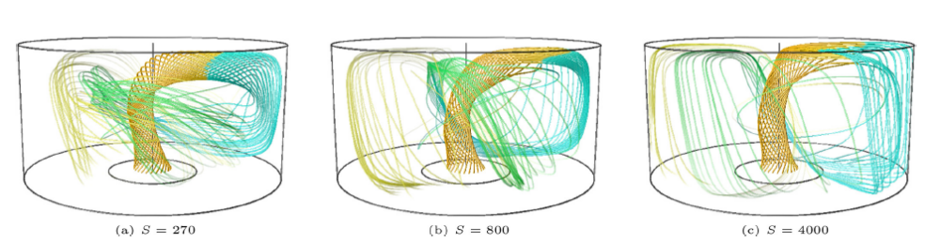(B)
Figure 3: Comparison of Figure 12 of the submitted manuscript (A) with Figure 9 (B) of the paper by Garcia-Martinez et al., which represents the field lines of the magnetic field at different Lundquist numbers.
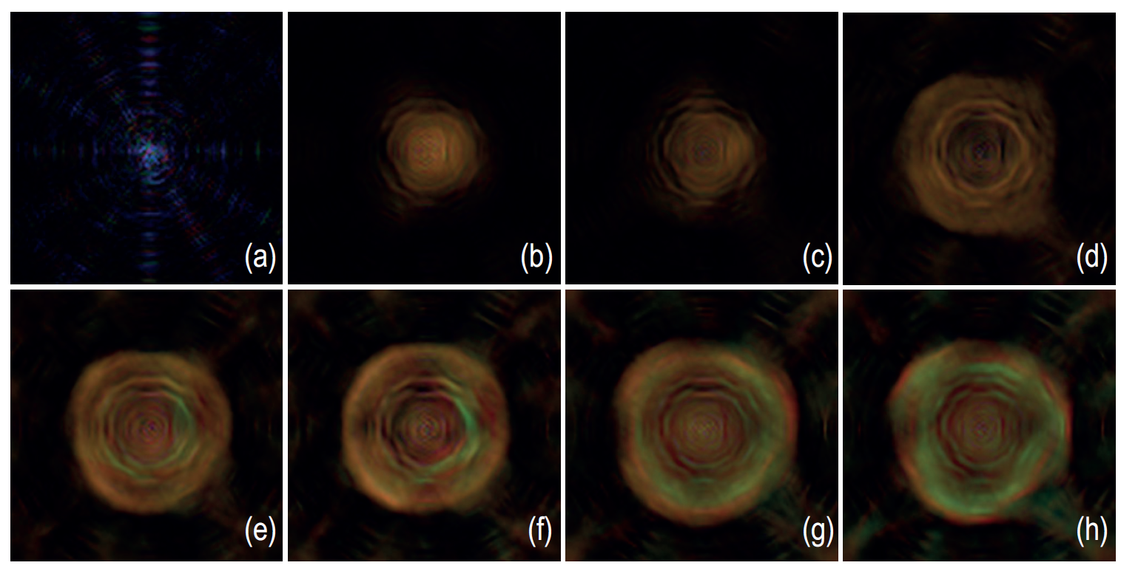(A)
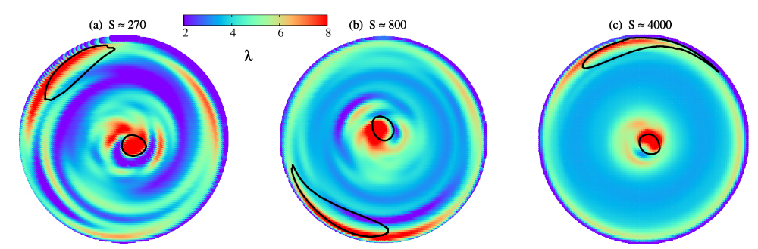(B)
Figure 4: Comparison of Figure 15 of the submitted manuscript (A) with Figure 8 (B) of the paper by Garcia-Martinez et al., representing the contourplot of the ratio between current density and magnetic field at different Lundquist numbers

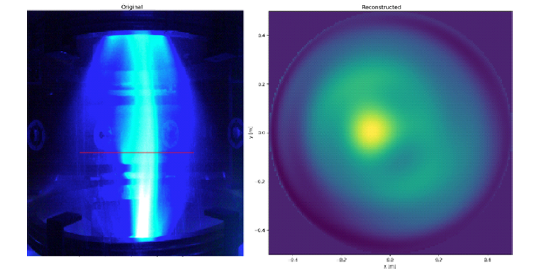
Figure 5: Pictures and related equatorial distribution of Argon plasma luminosity obtained by Zernicke polynomials inversion (Y. Damizia et al. Optical tomography of the plasma on the PROTO-SPHERA experiment (2021))

