1.X.Y .n+1 Protosphera assembly and operations (WP-TE ?)

The PROTO-SPHERA experiment was built with the aim of sustaining a Spherical-Torus not around a metal centerpost, as Spherical-Tokamaks do, but around a Plasma-Centerpost, which is a screw pinch arc discharge. PROTO-SPHERA is therefore a simply connected plasma magnetic configuration, which gets rid of a toroidal magnet.
This choice implies an enormous simplification, i.e. the cylindrical shape of the container. Conversely the PROTO-SPHERA configuration requires two electrodes to be present inside the cylindrical vacuum vessel.
PROTO-SPHERA is an attempt to emulate in the laboratory the jet + torus plasma of the Crab Nebula: an internal magnetized centerpost of plasma (jet) on the axis of symmetry of the configuration, surrounded by an orthogonal magnetized plasma torus. PROTO-SPHERA was built and operated in its initial Phase-1 from mid-2014 until the beginning of 2018. Inside the Aluminium vacuum chamber there were eight poloidal magnetic field coils. The full current of the centerpost plasma, that was the aim of Phase-1, I_{e}= 10 kA in Hydrogen, was sustained for the duration of 1 sec at the beginning of 2018. In the same year 2018, thanks to 4 impromptu PFext coils wound external to the vessel that provide a vertical constricting field, the formation of the first plasma tori has been achieved, even before the new internal compression coils are built, that are necessary in order to carry PROTO-SPHERA to its final Phase-2. PROTO-SPHERA produced and sustained as well, for 0.5 seconds, its first plasma tori, carrying a toroidal current up to I_{ST}= 7 kA. The obtained tori were the first laboratory emulations of the Crab Nebula configuration. In the Phase-2 of the experiment a new set of six internal armored coils (PFInt-A compression coils) will contain the expansion force of the current carrying spherical tori. In the Phase-2 of the experiment, the total number of cathode Tungsten filaments will grow by a factor of 7, from 54 to a total of 378, alongside with the plasma centerpost current, which will increase from 10 kA to 70 kA; the expected "spherical" shaping should allow for up to 300 kA of toroidal plasma current to flow inside the spherical tori that will be sustained for up to 1 sec. Before increasing by a factor of 7 the electrode-driven current in the plasma centerpost, in order to move towards the Phase-2 of PROTO-SPHERA, it was decided to operate an intermediate Phase-1.5, with a provisional set of six internal coils (PFInt-A compression coils), having the aim of progressively pushing the plasma from the "lean" tori of Phase-1 to the "spherical" tori of Phase-2.
Satisfactory results were obtained in 2020-2021 campaign.

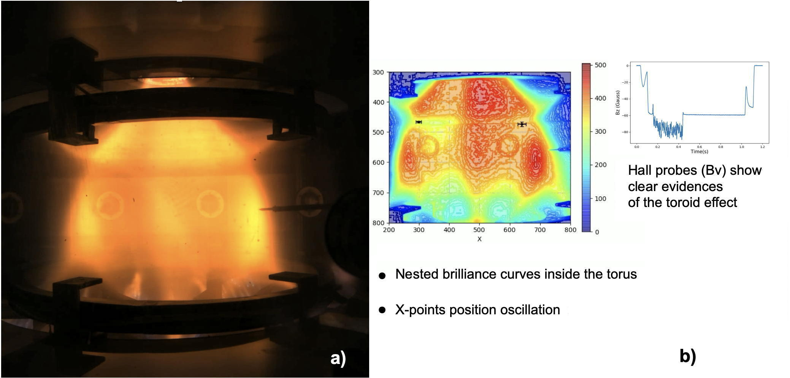
FIGURE 1. (a) Image from the fast camera of a Helium PROTO-SPHERA plasma clearly showing the toroid around the pinch discharge. (b) Nested brilliance surfaces inside the torus and Hall probes magnetic signal showing the torus effect on vertical field Bv.
Clear evidences of nested magnetic surfaces inside the tori was obtained, both with visible light images from a fast camera (3600 fps) located outside the new (transparent) vacuum vessel and also with a 3D reconstruction from 6 medium-speed cameras (600 fps). The Hall equatorial probes, that were inserted on the back of the movable Langmuir probes, have collected signals, which show that the tori observed in visible light are associated with a toroidal current inside the plasma tori; the value of the toroidal current estimated from the Hall probes agrees with the value that can be derived from the distance between the X-points, as observed on the visible images. The injection of current inside the plasma tori from the central screw pinch looks like a quasi-periodical sawtooth, a succession of relaxation oscillations whose quasi-periods lasts from 1 to 10 msec. The sequence of relaxations shows remarkable correlations among visible images, the electron density measured by the Langmuir probes and the vertical field measured by the Hall probes.
Nevertheless the Technical Program 2020-2021 does not fully succeed, since the insulation of the upper/lower divertor did not work correctly and it caused a strong up/down asimmetry of the plasma. Furthermore the presence of Teflon insulator too close to the plasma itself generated a too high plasma pollution that forced the pulse duration to 0.3 sec.

Those problems will be hopefully solved in the 2022 campain, after the improvements to the internal load assembly of the machine performed in the second half of 2021. In particular the insulation of the upper/lower divertor has been improved with thick Teflon foils and the Teflon insulator too close to the plasma has been modified and protected with Molibdenum. Also a further gas injection through the catode has been added.

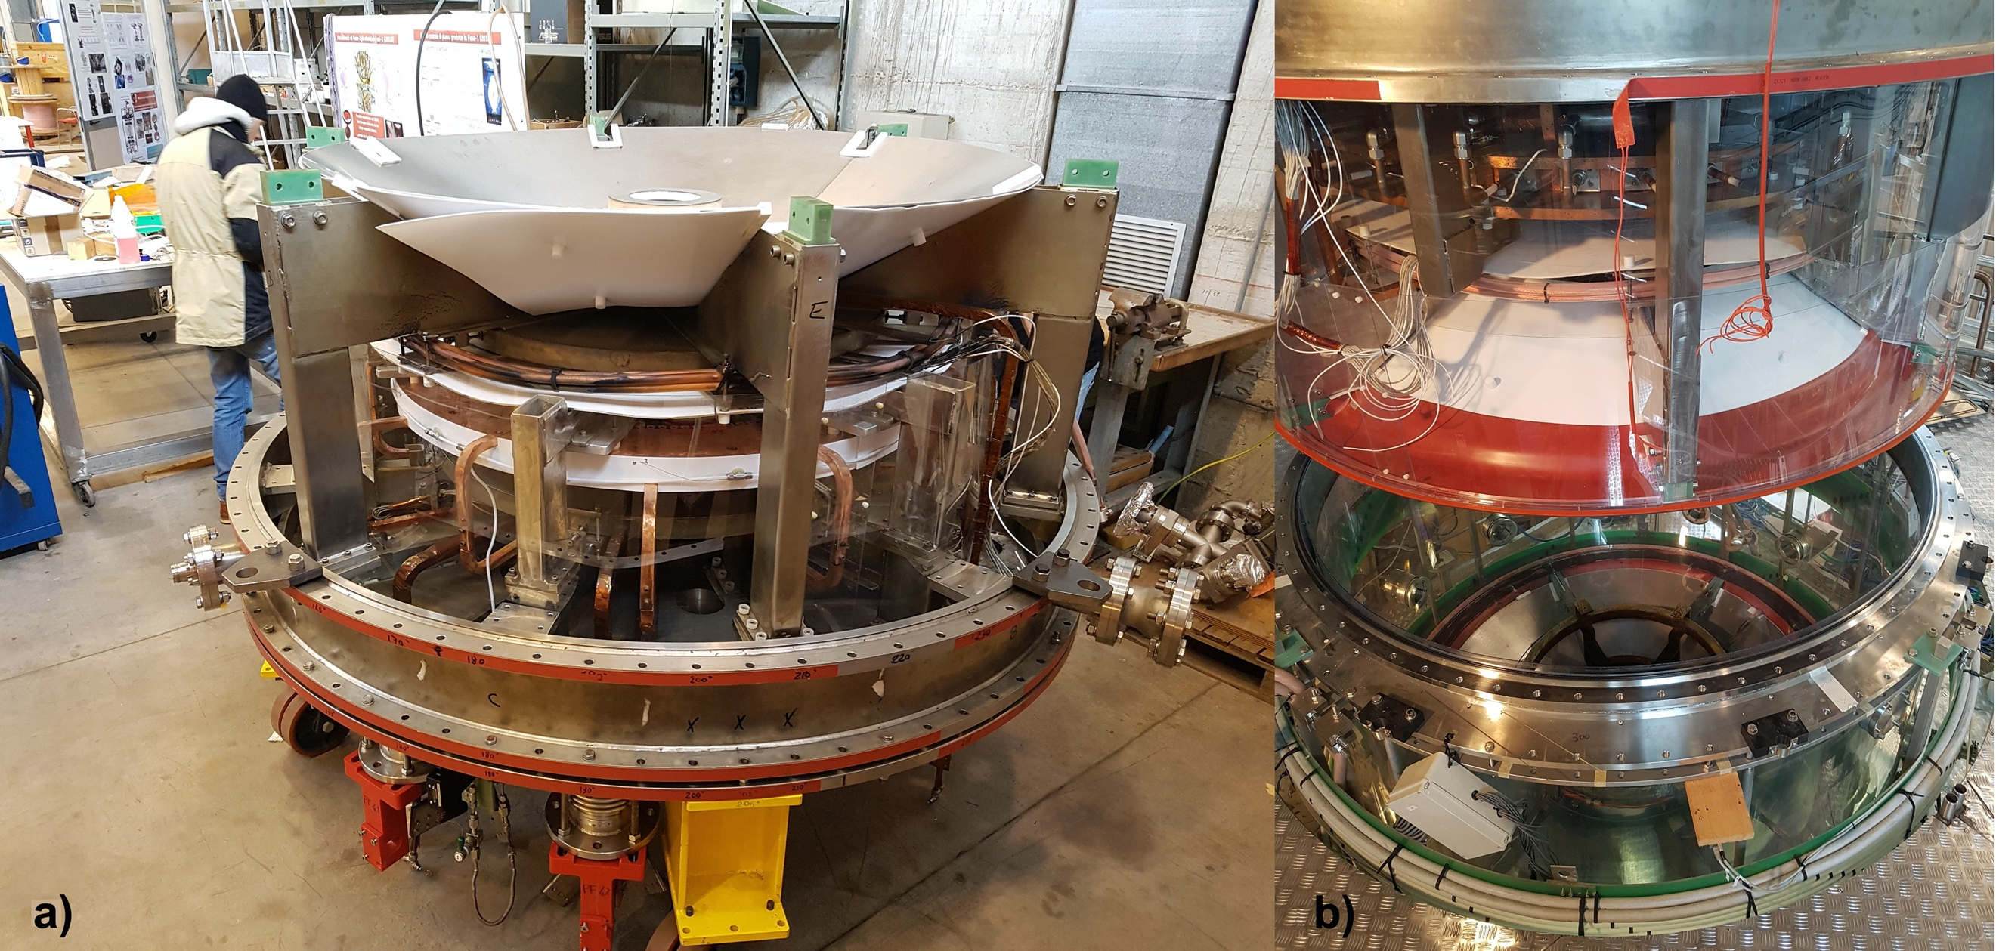
FIGURE 2. (a) Assembly of PROTO-SPHERA (lower section): new Teflon foils are visible.
(b) The PROTO-SPHERA upper section is lifted on the transparent vacuum vessel.
[1] F. Alladio, P. Costa, A. Mancuso, P. Micozzi, S. Papastergiou and F. Rogier, Nucl. Fusion 46 (2006) S613– S624
[2] P. Micozzi, F. Alladio, A. Mancuso and F. Rogier, Nucl. Fusion 50 (2010) 095004
[3] Y. Damizia, M. Iafrati, D. Liuzza, L. Boncagni, P. Micozzi, F. Alladio, Fusion Eng. and Design 169 (2021) 112461

