1.X.Y .n+1 Protosphera assembly and operations (WP-TE ?)

The PROTO-SPHERA experiment was designed and built with the aim of create a stable Spherical-Torus plasma starting with a linear DC plasma discharge, avoiding the metal centerpost as in Spherical-Tokamaks. Using a Plasma-Centerpost (a screw pinch arc discharge) PROTO-SPHERA is a simply connected plasma magnetic configuration, which avoid the necessity of the complex magnets systems required in TOKAMAKs. Also, the geometry of the vessel is substantially simplified: from a torus to a simple cylinder. Conversely the PROTO-SPHERA configuration requires two electrodes to be present inside the cylindrical vacuum vessel.

From an astrophysical perspective, PROTO-SPHERA is an attempt to emulate in the laboratory the jet plus torus plasma of the Crab Nebula: an internal magnetized centerpost of plasma (jet) on the axis of symmetry of the configuration, surrounded by an orthogonal magnetized plasma torus.
Beside the main scope of studying a new way to produce a stable plasma torus, PROTO-SPHERA can be used as low-cost testbed for plasma diagnostic systems like Langmuir probles, Laser Thomson Scattering, spectrometers and polarometers, etc. Also, data acquisition and real time control systems can be prototyped and real-world tested on PROTO-SPHERA. Finally, for the Phase-2 of the experiment, the power supply systems will be based on hybrid storage systems (batteries and supercapacitors) reducing the utility costs.
All these feaures will be used to support the DTT (Divertor Test TOKAMAK) iniatitive currently running in ENEA Frascati.
From the beginning of the project, the PROTO-SPHERA was designed with two steps in mind: the Phase-1 (low current, up to 10 kA) and Phase-2 (high current, up to 70 kA). The full current of the centerpost plasma, that was the aim of Phase-1, I_{e}= 10 kA in Hydrogen, was sustained for the duration of 1 sec at the beginning of 2018. In the same year 2018, thanks to 4 external PFext coils wound external to the vessel that provide a vertical constricting field, the formation of the first plasma tori has been achieved. The obtained tori were the first laboratory emulations of the Crab Nebula configuration.
Satisfactory results were obtained in 2020-2021 campaign.

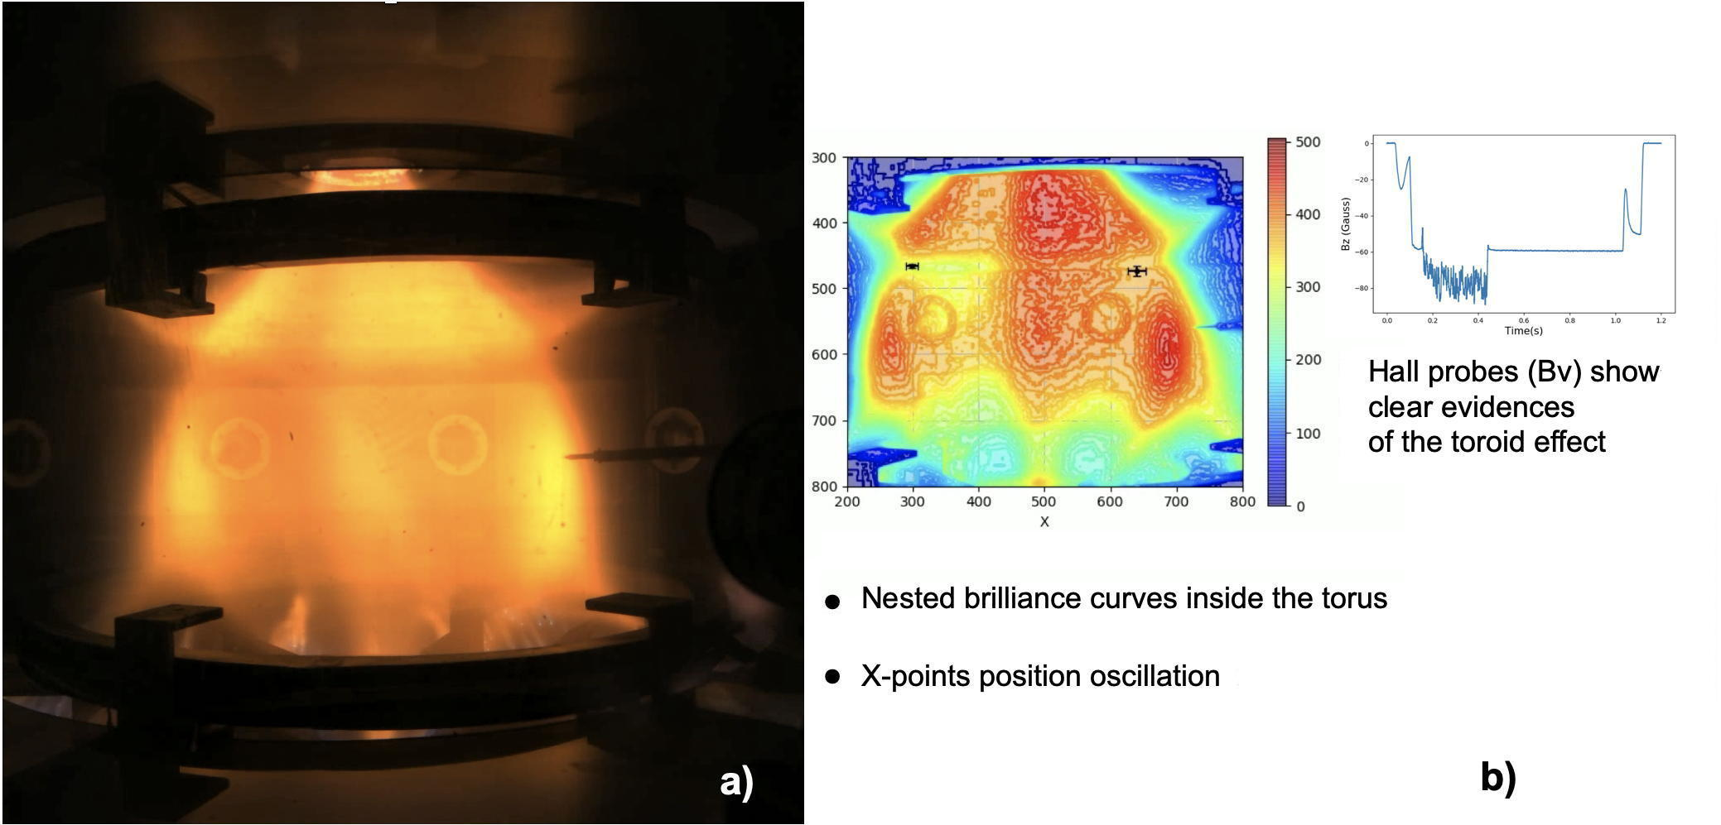
FIGURE 1. (a) Image from the fast camera of a Helium PROTO-SPHERA plasma clearly showing the toroid around the pinch discharge. (b) Nested brilliance surfaces inside the torus and Hall probes magnetic signal showing the torus effect on vertical field Bv.
Clear evidence of nested magnetic surfaces inside the tori was obtained, both with visible light images from a fast camera (3600 fps) located outside the new (transparent) vacuum vessel and with a 3D reconstruction from 6 medium-speed cameras (600 fps). The Hall equatorial probes, that were inserted on the back of the movable Langmuir probes, have collected signals, which show that the tori observed in visible light are associated with a toroidal current inside the plasma tori; the value of the toroidal current estimated from the Hall probes agrees with the value that can be derived from the distance between the X-points, as observed on the visible images. The injection of current inside the plasma tori from the central screw pinch looks like a quasi-periodical sawtooth, a succession of relaxation oscillations whose quasi-periods lasts from 1 to 10 msec. The sequence of relaxations shows remarkable correlations among visible images, the electron density measured by the Langmuir probes and the vertical field measured by the Hall probes.
The thecnical problems of the 2020-2021 campaign, that limited the pulse duration to 0.3 sec and caused an up/down asimmetry of the plasma, will be hopefully solved in the 2022 campain, after the improvements to the internal load assembly of the machine performed in the second half of 2021.

In the Phase-2 of the experiment, planned from 2023, the total number of cathode Tungsten filaments will grow by a factor of 7, from 54 to a total of 378, alongside with the plasma centerpost current, which will increase from 10 kA to 70 kA; the expected "spherical" shaping should allow for up to 300 kA of toroidal plasma current to flow inside the spherical tori that will be sustained for up to 1 sec.

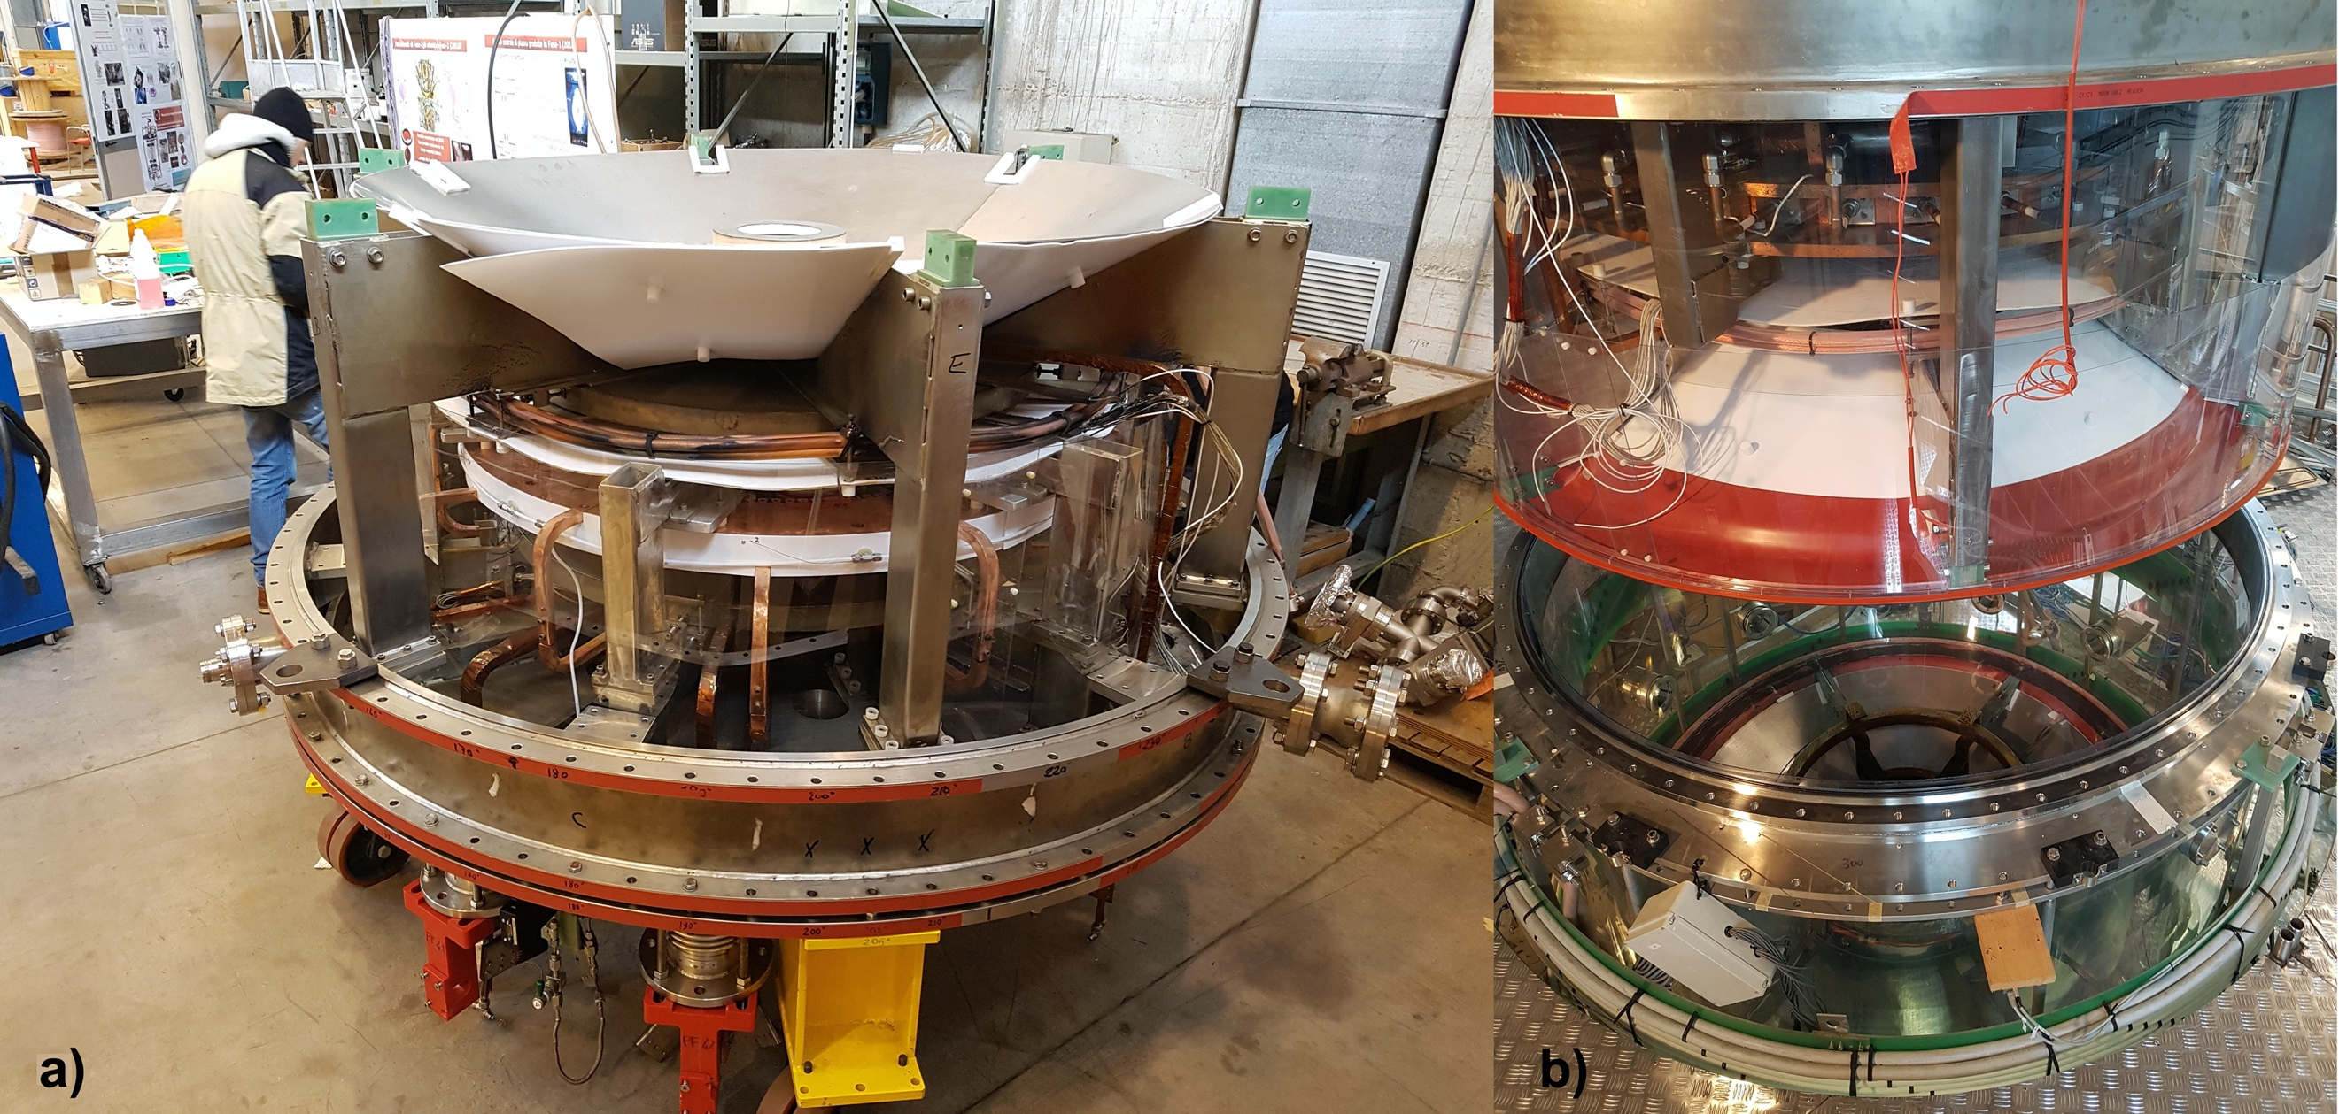
FIGURE 2. (a) Assembly of PROTO-SPHERA (lower section): new Teflon foils are visible.
(b) The PROTO-SPHERA upper section is lifted on the transparent vacuum vessel.

[1] F. Alladio, P. Costa, A. Mancuso, P. Micozzi, S. Papastergiou and F. Rogier, Nucl. Fusion 46 (2006) S613–
S624
[2] P. Micozzi, F. Alladio, A. Mancuso and F. Rogier, Nucl. Fusion 50 (2010) 095004
[3] Y. Damizia, M. Iafrati, D. Liuzza, L. Boncagni, P. Micozzi, F. Alladio, Fusion Eng. and Design 169 (2021)
112461

