The PROTO-SPHERA experiment is a magnetic confinement configuration with rotation symmetry, just like the Tokamak: the plasma, studied in view of controlled fusion nuclear reactions, must take the form of a torus and there are two indispensable requirements for confining it. First there must be a toroidal magnetic field B_{T} (directed along the large circle of the torus) and second a poloidal magnetic field B_{pol} (directed along the small circle of the torus), this last requirement is equivalent to the presence of a toroidal electric current flowing inside the plasma torus. The plasma thus becomes organized according to magnetic flux surfaces, each contained inside another; on every flux surface the lines of magnetic force are wrapped along helices, as in figure 1(a). PROTO-SPHERA tries to removes the two metal central conductors of the Tokamaks, hitherto considered fundamental: the vertical central conductor (which closes the electric current of the external toroidal magnet, figure 1(a) top, and generates the toroidal magnetic field) and also the finite length straight solenoid transformer coil, whose variable electric current wraps around the vertical central conductor, and induces the toroidal current in the Tokamak plasma that surrounds it. Both metal conductors are replaced in PROTO-SPHERA by a different conducting material: a current carrying centerpost plasma discharge (CP in figure 1(b)), with lines of magnetic force and lines of electric current also helically wrapped (figure 1(a) bottom); this plasma centerpost is surrounded by the plasma torus (ST in figure 1(b)).

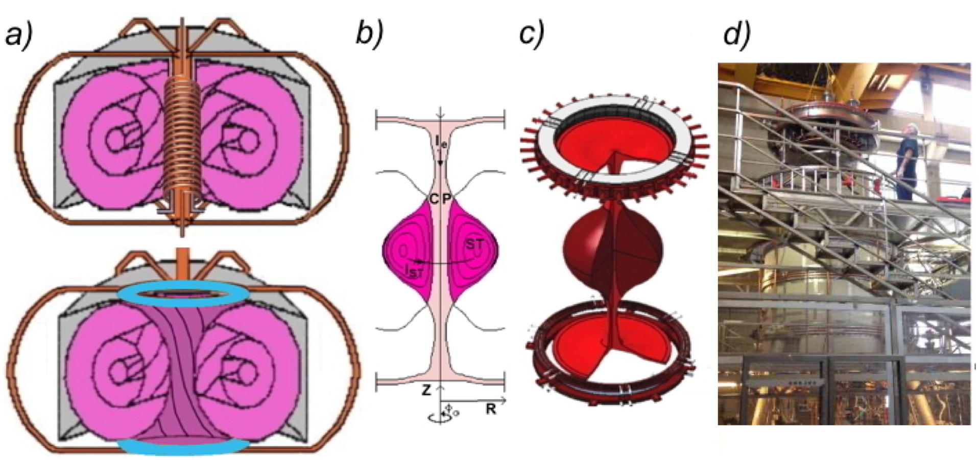

FIGURE 1. (a) Scheme of a Tokamak (top) and of PROTO-SPHERA (bottom): pink colour is for plasma, grey for vessel, orange for metal bars, blue for electrodes. (b) Poloidal cross-section of PROTO-SPHERA plasma, CP stands for centerpost, ST for torus. (c) Perspective sketch of the plasma and of the annular electrodes. (d) PROTO-SPHERA load assembly.

This choice implies an enormous simplification, i.e. the cylindrical shape of the container: the toroidal vacuum chambers are big complications for Tokamaks, already in their construction phase, but even more in the cases where interventions and repairs are necessary. Conversely the PROTO-SPHERA configuration requires two electrodes to be present inside the cylindrical vacuum vessel. The plasma centerpost has a variable diameter for a length of about 1 m and opens in the form of a “mushroom” in front of both annular electrodes, figure 1(c). The annular form of the electrodes was chosen not only in order to dilute the density of power and of electric current impinging upon them, but also because the “mushroom” shaped plasma in front of both electrodes stabilizes the overall confinement configuration. The anode was built as a hollow gas-puffed annular anode, composed of 30 Copper modules, protected on its plasma facing side by tiles of Copper-Tungsten alloy with 20 holes each in front of the plasma, each module is fed by gas on its rear and the plasma is able to diffuse into the front holes. The cathode is a hot annular cathode, divided in 6 sectors, with a total of 54 Tungsten filaments, heated to about 2900 ºC.

PROTO-SPHERA is an attempt to emulate in the laboratory the jet + torus plasma of the Crab Nebula: an internal magnetized centerpost of plasma (jet) on the axis of symmetry of the configuration, surrounded by an orthogonal magnetized plasma torus. PROTO-SPHERA was built and operated in its initial Phase-1 from mid-2014 until the beginning of 2018. Inside the Aluminium vacuum chamber there were eight poloidal magnetic field coils. The full current of the centerpost plasma, that was the aim of Phase-1: I_{e}= 10 kA in Hydrogen, was sustained for the duration of 1 sec at the beginning of 2018. The excellent surprise was that the plasmas produced were as dense as those of high-field Tokamaks (> 10²⁰ particles/m³) and that the central plasma discharges rotated at about 500 turns/sec around their symmetry axes. In the same year 2018, PROTO-SPHERA produced and sustained as well, for 0.5 seconds, its first plasma tori, carrying a toroidal current up to I_{ST}= 7 kA. The obtained tori were indeed quite "lean" but they were the first laboratory emulations of the Crab Nebula configuration. The tori were obtained by adding four impromptu (PFExt) poloidal magnetic vertical field coils, wound around the vacuum chamber, built with some length of available electric cable. In the second Phase-2 of the experiment the tori will be shaped not anymore in the form of "lean" tori, but of "spherical" tori: the plasma confinement properties improve with the increase of the current flowing inside the torus, so it is indeed expedient to fatten the torus and to restrict the centerpost, as much as possible. In the Phase-2 of the experiment a new set of six internal armored coils (PFInt-A compression coils) will contain the expansion force of the current carrying spherical tori. In the Phase-2 of the experiment, the total number of cathode Tungsten filaments will grow by a factor of 7, from 54 to a total of 378, alongside with the plasma centerpost current, which will increase from 10 kA to 70 kA; the expected "spherical" shaping should allow for up to 300 kA of toroidal plasma current to flow inside the spherical tori that will be sustained for up to 1 sec.

Before increasing by a factor of 7 the electrode-driven current in the plasma centerpost, in order to move towards the Phase-2 of PROTO-SPHERA it was decided to operate in 2019 an intermediate Phase-1.5, having the aim of progressively pushing the plasma from the "lean" tori of Phase-1 to the "spherical" tori of Phase-2.
In order to remove the electrical conductivity in the cylinder enclosing the experiment, a new insulating cylindrical vacuum vessel was designed in 2018 and then commissioned to an industrial firm. The new insulating vessel was chosen not only in order to solve a variety of insulation problems, but in order to remove as well the skin current effect of the Phase-1 conductive Aluminium vessel, allowing for the sustainment of the centerpost + torus plasma to reach the full 1.1 s, the maximal duration deliverable by the power supply. The only suitable material for producing a 1.7 m high and 2 m internal diameter insulating cylinder turned out to be PMMA (poly-methyl-metacrylate). The thickness of the PMMA wall was fixed to 9 cm (figure. 2).
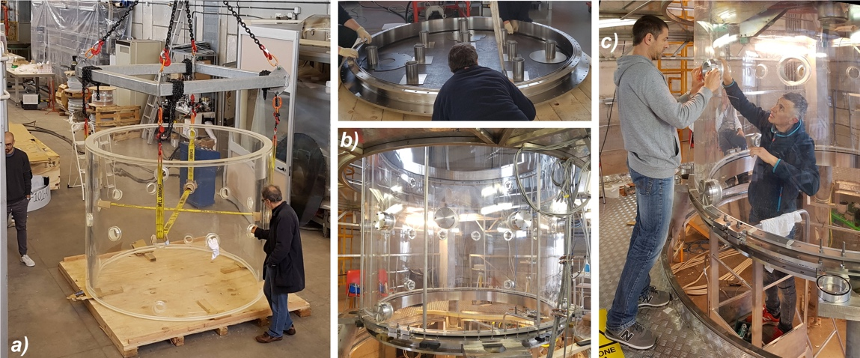

FIGURE 2. (a) The 9 cm thick, 2 m internal diameter, 1.7 m high, new PMMA vessel. (b) One of the two new AISI304 ferrules being tested upon a 10 mm thick Viton flat gasket (top). The new vessel placed in position, with the Viton flat gasket interfacing it with the new bottom ferrule, held by the sustaining legs, pre-charged by compression poles and aligned by brackets (bottom). (c) Closing the diagnostic ports by “bulkhead fitting” technology.

A reduced-current version of the future PFInt-A compression coils, shown in figures 3(a) and 3(b), was home-manufactured and inserted inside the machine during the summer of 2019: it was a group of 6 coils, all fed in series, earlier not present in the experiment. Four of the PFInt-A coils were contained inside two new (industrially built) 2 mm thick AISI304 conical divertor plates, on their plasma-facing sides. The new home-manufactured PFInt-A coils were not enclosed into full metal casings and had a similar geometry, but a reduced number of turns, with respect to the final armored PFInt-A coils, that are planned to be industrially built for the Phase-2 of the experiment. The present intermediate Phase-1.5 of the machine aims therefore at producing plasmas as similar as possible to the Phase-2 plasmas, albeit at much lower currents.

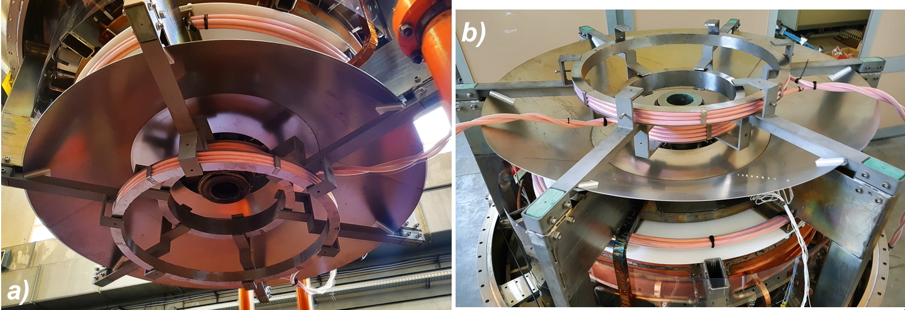

FIGURE 3. The new six PFInt-A compression coils: (a) Two within the upper conical divertor plate and one above it; (b) Two within the lower conical plate and one below it. The green fiberglass blocks insulate the horizontal supports holding the compression coils from the vertical sustaning columns.

The Hydrogen "lean" tori, already obtained in the year 2018, were produced again in the autumn of year 2019, and with the same recipe: i.e. using the external PFExt as the only compression coils. The new "lean" tori had identical characteristics and the same level of toroidal current as the ones of 2018, notwithstanding the absence of any metallic vacuum vessel surrounding the plasma; furthermore, just because of the absence of skin effects, in the 2019 plasma campaign the "lean" tori could be sustained for up to 1 sec.

The Technical Program 2020 had the main aim to eliminate the spurious plasma current paths that have affected the operation and the performances of the experimental machine since the inception of the intermediate Phase-1.5 in September 2019.
The Scientific Program 2020 had more composite aims, that was nevertheless essential for moving to Phase-2, minimizing the risk of future scientific failures.
The first aim of the scientific program was to produce a quasi-spherical torus in Hydrogen, or at least a "fattish torus" (with an aspect ratio R/a of about or less than 2.5).
The second aim was to ascertain that magnetic reconnections are the driving mechanism for sustaining and heating the resulting torus, though DC helicity injection.
The third aim was to get as more diagnostics as possible taking measurements on the plasma in order to characterize as best as possible the magnetic reconnections.

Satisfactory results were obtained in 2020 for the Scientific Program.
The tori obtained in 2020 are much more evident than the ones obtained in 2018 and 2019, on the images of all visible cameras (figure. 4).

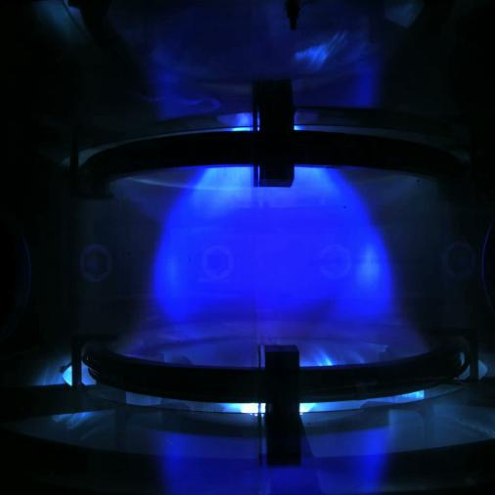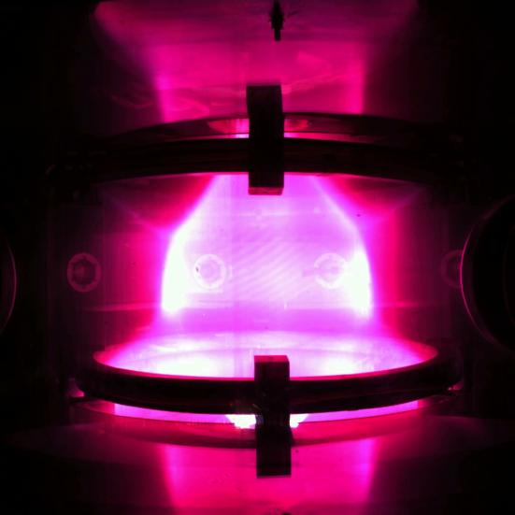
FIGURE 4a) #1823, Argon FIGURE 4b) #1888, Hydrogen

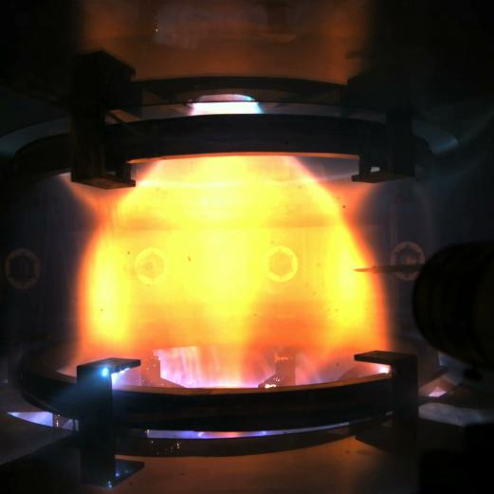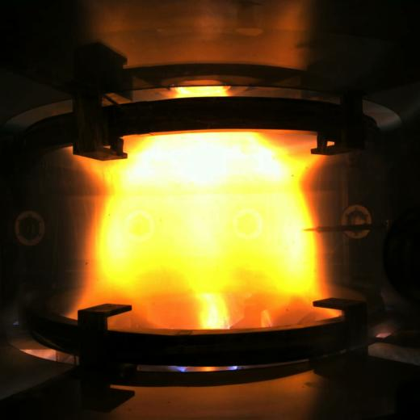
FIGURE 4c) #2126, Helium, A = 5 FIGURE 4d) #2120, Helium, A ~ 4

The produced tori were enlarged, not yet down to an aspect ratio of 2.5 but only down to about 4 in Helium.
The Hall equatorial probes, that were inserted on the back of the movable Langmuir probes (figure. 6), have collected signals, which show that the tori observed in visible light are associated with a toroidal current inside the plasma tori; the value of the toroidal current estimated from the Hall probes agrees with the value that can be derived from the distance between the X-points, as observed on the visible images. The injection of current inside the plasma tori looks like a quasi-periodical sawtooth, a succession of relaxation oscillations whose quasi-periods lasts from 1 to 10 msec. The sequence of relaxations shows remarkable correlations among visible images, the electron density measured by the Langmuir probes and the vertical field measured by the Hall probes (figure. 5).

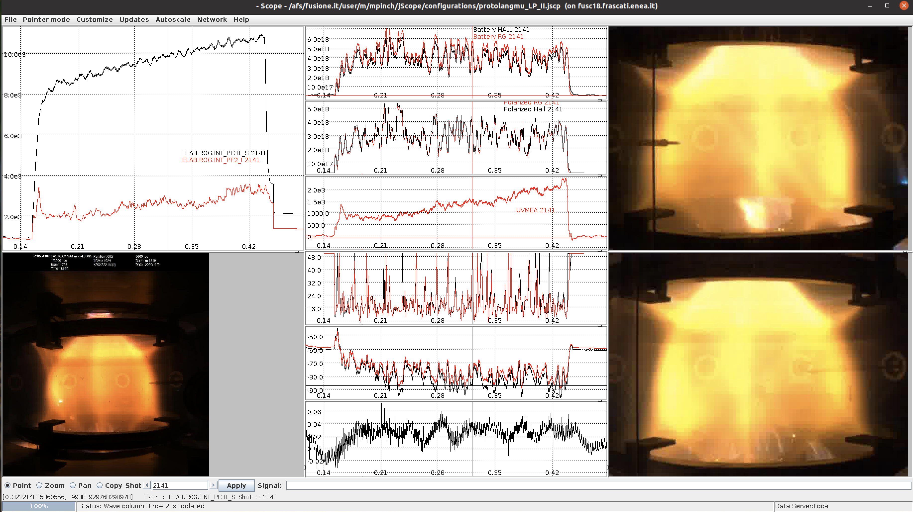

FIGURE 5. Plots of Pinch current (from Rogowsky sensors), density and temperature (from Langmuir probes), UV (from diamond diagnostic), vertical magnetic field (from Hall sensors) and line averaged density (from 2 colors interferometer).

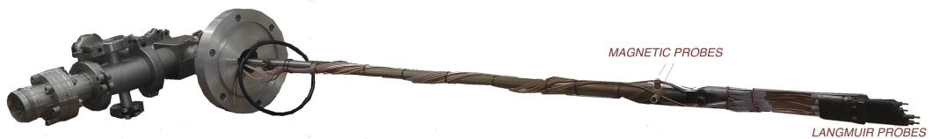
FIGURE 6. Langmuir Probes and Hall magnetic probes.

It is particularly remarkable that the contour plots obrained both with the fast camera (3600 fps) as well as with the 6 semi-fast cameras (600 fps), located around the vacuum chamber, show clearly the presence of nested surfaces inside the torus (figure. 7).

FIGURE 7. Shot #2141: contour plots from the fast camera (on the top) and from the 6 semi-fast cameras.

Such oscillations perturb the axial symmetry of the magnetic configuration with a rotating deformation which has a n=1 toroidal wave number and an m=1 poloidal wave number; the magnetic lines of force on the outside of the torus run the poloidal distance between the top X-point and the bottom X-point in half a toroidal turn, along the azimuthal angle φ: this is confirmed when the Langmuir probe tips are advanced on their foremost position and interact with the plasma on the outboard of the torus, evidencing the shape of the lines of force.
The first measurements of the UV emission from the plasma, observed by a diamond detector, have been performed: the results are still being analyzed.
The 2 colors interferometer has been put in operation, achieving the first measurements on a plasma endowed with tori: in the previous campaign of 2017 the interferometer took measurements on plasma central columns only. The most surprising result is that, in presence of the plasma torus the line-averaged electron density <n_{e}> across the whole plasma is lower by a factor of 3 times with respect to <n_{e}> in presence of the plasma centerpost only: from <n_{e}> 6•10¹⁹ to <n_{e}> 2•10¹⁹ m⁻³ in Helium.
It is possible that most of the density is concentrated inside the plasma torus and that the plasma centerpost in presence of the torus becomes much more tenuous than in absence of it. But this is just a guess; further measurements will be required to understand this point. The first measurements by Langmuir probes on the equatorial plane have been performed: the preliminary results indicate at the equatorial edge of the plasma torus an electron density n_{edge} in the range 10¹⁷ to 10¹⁹ m⁻³ and an electron temperature T_{edge} of 20-25 eV, but there are spikes which reach up to T_{edge} 45 eV.

Nevertheless the Technical Program 2020 does not fully succeed, since the insulation of the upper/lower divertor did not work correctly and it caused a strong up/down asimmetry of the plasma. Furthermore the presence of Teflon insulator too close to the plasma itself generated a too high plasma pollution that forced the pulse duration to 0.3 sec.

Those problems will be hopefully solved in the 2021 campain.

