The PROTO-SPHERA experiment is a magnetic confinement configuration with rotation symmetry, just like the Tokamak: the plasma, studied in view of controlled fusion nuclear reactions, must take the form of a torus and there are two indispensable requirements for confining it. First there must be a toroidal magnetic field B_{T} (directed along the large circle of the torus) and second a poloidal magnetic field B_{pol} (directed along the small circle of the torus), this last requirement is equivalent to the presence of a toroidal electric current flowing inside the plasma torus. The plasma thus becomes organized according to magnetic flux surfaces, each contained inside another; on every flux surface the lines of magnetic force are wrapped along helices, as in figure 1(a). PROTO-SPHERA tries to removes the two metal central conductors of the Tokamaks, hitherto considered fundamental: the vertical central conductor (which closes the electric current of the external toroidal magnet, figure 1(a) top, and generates the toroidal magnetic field) and also the finite length straight solenoid transformer coil, whose variable electric current wraps around the vertical central conductor, and induces the toroidal current in the Tokamak plasma that surrounds it. Both metal conductors are replaced in PROTO-SPHERA by a different conducting material: a current carrying centerpost plasma discharge (CP in figure 1(b)), with lines of magnetic force and lines of electric current also helically wrapped (figure 1(a) bottom); this plasma centerpost is surrounded by the plasma torus (ST in figure 1(b)).

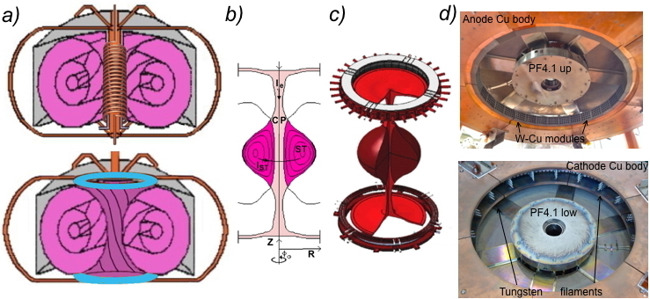

FIGURE 1. (a) Scheme of a Tokamak (top) and of PROTO-SPHERA (bottom): pink colour is for plasma, grey for vessel, orange for metal bars, blue for electrodes. (b) Poloidal cross-section of PROTO-SPHERA plasma, CP stands for centerpost, ST for torus. (c) Perspective sketch of the plasma and of the annular electrodes. (d) View of the annular anode (top) and of the annular cathode (bottom).

This choice implies an enormous simplification, i.e. the cylindrical shape of the container: the toroidal vacuum chambers are big complications for Tokamaks, already in their construction phase, but even more in the cases where interventions and repairs are necessary. Conversely the PROTO-SPHERA configuration requires two electrodes to be present inside the cylindrical vacuum vessel. The plasma centerpost has a variable diameter for a length of about 1 m and opens in the form of a “mushroom” in front of both annular electrodes, figure 1(c). The annular form of the electrodes was chosen not only in order to dilute the density of power and of electric current impinging upon them, but also because the “mushroom” shaped plasma in front of both electrodes stabilizes the overall confinement configuration. The anode was built as a hollow gas-puffed annular anode, composed of 30 Copper modules, protected on its plasma facing side by tiles of Copper-Tungsten alloy, the grey elements of figure 1(d) top, with 20 holes each in front of the plasma, each module is fed by gas on its rear and the plasma is able to diffuse into the front holes. The cathode is a hot annular cathode, divided in 6 sectors, with a total of 54 Tungsten filaments, shown in figure 1(d) bottom, heated to about 2900 ºC; the six-phased AC heating of the filaments is switched off just before a DC voltage is applied between the annular electrodes in order to obtain the break-down of the plasma centerpost.
PROTO-SPHERA is an attempt to emulate in the laboratory the jet + torus plasma of the Crab Nebula (figure 2): an internal magnetized centerpost of plasma (jet) on the axis of symmetry of the configuration, surrounded by an orthogonal magnetized plasma torus. PROTO-SPHERA was built and operated in its initial Phase-1 from mid-2014 until the beginning of 2018. Inside the Aluminium vacuum chamber there were eight poloidal magnetic field coils: the PFInt-B shaping group coils, shown in figure 2(a), industrially built, all fed in series and armored by 5 to 10 mm thick AISI304 casings. The centerpost discharge passes through the holes inside both of the two PF2 coils, which are internally protected by additional Copper-Tungsten cylindrical shells. The full current of the centerpost plasma, that was the aim of Phase-1: I_{e}= 10 kA in Hydrogen, was sustained for the duration of 1 sec at the beginning of 2018, see figure 2(b). The excellent surprise was that the plasmas produced were as dense as those of high-field Tokamaks (> 10²⁰ particles/m³) and that the central plasma discharges rotated at about 500 turns/sec around their symmetry axes. In the same year 2018, PROTO-SPHERA produced and sustained as well, for 0.5 seconds, its first plasma tori, carrying a toroidal current up to I_{ST}= 7 kA. The obtained tori were indeed quite "lean" (in figure 2(c) the torus appears as a brighter belt at the outer edge of the Hydrogen plasma centerpost) but they were the first laboratory emulations of the Crab Nebula configuration, shown in figure 2(d). The tori were obtained by adding four impromptu (PFExt) poloidal magnetic vertical field coils, shown in figure 2(e), wound around the vacuum chamber, built with some length of available electric cable. In the second Phase-2 of the experiment the tori will be shaped not anymore in the form of "lean" tori, but of "spherical" tori, i.e. "apples with thinly perforated cores": the plasma confinement properties improve with the increase of the current flowing inside the torus, so it is indeed expedient to fatten the torus and to restrict the centerpost, as much as possible. In the Phase-2 of the experiment a new set of six internal armored coils (PFInt-A compression coils) will contain the expansion force of the current carrying spherical tori. In the Phase-2 of the experiment, the total number of cathode Tungsten filaments will grow by a factor of 7, from 54 to a total of 378, alongside with the plasma centerpost current, which will increase from 10 kA to 70 kA; the expected "spherical" shaping should allow for up to 300 kA of toroidal plasma current to flow inside the spherical tori that will be sustained for up to 1 sec.

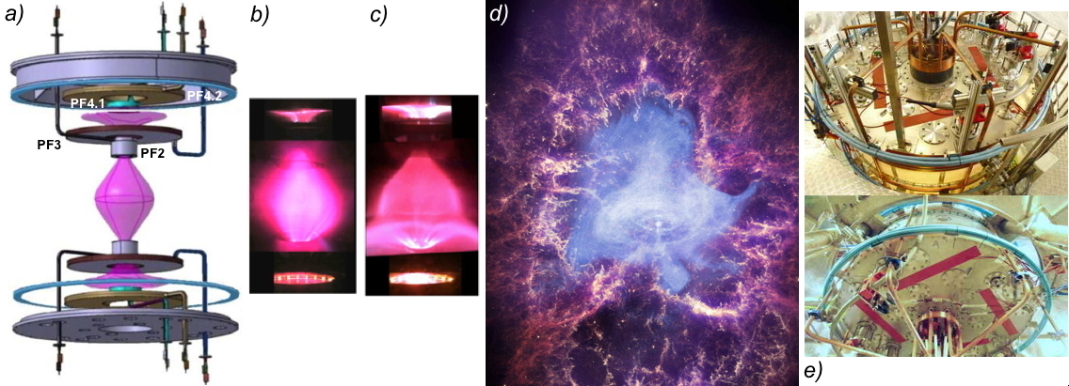

FIGURE 2. (a) Scheme of plasma centerpost (pink) and of PFInt-B internal armored coils, the main plasma is limited by the two PF2 mirror coils; the mechanical structures of both electrodes are removed from the scheme. (b) Image of Hydrogen plasma centerpost at I_{e}= 10 kA, shot #969. (c) Image of centerpost at I_{e}= 10 kA & of torus at I_{ST}= 7kA, Hydrogen shot #1280. (d) Composite image of Crab nebula from Chandra (X rays), Hubble (visible) and Spitzer (infrared) space telescopes. (e) The 4 PExt coils (green-blue) wound in 2018 around the vacuum vessel.

Before increasing by a factor of 7 the electrode-driven current in the plasma centerpost, in order to move towards the Phase-2 of PROTO-SPHERA it was decided to operate in 2019 an intermediate Phase-1.5, having the aim of progressively pushing the plasma from the "lean" tori of Phase-1 to the "spherical" tori of Phase-2.
In order to remove the electrical conductivity in the cylinder enclosing the experiment, a new insulating cylindrical vacuum vessel was designed in 2018 and then commissioned to an industrial firm. The new insulating vessel was chosen not only in order to solve a variety of insulation problems, but in order to remove as well the skin current effect of the Phase-1 conductive Aluminium vessel, allowing for the sustainment of the centerpost + torus plasma to reach the full 1.1 s, the maximal duration deliverable by the power supply. The only suitable material for producing a 1.7 m high and 2 m internal diameter insulating cylinder turned out to be PMMA (poly-methyl-metacrylate). The thickness of the PMMA wall was fixed to 9 cm (figure. 3). From the point of view of the vacuum performances the new PMMA vessel was even better than the old Aluminium one: a base pressure of 6•10⁻⁵ mbar was achieved after two weeks in the first round of vacuum pumping; this is more than enough, as the plasma is obtained at a filling gas pressure of about 10⁻²-10⁻¹ mbar; on the other hand the base pressure is clearly limited by more than 5 tons of various components contained inside the 8 cubic meters of the internal volume of the machine. After the first plasmas were produced inside the PMMA vessel, in the following rounds of opening and closing of the machine, an acceptable vacuum was recovered in a much shorter period of time: only 2-3 days.
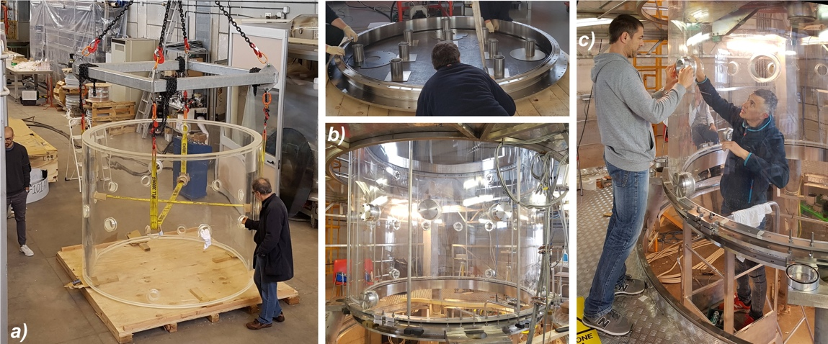

FIGURE 3. (a) The 9 cm thick, 2 m internal diameter, 1.7 m high, new PMMA vessel. (b) One of the two new AISI304 ferrules being tested upon a 10 mm thick Viton flat gasket (top). The new vessel placed in position, with the Viton flat gasket interfacing it with the new bottom ferrule, held by the sustaining legs, pre-charged by compression poles and aligned by brackets (bottom). (c) Closing the diagnostic ports by “bulkhead fitting” technology.

A reduced-current version of the future PFInt-A compression coils, shown in figures 4(a) and 4(b), was home-manufactured and inserted inside the machine during the summer of 2019: it was a group of 6 coils, all fed in series, earlier not present in the experiment. Four of the PFInt-A coils were contained inside two new (industrially built) 2 mm thick AISI304 conical divertor plates, on their plasma-facing sides. The new home-manufactured PFInt-A coils were not enclosed into full metal casings and had a similar geometry, but a reduced number of turns, with respect to the final armored PFInt-A coils, that are planned to be industrially built for the Phase-2 of the experiment. The present intermediate Phase-1.5 of the machine aims therefore at producing plasmas as similar as possible to the Phase-2 plasmas, albeit at much lower currents.

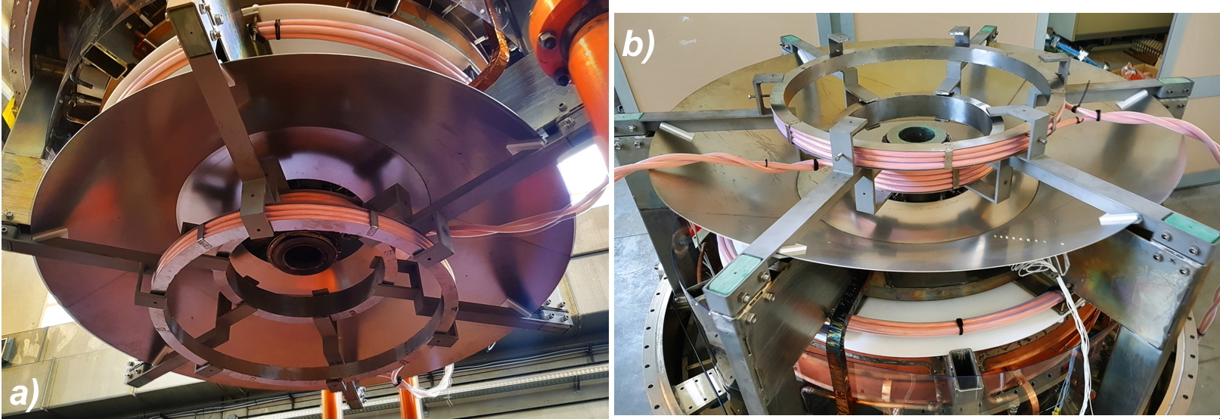

FIGURE 4. The new six PFInt-A compression coils: (a) Two within the upper conical divertor plate and one above it; (b) Two within the lower conical plate and one below it. The green fiberglass blocks insulate the horizontal supports holding the compression coils from the vertical sustaning columns.

The external poloidal field compression coils PFExt were also rebuilt in 2019 with cables of much larger cross section than the ones used in 2018. Therefore in 2019 PROTO-SPHERA was endowed with 18 poloidal field coils (PF), divided in 3 sets: the 8 internal PFInt-B shaping coils, the original armored ones, shown in the CAD design of figure 1(a), the 6 new internal PFInt-A compression coils, illustrated in figures 4(a) and 4(b) and the 4 external PFExt coils, shown in figures 5(c) and 5(d). This has allowed, with the two existing PF coils power supplies, either to feed independently PFInt-B and PFExt coils, or independently PFInt-B and PFInt-A coils or even to feed independently PFInt-A coils and the series of PFInt-B and PFExt coils. In its final Phase-2 the experiment will have a third additional PF coils power supply, so that it will be possible to feed independently all the 3 sets of coils.
Two large insulating diaphragm separators, made out of a 10 mm thick polycarbonate slab, had to be rebuilt. Their internal holes were enlarged to a diameter of 1500 mm, as figure 5(a) and 5(b) show, and they were fixed to the anodic and cathodic mechanical groups. In order to avoid that spurious plasma currents could sneak through the narrow outermost clearance (1-2 mm) between the polycarbonate diaphragms and the inside of the PMMA vessel, a foldable 3 mm thick Norseal red Silicon gasket, soft and pliable, was glued to each diaphragm and held in position by a further polycarbonate lining 2 mm thick, which appears on top of figure 5(b). The two mechanical groups were successfully inserted inside the vessel (and later successfully extracted from it): both Silicon gaskets were able to fold (and unfold) properly, guaranteeing a reusable sealing, hermetic to any spurious plasma current sneaking in.
The Hydrogen "lean" tori, already obtained in the year 2018, were produced again in the autumn of year 2019, and with the same recipe: i.e. using the external PFExt as the only compression coils. The new "lean" tori had identical characteristics and the same level of toroidal current as the ones of 2018, notwithstanding the absence of any metallic vacuum vessel surrounding the plasma; furthermore, just because of the absence of skin effects, in the 2019 plasma campaign the "lean" tori could be sustained for up to 1 sec.
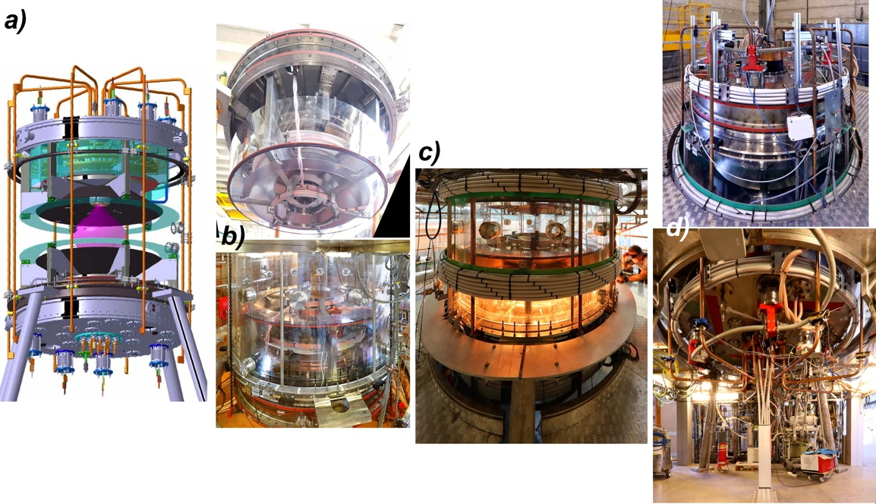

FIGURE 5. (a) CAD design of PROTO-SPHERA, rebuilt for Phase-1.5: plasma (pink), diaphragms (semitransparent green) and conical divertor plates (black). (b) Transparent diaphragm and foldable 3 mm thick red Silicon gasket at the edge of the upper mechanical group (top). Lower mechanical group, inserted into the PMMA vessel, with folded red Silicon gasket (bottom). (c) New external coils PFExt (grey), near the equator of the experimental machine and in presence of hot cathode filaments. (d) Upper and lower new PFExt coils, wound in 2019.

The first plasma operations of Phase-1.5, in which the new PFInt-A compression coils were energized (in presence or in absence of currents flowing in the external PFExt), gave reasonable results for Argon discharges: an example is shown in figure 6(a). Plasma tori with an aspect ratio lower than the "lean" tori of 2018 were obtained, this time the plasma inside the tori became more transparent than the centerpost plasma, suggesting that the tori have a higher temperature than the centerpost, and furthermore they could be sustained for 1 sec. The filamentation of the plasma emerging from the lower (cathodic) PF2 internal mirror coil was usually absent or very limited, as shown in figure 6(b). Unfortunately the empty space of about 2 cm left open between each polycarbonate diaphragm and its nearby AISI304 conical divertor plate, figure 5(a), allowed for spurious Argon plasma currents, evident in figures 6(c) and 6(d), to bend around the lower polycarbonate diaphragm.
Also in Helium discharges, shown in figure 7, when the new PFInt-A compression coils were energized, the behaviour of the plasma was quite similar and produced tori with aspect ratio lower than the "lean" tori of 2018.

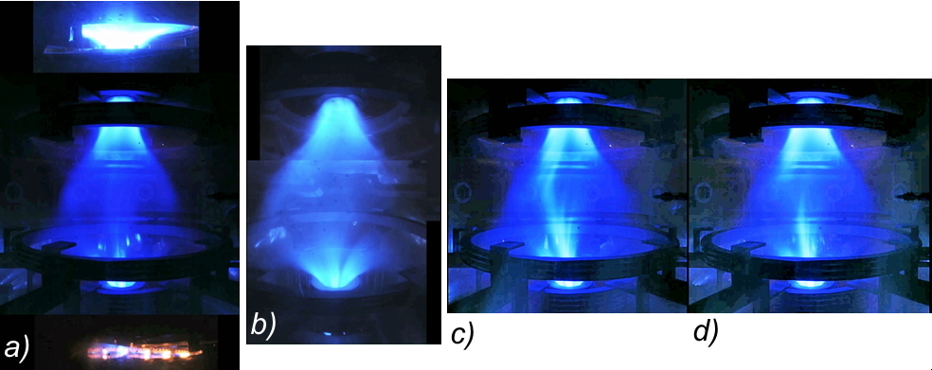

FIGURE 6. Shot #1687, Argon plasma with the PFInt-A compression coils energized. (a) Overall view (superposition of anodic, main and cathodic plasma images from 3 different cameras). (b) View of the main plasma, with distorted perspective, composed by images of two tilted cameras looking at the upper and at the lower PF2 mirror coils, from which the plasma centerpost emerges. (c) Spurious Argon currents, observed as low luminosity stripes in front of the lower PFInt-A coils. (d) Luminosity stripes at different positions for a later time-slice.

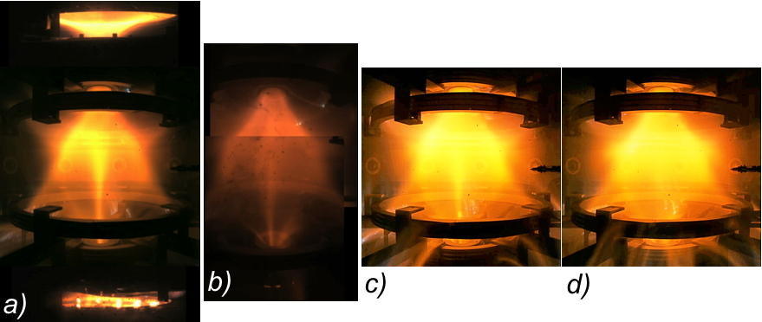

FIGURE 7. Shot #1752, Helium plasma with the PFInt-A compression coils energized. (a) Overall view (superposition of anodic, main and cathodic plasma images from 3 different cameras). (b) View of the main plasma, with distorted perspective, composed by 2 tilted images of cameras looking at the upper and at the lower PF2 mirror coils, from which the plasma emerges. (c) Spurious Helium plasma currents, observed as low luminosity stripes in front of the lower PFInt-A coils. (d) Luminosity stripes at different positions for a later time-slice.

The circles of X-points and the separatrix fans associated with the Helium tori, evident in figure 7(a), were much sharper than in Argon plasmas (see figure 6(a)), but some filamentation of the plasma still emerged from the upper (cathodic) PF2 internal mirror coil, and is evident in figure 7(b). The spurious filamented Helium plasma currents, clearly visible in figures 7(c) and 7(d), did bend as well around the lower polycarbonate diaphragm, just as in the Argon plasma. Because of the large spurious plasma currents, it was impossible to estimate the toroidal current contained either inside the Argon or inside the Helium tori. In order to suppress the presence of spurious plasma currents, which appeared in the 2019 plasma operation of Phase-1.5, a number of actions are presently underway. After all these corrections will have been implemented, the hope is to produce in 2020 the first Hydrogen spherical tori.

