The PROTO-SPHERA experiment was built with the aim of sustaining a Spherical-Torus not around a metal centerpost, as Spherical-Tokamaks do, but around a Plasma-Centerpost, which is a screw pinch arc discharge. PROTO-SPHERA (Fig. 1a) is therefore a simply connected plasma magnetic configuration, which gets rid of a toroidal magnet. In its next second stage it will consist of a Spherical-Torus plasma (equatorial diameter 2R_{sph}=0.7 m, toroidal plasma current I_{ST}=¼ MA) around a Plasma-Centerpost (2 m long, midplane diameter ≈0.08 m), fed by annular electrodes (radius =0.40 m, height =0.04 m), carrying a longitudinal electrode plasma current I_{e}=60 kA (Fig. 1b); the plasma is mushroom-shaped in front of both the annular electrodes. Copper bars outside the cylindrical Aluminum vacuum vessel return the centerpost current and are the only residual components of a toroidal magnet (Fig. 1c). PROTO-SPHERA is however completely different from apparently similar configurations, such as Spheromaks, that are contained by conducting stabilizing vacuum walls very near to the plasma: the PROTO-SPHERA plasma is far from any conducting wall and is contained by a group (Group-B-PFint) of 8 poloidal field (PF) coils (Fig.1c), internal to the vacuum vessel and all in series: their AISI304 casings are each individually electrically insulated. The directly heated annular cathode has a Cu body: in the present stage (able to deliver only I_{e}=10 kA) it is partially filled with 18 modules of 3 doubly wound W-VM filaments (Fig. 1d bottom). The anode’s Cu body is a hollow annular gas-puffed one, its plasma facing material is W-Cu; from its rear gas is puffed into holes facing the plasma (Fig. 1d top), which is able to spread inside the holes.

a b c d e
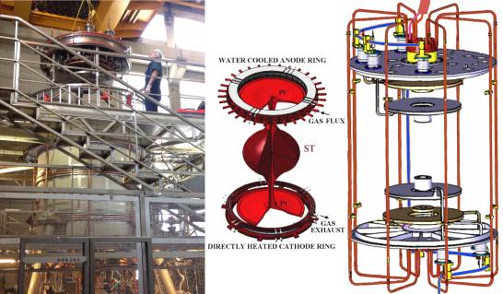
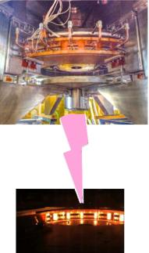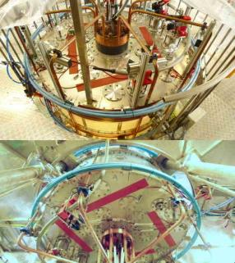

Fig.1 a) PROTO-SPHERA. b) Spherical-Torus (dark) around Plasma-Centerpost (bright), which terminates on annular electrodes. c) Group-B-PFInt coils inside & current return bars outside the vacuum vessel. d) Top anode, bottom cathode. e) PFExt coils (blue) around the vacuum vessel, seen from top & bottom.

The timing of the plasma shot is: the Tungsten filaments are heated to ≈2900 ºC for about ≈30s; then the working gas (Argon or Hydrogen) is puffed and the Group-B-PFint shaping field is energized inside the 4 cm thick cylindrical Aluminum vacuum vessel; finally the Plasma-Centerpost power supply is fired: it can sustain the plasma for up to 1.1s. The aim of Phase-1of PROTO-SPHERA experiment (I_{e}=10 kA Plasma Centerpost in Hydrogen) was already achieved with full success in the year 2017. In the year 2018, thanks to 4 impromptu PFExt coils wound external to the vessel (Fig. 1e), that provide a vertical constricting field, the formation of the first plasma tori has been achieved, even before the new internal compression coils are built, in order to carry PROTO-SPHERA to its final Phase-2. The current in the two PFExt coils nearer to the equatorial plane flows in a toroidal direction opposite to that of the Plasma-Centerpost current, in order to contrast with a vertical field the expansion the plasma torus. The torus formation enlarges the plasma equatorial outboard, making it bulging out in the shape of a sphere. The volume of closed flux surfaces carved out by the torus from the Plasma-Centerpost would be quite small (<8%) (Fig. 2a), as the field of PFExt coils is almost vertical, whereas the future Group-A-PFInt coils has obviously been designed such as to carve from the Plasma-Centerpost the largest possible volume of closed flux surfaces (>95%). The torus exhibits an axisymmetric double-null (DN) separatrix, endowed with divertor fans; a fit of the distance between the two X-points of the DN separatrix (Fig. 2b) measures a toroidal current I_{ST}=7 kA inside the Hydrogen-torus, with an uncertainty of
±1 kA, due to the diffused (ergodic) character of the X-points. The plasma break-down voltage increases from 320 V in absence of the torus to 360 V, but the anode-to-cathode voltage at the current flat-top increases only from 220 V to 240-255 V: the power required for sustaining the
H-torus, with respect to the 2.2 MW required by the H Plasma-Centerpost, is only 200-350 kW. The Hydrogen plasma-tori are sustained as long as the DC anode-to-cathode voltage is applied; this time interval is now <0.5 sec, as the external field takes 0.6 s to penetrate the 4 cm thick Aluminum vacuum vessel and the plasma break-down has then to be delayed by 0.6 s. The tori obtained, with aspect-ratio A≈7.0 and elongation b/a=κ≈3.5, could not be produced in a Tokamak: such a high elongation and aspect ratio, in absence of a close-fitting conducting wall, would be absolutely unstable.

a b c
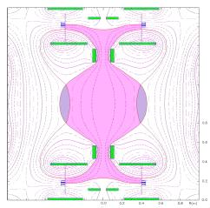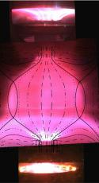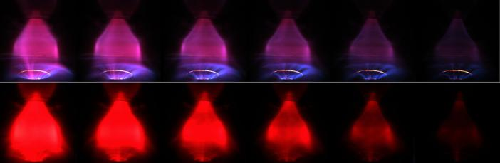
Fig.2 a) The field configuration calculated in presence of a plasma torus. b) H discharge #1280: superposition with the equilibrium fit at I_{ST}=7 kA. c) Sequence of main plasma frames during I_{e} ramp down, last 3 ms of plasma: upper visible light, H shot #1224; lower through H-alpha filter, H shot #1219: the confined torus survives longer than the centerpost.

But the most surprising aspect is the unexpected production of the torus in absence of any applied variation of magnetic flux, i.e. in a purely magnetostatic configuration of the axisymmetric poloidal field pre-existent to the plasma. The evidence that the Hydrogen-tori appear in perfectly static field conditions rules out any interpretation in terms of inductive phenomena. The fact that the plasma current density is antiparallel to the magnetic field 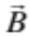 all over the plasma makes plausible that magnetic reconnections transfer plasma current from the centerpost to the torus. The presence of ordinary X-points (Fig. 2b) in the DN separatrix is a second hint to magnetic reconnections: in the 2D approximation they occur naturally at ordinary X-points. The longer persistence of the current inside the torus, with respect to the current inside the Plasma-Centerpost (Fig. 2c), indicates a current confinement of ≈1 ms inside the torus. The third hint to magnetic reconnections is the repetition of distinctive bursts that gently shake the plasma shape, with quasi-periodicity of 2-3 ms; such bursts are accompanied by emissions of plasma into the divertor fans.
So in 2018 PROTO-SPHERA has shown that:
• A toroidal magnet is not unavoidable for the steady-state sustainment of quasi-axisymmetric confined tori: a Plasma-Centerpost discharge, driven by a DC voltage between two annular electrodes, is sufficient for obtaining such an aim.
• The tori are produced in pre-existing purely magnetostatic axisymmetric poloidal fields: no current variation is required in the PF coils that surround the plasma tori, in order to oppose their expansion.
• In PROTO-SPHERA an unwanted plasma termination never occurred, even if discharges were severely deformed.
• The magnetically confined tori can be maintained in quasi-steady state as long as the anode-to-cathode DC voltage is applied: it is highly plausible that magnetic reconnections are able to provide a completely steady-state current drive to a high density rotating toroidal plasma.
The next second stage of PROTO-SPHERA will assess whether a vigorous self-organized heating of the plasma torus can be provided by magnetic reconnections: a total power up to 21 MW will be input into the overall plasma.

