STATUS of CONSTRUCTION of PROTO-SPHERA EXPERIMENT
Chandrasekhar-Kendall-Furth (CKF) magnetic configurations are a novel approach to magnetic confinement fusion research. They are simply-connected axisymmetric plasma equilibria containing a magnetic separatrix with ordinary X-points (B≠0), which divides a main Spherical Torus (ST), two secondary tori on top and bottom and a Surrounding Plasma discharge around the three tori (Fig.1 and Fig.2). Furthermore two degenerate magnetic
X-points (B=0) are present on the symmetry axis near the edge of the configuration. Whereas CKF force-free fields (with current density everywhere aligned to the magnetic field ) cannot sustain any pressure gradient (=0) and would have a relaxation parameter
μ=μ₀•/B² constant all over the plasma, unrelaxed (≠0, ≠0) CKF equilibria can be calculated with the boundary condition that μ=μ₀•/B² is constant only at the edge of the plasma. The surface averaged value μ=μ₀•/B² will therefore decrease from the edge of the Surrounding Plasma discharge to the axis of the main Spherical Torus.
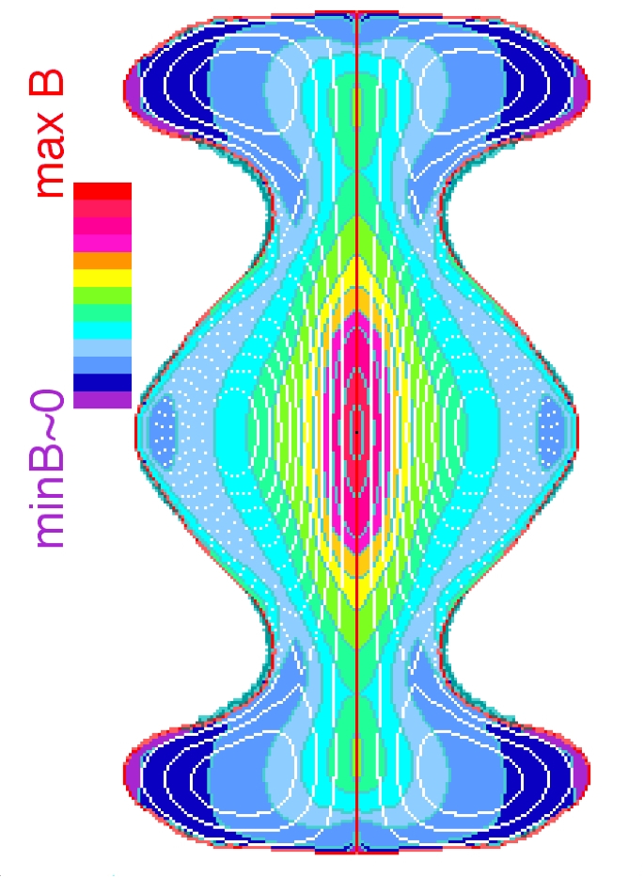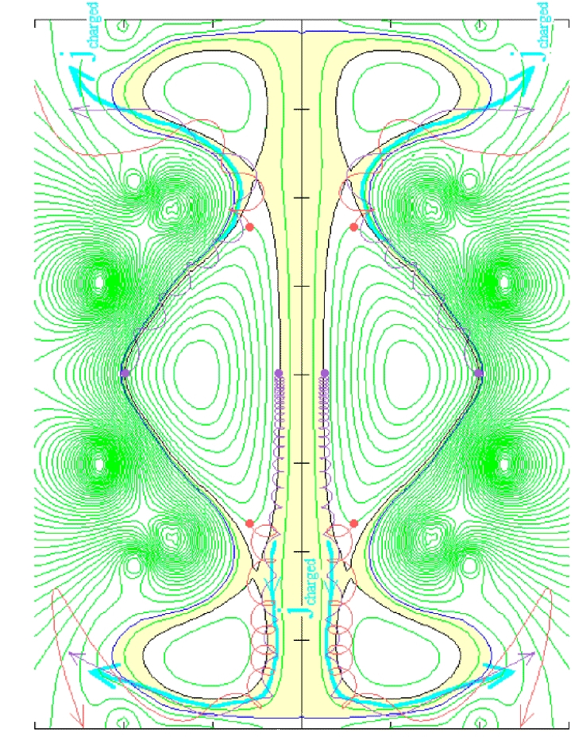

Fig.1 CKF a) Magnetic CKF flux surfaces (contours) and field strength (colours); b) cross sectional view of path of charged fusion products lost from the Spherical Torus
If the Surrounding Plasma discharge is sustained by driving current along its closed flux surfaces, magnetic helicity will flow down the gradient and will be injected into the main Spherical Torus, through magnetic reconnections at the X-points. The gradient of the pressure profile will be concentrated in the same region where has its largest values. Unrelaxed CKF equilibria, with this kind of relaxation parameter μ- and pressure p-profiles, have been calculated to be stable to all ideal MHD perturbations with low toroidal mode number (n=1, 2, 3), up to unity plasma beta values, β=2μ₀<p>_{Vol}/<B²>_{Vol}≈1. Unrelaxed CKF fusion burners with the right helicity injection, β limit and energy confinement will allow for an unimpeded outflow of a part (≈15%) of the high energy charged fusion products. The charged fusion products will drift across the magnetic separatrix, to the degenerate magnetic X-points (B=0) on top/bottom of the configuration, easing direct energy conversion and the use of the fusion burner as a space thruster (Fig. 1). The high plasma, β≈1, opens the possibility that plasma motions, i.e. radial electric fields, can sustain the magnetic field of CKF configurations. A CKF fusion burner could be self-sustaining as a radial electric field can will be the natural result of losses of charged fusion products, and would therefore impress a torque upon the Plasma Column surrounding the symmetry axis, between the upper and lower degenerate magnetic X-points. Such a torque could sustain, through magnetic reconnection, the helicity injection into the burning main Spherical Torus.
As at present it is far from clear how to obtain a full CKF configuration in the laboratory, with the aim of beginning an experimental study of these configurations, a plasma producing machine has been built: PROTO-SPHERA. It will study the properties of a CKF configuration where a Hydrogen Central Plasma column, in the form of a Screw Pinch (SP) fed by electrodes, replaces the central part the surrounding discharge of a CKF configuration, while poloidal field coils replace the secondary tori (Fig.2). PROTO-SPHERA can be viewed as restricting the Surrounding Plasma discharge of CKF to the Central Plasma column only, or as enlarging the Spherical Tokamak configuration with metal centerpost to one with a plasma centerpost. In order to compare the performances of PROTO-SPHERA with plasma Central Column to those of a Spherical Tokamak with metal centerpost, geometrical size and plasma currents very similar to the ones of the pioneering Spherical Tokamak experiment START, operated in Culham from 1991 to 1998, were chosen: PROTO-SPHERA, with a central plasma column current I_{e}=60 kA, has been designed in order to produce a spherical torus of diameter 2•R_{sph}=70 cm, aspect ratio A=1.2÷1.3, carrying a toroidal current I_{p}=120÷240 kA. A collaboration was established with UKAEA-Culham British Association. Within that framework Culham in 2004 donated to Frascati the available START equipment (in particular the vacuum vessel).
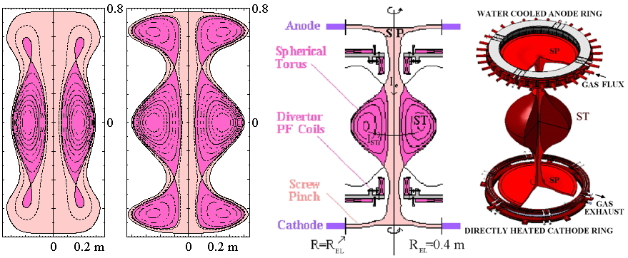
Fig.2 a) Force-free CKF magnetic configuration; b) unrelaxed CKF equilibrium; c) PROTO-SPHERA scheme with SP fed by anode and cathode replacing the Surrounding Plasma and poloidal field coils replacing the secondary tori; d) PROTO-SPHERA scheme with details of electrodes
In order to clarify the breakdown conditions and the central plasma column stability before the formation of the Spherical Torus, the Phase-I load assembly of PROTO-SPHERA was built in the years 2007-2009 by ASG Superconductors in Genova (Italy), inside the START vacuum vessel. PROTO-SPHERA Phase-I will assess and clarify the most critical points of the PROTO-SPHERA machine from the central plasma column point of view: its breakdown conditions and its stability in the starting phase of the PROTO-SPHERA discharge, in presence of the poloidal field (PF) shaping coils alone and therefore in absence of the Spherical Torus. If PROTO-SPHERA Phase-I gives adequate results, it will possible to proceed in a couple of years to the full completion of PROTO-SPHERA, by building the Spherical Torus compressing poloidal field coils (whose attachment points have already been built in the present PROTO-SPHERA load assembly). The machine was delivered in Dicember 2009 to Frascati. During the first 6 months of 2010 it has been put in its final position, lifted on long legs in order to allow the extraction of the cathode from the bottom of the machine. The machine has therefore become more than 5 m tall on its top: a suspended platform has been built around the machine, in order to allow for easy mounting of auxiliary systems and diagnostics (Fig. 3).
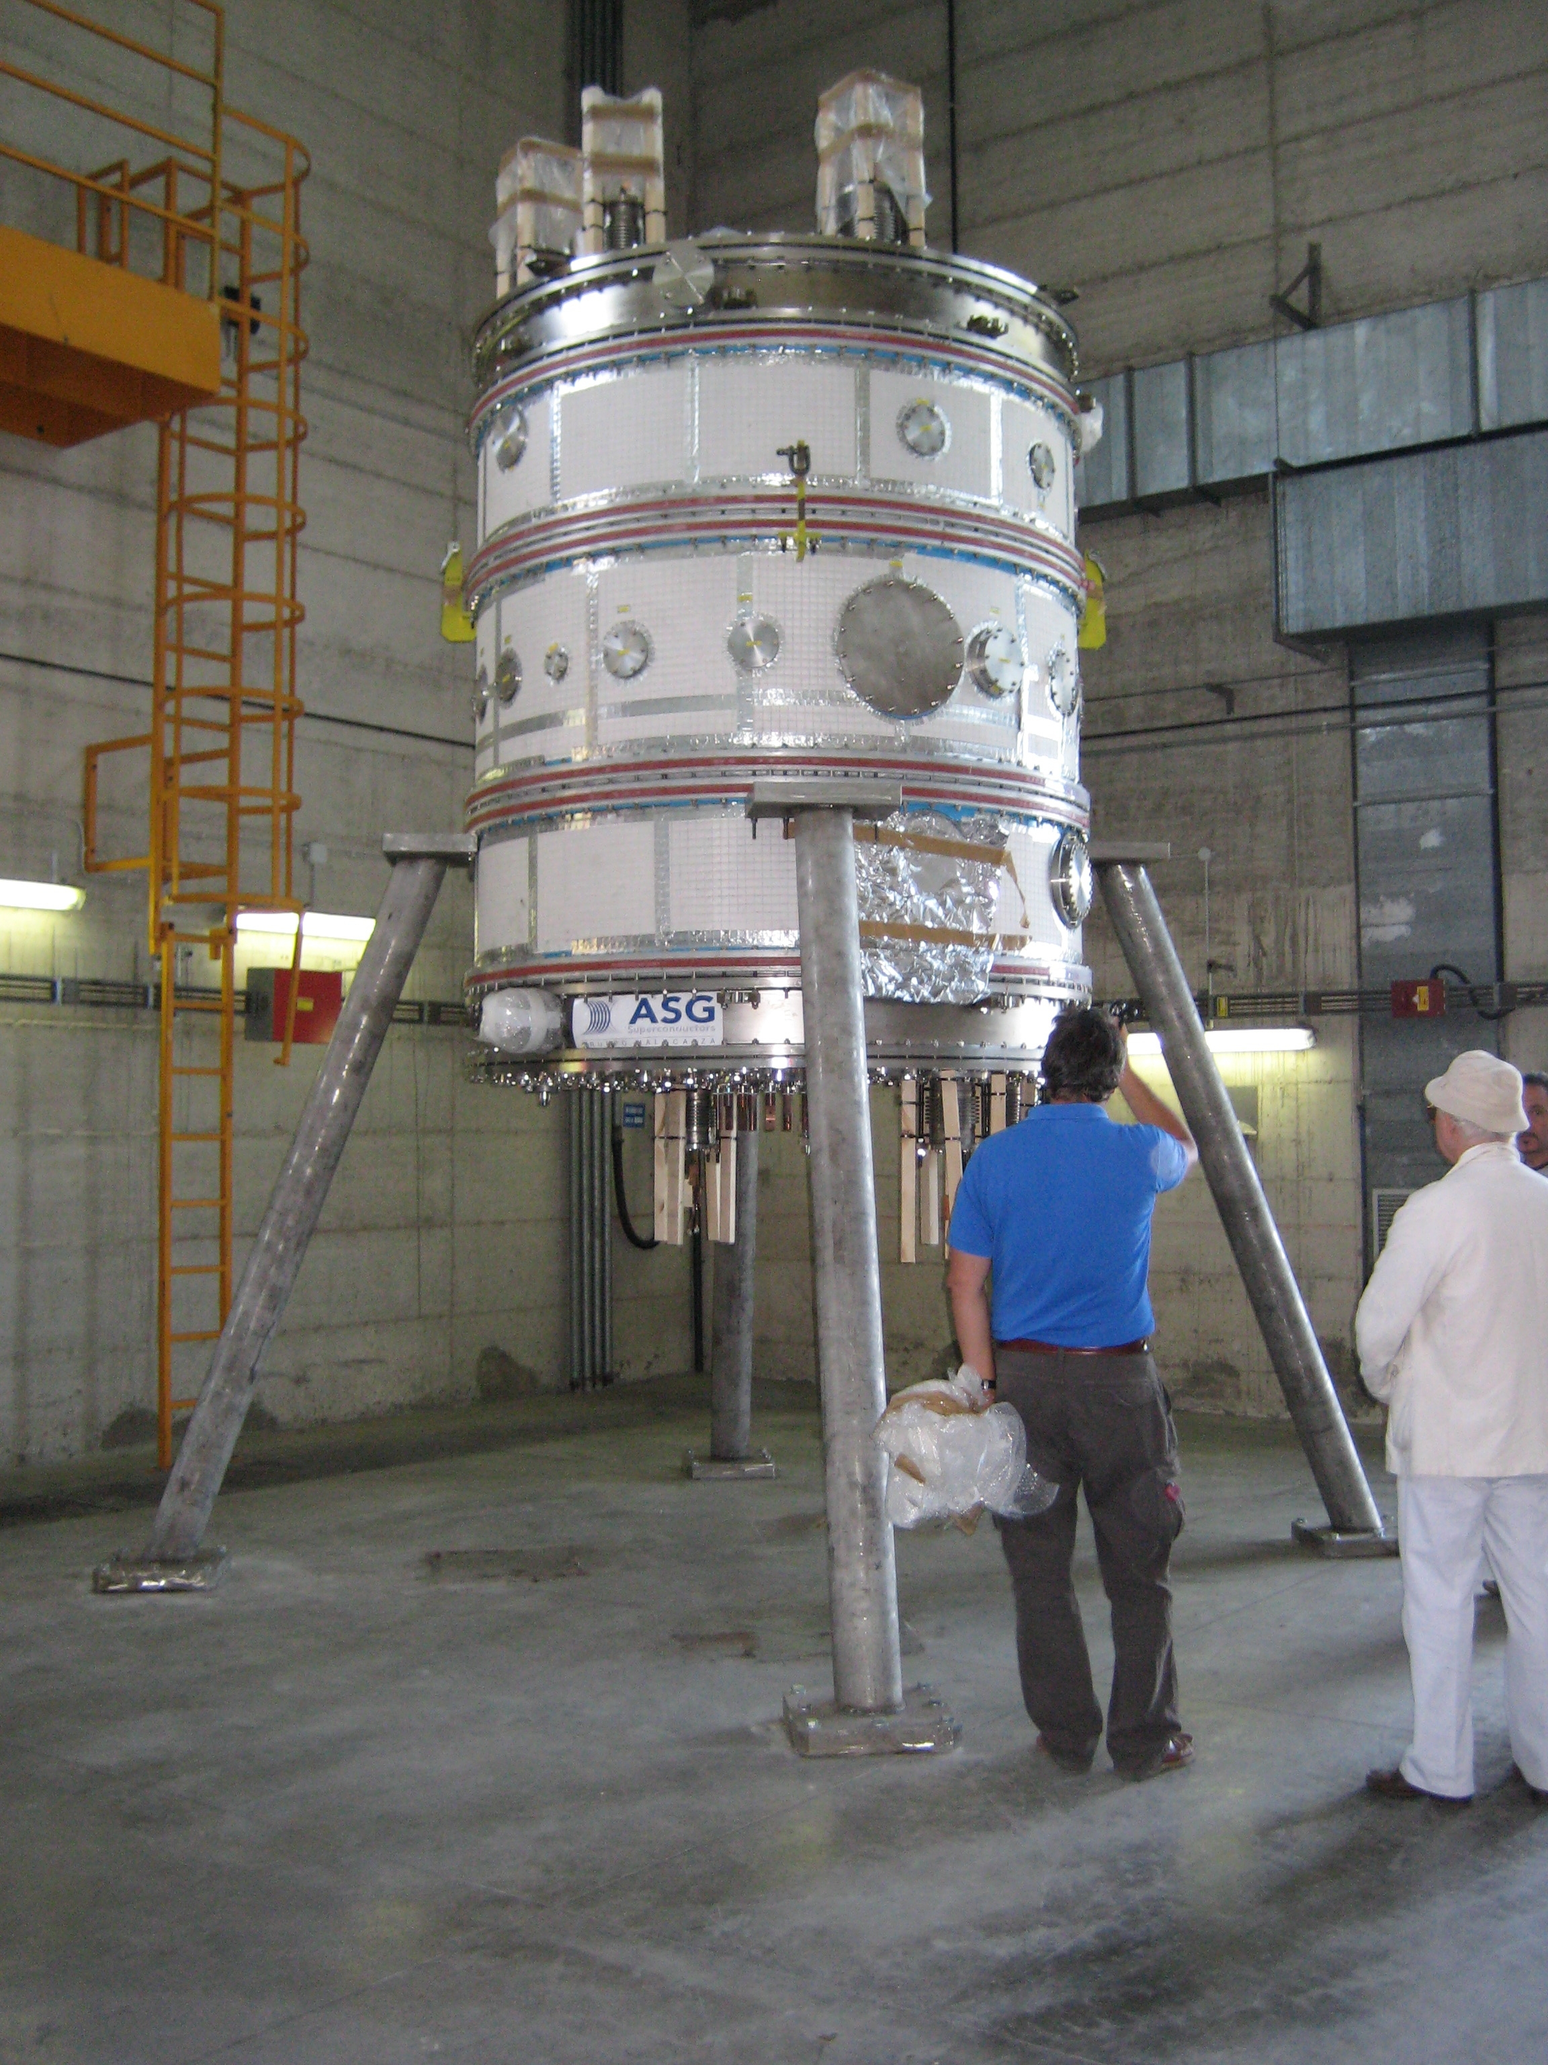
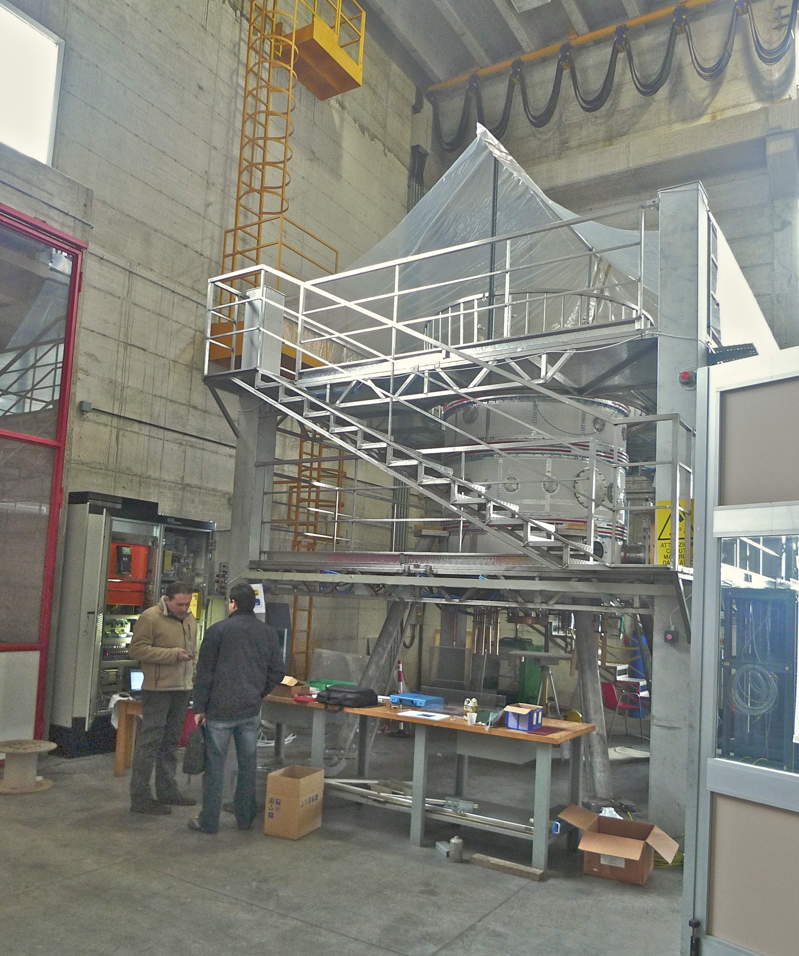
Fig.3 a) PROTO-SPHERA load assembly; b) platform around it with nearby cathode power supply
The Power Supplies for the PROTO-SPHERA Phase-I experiment have been built by EEI of Vicenza since January 2012, they were ready in January 2013, delivered to Frascati in January-February 2013 and then tested on resistive loads in March-April 2013 (Fig. 4).
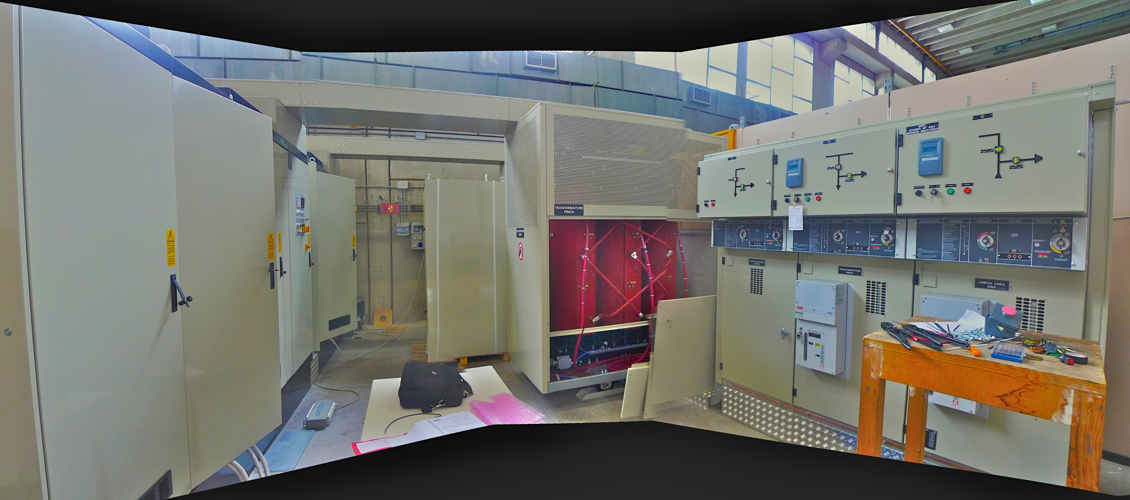
Fig. 4 Poloidal field coils and plasma Central Column power supplies of PROTO-SPHERA
The baking has been installed in June 2013, along with the gas injection system and the components required for improving the vacuum (Fig. 5).
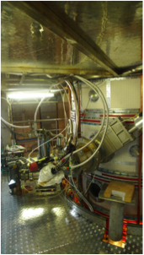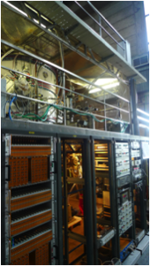
Fig.5 Vacuum system of PROTO-SPHERA
Components for the data acquisition system have been purchased and tried. Components for the initial diagnostic systems have also been ordered and installed. The further cablings between the Power Supplies and the machine have been designed, all required mechanical components in charge of ENEA have already been built and installed on the machine (Fig. 6) and a tender for the remaining cabling has been adjudicated. This remaining part of cabling work should be done by March 2014. The first plasma should be produced inside PROTO-SPHERA Phase-I within Summer 2014.
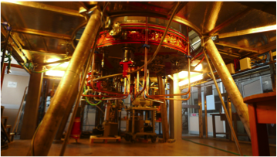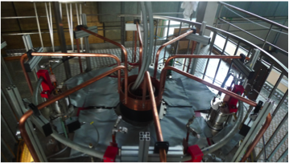
Fig.6 a) Poloidal field coils and cathode connections below PROTO-SPHERA, b) Poloidal field coils and anode connections on top of it

