- A simplified magnetic confinement configuration

The PROTO-SPHERA experiment, is a unique plasma physics facility at ENEA-Frascati that can be used to study high energy astrophysics phenomena driven by magnetic reconnection [1]. It consists in a plasma confined in a cylinder with 2m diameter and 2.5m height. It is inspired by the jet+torus astrophysical plasmas, a rather common morphology in the cosmos. Pulsar Wind Nebulae (PWNae), shown in Figure 1 left, are the best known and observed cosmic objects endowed with evident jets and tori, confined predominantly by electromagnetic forces. They are the most efficient known natural accelerators as they are the main producers of cosmic rays in the Milky Way [2]. The PROTO-SPHERA experiment has the aim of producing in the laboratory a combined configuration: a current carrying confined plasma torus around a plasma jet (or centerpost plasma) and to study its formation and its stable sustainment [3]. The radical novelty of PROTO-SPHERA, with respect to the usual approaches (Figure 1 center-top), resides therefore in the emulation of the self-organized natural morphology of plasma arrangement.

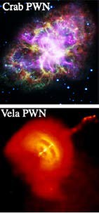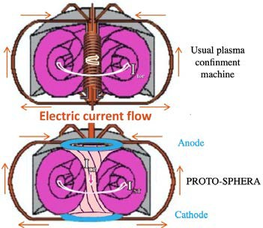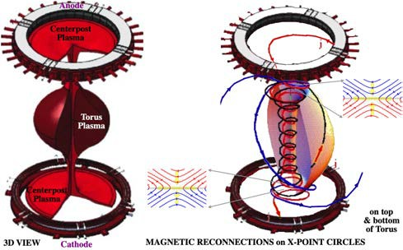
Figure 1: left – plasma X-ray emission in PWNae, center – usual plasma torus confinement compared to PROTO-SPHERA, right - 3D view of plasma and electrodes inside cylinder, along with scheme of magnetic field-lines reconnection
This implies relevant simplifications, such as the absence of a toroidal magnet and the (in principle) unlimited duration of the confined plasma, as the toroidal plasma current is sustained in quasi-steady state by the DC-current drive of the centerpost plasma, applied by DC-voltage between electrodes on top and bottom of the plasma torus, as shown in Figure 1 center-bottom. The experiment was built in a preliminary Phase-1 at the CR-ENEA laboratory in Frascati, with only 4+4 centerpost shaping poloidal field (PF) coils inside the vacuum vessel, see Figure 2 left, and the aim of demonstrating the sustainment of a Hydrogen centerpost plasma (screw-pinch), with a current of 10kA lasting for 1 sec, between two annular electrodes inside the vessel, a setting never tried before. After the successful conclusion of Phase-1 [4], the aim is now to implement its final Phase-2, which would become a unique plasma physics facility, which can be used to study high energy astrophysical phenomena driven by magnetic reconnection.

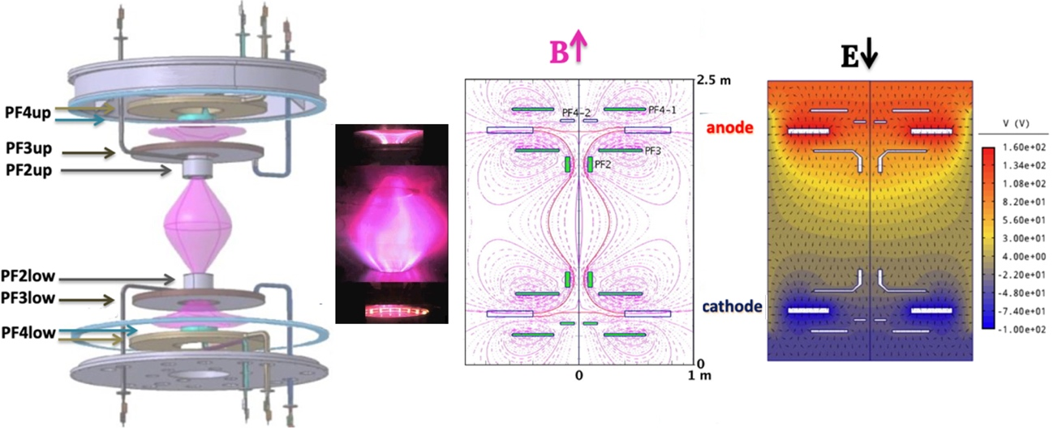
Figure 2… First full current 10kA hydrogen plasma centerpost in PROTO-SPHERA obtained in 2018

- The physical base

Magnetic reconnections can be so summarized: near a point, or a curve, where two magnetic field lines nearly touch each other, but have opposite field directions (the so-called X-points, Figure 1 right), a ‘tearing’ of those lines occurs, followed by a different ‘stitching’ between them. Magnetic Reconnection converts part of the plasma jet into the formation of the torus.
The transfer of Magnetic Helicity (twisting of magnetic field) is a dynamo effect, which uses the longitudinal current inside the plasma jet to sustain the toroidal current carrying plasma torus for quite extended times and remarkable stability. Magnetic reconnections are associated with non-ideal MHD plasma dissipative effects (such as finite resistivity) and are ubiquitous in astrophysical plasmas. Magnetic reconnection allows topological changes of the magnetic configuration, possibly giving access to states with a lower magnetic energy, which leads to thermal plasma heating as well as to super-thermal particles acceleration. The production of super-thermal particles in reconnection phenomena is particularly interesting, as the PWNae are the most efficient accelerators of cosmic rays in our galaxy [4]. The widespread Cosmic Dynamo phenomenon can be explained by magnetic reconnections, as they are able to convert a current flowing in a direction to another one flowing in an orthogonal direction. In particular in PROTO-SPHERA the open lines of force that wind around the plasma centerpost from anode to cathode are broken and reconnected into closed lines of force, winding along the nested magnetic surfaces of the plasma torus, Figure 1 right. But dynamo phenomena cannot occur in perfectly axisymmetric magnetic configurations, therefore they always imply intrinsic (hopefully slight) symmetry breaking mechanisms [5].
The Magnetic Helicity K, well-defined for every closed magnetic flux tube in a perfectly conducting plasma, is a volume integrated quantity, with the dimension of a squared magnetic flux Φ² (K= ∫• dVol, is the magnetic field and its vector potential). Magnetic helicity [9,10] describes how much the lines of force are interlinked, kinked or twisted and is a slowly decaying invariant. In both the astrophysical (PWNae) as well as in the laboratory settings (PROTO-SPHERA) the configuration starts from an initial condition endowed with a magnetic helicity K. The Taylor assumption [11] is that the magnetic energy decays in a plasma to its minimum value, and is subject to the conservation of magnetic helicity K, defined for closed field structures (flux tubes) and contained within a magnetic surface, where the magnetic field has zero normal component, 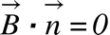. Minimizing the magnetic energy W=(1/2µ₀ ∫• dVol), under the constraint , the Beltrami equation is obtained: 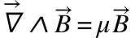; 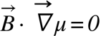: a force-free magnetic field, with µ=constant all over the plasma. This explains why in ffmfs the proportionality parameter µ takes the name of relaxation parameter.
Force-free magnetic field configurations (referred to as ffmf) [6,7] are self-consistent distributions of magnetic field and electric current density such that 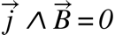. Apart from the trivial vacuum case (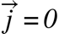 ), this usually implies 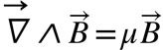. This means that magnetic field and current density are aligned inside the plasma with a proportionality parameter 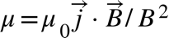. Ffmfs are therefore not subject to Lorentz forces. Hence, their currents and fields can decay exponentially without causing material fluid motions [8], with long e-folding times (compatible with the tiny resistivity of astrophysical plasmas and the smallness of other dissipative effects). These times are much longer than the time scales caused by a direct Lorentz force and the consequent abrupt plasma motions. These two reasons make ffmfs the simplest choice for describing long-lasting large-scale structures in the cosmos and can very often provide an inspiration for magnetic confinement configurations in laboratory plasmas. Real plasmas are never perfectly conducting, so magnetic reconnections redistribute the magnetic helicity without destroying it [11]: this phenomenon is called transfer of magnetic helicity. this phenomenon is called transfer of magnetic helicity. If the relaxation parameter µ is not constant all over the plasma, but only on each flux surface, the magnetic helicity flows from magnetic flux surfaces with higher µ value [11] to magnetic flux surfaces with lower µ. In a thermodynamical-like approach the helicity transfer is the analogue of transfer of heath from a high temperature to a low temperature material: in the case of magnetic helicity the relaxation parameter µ plays the role of temperature. If open field lines are present in a configuration endowed with electrodes, such as in the case of PROTO-SPHERA, a relative magnetic helicity ΔK can still be well-defined [9] and enjoys the same properties of the magnetic helicity K; the relative helicity source is the centerpost plasma (CP), with higher relaxation parameter µ_{CP}, and the relative helicity sink is the spherical torus (ST), with lower relaxation parameter µ_{ST,} see Figure 3. Two circles of X-points are present and two divertor tails appear between the torus and the centerpost.

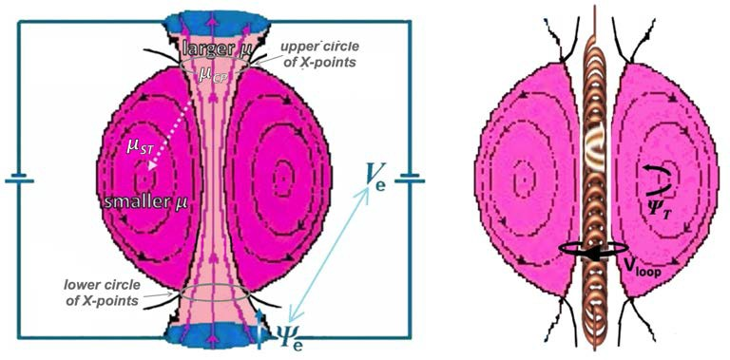

Figure 3: left - DC magnetic helicity injection in PROTO-SPHERA, right – AC magnetic helicity injection in ohmic drive

For un-relaxed plasma equilibria, endowed with pressure, with µ no longer constant on each flux surface, the surface-averaged [D’haeseleer] relaxation parameter 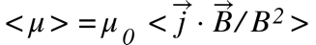 takes the role of injecting helicity from the centerpost edge to the spherical torus axis. The dynamics of the relative magnetic helicity in a domain (its normal pointing outside), can be expressed through a kind of "Poynting's theorem" [12]:
,
Where the DC helicity injection is represented by 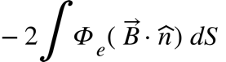 and Φ_{e} is the electrostatic potential on the boundary; the continuous drive of DC magnetic helicity injection is twice the product of the poloidal magnetic flux Ψ_{e} through the electrodes times the DC voltage between electrodes V_{e}: ∂(ΔK)/∂t= 2Ψ_{e}V_{e}, see Figure 3 left. Reconnections at the circles of X-points inject flux surfaces from the centerpost plasma, with higher <µ_{CP} >, into the torus edge, with lower <µ_{ST} > and are finally dissipated while moving toward the magnetic axis of the torus, with still lower <µ_{axis} >.
The AC helicity injection is represented by 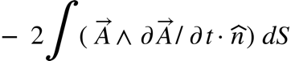: the inductive helicity injection (ohmic drive) becomes ∂(ΔK)/∂t= 2Ψ_{T}V_{loop}, which is twice the product of the toroidal magnetic flux 2Ψ_{T} inside the toroidal cross section of the torus times the loop voltage V_{loop}, induced by a solenoidal transformer which sits in the hole of the Torus, see the solenoid of Figure 3 right.
The total helicity dissipation is represented by ∂(ΔK)/∂t=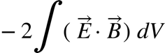. In order to sustain the torus, either DC or AC helicity injection must overcome the magnetic helicity dissipation, which is due to a generalized Joule effect. The magnetic helicity injection DC drive 2Ψ_{e}V_{e}, is a steady-state replacement of transient AC ohmic drive 2Ψ_{T}V_{loop}, the latter is limited by the total flux deliverable by the solenoidal transformer in its excursion, from the minimum current -I_{max} to the maximum one + I_{max}, it can stand without being damaged. Both systems can sustain a confined plasma torus by injecting a toroidal current inside it, but the ohmic drive is by its very nature a transient one, whereas the magnetic helicity drive is a continuous one, sustained by a DC current flowing between electrodes, obtained by applying a DC voltage between them. One of the main advantages and novelties of PROTO-SPHERA is therefore the in-principle unlimited sustainment of the plasma, allowed by the DC nature of its drive. An earlier experiment, which was a source of confidence for PROTO-SPHERA design, has been the TS-3 reconnection experiment in Tokyo University, which in 1993 [13] produced impulsively, with a 10kV voltage, a toroidal plasma lasting 80µsec (120 Alfvén times) around a pre-existing screw pinch centerpost, but did not try and sustain it. A later proposal very similar to PROTO-SPHERA: a “Proposed Experiment to Study Relaxation Formation of a Spherical Tokamak with a Plasma Center Column” was put forward by Hsu, Tang and Boozer [14,15] for Los Alamos National Laboratory 2006-2007, but unfortunately it was never built. Other simply connected plasma confinement experiment have been built since the ’80s: the so-called Spheromaks [16,17]. The PROTO-SPHERA experiment is however quite different from spheromaks, as the latter are usually formed by kV voltage magnetized coaxial plasma guns, used as helicity injectors, and are completely surrounded by a nearby highly electrically conducting shell, used as a flux conserver. The conserver gives its shape to the external boundary of the spheromak and maintains it for the duration of its skin time: tipically a few msec only. PROTO-SPHERA is formed instead by the low voltage (80 to 300V) breakdown of the central screw pinch plasma, thanks to the thermionic emission from the 2900 ºC tungsten filaments that compose the hot annular cathode [3,18], shown in Figure 1 right.
The reason why tori are formed in in both the Astrophysical (PWNae) and in the laboratory settings is that K is conserved while the magnetic energy decays. the final combined configuration is reached from an initial condition endowed with magnetic helicity: in a PWN the initial helicity is due to the presence of twisted plasma and magnetic field, anchored to the Pulsar surface; in PROTO-SPHERA the initial helicity is due to the setup of the poloidal magnetic field, before the plasma current between the electrodes is ramped up. Maintenance is due to the continuous rotation of the plasma and magnetic field in the PWNae and to the continuous application of the electrical potential difference between the two electrodes in PROTO-SPHERA. Being a magnetic confinement experiment that is sustained by a dynamo effect, the main aim of PROTO-SPHERA is trying to assess whether the requirement of axial-symmetry (imposed by magnetic confinement) is compatible with the intrinsic (hopefully slight) symmetry-breaking mechanisms of dynamo effects.

- Progress of the experiment in Phas-1.5 and unexpected results

The machine began its Phase-1 plasma production in 2015. While the magnetic configuration was completely successful since the first shot, it took almost three years, from May 2015 to January 2018, to obtain -by trial and error- the right electrostatic boundary conditions for allowing the full current of 10kA to flow for 1 sec between the annular anode and the annular cathode in the plasma centerpost (Figure 2, left). Since Phase-1 the plasma electrostatically charges all nearby metallic conductors present inside the vacuum vessel. Even if the magnetic field is up-down even-symmetric, each metal surface, like the internal PF coils, charges at a specific electrostatic potential, with +2V_{e}/3 on the anode to -V_{e}/3 on the cathode; the electrostatic potential is therefore not up-down odd-symmetric at all: its zero value is quite near to the lower cathodic PF shaping coils and quite far from the the upper anodic PF shaping coils. This was the first unexpected result of PROTO-SPHERA in Phase-1: it will be explained in full detail in a separate paper. An 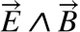 induced rotation is always present in the central part of the PROTO-SPHERA plasma, due to the not up-down odd-symmetric electrostatic potential crossed with the up-down even-symmetric magnetic field. This was the second unexpected result of PROTO-SPHERA in Phase-1.

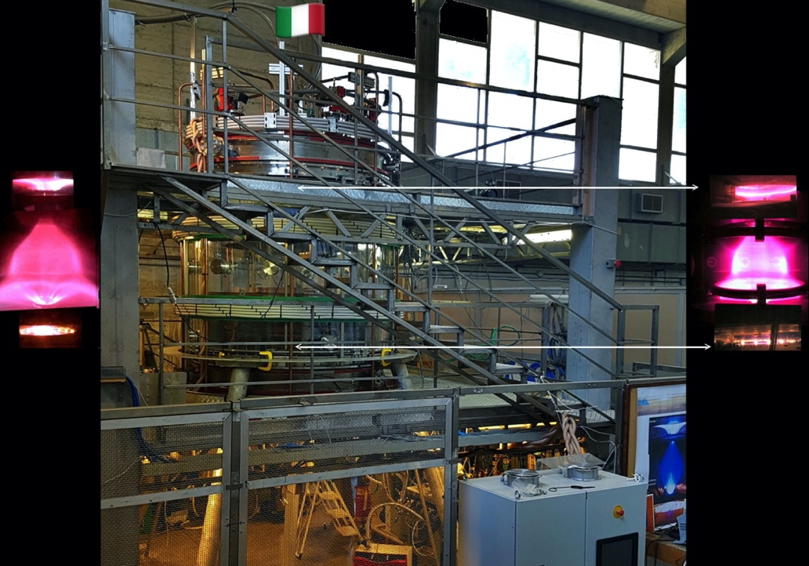

Figure 4: left - first lean torus, obtained in 2018, center – photo of the experiment in 2019, right – fatter hydrogen tori obtained in 2020

By adding powering 4 further PFExt field coils, built in-house outside the vacuum vessel (wound from grey cables in the central picture of Figure 4), able to produce opposite field directions inside and outside the plasma centerpost, in such a way as to form two circles of X-points prone to magnetic reconnections (just as in Figure 3 left), the first lean tori were obtained in 2018 as well, Figure 4 left.
The third unexpected result of Phase-1 was that the formation of the torus occurred in completely static magnetic field. This fact implied a great simplification for the construction and the operation of the Phase-2 of the experiment: the original design idea for Phase-2 was that the torus formation would have required a very fast increase of all the currents (of plasma centerpost and of PF compression coils), in order to break-through kink instability without destroying the plasma. During all plasma operations the field imposed by the centerpost shaping PF coils is going upwards near the symmetry axis whereas the current density is going downwards from anode to cathode, see Figure 2(…), so in the plasma Centerpost the sign of 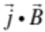 is negative and the plasma current winds in the Centerpost in the anticlockwise direction (seen from above). Also the current in the torus is anticlockwise, as the current in the PFExt is in the clockwise direction and confines the torus. Then the sign of the toroidal current in the torus is the same as the sign of the toroidal current in the Plasma-Centerpost: the sign of is therefore negative all over the plasma. The direction of rotation of the main plasma is clockwise, at an angular frequency ω_{Τor} ~ 500÷600 rad/sec, which is coherent with the anodic direction of in the main plasma region, between the two mirror coils PF2up and the PF2low of figure 2(…).
The spontaneous toroidal rotation in the central part of the PROTO-SPHERA plasma didn’t vanish in presence of the torus, but the electrostatic configuration did immediately show a number of mishaps: the boundary conditions in presence of the torus had therefore to be corrected. In the year 2019 the Phase-1 experiment was partially rebuilt, such as to give rise to an intermediate Phase-1.5. Figure 4 summarizes the evolution of the experiment in Phase-1 and Phase-1.5, on the left the hydrogen plasma centerpost at I_{CP}=10 in Phase-1 of 2018, just adjacent to it the first hydrogen slim torus, also in Phase-1 of 2018; on the right a picture of the experiment after 2019 and an aspect ratio A~4 hydrogen torus in Phase-1.5, from 2020 to 2024.
For Phase-1.5 a new insulating and transparent PMMA vacuum vessel (shown in Figure 4 center and Figure 5 left) replaced in 2019 the previous aluminum one; 3+3 new PFInt-A provisional poloidal compression coils were inserted inside the vessel, built in-house as reduced replicas of the industrial compression coils designed for Phase-2 (shown red in Figure 5 left); along with two truncated conical divertor plates made of stainless steel placed on top and bottom of the torus (shown in Figure 5 right). This amounted to a large increase in the PF coils number, from 8 in Phase-1 (8 PFInt-B) to 18 (8 PFInt-B + 4 PFExt + 6 provisional PFInt-A) in Phase-1.5. A new super-capacitor power supply, able to feed the 6 new provisional compression coils with limited power, was introduced as well. But the level of all plasma currents in the experiment were kept within the same limits as in Phase-1.

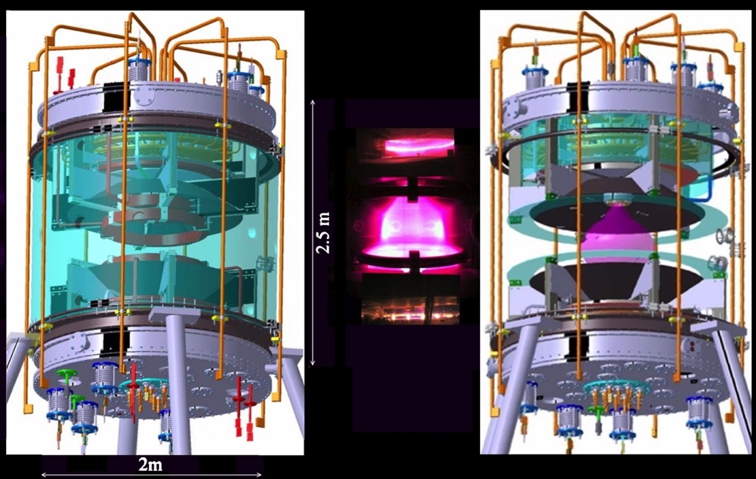

Figure 5: left – full CAD of PROTO-SPHERA, center – PROTO-SPHERA Phase-1.5 hydrogen plasma, right – partial CAD of PROTO-SPHERA, evidencing conical divertor plates (black) and plasma (pink).

The production of tori in Phase-1.5 is rather surprising, as the limited plasma current (10kA in the centerpost) available yields a too low relaxation parameter (ratio between electrical current density j and magnetic field B), a µ~(j•B)/|B|² not sufficient to allow the direct magnetic helicity transfer from the plasma centerpost to the plasma torus, in the absence of azimuthally-localized current paths. Figure 6 shows on the left an equilibrium reconstruction of the Phase-1.5 plasma, superposed to an actual image, and on the right, two most extreme modeled µ profiles: a flat µ profiles and an extremely edge-peaked µ profiles, in the absence of azimuthally-localized paths. The relaxation parameter µ_{CP} in the centerpost plasma is therefore typically smaller than the relaxation parameter µ_{ST} in the torus, so no direct helicity injection from the centerpost plasma to the torus plasma should have been expected in Phase-1.5.

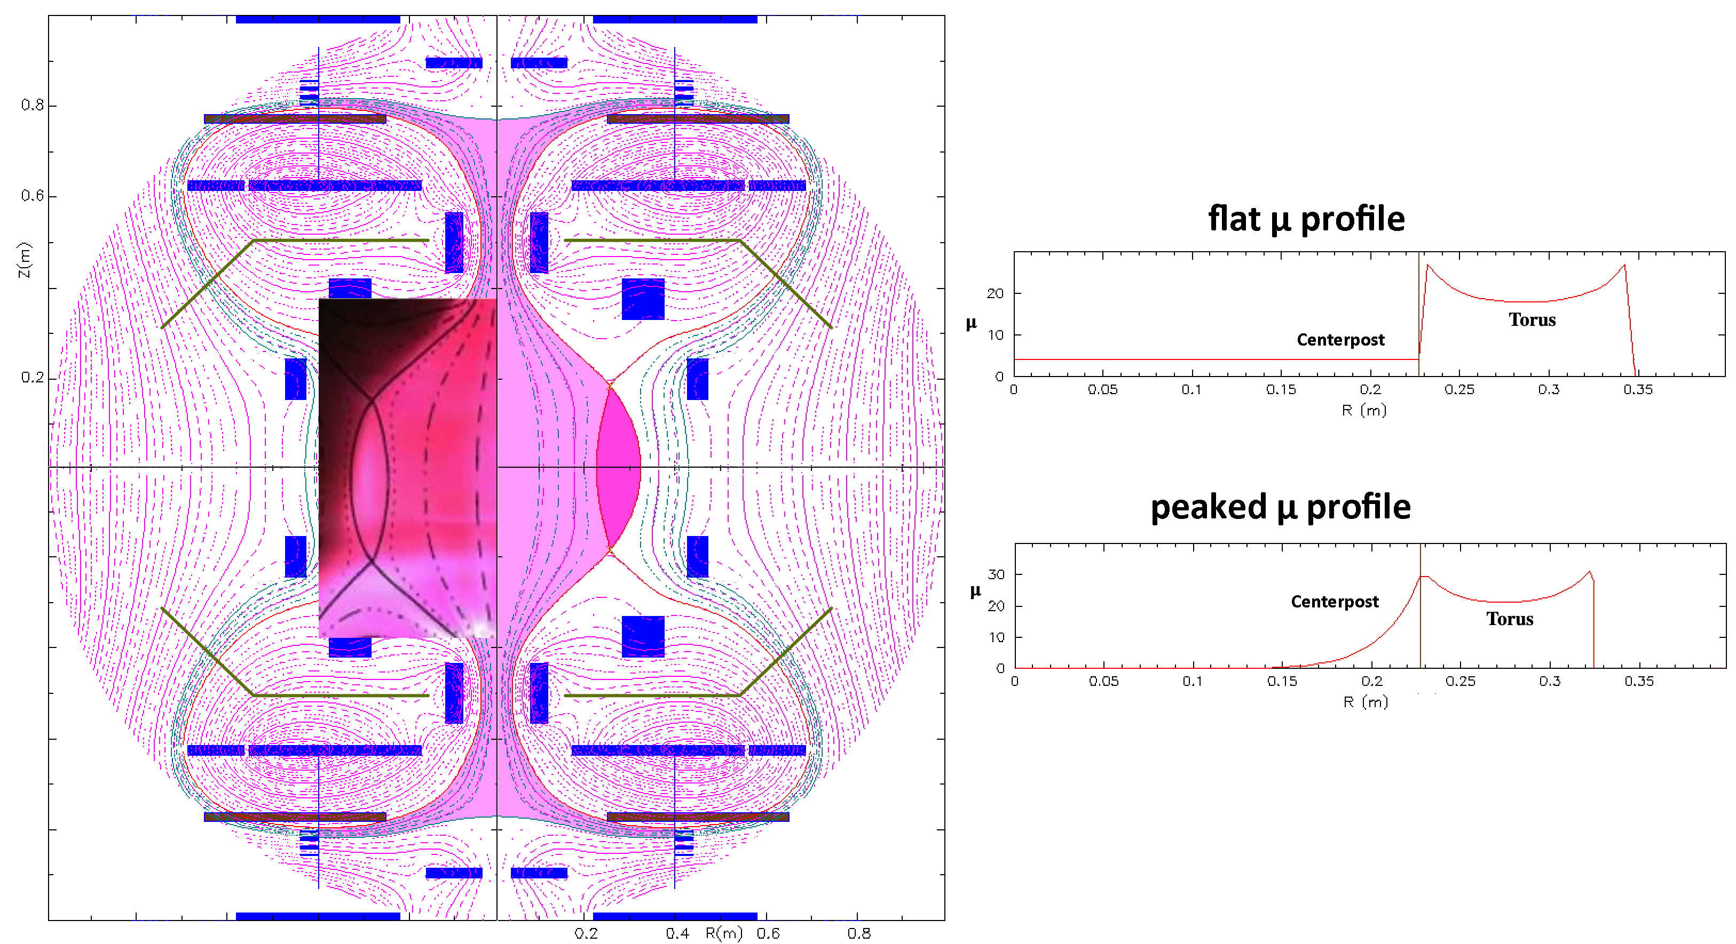
Figure 6: left - equilibrium reconstruction of Phase-1.5 hydrogen plasma, superposed with a photographic image, right – calculated relaxation parameter µ profile on the equator, from axis R=0 to outer plasma edge: in the plasma centerpost this parameter is smaller than in the plasma torus: µ_{CP}≤µ_{ST}; no direct helicity injection should then occur in Phase-1.5

A number of diagnostics began to clarify the mechanisms allowing for the transfer of plasma current from the plasma centerpost to the plasma torus, see Figure 6 left, which refers to Helium shot #2141, produced in 2021. The obtained tori appeared more and more as tilted oblique rotators [4]. The axial symmetry of the torus was observed as slightly broken, which is a confirmation of the non-axisymmetric nature of the magnetic reconnections, see Figure 7 center and right.

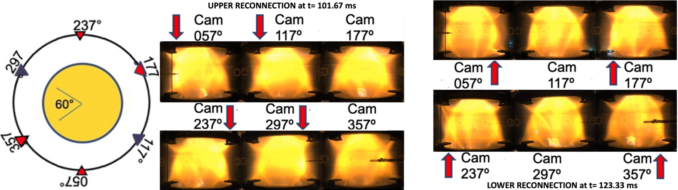

Figure 7: left – ; center – ; right –

The reconnections can be identified by time-frames where a higher luminosity of the plasma visible light occurs on the upper (or the lower) tails of the divertor. They exhibit two distinct behaviours: some are evident around the upper X-points, like the one of Figure 7 center; others are evident around lower X-points, as the one of Figure 7 right. In particular thanks to the successful analysis of 3D tomographic reconstruction [21] of the visible light emission, successfully completed in 2024, obtained from 6 cameras at 600fps, equally spaced around the equator of the machine, looking directly through the transparent vacuum vessel. The tomographic vertical cross section of the visible light emission at the two reconnections illustrated in Figure 7 center and right are shown in Figure 8 left and center, illustrating that different visible light spectra are emitted from the different regions of the central plasma. The ionization edge of the overall central plasma shines in orange-brown colour; not only the plasma torus but also the plasma centerpost shine in green colour, suggesting that the magnetic reconnection raises the temperature of the plasma centerpost too. The initial formation of the torus in the same Helium plasma shot #2141 is shown in Figure 7 right, as a time sequence of equatorial horizontal tomographic cross sections; such a sequence, shows that the plasma centerpost is shining in orange-brown colour at the very beginning and starts shining green only when the torus begins to form, confirming the effect of the magnetic reconnections on the plasma centerpost temperature.

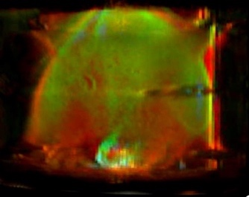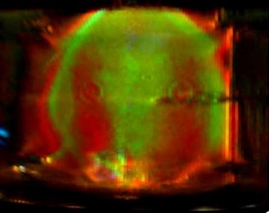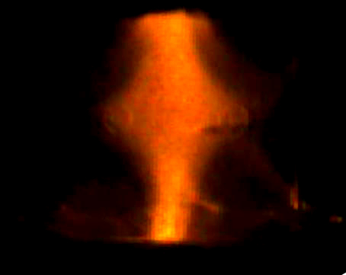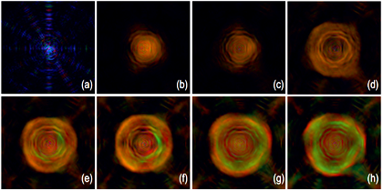

Figure 8: Tomographic inversion of visible light. Left vertical cross sections – fatter helium plasma torus after 2020 (a Langmuir probe is in front of camera) upper reconnection of frame at 256.20ms; – lower reconnection of frame at 277,87ms, evidencing that the visible light emission has different spectra in different regions of the plasma: torus, centerpost and ionization edge. Center vertical cross section – initial centerpost plasma at 156,060ms. Right – torus initial formation as a sequence of equatorial sections, frames sequence at 600fps.

The tomographic reconstructions of the visible light images allow for identifying more precisely the times at which the magnetic reconnections occur. At the times of reconnections on the upper divertor tail the torus is displaced in the upper direction, the green light is most extended, suggesting that the hotter plasma (green shining) is extending into the lower temperature plasma (orange-brown shining), in particular in its upper domain. Green shining upper divertor tails are often observed above the upper X-point circle, where the plasma often tinges with blue light, indicating that this is the region where the magnetic reconnection occurs, see Figure 8a. At the times of reconnections on the lower divertor tail the torus is displaced in the lower direction, the green light is most extended, suggesting that the hotter plasma (green shining) is extending into the lower temperature plasma (orange-brown shining), in particular in its lower domain. Green shining lower divertor tails are sometimes observed and extend downward with a brighter orange-brown below the lower X-point circles, where the plasma sporadically tinges with blue light, indicating that this is the region where the magnetic reconnection occurs, see Figure 8b.

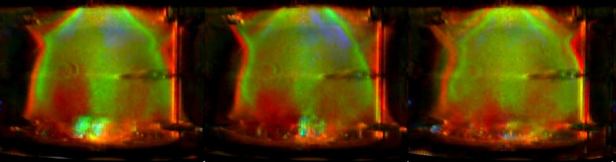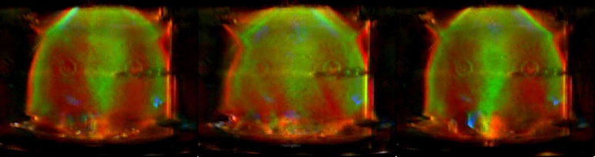

Figure 9: a) _, b)_

The plasma centerpost and the plasma torus are furthermore separated, see Figures 8 and 9, by an orange-brown region, which indicates that torus and centerpost are not adjacent everywhere along their boundaries, suggesting that a lower temperature plasma exists between the hotter (green shining) plasma. This unexpected observation evidenced that the helicity transfer is not what was schematized in Figure 3 left, confirming that it is not a phenomenon occurring between adjacent plasma centerpost and plasma torus, with µ_{CP>} µ_{ST}, but that it shows unexpected features.
A correlated surprise of Phase-1.5 was that, when the plasma torus was formed and sustained, only when, while the full plasma centerpost current delivered by the power supply always went completely inside the upper PF2 mirror coil, instead up to 80% was missing from inside the lower PF2 mirror coil, see Figure 10 upper left. The missing centerpost plasma current impinged instead into the lower metal divertor plate, charged it electrically and created a non-axisymmetric localized plasma current coming out of the lower divertor plate and impinging into the metal case of the lower PF2 mirror coil. That behaviour reminds the Hsu, Tang and Boozer design of the “Tokamak with a Plasma Center Column” [14,15], which included secondary bias polarization electrodes for the unbuilt Los Alamos experiment, Figure 10 right.
The missing current ended, below the lower divertor plate and the nearby PF2 and PF3 coils up into the underlying cathode, through local discharges occurring between metal components.
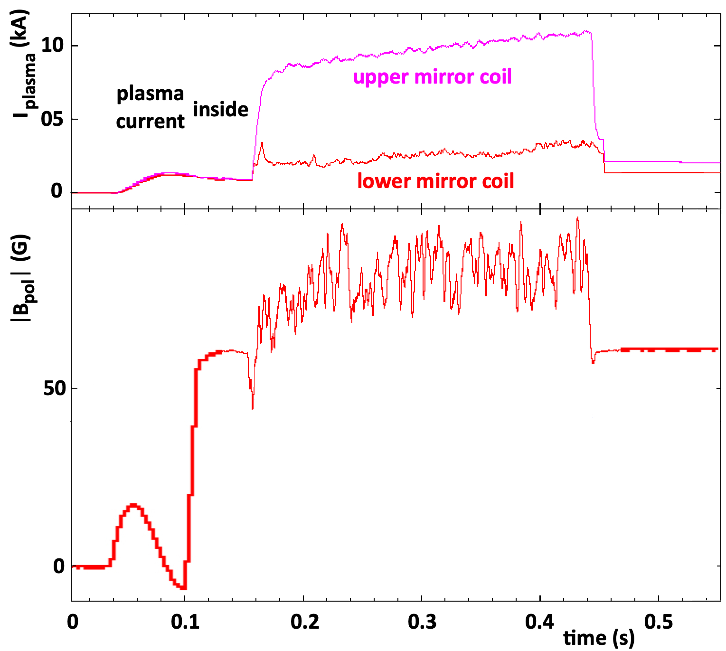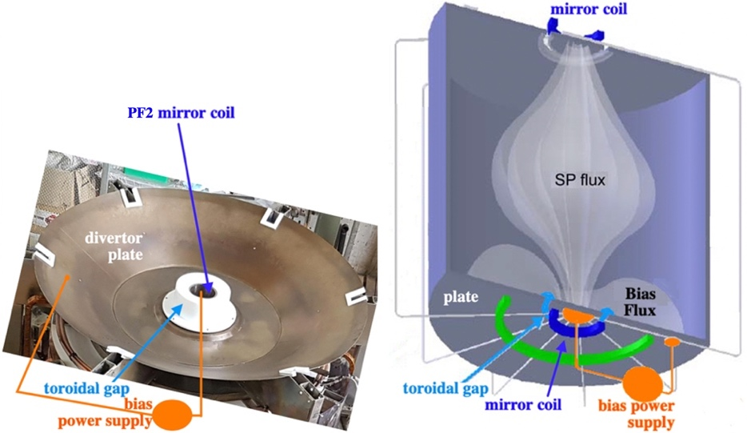

Figure 10:

Then the unexpected azimuthally-localized plasma current had to flow from the lower divertor plate to the lower PF2 mirror coil, and either 1) had to surround the torus completely and reconnect near the upper X-point circle -as shown in Figure 11 left, or, 2) near the circle of lower X-points, did reconnect the azimuthally-localized plasma current with the current flowing on the inner side of the torus -as shown in Figure 11 right. The two different localized current paths should have quite different effects: injecting current from the plasma centerpost to the torus when the reconnection occurs near the upper X-point circle; ejecting current from the plasma torus when the reconnection occurs near the lower X-point circle.

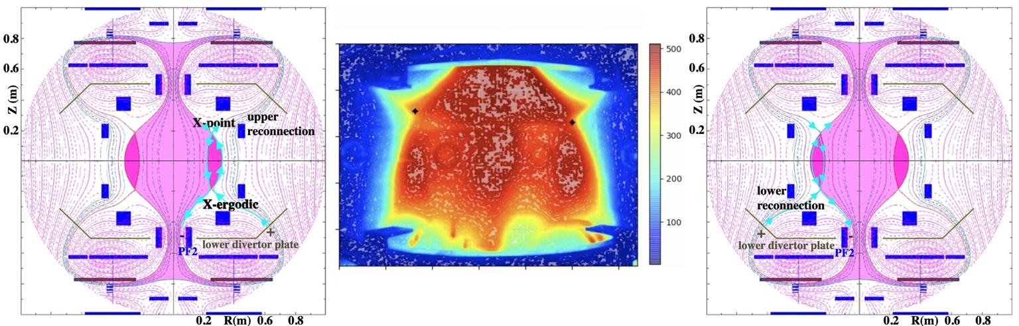

Figure 11:

A Hall probe placed at the tip of a single insertable arm (evident in Figures 7, 8 and 9) measured the poloidal vertical field at the edge of the plasma torus a vertical poloidal field of ~40 G (Figure 10 lower left), which confirmed the value of the total current flowing inside the torus (~4-5 kA) and agreed with the vertical distance between the upper and lower X-point circles (Figures 8 and 9); at the same time this measurement did show that the toroidal current flowing inside the torus is subject to relaxation oscillations, some of which injected plasma current into the torus, while others ejected current out of it. The tilted structure of an oblique plasma rotator is shown again in Figure 11 center by the total plasma brightness from fast camera (in false colours): while the upper X-points are clearly identified by crosses with error bars; the lower X-points have instead a more unsteady blurred structure, which can be attributed to a slightly ergodic magnetic field, due to the non-axisymmetrical nature of the non-axisymmetric localized plasma currents near the lower circle of X-points. The different roles played by the upper and lower circles of X-points is explained by the different electrostatic potential: +2V_{e}/3 on the anode and -V_{e}/3 on the cathode; such not up-down symmetric distribution makes the floating potentials of the (insulated, Figure 10 center) lower metal divertor plate and of the metal cases of the nearby PF2 and PF3 coils (which are instead electrostatically connected between themselves) very near to the zero-voltage value. Then all the metal components near the lower X-points can act as charge-clearing electrodes, being able to both emit as well as to absorb electrons from the plasma, allowing for localized plasma current to develop in between the lower divertor plate and the PF2 lower mirror coil, even if limited voltage differences appear; the metal components near the upper X-points at ~+V_{e}/3 potential can only absorb electrons from the plasma and cannot act as charge clearing-electrodes.
The first evidences of reconnective conversion of magnetic energy into plasma thermal energy as well as into suprathermal electron production have been observed by Langmuir probes since the 2020 plasma campaign. The electron temperature spikes from Langmuir probes placed at the tip of the single insertable arm (near to the Hall probes) at the edge of the torus are shown in Figure 12 top. The data from the Hall probe (shown in less detail in Figure 10 left bottom) are expanded in terms of positive and negative poloidal vertical field relaxation oscillationat the edge of the torus in Figure 12 bottom. The comparison between the electron temperature spikes and the torus plasma current shows that all the temperature spikes are associated with relaxation oscillations of the torus current. The vertical lines in Figure 12 correspond to the frames which are identified as reconnections from the tomographic reconstruction of the visible light emission (see Figure 9), excluding the plasma centerpost current rise and decay phases. A total of 87 magnetic reconnection take place during 256.67ms, so the average repetition rate is 2.95ms, within a range from 1.667ms to 5.0ms. Temperature spikes are associated with torus current increase as well as with torus current decrease. The difference being that every torus current increase is associated with an upper circle X-point reconnection as observed by the tomographic system. Every torus current decrease is conversely associated with a lower circle X-point reconnection as observed by the tomographic system. The only ambiguous cases are the ones where two successive reconnections are separated by one time frame only, 1/600 fps= 1.667ms.

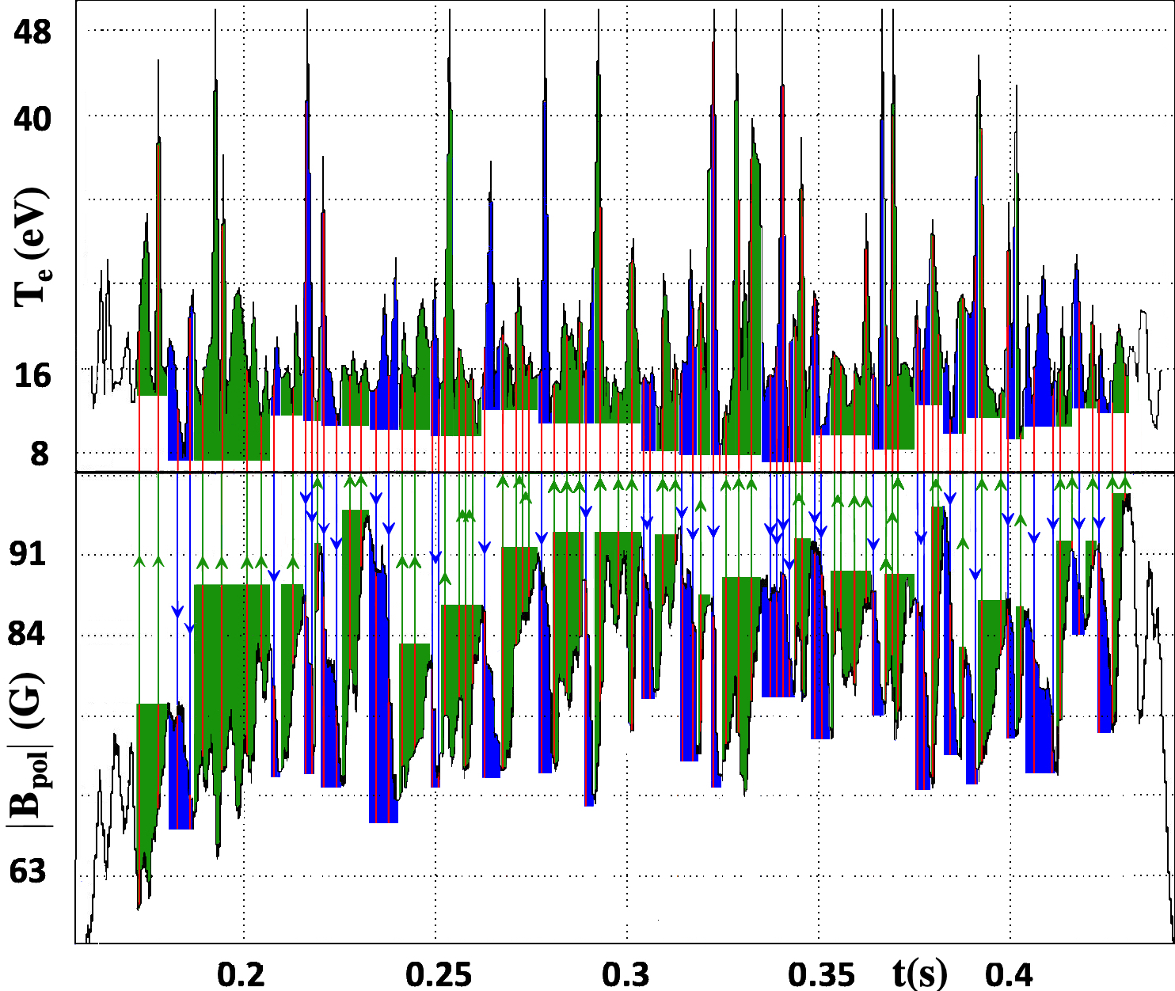

Figure 12:

As the number of reconnection is quite large, as up to 4 reconnections can occur in each current increase or current decrease phase the association between the upper/lower reconnections and the increase/decrease of the plasma current in the torus is shown only for one reconnection (the strongest one) per phase. The plot of Figure 12 is then simplified to the plot shown in Figure 13, which evidences only 45 strongest reconnections, one per current increase/decrease phase.

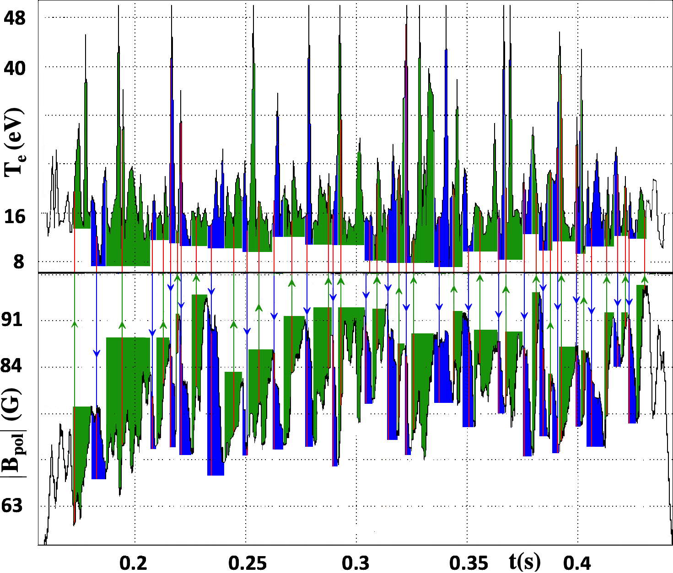

Figure 13:

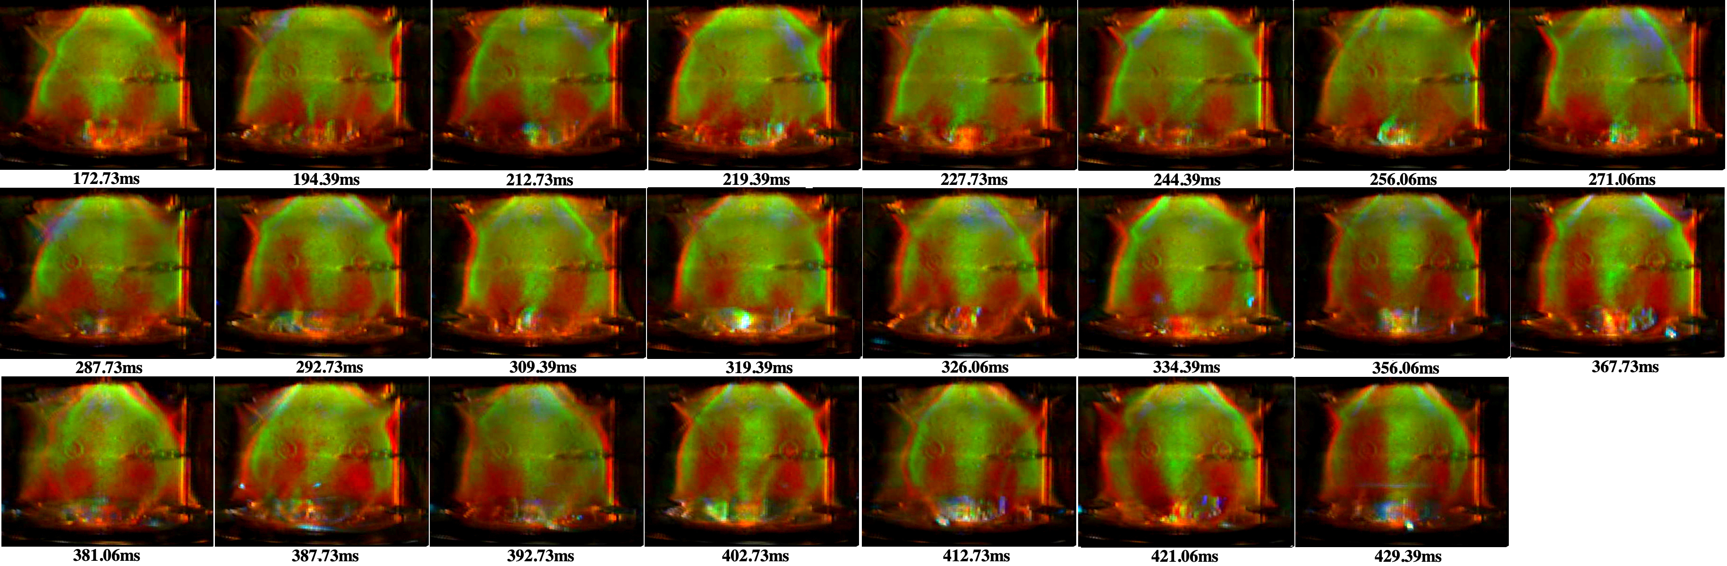

Figure 14

The 23 strongest reconnections during current increase phases are displayed in Figure 14 by their tomographic cross-sections. In all of them the torus is displaced in the upper direction, the green light is most extended in its upper domain. Green shining upper divertor tails are often observed and the plasma of the often tinges with blue light in its highest part, indicating that this is the region where the magnetic reconnection occurs.

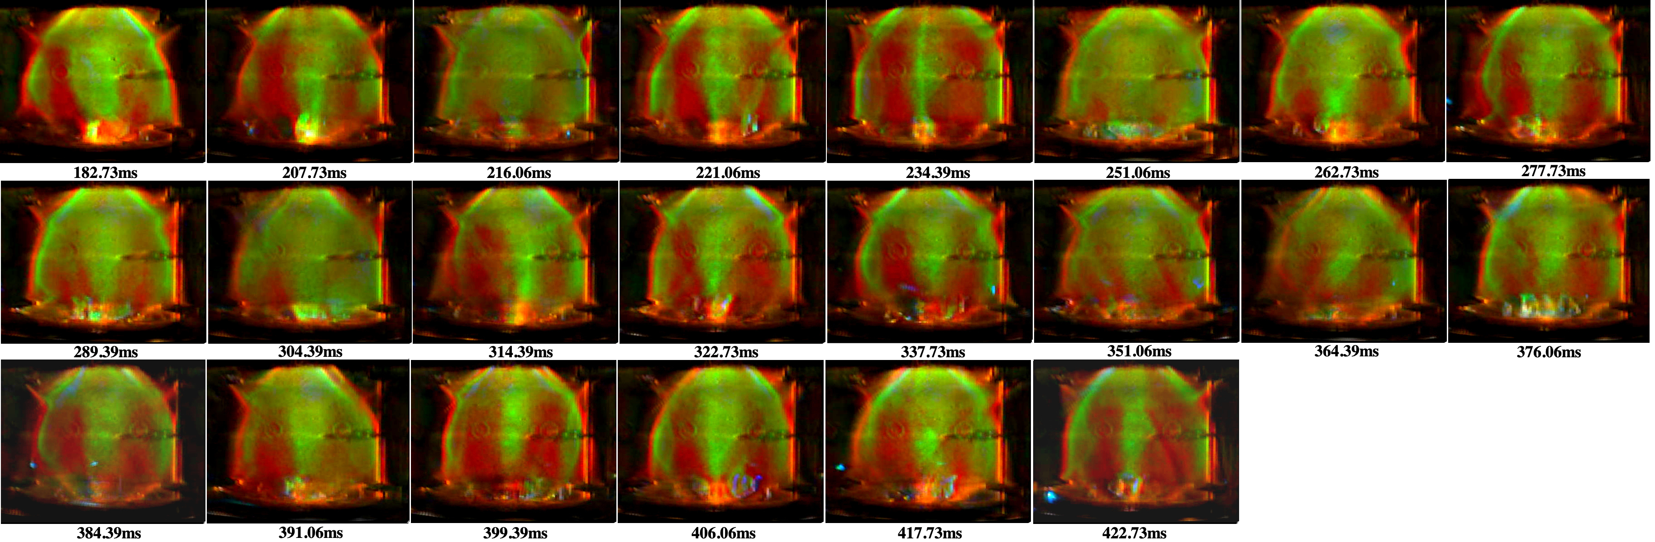

Figure 15

The 22 strongest reconnections during current decrease phases are displayed in Figure 15 by their tomographic cross-sections. In all of them the torus is displaced in the lower direction. Green shining lower divertor tails are sometimes observed and extend downward with a brighter orange-brown below the lower X-point circles, but the plasma torus seldom tinges with blue light in its lowest part. The green torus is often disconnected in its highest part from the high plasma centerpost by orange brown gaps , indicating that the magnetic reconnection does not happen on the circle of upper X-points.

- The future Phase-2 of the experiment

Only with the larger plasma current (70kA in the centerpost) of Phase-2 the feasibility of direct helicity injection from the centerpost to the torus will be fully assessed [6]. Direct helicity injection is preferrable since the plasma tori of PROTO-SPHERA, in order to exhibit good magnetic confinement, must be as axisymmetric as possible. A plasma torus is indeed required for plasma confinement, but then mathematical rigor demands exact axial-symmetry for the presence of unbroken confining magnetic surfaces inside such a torus (which must furthermore carry a toroidal plasma current inside it).
Trying to assess whether the requirement of axial-symmetry (imposed by magnetic confinement) is compatible with the intrinsic (hopefully slight) symmetry-breaking mechanisms of dynamo effects describes the main physical aim of PROTO-SPHERA in Phase-2. The observations that PWNae are efficient accelerators of cosmic rays are very promising. If the cosmic ray acceleration is due to magnetic reconnections that occur near the PWN tori, the production of accelerated particles up to PeV [7] energies means that the particle confinement inside the same tori is good enough to allow for many orbits to occur before the accelerated particles are finally lost. Although the reconnection dynamo effect is a symmetry breaking, the overall axial-symmetry of the toroidal magnetic flux surfaces of PWN tori must be sufficiently preserved. All elements for moving to a successful Phase-2 of the experiment have been achieved by the end of the 2024 plasma campaign of Phase-1.5. At the beginning of 2025, the experimental machine has been transferred inside a more suitable experimental hall and the transfer of its power supplies is underway. The PROTO-SPHERA experiment, as a concept exploration experiment, has been built with a budget (up to now less that 2.5 M€), much cheaper with respect to other magnetic confinement machines. The cost has been reduced by choosing low levels of plasma currents and by limiting the duration of plasma pulses to 1 sec only. Both limitations have allowed for choosing cheap and no high-tech materials in the load-assembly. The proposed Phase-2 will produce the highest plasma currents and the longest time duration of plasma pulses, still compatible with the cheap load-assembly. The results of PROTO-SPHERA Phase-2 results can nevertheless open a new path in the development of magnetic confinement.
The compelling reasons for moving to the higher plasma currents of Phase-2 are: a) demonstrate that the magnetic reconnection heating can bring the plasma electronic temperature to 500 eV, while producing a large enough energy confinement time. We aim to demonstrate a magnetic confinement scheme that combines plasma production and heating in a single machine, without the need for additional heating systems; b) assess the feasibility of direct helicity injection from the centerpost plasma to the torus, which requires 70kA in the centerpost plasma [6]; c) show that the reconnection helicity transfer and heating at high electronic temperature can sustain the plasma for 1sec, which from the Phase-2 plasma point of view is perfectly equivalent to steady-state and d) confirm that the magnetic reconnections and the magnetic helicity transfer become more efficient as the plasma temperature increases. The main innovations stemming from PROTO-SPHERA could be: 1) If the magnetic reconnection heating is efficient enough and if at the same time the energy confinement in the plasma torus is as good as in the usual confinement machines, it will prove the feasibility of a magnetic confinement scheme which unites in a single machine the plasma production and its heating. 2) If the stable sustainment and heating of the toroidal plasma lasts for 1 sec in Phase-2, it would provide a confinement machine that is inherently steady state. The duration of 1 sec for the PROTO-SPHERA plasma pulses is indeed more than enough to demonstrate this result, as the ideal MHD instabilities Alfvén time scale is only τ_{A}~0.5µsec and the largest resistive MHD instabilities time scale, the resistive diffusion time, will be at most τ_{R}~70msec. The intermittent sustainment of the plasma torus for 1 sec has already been achieved in Phase-1.5, but at a level of very reduced plasma currents. In Phase-1.5 the magnetic Lundquist number was less than S=τ_{R}/τ_{A}~10³. 3) The sustainment and heating must be demonstrated instead in a less collisional plasma at much higher temperature, with a level of magnetic Lundquist number such as S=τ_{R}/τ_{A}~10⁵, a range that Phase-2 could achieve [6]. 4) The demonstration of particle acceleration by magnetic reconnection in a stable magnetic torus confined in a quasi-steady state has relevant astrophysical implications. 5) Although the PROTO-SPHERA experiment is relying on normal conducting coils, for cost reasons, the formation of the plasma torus in a purely magnetostatic field, has been already demonstrated in Phase-1.5, but it must be reconfirmed at much higher plasma currents in Phase-2. This paves the way to the possibility of designing axisymmetric magnetic confinement devices purely based on permanent magnets, in which all magnetic fields pre-existing to the plasma are curl-free and where the only curl-endowed magnetic field is the one due to the plasma centerpost current. 6) The mechanical scheme of PROTO-SPHERA is much simpler than any other magnetic confinement scheme, as it lacks the most complicated items: the toroidal field coils and the central solenoidal transformer. Its structure also simplifies any repairs inside the machine: having a simply connected plasma topology the machine has a cylindrical structure and it has been repeatedly dismounted in Phase-1 from both ends, a much easier procedure than making repairs in a toroidal topology machine. 7) The simply connected plasma torus produced in the PROTO-SPHERA experiment does not need the proximity of any stabilising metallic flux conserver, which constitutes a further evident advantage with respect to other magnetic confinement schemes. But this too must be reconfirmed at much higher plasma currents in Phase-2.
By providing open and accessible data about all aspects of its design, construction, numerical codes, plasma operation and diagnostics results, PROTO-SPHERA in the proposed Phase-2 will keep the same open character of its Phase-1 [8], looking to any kind of possible external collaboration. The machine is versatile: it is easy to open, to dismount, to be modified and to be assembled again, it will be therefore simple for outsiders to propose changes to the machine set-up, in particular for experiments focusing on the subjects of magnetic reconnection and of plasma acceleration, which are the ones of broader interest in physics and astrophysics, among all other aims of the experiment.

