First results of the PROTO-SPHERA experiment: progress towards the sustainment in steady state of the jet + torus combined plasma configuration

Paolo Micozzi¹, Franco Alladio², Alessandro Mancuso^{1,retired}, Vincenzo Zanza^{1,retired}, Gerarda Apruzzese¹, Francesca Bombarda¹, Luca Boncagni¹, Paolo Buratti², Francesco Filippi¹, Giuseppe Galatola Teka¹, Francesco Giammanco^{3,retired}, Edmondo Giovannozzi¹, Andrea Grosso^{1,retired}, Matteo Iafrati¹, Alessandro Lampasi¹, Violeta Lazic¹, Simone Magagnino¹, Simone Mannori¹, Paolo Marsili³, Valerio Piergotti¹, Giuliano Rocchi¹, Alessandro Sibio¹, Benedetto Tilia^{1,retired}, Onofrio Tudisco¹

¹ ENEA Agenzia Nazionale per Le Nuove Tecnologie l'Energia e lo Sviluppo Economico Sostenibile, CR Frascati CP 65 Via E Fermi 45, 00044 Frascati (Rome), Italy

² INAF – IAPS, Via Fosso del Cavaliere 100, 0133 Rome, Italy
³ University of Pisa Faculty of Natural Sciences Mathematics and Physics, Physics Department, Largo B. Pontecorvo 3, 56127, Pisa, Italy

E-mail: paolo.micozzi@enea.it

Abstract
In Astrophysics the boundary conditions for plasma phenomena are provided by Nature and the astronomer faces the problem of understanding them from a variety of observations [1], on the other hand in laboratory plasma experiments the electromagnetic boundary conditions become a major problem in the set-up of the machine that produces the plasma, an issue that has to be investigated step by step and to be modified and adapted with great patience, in particular in the case of an innovative plasma confinement experiment. The PROTO-SPHERA machine [2-3] is a magnetic confinement experiment, that emulates in the laboratory the jet + torus plasma configurations often observed in Astrophysics: an inner magnetized jet of plasma centered on the (approximate) axis of symmetry and surrounded by a magnetized plasma torus orthogonal to this jet. The PROTO-SPHERA plasma is simply connected, i.e. no metal current conducting rod is linked to the plasma torus, while instead it is the inner magnetized plasma jet (in the following always called the plasma centerpost) that is linked to the torus. It is mandatory that no spurious plasma current path modifies the optimal shape of the plasma centerpost. Moreover, as the plasma torus is produced and sustained, in absence of any applied inductive electric field, by the inner plasma centerpost through magnetic reconnections [4], it is required as well that spurious current paths do not surround the torus on its outboard, in order not to lower the efficiency of the magnetic reconnections that maintain the plasma torus at the expense of the plasma centerpost. Boundary conditions have been corrected, up to the point that the first sustainment in steady state has been achieved for the combined plasma.

PACS numbers:
Key words: astrophysical plasmas, laboratory plasmas, magnetic confinement

Introduction: magnetic reconnections in Laboratory and Astrophysical plasmas

The phenomenon of magnetic reconnection is ubiquitous in astrophysical plasmas, from the terrestrial Magnetosphere [5], to the solar Corona [6], until to the Pulsar-wind Nebulae [7,8] inside the Supernovae remnants and to the AGN jets [9], in order of increasing cosmic scale. These phenomena can be so summarized: near a point, or a curve, where two magnetic field lines touch each other but have opposite field direction (so-called X-points), a "tearing" of those lines can occur, followed by a subsequent different "stitching" between them [10]; the new resulting magnetic field configuration contains a lower energy and so the magnetic reconnection leads to an expulsion of energy from the magnetic field and to the consequent heating of the plasma itself [11]. In magnetic reconnections, in addition to the transfer of energy, there is also a transfer of magnetic flux and of electric current [12].
The PROTO-SPHERA experiment [2-3] was built at the CR-ENEA in Frascati in order to study an innovative configuration of plasma magnetic confinement, in view of Controlled Fusion research, and it is quite different from the confinement experiments studied up to now. PROTO-SPHERA is an attempt to emulate in the laboratory the jet + torus plasma of the Crab Nebula [8,13]: an internal magnetized plasma centerpost (jet) on the axis of symmetry of the configuration, surrounded by a magnetized plasma torus orthogonal to the plasma centerpost, as shown in figure 1. The confined plasma geometry is simply connected, as well as the geometry of the machine that encloses it: no metal conductor is topologically linked to the plasma torus and consequently the vacuum chamber is simply a cylinder. The plasma centerpost is sustained by a DC voltage, applied between electrodes internal to the vacuum vessel, and the plasma torus is formed by self-organization around the plasma centerpost: the lines of force that wind around the centerpost are broken and reconnected into lines of force that wind around the torus (DC Helicity Injection). The experiment is capable of sustaining the torus as long as the centerpost is kept running, provided that magnetic reconnections are recurring and that the magnetic flux transfer from the jet to the torus is efficient enough.
The first and unavoidable difference between PROTO-SPHERA and its cosmical examples is that in Astrophysics the containment force fulfilling the virial theorem is obviously the gravitational one, whereas in the case of a laboratory experiment the virial theorem must be fulfilled by means of the magnetic field produced by poloidal field coils (PF coils), external to the plasma configuration [14], coils which are responsible for containing the expansive force of the current carrying plasma torus. The second difference is that the boundaries of some of these astrophysical configurations are often not in static equilibrium but keep on expanding, while slowing down, like in the case of the Supernova remnants [15]. The third difference is that in the Pulsar Wind Nebulae models the plasma current [16,17,18] reverses direction in the 2 emispheres [19], whereas in PROTO-SPHERA the plasma current density goes through the center of the magnetic configuration without changing direction. The final difference, which is less obvious, is that in Astrophysics, in the nonrelativistic approximation, the solenoidal condition for the plasma current density 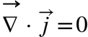 is automatically satisfied everywhere [20]; instead in a laboratory experiment there are nearby metallic conductors, which the plasma can charge, and therefore divergences of the plasma current density can occur. On one hand the electric charging of these metal surfaces can induce the spontaneous rotation of the plasma around its symmetry axis, which makes the laboratory configuration more similar to the astrophysical ones, while on the other it can trigger the release of secondary spurious plasma currents. We will see in the following that the electrostatic boundary conditions are very critical for the stability of the jet + torus plasma configuration in the laboratory.

Purpose and aims of the experiment

A confinement experiment based upon magnetic reconnections

The presence of a toroidal field B_{T} in PROTO-SPHERA is a straight consequence of Maxwell’s equations (Ampere’s theorem), provided that the electrodes are able to produce the plasma current I_{CP} in the centerpost discharge, according to the design specifications. However, in astrophysical examples and in the PROTO-SPHERA machine, the existence of the confined plasma, i.e. of a torus carrying a current I_{ST}, around the plasma jet (or centerpost) relies on plasma-dynamic phenomena, in particular on magnetic reconnections, where dissipative phenomena, such as plasma resistivity or viscosity, play a crucial role. It is a general observation that nature is able to form resilient toroidal configurations in fluid media where jet stream forces act. The most obvious fluid-dynamical analogies are the smoke rings, that are produced by straight jets of steam from erupting volcanoes [21] as well as by skilled cigarettes smokers, but also the the air rings that are created and supported underwater by playful cetaceans [22]. The vortex rings are due to the presence of a jet stream of a fast-moving fluid in a distinct fluid quiescent background. The shear imposed at the interface between the two fluids slows down the outer layer of the fast-moving fluid relatively to the centerline one. The fluid spins around a closed loop forming a toroidal vortex.
In the magnetic reconnections, in addition to the transfer of energy, there is also a transfer of magnetic flux and of electric current: in the case of PROTO-SPHERA part of the toroidal electric current, which is wrapped inside the plasma centerpost discharge, is therefore transferred to wrap inside the surrounding torus, right through the tears that occur on the two circles of ordinary X-points. Many aspects of magnetic reconnection are still today poorly understood [23]: even the reconnection time is assessed differently on the basis of different theoretical models [24]. In magnetic confinement experiments magnetic reconnections tipically have more adverse than advantageous effects, as often they spoil the integrity of the magnetic toroidal flux surfaces, but a very relevant aspect is their ability to accelerate, out of thermal equilibrium, the plasma electrons: a characteristic that causes sudden X-ray emissions [25]. Furthermore, the magnetic reconnections, by converting a part of the magnetic energy of the field into the kinetic energy of the plasma, are also able to heat the plasma [11], by affecting the thermal component of its distribution function; this characteristic makes magnetic reconnections extremely interesting in the pursuit of controlled fusion. A heating method based on natural phenomena, intrinsically produced by the self-organization of the plasma configuration, could prove to be more effective than the heating methods that have to resort to additional heating devices, located outside the machine that produces and confines the plasma, as building the former is often even more complicated than building the latter. The possibility of obtaining the heating of the plasma by magnetic reconnections is suggested by the Astrophysics of the Sun: today a credited hypothesis for the high temperature of the Solar Corona (from 4500-6000 ºK of the underlying Solar Photosphere to millions of ºK of the outer Corona) is that it is due to the magnetized flux tubes rising from the thin solar Tachocline, crossing the whole convective region of the Sun, piercing the Photosphere and the Chromosphere and finally undergoing magnetic reconnections (such as solar flares) and releasing thermal energy to the lower density plasma of the Solar Corona [26,27].

The PROTO-SPHERA configuration

The PROTO-SPHERA experiment is a magnetic confinement configuration with axial symmetry, just like the Tokamak [28]: the plasma, studied in view of controlled fusion nuclear reactions, must take the form of a torus and there are two indispensable requirements for confining it. First there must be a toroidal magnetic field B_{T} (directed along the large circle of the torus) and second a poloidal magnetic field B_{pol} (directed along the small circle of the torus), this last requirement is equivalent to the presence of a toroidal electric current flowing inside the plasma torus.

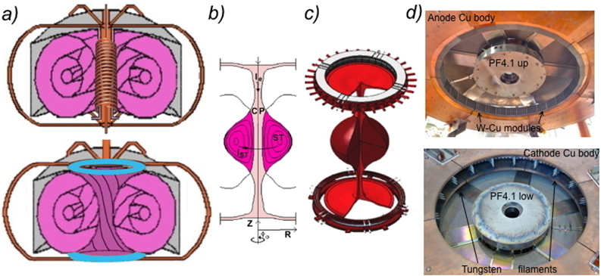
Figure 1. (a) Scheme of a Tokamak (top) and of PROTO-SPHERA (bottom): pink colour is for plasma, gray for vessel, orange for metal bars, blue for electrodes. (b) Poloidal cross-section of PROTO-SPHERA plasma, CP stands for centerpost, ST for torus, the mechanical structures of the poloidal field coils are removed from the scheme. (c) Perspective sketch of the plasma and of the annular electrodes. (d) View of the annular anode (top) and of the annular cathode (bottom).

The plasma thus becomes organized according to magnetic flux surfaces, each contained inside another; on every flux surface the lines of magnetic force are wrapped along helices, as in figure 1(a).
PROTO-SPHERA is a variant of the Tokamak configuration, in which a central plasma discharge, dubbed CP in figure 1(b) and surrounded by the torus, dubbed ST, replaces both central metal conductors: the inner side of the toroidal field coils and the ohmic transformer, shown in figure 1(a), and consequently eliminates them. This choice implies an enormous simplification of the shape of the container, which is a cylindrical vacuum vessel, but the configuration requires that two electrodes [3,29] are present inside the vacuum. The plasma centerpost has a variable diameter for a length of about 1 m and opens in the form of a mushroom in front of both annular electrodes, figure 1(c). The annular form of the electrodes was chosen not only in order to dilute the surface density of the plasma power and of electric current impinging upon them, but also because the "mushroom" shaped plasma in front of both electrodes stabilizes the overall configuration in ideal MHD [30].
The anode was built as a hollow gas-puffed annular anode, composed of 30 Copper modules, protected on its plasma facing side by tiles of Copper-Tungsten alloy, the gray elements of figure 1(d). Each module has 20 holes each in front of the plasma and neutral gas is diffused from its rear toward the plasma: the plasma is, on its turn, able to diffuse inside the front holes toward the neutral gas. The cathode, which is not fed by neutral gas, is a hot annular cathode, divided in 6 sectors, with a total of 54 Tungsten filaments, shown in figure 1(d), heated to about 2900 ºK; the six-phased AC heating of the filaments is switched off just before a DC voltage is applied between the electrodes in order to obtain the plasma break-down.

The PROTO-SPHERA load-assembly

The first PROTO-SPHERA vacuum vessel was the former START Tokamak [31] vacuum vessel (made of Aluminium, 2 m internal diameter, 4 cm thick, a gift of Culham UKAEA Research Center in 2004). For using it on PROTO-SPHERA the original START vessel was supplemented by two AISI304 ferrules, reaching a total eighth of 2.5 m. Following the requirements illustrated in the previous paper [3], derived from the choices of compression, shaping and elongation of the magnetic configuration, in the initial load-assembly (built from 2006 to 2009) there were eight poloidal magnetic field coils inside the vacuum chamber: the PFInt-B shaping group coils, shown in figure 2(a), were industrially built, are armored by 5 to 10 mm thick AISI304 casings, but all fed in series by a single power supply.
The casing of the coils are electrically floating; in particular the PF2 and PF3.1 shaping coils are connected together, as well as the PF4.1 and PF4.2 shaping coils. The PFInt-B group coils are capable of shaping the centerpost plasma, while distiguishing the plasma discharge in three sections: on top the anodic plasma, in the middle the main equatorial plasma (located within a 0.87 m vertical space between the two PF2 poloidal field mirror coils) and on the bottom the cathodic plasma. The centerpost discharge passes through the holes inside both of the two PF2 mirror coils, which are internally protected by additional Copper-Tungsten cylindrical shells. The poloidal magnetic field reaches in the holes of the PF2 mirror coils its maximal value: about 0.5 T.

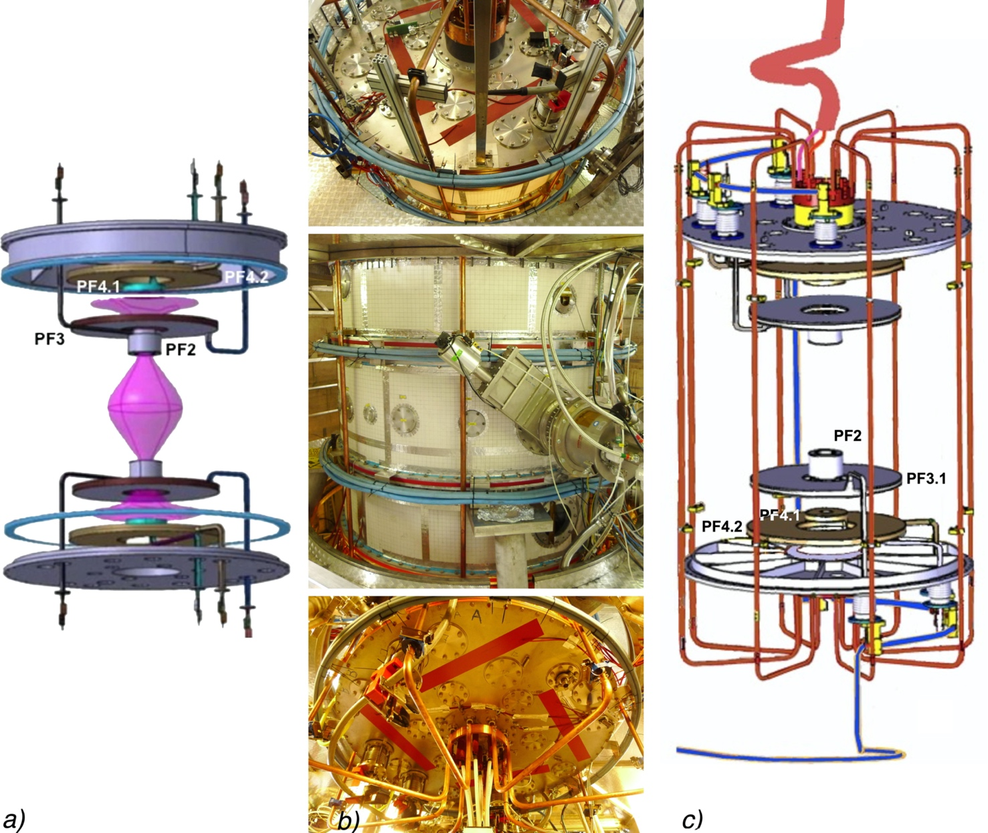

Figure 2. (a) Scheme of plasma centerpost (pink) and of PFInt-B internal armored coils, the main plasma is limited by the two PF2 mirror coils; two polycarbonate insulating spacer ring (shown in blue) separate the Aluminum vessel from the two ferrules on top (shown) and bottom (not shown); the mechanical structures of the cylindrical vessel and of both electrodes are removed from the scheme. (b) The 4 PExt coils (green-blue) wound around the vacuum vessel and, at the center of top and bottom lids, the copper busbars that introduce inside the vessel the current that the electrodes convert into the plasma centerpost current. (c) The copper bars, shown in red outside the vacuum vessel, which return the Plasma-Centerpost current from a lower collecting ring to an upper outer coaxial ring; the coaxial cable that feeds the PFInt-B coils is shown in blue.

All the eight Group-B-PFInt coils, whose names are indicated in figure 2(a) and 2(c), being contained inside the vacuum vessel, are near the plasma and their AISI304 casings reach during the plasma discharge different floating electric electrostatic potentials, roughly proportional for each individual coil to the plasma current I_{CP} flowing in the centerpost. Later (2017), in order to attempt the formation of the first confined tori, four magnetic vertical field coils, the PFExt coils shown in figure 2(b), wound around the vacuum chamber, were added and fed in series with the PFInt-B internal coil.
With the exception of the six-phased AC Cathode heating power supply, all the conductors that carry the currents from the power supplies to the PF coils and to the machine are coaxial cables; in particular the power supply of the Plasma Centerpost is applied to the anode through two coaxial metal rings on top of the machine, in order to minimize any error field. Copper bars outside the vacuum vessel return the Plasma-Centerpost current I_{CP} from a lower copper collecting ring to a similar upper copper ring: the copper bars are the only components reminiscent of the outer part of a toroidal magnet in a Tokamak and are shown in Fig. 2(c).
The power supplies of the experiment are briefly described in Appendix A.

The PROTO-SPHERA operation

PROTO-SPHERA was built and operated in its initial Phase from mid-2014 until the beginning of 2018. Details on its geometry, operative procedure and preliminary results has been already given elsewhere [3, 32]. The discharge sequence of the experiment is the following: first of all the 6-phased AC currents heating the cathode filaments are rised up with a ramp lasting about 30 s, such that the required 2900 ºK are reached at the end of the current ramp. Within the last 10 seconds of the cathode heating the vacuum vessel is filled by the operating neutral gas, through the holes of the anode, at a pressure ranging from 5•10⁻³ to 5•10⁻² mbar, and the filling continues until the end of the plasma discharge. During the last 50 ms of the cathode heating the poloidal field coils internal to the vacuum vessel (PFint-B) are energized, and in case also the ones external to the vessel (PFext). Finally by switching on the power supply of the plasma centerpost a DC voltage appears between anode and cathode and the plasma centerpost is created, at least 50 ms after the cathode filaments heating currents have been switched off. The top part of the vessel (an AISI304 ferrule-and-lid) and its bottom symmetrical ferrule-and-lid are insulated, interposing spacer rings, from the grounded Aluminum middle vessel and left floating, see figure 2(a). A number of magnetic sensors internal to the vacuum vessel measure the poloidal magnetic field generated by the plasma centerpost as well as its current I_{CP}, in different locations along it.
A preliminary campaign of experiments on PROTO-SPHERA was run from the summer of 2014 up to February 2015, devoted to assess the plasma break-down. In this phase the plasma central discharge was obtained in presence of the final annular cathode on the bottom of the machine, but with a simpler provisional cylindrical anode on top of it.

Electrostatic and magnetic boundary conditions

The Phase-1 of the experimental campaign was aimed to obtain a 1 sec lasting centerpost Hydrogen plasma at the full plasma current I_{CP} = 10 kA, the maximum deliverable by the plasma centerpost power supply (see Appendix A). When the commissioning of the PROTO-SPHERA experiment started, a number of problems appeared, which prevented the achievement of the operational aim of the machine, in particular at the beginning it was impossible to feed the centerpost plasma with the full current, a stationary centerpost discharge was not immediately achievable and it was even impossible to produce a stable Hydrogen plasma centerpost. It took almost three years of work (from May 2015 to January 2018) to modify and correct the boundary conditions of the experiment, in order to achieve the full aim of the Phase-1 centerpost plasma.
The problems and the solutions found during the commissioning of PROTO-SPHERA in Phase-1 will be presented in the following.

Insulation of anode gas feeding system by Teflon components

Eventually in May 2015 the final annular anode, enclosed within the upper mechanical group, was lowered on top of the Aluminium cylindrical vacuum vessel, see figure 3(a).

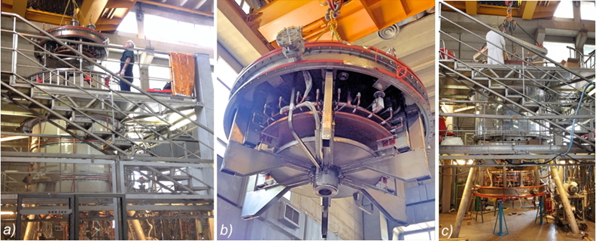
Figure 3. (a) The annular anode being lowered on the Aluminium vacuum vessel (May 2015). (b) Image of the copper anode, on the rear side of which white Teflon blocks and tubes insulate the gas-puffing system from the upper lid; the metal disc below is the PF3.1 coil and the cylinder the PF2 mirror coil, through whose hole the plasma emerges in the equatorial section of the machine. (c) The annular cathode, below the machine, being lifted into the vacuum vessel.
Just at this time the first use of plastic insulators began: the annular anode gas-puffing system had to be electrically insulated from the AISI 304 top lid of the machine; Teflon blocks and Teflon tubes for injecting gas on the rear of each of the 30 annular anode modules were introduced, see figure 3(b). The experiment has been run since 2015 without any damage to these Teflon components. Figure 3(c) illustrates the lifting of the lower cathodic mechanical group from the bottom of the machine, showing that the cylindrical geometry is quite suitable for all kind of interventions, repairs and corrections. During the years from 2014 to 2021 the experiment was opened for repairs and corrections, 9 times the upper mechanical group and 7 times the lower mechanical group were removed and reinserted. This possibility of easily opening, repairing, correcting and closing the machine, is the unique feature that has allowed for the progressive adjustment of the boundary conditions of the experiment.

Magnetic nozzle insulation by large Polycarbonate top & bottom flanges

The proper Phase-1 operation of PROTO-SPHERA began during the year 2015, in presence of the final annular anode. Argon plasmas were produced at first, as their initial break-down voltage (over a total distance of 2.1 m along the magnetic field lines) was as low as 80 V; nevertheless in October 2015, the centerpost current reached only I_{CP}=3.0 kA in Argon plasmas and lasted only 0.3 s. Copper busbars, already shown in figure 2(b), penetrate through the top and the bottom lids, and introduce inside the vacuum vessel the current that the electrodes convert into the plasma centerpost current. The busbars went at that time through two big AISI304 flanges, placed in the center of the upper and the lower lid of the machine. The problem was that the plasma deposited an increasing level of metallization upon the Copper busbars, shown in figure 4(a). The space available for insulating of busbars with respect to the flanges was quite narrow, see figure 4(b).

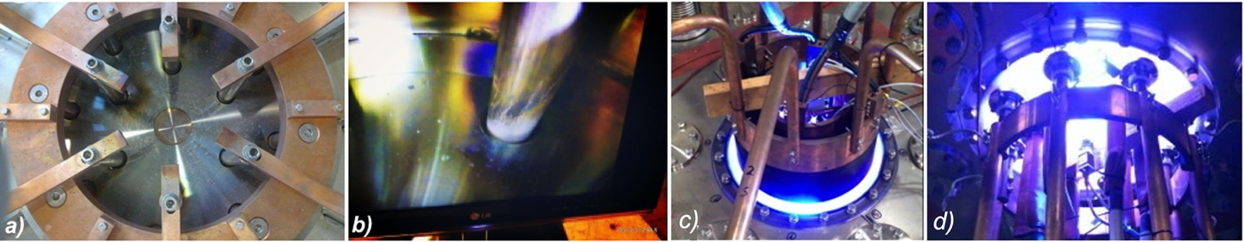
Figure 4. In presence of AISI304 central lid flanges: (a) Anode top busbars viewed from inside the vessel. (b) Enlarged view of one of the cathode bottom busbar, also from the inside, showing a relevant metallization. (c) The visible light of an Argon plasma centerpost emerging from the upper anodic polycarbonate flange, shot #567. (d) The visible light of an Argon plasma centerpost emerging from the lower cathodic polycarbonate flange, shot #577.
The two big AISI304 flanges were then replaced by two 4 cm thick polycarbonate insulating flanges, machined with the same mechanical details as the metal ones. This replacement happened in June\July 2016. Thanks to the polycarbonate flanges the metallization problem has been solved on both sides of the machine and more than 1200 plasma discharges have thereafter been obtained, without any further deterioration, see figures 4(c) and 4(d).

Triple magnetic X-points and magnetic nozzle

The problem with the top and bottom busbars was not only one of electrical insulation, it was a direct effect of the physics upon which the experiment is based: one of the appealing features of configuration similar to PROTO-SPHERA, in view of future magnetic confinement thermonuclear reactors, is that they contain two degenerate (or triple) X-points [33]. Such triple X-points have null field B=0 and are placed on the symmetry axis, on the opposite sides of the machine, each sitting in the middle of both annular electrodes.

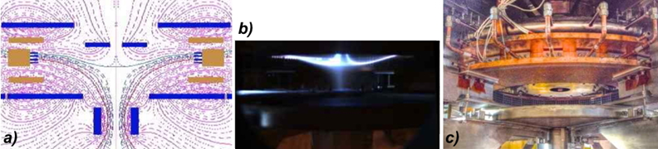
Figure 5. (a) Poloidal cross section map of magnetic lines of force near the anode (yellow), showing the triple X-point on axis, in the middle of the anodic PFInt-B coils (blue). (b) Image of the upper triple X-point, while the plasma centerpost (which lays below) is being switched-off, shot #117. (c) The hollow annular anode.

One of the two triple X-points, the upper one illustrated in the field map of figure 5(a), can be clearly observed – figure 5(b) – in the PROTO-SPHERA discharges, in the middle of the annular anode, figure 5(c). Due to the strong light emission from the anode, the observation is easier during the decay of the plasma centerpost I_{CP} current, when the discharge is being switched off. It is quite evident that the triple X-point is able to channel the plasma directly upon the flanges placed in the center of the upper lid of the machine. The strong permanent light emitted, during the plasma switch-off, from the hot cathode filaments does not allow the observation of the lower cathodic triple X-point.
In a future fusion reactor the high energy, large poloidal Larmor radius, charged fusion products would drift across the magnetic separatrix, shown in figure 1(b), from the nuclear burning torus into the open field lines of the plasma centerpost; their expulsion from the plasma centerpost will be preferentially from one of the two triple X-points [33], depending upon the sign of 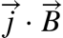 inside the plasma. This preferential triple X-point could become the basic component of a magnetic nozzle, allowing for the use of the nuclear fusion burner as a space thruster, whereas the other triple X-point could be used for direct energy conversion.

The spurious current bridges

After the introduction of the two polycarbonate top and bottom lid flanges, spurious discharges that were able to close the centerpost plasma current onto the Aluminium cylindrical vessel became the next most relevant problem. In Argon these spurious current were not strong enough to trigger abrupt plasma terminations, their effect was limited to sudden decreases of the plasma centerpost current, an example of which is shown in figure 6; the sudden current drops were in all cases associated with the plasma centerpost discharging onto the conducting Aluminium vacuum vessel.

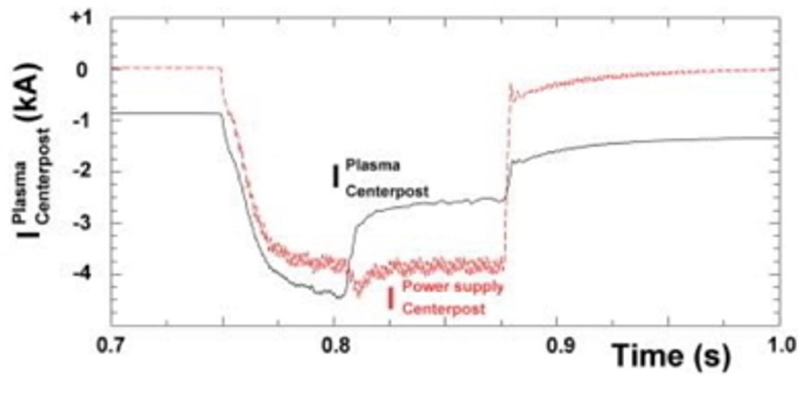

Figure 6. Waveforms of Argon centerpost plasma current, evidencing a sudden decrease after the centerpost discharge becomes attached to the Aluminium cylindrical vacuum vessel, shot #208.

The Aluminium conducting vacuum vessel acted therefore in Argon plasmas as an unwanted current bridge, in parallel and in competition with the plasma centerpost current I_{CP}, see figure 7(a). In Hydrogen plasmas however the unwanted current paths were so strong as to lead to plasma terminations, an example of which is shown in figure 7(b) and 7(c); the termination phenomenon was not so different from the well-known Tokamak disruption [34]. The Hydrogen plasma was much more prone to terminations than the Argon plasma, as the initial break-down voltage increased from the 80 V for the Argon plasmas up to 240 V for the Hydrogen plasma.

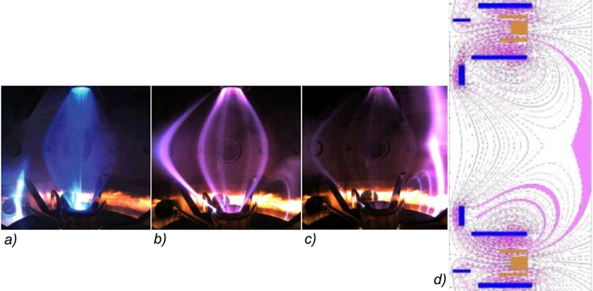
Figure 7. Spurious current path (on the left of the centerpost) in presence of the Aluminium vacuum vessel: (a) Argon centerpost partially affected, shot #128; (b) Hydrogen centerpost seriously affected, shot #78; (c) Hydrogen centerpost driven to plasma termination on sub-millisecond timescale. (d) Maps of magnetic field with spurious current paths being evidenced.

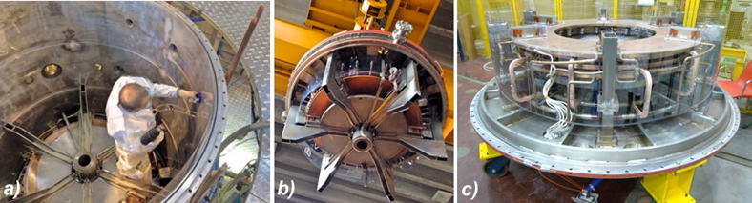
Figure 8. (a) The Aluminium vessel being lined on its inner wall, by two, doubly overlapping, 2mm thick polycarbonate cylindrical foils. (b) Similar doubly overlapping polycarbonate foils surround the upper anodic mechanical group. (c) Same for the lower cathodic mechanical group.

This problem was fixed by lining the inner side of the Aluminium vacuum cylinder with two large polycarbonate foils, doubly overlapping, 2 mm thick, 2.05 m high, about 6.4 m overall circumference, shown in figure 8(a). In addition, two secondary, again doubly overlapping, polycarbonate linings, also 2 mm thick, were added on the rear of the upper anodic mechanical group, figure 8(b), and on the rear of the lower cathodic mechanical group, figure 8(c).
Despite plasma terminations were never more observed after that, the Argon plasma centerpost current could not yet overcome the current I_{PC}=3.5 kA (the target current being I_{PC}=10 kA) as shown in figure 9(a); the reason was again the presence of residual plasma currents flowing outside the proper centerpost path. Thin current carrying plasma filaments, emerging from the lower (cathodic) PF2 mirror coil, as shown in figures 9(b) and 9(c), were usually brighter on their plasma-metal terminations at their negative electric potential but almost invisible on their plasma-metal terminations at the positive potential. Like in the case of ELM instabilities [35], the filaments followed closely the magnetic lines of force and significantly broke the axial symmetry of the machine.

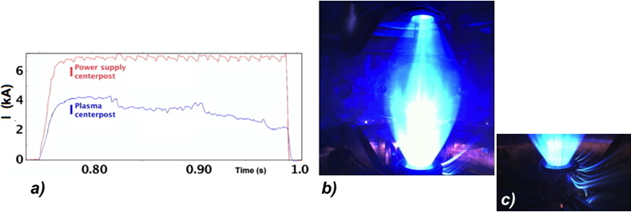
Figure 9. (a) Waveforms of Argon centerpost plasma current, evidencing a slow decrease of plasma centerpost current I_{e}. (b) and (c) Spurious plasma currents with filamentary patterns near the lower PF2 mirror coil. All figures refer to shot #597.
Other modifications were made in order to prevent the flowing of plasma currents outside the prescribed path: first two large insulating diaphragm separators, see figure 10(a), made out of a 10 mm thick polycarbonate slab, pierced by two passing holes for the plasma, were inserted in the central part the machine, attached to edges of the upper and of the lower mechanical groups, not far from the two PF2 internal mirror coil, which are separated from each other by 0.87 m. A polycarbonate insulating spacer ring, vacuum sealed with two o-rings on both sides, was furthermore inserted between the upper ferrule and the Aluminium vessel, see figure 10(b); an identical insulating spacer ring was put in position on the bottom of the machine. The purpose of the two spacing rings is to insulate electrically the Aluminum vessel from the two ferrule-and-lid on top and bottom.

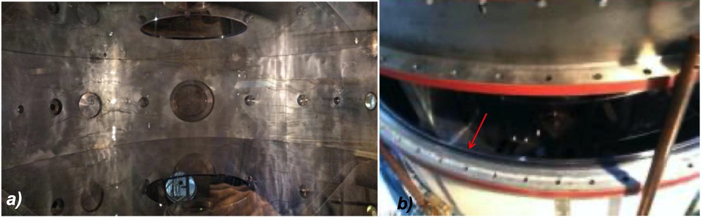
Figure 10. (a) Upper and lower diaphragm glued to the cylindrical large polycarbonate foil with a vacuum compatible strong sealant, able to sustain the diaphragm weight. (b) Polycarbonate insulating spacer ring, vacuum sealed with two o-rings on both sides, inserted between the upper ferrule and the Aluminium vessel, sketched also in Fig. 2(a).

After these two last modifications of the electrostatic boundary conditions, the aim of the Plasma-Centerpost for the experimental Phase-1, see figure 11(b) and 12(a), was obtained in Argon in January 2018, with break-down voltage ≈ 90 V: the electrode plasma current I_{CP} was sustained for 1 second at 10 kA while the anode-to-cathode voltage increased to ≈ 200 V.
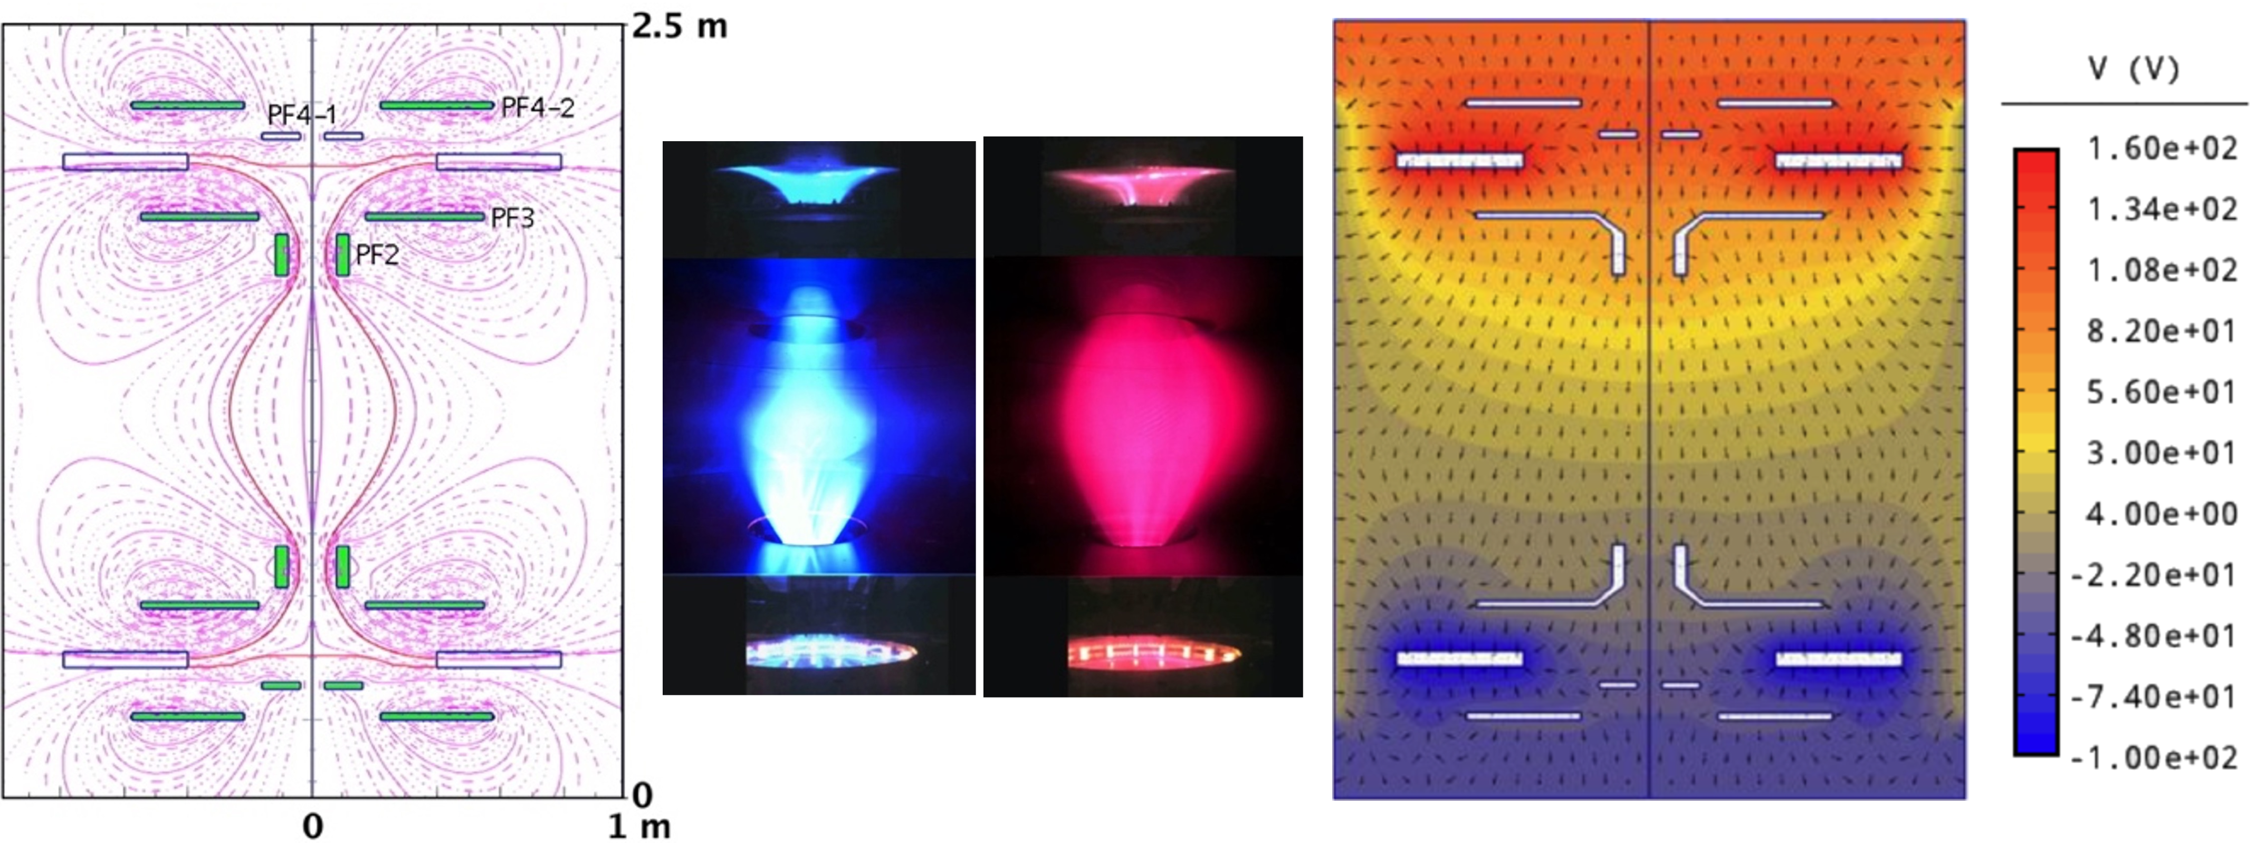
d
c
b
a

Figure 11. (a) Shaping magnetic field, up/down symmetric, produced by the eight Group-B-PFInt coils, the four upper coils are denominated in this figures, the lower four ones being mirror symmetric across the equatorial plane. (b) Argon centerpost discharge #1037 at I_{CP}=10 kA: pictures from 3 cameras (at different azimuthal angles) are superposed. (c) Hydrogen discharge #1010 at I_{CP}=10 kA. (d) The electrostatic potential in H discharges at I_{CP}=10 kA (shown with different colors) is not up/down antisymmetric, i.e. the plasma charges the Group-B-PFInt coils on the anode side with a different pattern of electric potential with respect to the cathode side.
The equatorial diameter of the Argon Plasma-Centerpost was 2R_{sph} ≈ 55 cm. The equatorial line-averaged electron density <n_{e}> in Argon was measured by a common-path Second-Harmonic-Interferometer (SHI) [36,37] and exhibited an almost linear dependence upon the electrode plasma current: <n_{e}> ∝ I_{CP}, with <n_{e}> = 4•10²⁰ m⁻³ at I_{CP}=10 kA.
As the magnetic field lines start from and end upon electrodes the Plasma-Centerpost temperature cannot be larger than a few eV; it was determined by Langmuir probe measurements only at the edge of the anodic mushroom-shaped plasma: the local electron temperature was measured to range from 2 to 8 eV, correspondingly the local electron plasma density ranging from n_{e} = 5•10¹⁹ m⁻³ to n_{e} = 2•10¹⁹ m⁻³.
a

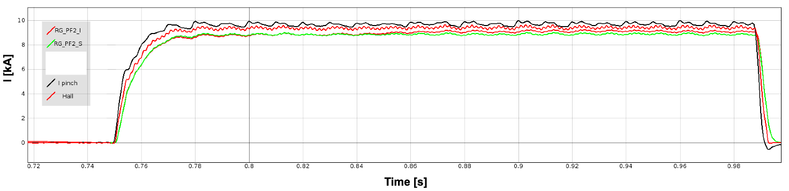
b

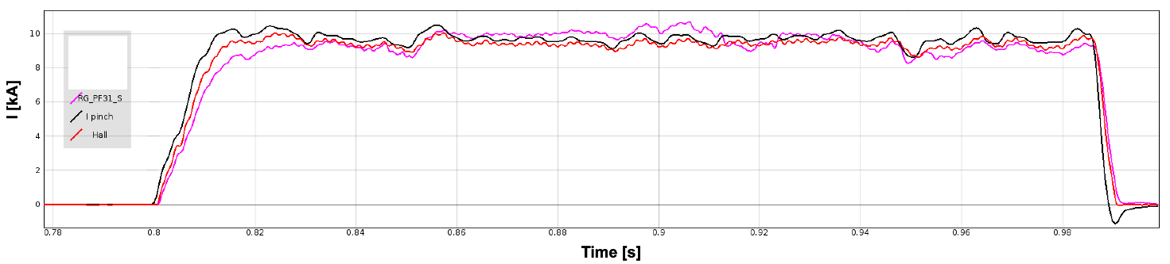

Figure 12. (a) Argon discharge #1037 at I_{e}=10 kA: waveforms of I_{CP} the plasma centerpost current as measured on the power supply and on the return bars of the machine (by Hall sensors) compared with the traces of two in-vessel Rogowski sensors. (b) Hydrogen discharge #1010 at I_{e}=10 kA: waveforms of the plasma centerpost current as measured on the power supply and on the return bars of the machine (by Hall sensors) compared with the trace of one in-vessel Rogowski sensor.

Hydrogen as well has no interest for Controlled Fusion [38], but it is highly indicative of the behavior of the Deuterium that will be used in Phase-2 of the experiment. The 10 kA Plasma-Centerpost in Hydrogen was also obtained in January 2018, see figure 11(c) and 12(b), its break-down voltage was ≈320 V and the electrode plasma current I_{CP} was sustained for 1 second at 10 kA while the anode-to-cathode voltage decreased to ≈220 V. The equatorial diameter of the Hydrogen Plasma-Centerpost was 2R_{sph}≈75 cm, larger than in Argon plasma. The equatorial line-averaged electron density <n_{e}> of the Hydrogen Plasma-Centerpost was <n_{e}>≈1.0•10²⁰ m⁻³ at I_{CP}=10 kA, lower than in Argon plasma. Preliminary results of spectroscopic observations [39] on the plasma equator indicate that in Hydrogen discharges the visible spectrum did show only Hydrogen lines, whereas the UV spectrum did show limited amounts of metallic impurities; this was presumably due to the fact that the two PF2 mirror coils – see figure 11(b) and 11(c) – act as effective impurity separators for the plasma (anode, cathode and main plasma). Both Argon and Hydrogen Plasma-Centerpost discharges were sustained as long as the anode-to-cathode voltage was applied. The much-feared anode arc-anchoring of the plasma [40,41] (i.e. the discharge concentrating upon a restricted anode spot, and inflicting local damage) never occurred; the explanation resides in the rotation of the Plasma-Centerpost in the azimuthal (toroidal direction), which is evident from the visible light movies collected by a 3600 fps fast camera.
The Plasma-Centerpost rotates approximately at an angular frequency ω∼2π•10² radians/sec. The cause of such a rotation appears to be the electrostatic charging of the PF coils casings by the plasma: all the 8 Group-B-PFInt coils inside the vacuum vessel reach different floating electric potentials; figure 11(a) indicates the names of the Group-B-PFInt coils. As previously mentioned, also the top part of the vessel (an AISI304 ferrule-and-lid) and its bottom symmetrical ferrule-and-lid were insulated and left floating from the Aluminum middle vessel, which was grounded for safety reasons. The PF coils casings were all left floating, as this was the best way to avoid spurious secondary discharges. In Hydrogen plasma at 10 kA, the anode (top) was charged to +140 V while the cathode (bottom) only at -80 V, the top ferrule-and-lid at +95 V while the bottom ferrule-and-lid at only -55 V, the two PF4 coils (plasma-nozzle-coils) to +50 V on top and only to -10 V on bottom and the PF2\3 coils (mirror-coils) to +95 V on top and only to -40 V on bottom. The E∧B drift of the plasma, that would have been opposite in the anode and cathode region, was therefore not compensated: the top anode has been calculated, by a simple electrostatic code [42], to have the larger electrostatic field, see figure 11(d), and apparently dictated the direction of the net plasma rotation. As the internal magnetic field pointed upwards, while the electrostatic field went downwards, from anode to cathode, the net plasma rotation was clockwise (as seen from the top of the machine).
The aims of Phase-1 of the PROTO-SPHERA experiment (10 kA Plasma Centerpost in Hydrogen [3]) had therefore been fulfilled, by introducing a variety of insulating materials. It is remarkable that after the full current Argon plasma centerpost was obtained, the Hydrogen plasma centerpost was immediately produced and sustained for 1 sec at the full level of 10 kA.

First evidences of plasma torus formation and sustainement

Before moving to the final Phase-2 of the experiment, the first attempts to obtain the plasma tori were performed already in the first months of 2018. The four magnetic vertical field coils, the PFExt coils wound around the vacuum chamber – see figure 2(b) –, were fed in series with the Group-B-PFInt internal coil – see figure 2(c) – with electric currents such that direction of the magnetic field inside the equatorial PFExt coils was opposite to the direction of the magnetic field inside the plasma centerpost discharge, see figure 13(a), but no further modifications were introduced in the machine. The first tori were obtained in Argon plasma. The predictive plasma equilibrium calculated under the assumption that the torus does not appear, exhibit for the Plasma-Centerpost a single circle of ordinary X-points (B_{pol}=0) on equator, as in figure 13(a); in the experiment, if the Argon centerpost discharge current was produced at low values (I_{CP} ~3 kA), the central plasma of figure 13(b) was quite narrow: ~32 cm from symmetry axis and was quite similar to what is calculated in figure 13(a).
If the predictive equilibrium calculation is performed instead under the hypothesis that a plasma torus forms, then a quite different configuration is obtained, exhibiting two circles of of ordinary X-points (B_{pol}=0) as shown in figure 13(c), one up and the other down the equator, both endowed with magnetic separatrices; in the experiment, if the centerpost discharge current was produced at I_{CP} >5-8 kA, the presence of the separatices became quite evident, and the shape of the central Argon plasma of figure 13(d) was quite broader and quite similar to what is calculated in figure 13(c).
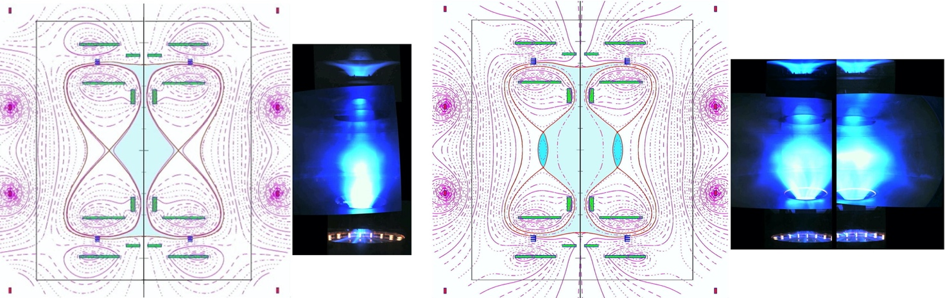
- b) c) d)
Figure 13. (a) Grad-Shafranov calculation of magnetic field configuration in absence of any closed flux surface current, with I_{CP}= 8 kA value of plasma centerpost current I_{CP} (the value of the current I_{CP} has negligible effects on the calculated centerpost shape); (b) Argon shot #1098 at centerpost plasma current I_{CP} = 3kA, obtained in the magnetic field shown in (a); (c) equilibrium calculation of magnetic field configuration with centerpost plasma current I_{CP}= 8 kA in presence of closed flux surface torus carrying I_{ST} = 5kA; (d) Argon shots #1149-1160 (looking at the two opposite sides of the central plasma) obtained in the magnetic field shown in (a).
What was found can be summarized by the conclusion that in Argon, when the direction of the magnetic field inside the equatorial PFExt coils was opposite to the direction of the magnetic field inside the plasma centerpost discharge a toroidal configuration was formed and sustained if the rotational transform of the Plasma centerpost (from anode to cathode) was lower than 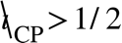, which roughly corresponds to I_{CP} > 8 kA, indicating that the formation can be attributed to an MHD instability.
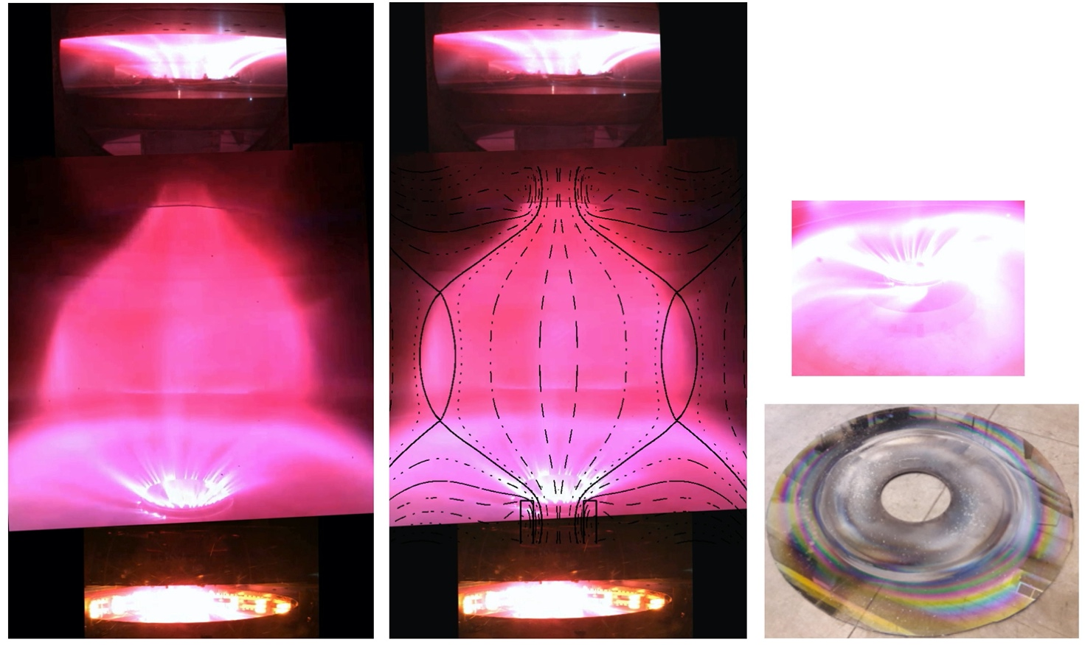
a) b) c) d)
Figure 14. (a) "Lean" torus visible as a brighter belt at the outer edge of the Hydrogen plasma centerpost. (b) Same, with superposed equilibrium calculation of magnetic flux surfaces. (c) Lower magnetic separatrix, just below the lower circle of X points, from a different camera. All three images refer to Hydrogen plasma shot #1280. (d) Polycarbonate lower diaphragm, removed at the end of the experimental campaign in which PROTO-SPHERA produced the first plasma tori.

Immediately also Hydrogen plasma tori were obtained carrying toroidal currents up to 5 kA, an exemple being shown in figure 14(a); they were much better visible than the Argon tori, albeit they were extremely "lean", see figure 14(b), as it was expected from predictive magnetic equilibrium calculations that included the PFExt coils effect. The skin-current effect of the 4 cm thick Aluminium vacuum vessel delayed by 0.6 s the penetration of the PFExt vertical magnetic field inside the machine; the plasma tori were therefore produced starting from 0.6 s, in the purely magnetostatic field obtained after the skin current flowing in the Aluminium cylinder was dissipated; the sustainment of the first Hydrogen tori was therefore limited to about 1/3 s. It has to be remarked that this time interval is anyway at least one order of magnitude greater than any other characteristic plasma time, including the current diffusion time, and therefore the tori can be considered stationary. The tori were however unexpectedly strongly up/down asymmetric and the power injected into the tori was almost totally discharged into the lower part of the plasma, as in figure 14(c).
The tori were always equipped with a "magnetic separatrix", i.e. a conical "fan" of plasma able to discharge the power dissipated inside the torus, out of the two circles of ordinary magnetic X-points (B_{pol}=0, B_{T}≠0). The filamentation of the plasma current, when it entered the lower PF2 internal mirror coil, was very intense, see figure 14(c).
The presence of two magnetic separatrices compels to introduce divertor plates, i.e. mechanical structures able to withstand the power flowing into the fans. The impact on the lower diaphragm, shown in figure 14(d) see did clearly evidence the nearly axisymmetric nature of the plasma torus. The lower diaphragm however acted as a divertor plate, but being a polycarbonate sheet, was therefore completely inappropriate for withstanding the power coming out from the lower magnetic separatrix.
Unpleasant effects for the plasma torus are associated with any kind of filamentation of the plasma current: the plasma filaments act as a relevant source of magnetic disturbances to the overall axial symmetry of the magnetic configuration. The two main disturbances from current carrying filaments are: a) to add a counterflowing current on the outboard edge of the torus and b) to introduce an ergodic component to the magnetic field inside the torus [43]. The results would be that: a) the filamentation could therefore contrast the Helicity Injection and b) the integrity of the magnetic toroidal flux surfaces could be spoiled. Both points could worsen the energy confinement inside the plasma torus in the future Phase-2 of the experiment: the first point could decrease the toroidal current in the spherical torus I_{ST}, by decreasing the current ratio I_{ST}/I_{CP}; the second point could directly enhance the energy losses through an ergodic magnetic field.
In order to move towards the Phase-2 of PROTO-SPHERA it was decided, at the end of 2018, to operate in 2019-2020-2021 an intermediate phase, having the aim of progressively pushing the plasma from the "lean" tori to the spherical tori. In order to mend the more relevant insulation problems, which appeared in the first plasma operation, a number of actions were undertaken, which have included a new insulating and transparent cylindrical vacuum vessel, new internal compression coils, new insertable and extractable polycarbonate diaphragms and insulated divertor plates. A following paper will illustrate the intermediate phase of PROTO-SPHERA.

Conclusions

The PROTO-SPHERA experiment, by removing the two metal central conductors of the Tokamak configuration and by replacing both with two electrodes feeding a plasma centerpost discharge, has overcome the need of a toroidal vacuum vessel for producing a magnetically confined plasma and has substituted it with a cylindrical chamber surrounding a simply connected plasma. The centerpost discharge is able, through magnetic reconnections (DC Helicity Injection), to form a plasma confining torus and to sustain it in steady state carrying a toroidal current. The greatest difficulty in this new configuration is obviously the possibility that spurious plasma currents flow inside the cylindrical enclosure, but outside the proper centerpost route, along unpredicted and uncontrolled paths, hampering the magnetic configuration, reducing the efficiency by which the plasma centerpost injects magnetic helicity into the torus and finally making the field ergodic inside the torus.
To prevent the spurious plasma current paths, a number of corrections to the boundary conditions of the experiment have been carried out in its initial phase (centerpost only), but are still underway in the following phase (first confined tori). All the electrostatic boundary corrections have introduced insulating materials inside the vacuum vessel in critical places near the plasma.
The corrections have, step by step, not only achieved their desired results, without introducing problems of impurity contamination, but have also shown that the confined plasma tori of PROTO-SPHERA can be sustained in steady state without any need of stabilization by a massive shell-like nearby metal conductor, as it happens in Spheromaks [44], since the Aluminium START vacuum vessel is very far from the plasma boundary. In any case this point will be definitely clarified by the insertion of the new insulating and transparent cylindrical vacuum vessel. This is also a point of interest for laboratory simulations of astrophysical plasma phenomena, as all the astrophysical plasma events in the cosmos are surrounded, after a given distance, by vacuum and therefore by one among the most effective electrical insulators.

Acknowledgments

The authors would like to thank Antonella De Ninno and Federica Causa for supporting this work and for the helpful discussions.
Appendix A: the power supplies

The Group-B-PFInt coils are fed by a DC machine that delivers 2 kA at 350 V DC, built by EEI in Vicenza (Italy), in the years 2011-2014. A further power supply for the new Group-A-PFInt compression coils will be built in Phase-2, as a DC machine able to deliver 1.2 kA at 600 V to the 10 new coils connected in series.
The Plasma Centerpost power supply, built by EEI as well, is instead limited to the first unit (I_{CP} =10 kA at 350 V DC, for 1.1 sec); a second unit will be built in Phase-2, able to increase the electrode plasma current up to I_{CP}=70 kA.
The electrical power supply for heating up the cathode is a six-phased AC machine, also built by EEI, able to deliver 1.7 kA up to 25 V rms to the nine Tungsten filaments present per phase at this moment; its current capability will be increased to 10 kA per phase in the Phase-2 version, where 54 Tungsten filaments will be present per phase, in order to increase the centerpost plasma current up to I_{CP}=70 kA.

References

[1] Hester J.J, Stone J.M., Scowen P.A., Byung-Ii J., Gallagher-Iii J.S., Norman M.L., Ballester G.E., Burrows C.J., Casertano S., Clarke J.T., Crisp D., Griffiths R.E., Hoessel J.G., Holtzman J.A., Krist J.E., Mould J.R., Sankrit R., Stapelfeldt K.R., Trauger J.T., Watson A.M. & Westphal J.A. 1996 WFPC2 Studies of the Crab Nebula. III. Magnetic Rayleigh-Taylor Instabilities and the Origin of the Filaments Astrophysical Journal 456 225
[2] Alladio F., Mancuso A., Micozzi P., Pieroni L., Alessandrini C., Apruzzese G., Bettinali L., Buratti P., Coletti A., Costa P., Crescenzi C., Cucchiaro A., De Angelis R., Fortunato T., Frigione D., Gasparotto M., Gatti G., Giovagnoli R., Grosso L.A., Maddaluno G., Maffia G., Mantovani S., Monari G., Nardi C., Papastergiou S., Pillon M., Pizzuto A., Roccella M., Rogier F., Santinelli M., Semeraro L., Sibio A., Tilia B., Tudisco O., Zannelli L. & Zanza V. 2001 PROTO-SPHERA ENEA Serie Energia Associazione Euratom-ENEA sulla Fusione RT/ERG/FUS/2001/14, ISSN 1124/7932
[3] Alladio F., Costa P., Mancuso A., Micozzi P., Papastergiou S. & Rogier F. 2006 Nucl. Fusion 46 S613–S624
[4] Taylor J.B. and Turner M.F. 1989 Nucl. Fusion 29 219
[5] Southwood D.J., Farrijgia C.J. & Saunders M.A. 1988 What Are Flux Transfer Events? Planet. Space Sci. 36 505-508
[6] Fehlau P.E., Chambers, W.H. Fuller J.C., Kunz W.E., Milkey R.W. & Blocker N.K. 1971 Periodic Solar Flare X-ray Emission Nature 232 42–43
[7] Kirk J. G. and Lyubarsky Y. 2001 Reconnection in pulsar winds Publications of the Astronomical Society of Australia 18 415
[8] Tavani M., Bulgarelli A., Vittorini V., Pellizzoni A., Striani E., Caraveo P., Weisskopf M.C., Tennan, A., Pucella G., Trois A., Costa E., Evangelista Y., Pittori C., Verrecchia F., Del Monte E., Campana R., Pilia M., De Luca A., Donnarumma I., Horns D., Ferrigno C., Heinke C.O., Trifoglio M., Gianotti F, Vercellone S., Argan A., Barbiellini G., Cattaneo P.W., Chen A.W., Contessi T., D’ammando F., Deparis G., Di Cocco G., Di Persio G., Feroci M., Ferrari A., Galli M., Giuliani A., Giusti M., Labanti C., Lapshov I., Lazzarotto F., Lipari P., Longo F., Fuschino F., Marisaldi M., Mereghetti S., Morelli E., Moretti E., Morselli A., Pacciani L., Perotti F., Piano G., Picozza P., Prest M., Rapisarda M., Rappoldi A., Rubini A., Sabatini S., Soffitta P., Vallazza E., Zambra A., Zanello D., Lucarelli F., Santolamazza P., Giommi P., Salotti L. & Bignami, G.F. 2011 Discovery of Powerful Gamma-Ray Flares from the Crab Nebula Science 331 Issue 6018 736-73
[9] Shukla A. and Mannheim K. 2020 Gamma-ray flares from relativistic magnetic reconnection in the jet of the quasar 3C 279 Nature Commun. 11 4176
[10] Stenzel R.L. and Gekelman W. 1981 Magnetic Field Line Reconnection Experiments 1. Field Topologies Journal of Geophysical Research 86 649-658
[11] Stenzel R.L., Gekelman W. & Wild N. 1982 Magnetic Field Line Reconnection Experiments 4. Resistivity, Heating, and Energy Flow Journal of Geophysical Research 87 111-117
[12] Fear R.C., Trenchi L., Coxon J.C. & Milan S.E. 2017 How Much Flux Does a Flux Transfer Event Transfer? Journal of Geophysical Research: Space Physics 122 310–327
[13] Hester J.J, Scowen P.A., Sankrit R., Burrows C.J., Gallagher-Iii J.S., Holtzman J.A., Watson A.M., Trauger J.T., Ballester G.E., Casertano S., Clarke J.T., Crisp D., Evans R.W, Griffiths R.E., Hoessel J.G., Krist J.E., Lynds R., Mould J.R., O'neill Jr. E.J., Stapelfeldt K.R. & Westphal J.A. 1995 WFPC2 Studies of the Crab Nebula. I. HST and ROSAT Imaging of the Synchrotron Nebula Astrophysical Journal 448 (1) 240-263
[14] Shafranov V.D. 1966 Plasma Equilibrium in a Magnetic Field Reviews of Plasma Physics ed M A Leontovich (New York: Consultants Bureau) 2 103
[15] Chevalier R.A. 1982 Self-similar solutions for the interaction of stellar ejecta with an external medium Astrophysical Journal 258 790-797
[16] Benford G. 1978 Current-carrying beams in astrophysics: models for double radio sources and jets MNRAS 183
29
[17] Chiuderi C., Pietrini P and Torricelli-Ciamponi G. 1989 Extragalactic Jets as Current-Carrying Systems. I. Equilibrium and Stability Astrophysical Journal 339 70
[18] Corbelli E. and Veltri P. 1989 Extragalactic Jets as Current Carrying Systems. II. Magnetohydrodynamic
Turbulence, Relativistic Electron Distribution, and Observable Quantities Astrophysical Journal 340 679
[19] Coroniti F.V. 1990 Magnetically striped relativistic magnetohydrodynamic winds: the Crab Nebula Revisited Astrophysical Journal 349 538-545
[20] Spruit H.C. 2013 Essential magnetohydrodynamics for astrophysics (http://arxiv.org/abs/1301.5572)
[21] Velasco Fuentes, O. 2014 Early observations and experiments on ring vortices European Journal of Mechanics B/Fluids 43 166–171
[22] Paulos R.D., Trone M. & Kuczaj S.A. 201 Play in Wild and Captive Cetaceans International Journal of Comparative Psychology 23 701-722
[23] Zweibel E.G. & Yamada M. 2016 Perspectives on magnetic reconnection Proc. R. Soc. A 472 20160479
[24] Loueiro, N.F. & Uzdensky, D.A. 2016 Magnetic reconnection: from the Sweet-Parker model to stochastic plasmoid chains Plasma Phys. Control. Fusion 58 014021
[25] Bühler R. & Blandford R. 2014 The surprising Crab pulsar and its nebula: a review Rep. Prog. Phys. 77 066901
[26] Parker E.N. 1990 Intrinsic magnetic discontinuities and solar X‐ray emission Geophys. Res. Lett. 17 2055
[27] Zweibel, E.G. & Yamada M. 2009 Magnetic Reconnection in Astrophysical and Laboratory Plasmas. Annu. Rev. Astron. Astrophys. 47 291–332
[28] Wesson J. 2011 Tokamaks. 4th ed. Oxford University Press, Oxford
[29] Alladio F., Grosso L.A., Mancuso A., Mantovani S., Micozzi P., Apruzzese G., Bettinali L., Buratti P., De Angelis R., Gatti G., Monari G., Pillon M., Sibio A., Tilia B. & Tudisco O. 2000 Results of Proto-Pinch Testbench for the Proto-Sphera experiment Proc. of the 27th EPS Conference on Contr. Fusion and Plasma Phys. Budapest, 12-16 June 2000 ECA Vol. 24B 161-164
[30] Micozzi P., Alladio A., Mancuso A. and Rogier F. 2010 Nucl. Fusion 50 095004
[31] Sykes A. et al. 1992 Nucl. Fusion 32 694
[32] Lampasi A., Maffia G., Alladio F., Boncagni L., Causa F., Giovannozzi E., Grosso L.A., Mancuso A., Micozzi P., Piergotti V., Rocchi G., Sibio A., Tilia B. and Zanza V. 2016 Progress of the Plasma Centerpost for the PROTO-SPHERA Spherical Tokamak Energies 9(7) 508
[33] Rogier, F., Bracco, G., Mancuso, A., Micozzi, P. & Alladio, F. 2002 Simply Connected High-Beta Magnetic Configurations 11th International Congress on Plasma Physics: ICPP 2002, AIP Conference Proceedings 669 557
[34] Boozer A.H. 2012 Theory of tokamak disruptions Phys. Plasmas 19 058101
[35] Kirk A., Wilson H.R., Akers R., Conway N.J., Counsell G.F., Cowley S.C., Dowling J., Dudson B., Field A., Lott F., Lloyd B., Martin R., Meyer H., Price M., Taylor D., Walsh M. & The Mast Team 2005 Structure of ELMs in MAST and the implications for energy deposition Plasma Phys. Control. Fusion 47 315
[36] Brandi F., Giammanco F., Harris W.S., Roche T., Trask E., and Wessel F.J. 2009 Electron density measurements of a field-reversed configuration plasma using a novel compact ultrastable second-harmonic interferometer Review of Scientific Instruments 80 113501
[37] Del Rosso T., Giammanco F., Anderson M.G., Conti F., Balvis A., Isakov I., Matvienko V., Strashnoy G., Waggoner W., Bonelli L., Paganini E. & Binderbauer M.W. 2011 Long-path second-harmonic interferometer with nanosecond time resolution: reliable diagnostic tool for electron density measurement in pulsed plasma devices Optics Letters 37 No. 18 3855
[38] Bethe H.A. and Critchfield C.L. 1938 The formation of Deuterons by Proton combination Phys. Rev. 54 248
[39] Lazic V., De Ninno A. 2017 Calibration approach for extremely variable laser induced plasmas and a strategy to reduce the matrix effect in general Spectrochimica Acta Part B 137 28–38
[40] Murphree D.L., Carter R.P. 1974 Observations on magnetically induced anodic arc region behavior Journal of Applied Physics 45 1915
[41] Miller H.C. 1989 A review of anode phenomena in vacuum arces Contributions to Plasma Physics 23 223-249
[42] Karban P., Mach F., Kůs P., Pánek D., Doležel I. 2013 Numerical solution of coupled problems using code Agros2D Computing 95 Issue 1 Supplement 381-408
[43] Alladio, F., Mancuso, A., Micozzi, P. 2008 Rotating twisted filaments buoyancy: Comparison between the convective region of the sun and the edge of a tokamak plasma Plasma Physics and Controlled Fusion 50 (12) 124019
[44] Hooper, E.B., Barnes, C.W., Bellan, P.M., Brown M.R., Fernandez J.C., Fowler T.K., Hill D.N., Jarboe T.R., LoDestro L.L., McLean H.S., Schaffer M.J., Thomassen K.I., Yamada M. 1998 The Spheromak path to fusion energy (UCRL-ID--130429) Lawrence Livermore National Laboratory US Govt. Printing Office Dep (https://doi.org/10.2172/304511)

