ENEA Frascati, July 12, 2022
Relaxation and poloidal flux amplification
n = 1 kink instability
Force free equilibria are characterized by lambda profile
Lambda = (J scalar B) / B^2
Elongation
Open flux through electrode psi_e
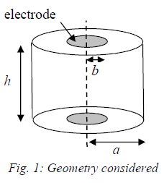
B = Bz z ; vertical B, axial, uniform magnetic field in the cylinder enclosed between the electrodes
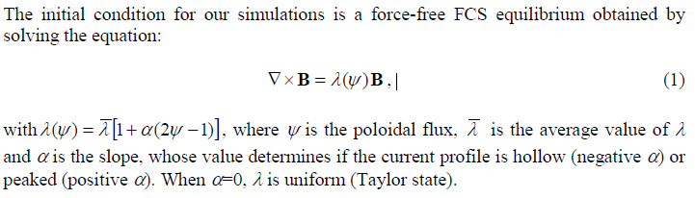

Lambda_avg
Alpha < 0 ; slope negative, current profile minimum (hollow) in the centre
Alpha = 0 ; slope zero ; current profile uniform (Taylor)
Lapha > 0 ; slope positive, current profile peaked in the centre
MHD solver
Resistive, isothermal, MHD equation
Alfven time tau_a = a / va
Resistive time tau_r = muzero / (eta lamda^2)
Lundquist number = tau_r/tau_a = 400

ENEA Frascati, July 13, 2022

QUESTIONS:

- Lambda equation suggested in the paper is a bit different (by mu_zero)
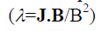
- Poloidal flux psi is normalized, otherwise
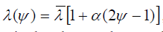
does not make sense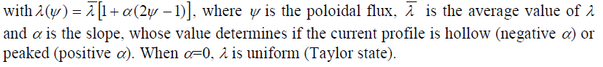
- Lengths are normalized, but timestep is not explicitly defined. TIME STEP normalization? (Fraction of Alfven time?)
- What represent the arrows in the following diagrams?

KINK AND TILT; Bz MAGNETIC FIELD; PSIe = 0 => no flux through electrodes
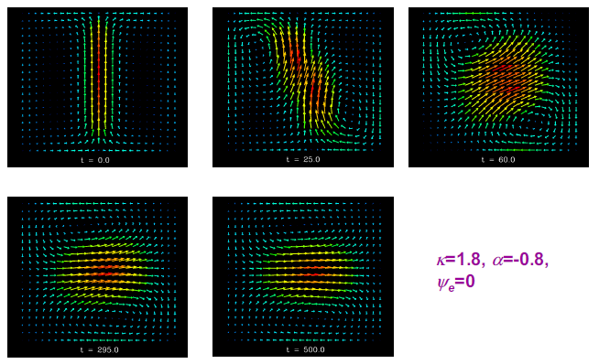

KINK AND TILT WITH MAGNETIC FIELD Bz; PSIe (normalized) = 0.1 (10%) flux through electrodes

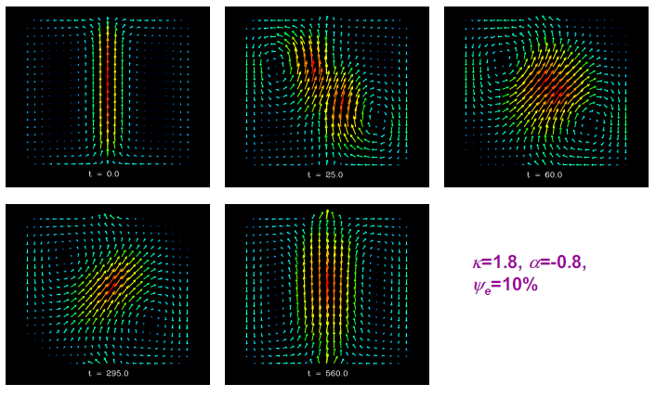

- KINK AND TILT EVOLUTION WITH MAGNETIC FIELD Bz; WITHOUT (left) and WITH (right)PSIe
- TIME NORMALIZED TO Tau_Alfven (approx. 1 microsecond)
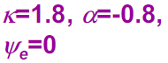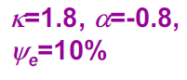
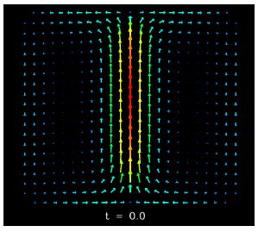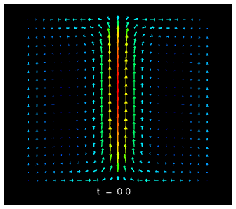
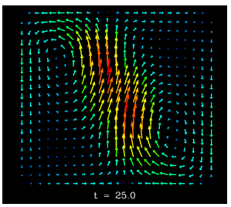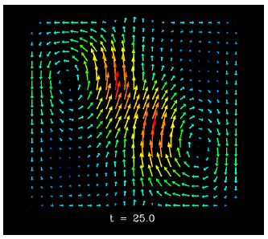
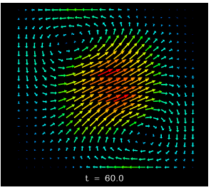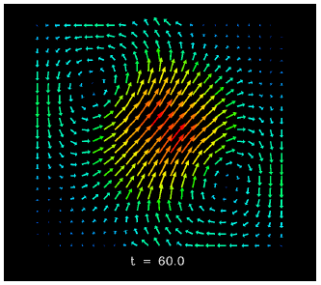
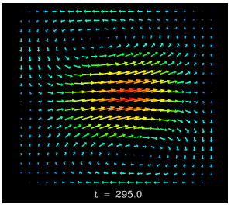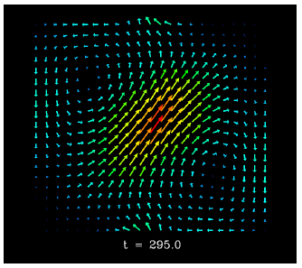
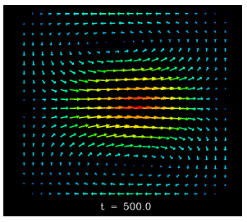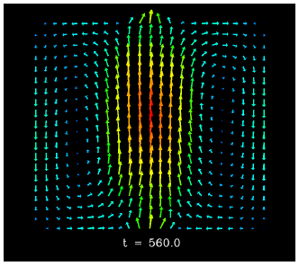

- MAGNETIC ENERGY POLOIDAL FLUX RELATIVE HELICITY (ALL NRMALIZED)
- TIME NORMALIZED TO Tau_Alfven (approx. 1 microsecond)
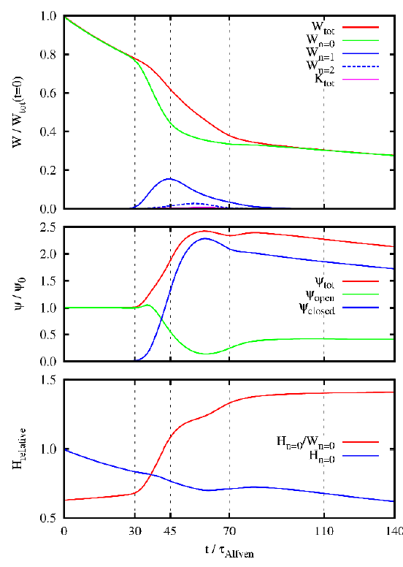

Spherical tokamaks with a high current carrying plasma centre column (2018)
Magnetic relaxation?
Poloidal flux amplification?
Non inductive current fraction?
Arbitrary current density profile
Kruskal-Shafranov (KS) limit?
In the limit of negligible pressure force, or zero beta, the equilibrium condition is satisfied whenever the magnetic field is parallel to the current density, i.e.,

