Relaxation and poloidal flux amplification
n = 1 kink instability
Force free equilibria are characterized by lambda profile
Lambda = (J scalar B) / B^2
Elongation
Open flux through electrode psi_e
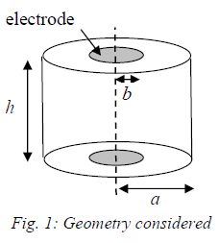
B = Bz z ; vertical B, axial, uniform magnetic field in the cylinder enclosed between the electrodes
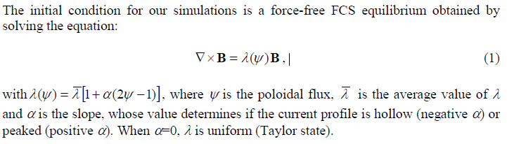

Lambda_avg
Alpha < 0 ; slope negative, current profile minimum (hollow) in the centre
Alpha = 0 ; slope zero ; current profile uniform (Taylor)
Lapha > 0 ; slope positive, current profile peaked in the centre
MHD solver
Resistive, isothermal, MHD equation
Alfven time tau_a = a / va
Resistive time tau_r = muzero / (eta lamda^2)
Lundquist number = tau_r/tau_a = 400

QUESTIONS:

- Lambda equation suggested in the paper is a bit different (by mu_zero) 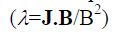
- Poloidal flux psi is normalized, otherwise 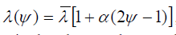 does not make sense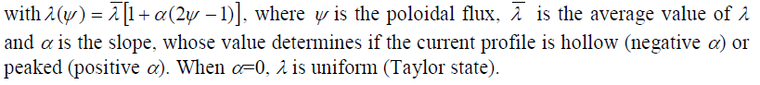
- Lengths are normalized, but timestep is not explicitly defined. TIME STEP normalization? (Fraction of Alfven time?)
- What represent the arrows in the following diagrams?

KINK AND TILT; Bz MAGNETIC FIELD ; PSIe =0 no flux through electrodes
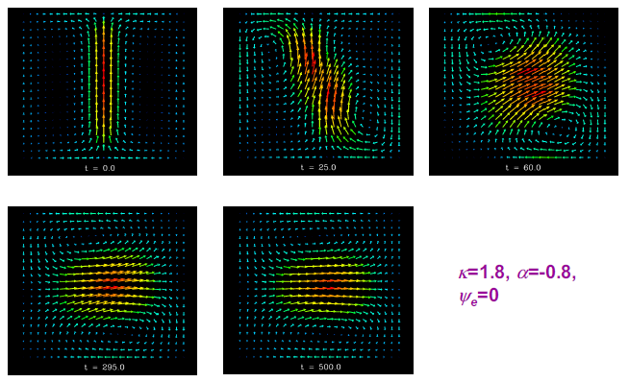

KINK AND TILT WITH MAGNETIC FIELD Bz; PSIe (nomalized) = 0.1 (10%) flux through electrodes

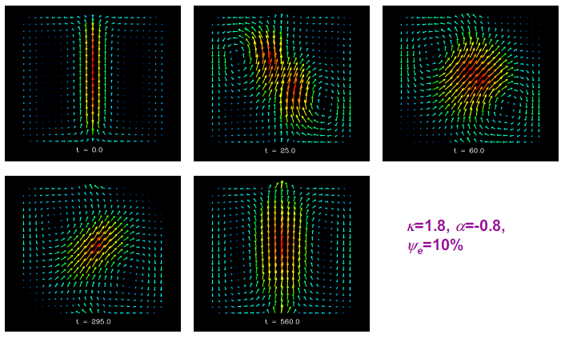

- KINK AND TILT EVOLUTION WITHOUT AND WITH MAGNETIC FIELD
- TIME NORMALIZED TO Tau_Alfven (approx. 1 microsecond)
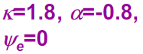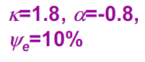
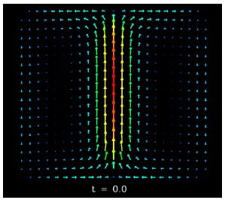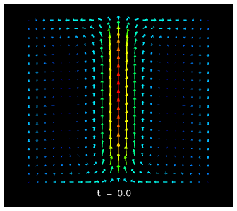
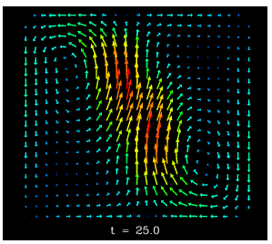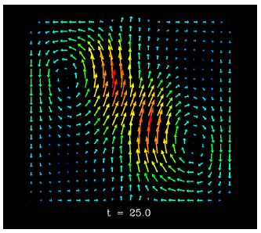
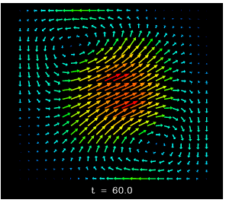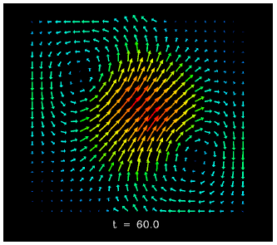
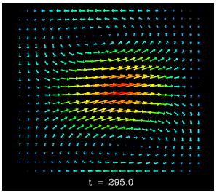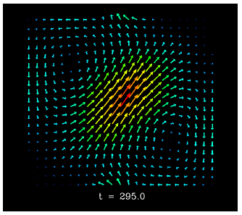
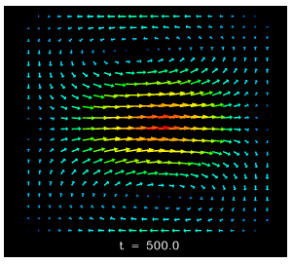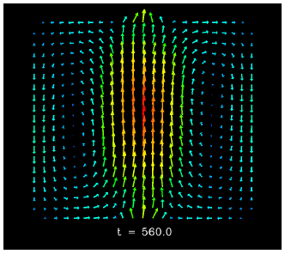

- MAGNETIC ENERGY POLOIDAL FLUX RELATIVE HELICITY (ALL NRMALIZED)
- TIME NORMALIZED TO Tau_Alfven (approx. 1 microsecond)
