The first phase of experiments on PROTO-SPHERA with central column plasma only (dubbed as MultiPinch) has been running from the summer of 2014 up to February 2015.
In this first phase the plasma central column was obtained in presence of the annular cathode on the bottom of the machine, but with a simple provisional cylindrical anode on top of it, after the completion of this first phase the final annular anode is at the moment being inserted in the top part of the machine and the plasma experiments with anode and cathode both annular will be performed during the year 2015; (See. Fig. 1 for a schematic comparison between the two phases and Fig. 2 for the actual load assemblies)
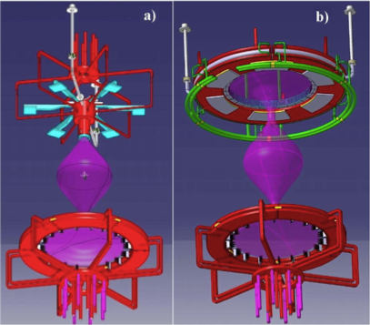
Fig. 1 CAD drawing of PROTO-SPHERA anode (red), cathode (red) and central plasma column (pink): a) first phase with cylindrical anode and annular cathode; b) second phase with both electrodes being annular
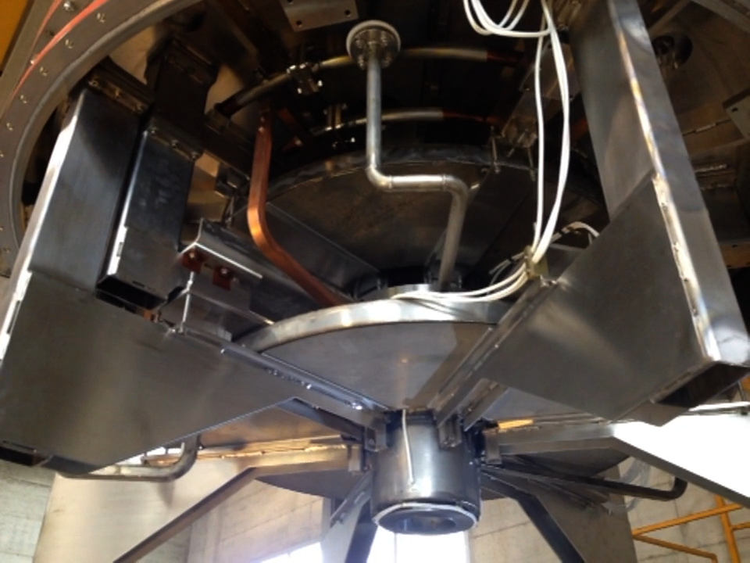
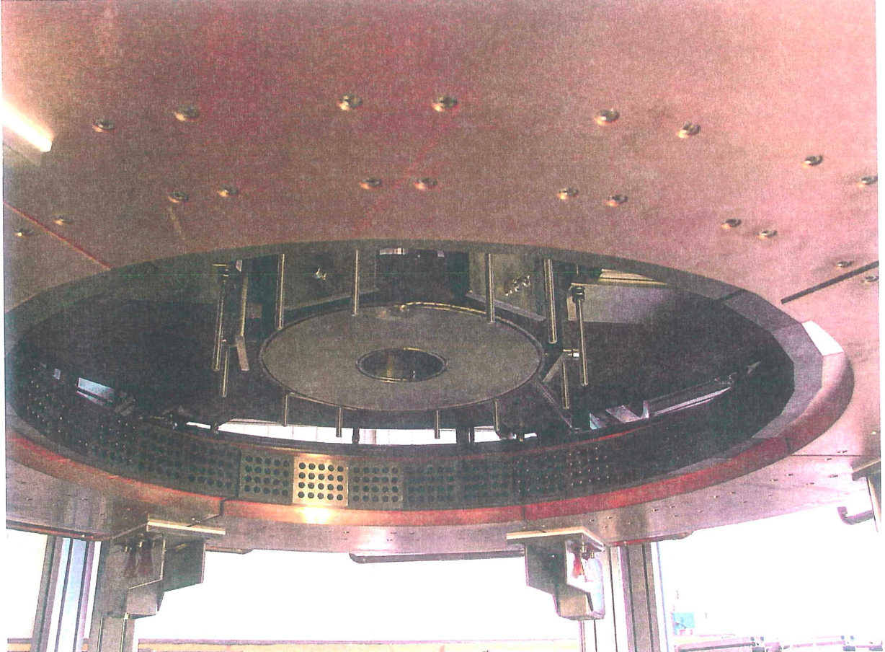
Fig. 2 Actual load assemblies of a) cylindrical anode inside the PF2 upper constriction poloidal field coil; b) annular anode as it was mounted for final check in the ASG production factory

However the cylindrical anode experiment's main goal was just to verify that the plasma break-down was achievable over the distance of 1.4 m between cylindrical anode and annular cathode, within the available power supply able to deliver at most 350 V to the central plasma column. The plasma break-down was obtained as expected in the range 170-200 V at a Hydrogen filling pressure of 10⁻³\10⁻² mbar. Unfortunately the magnetic field configuration near the anode was obviously designed for the annular anode, therefore two patologies in the plasma discharge appeared: either a back-firing discharge was produced by accident, with the plasma attempting to reach the not yet inserted annular anode (see Fig. 3a), or, when the field configuration was modified in the upper part of the machine, accidental discharges were produced at the anode busbar feeding (see Fig. 3b).

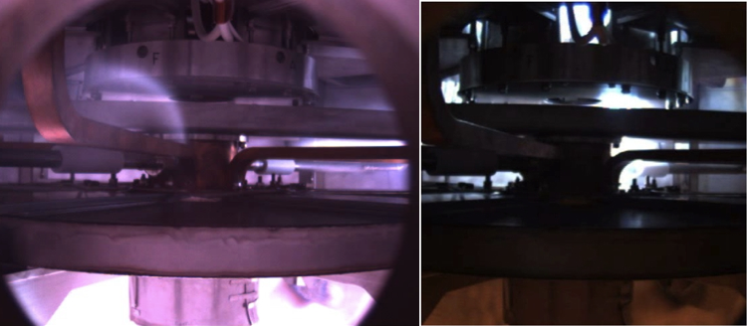
Fig. 3: Accidental plasma discharges in the top part of the machine due to: a) cylindrical anode back-discharge in presence of magnetic field modeled for annular anode; b) cylindrical anode back-discharge towards anode busbars, when magnetic field was altered in the top part of the machine.

Notwithstanding these troubles discharges up to 1.5 kA in the central plasma column were obtained and sustained for 20 ms, with the expected shape of the Hydrogen plasma central column and in absence of accidental discharges in the top part of the machine (see Fig. 4), when the lower PF2 poloidal contriction coil near the anode was positively biased with respect to the cathode.
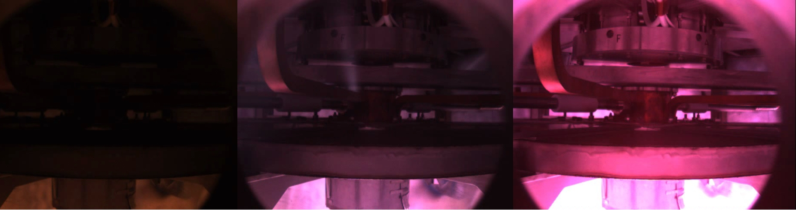
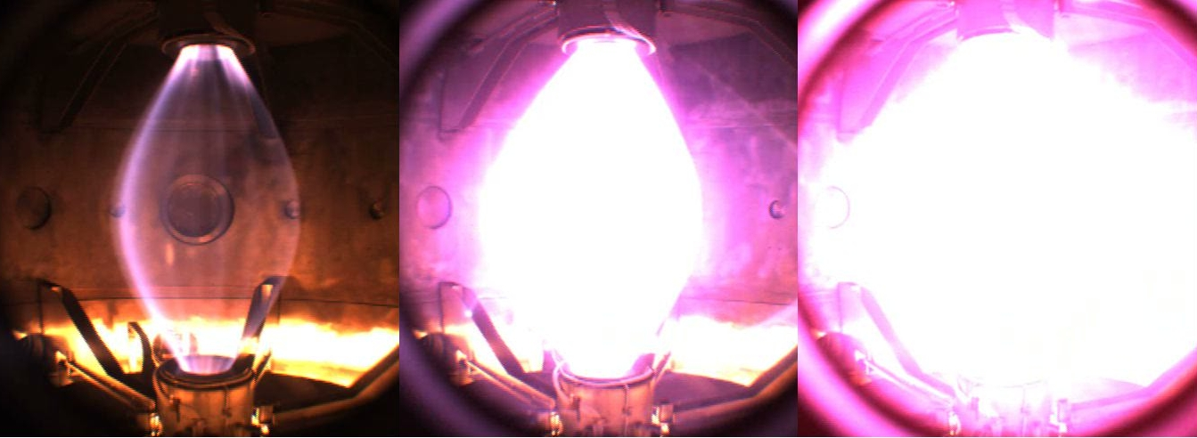
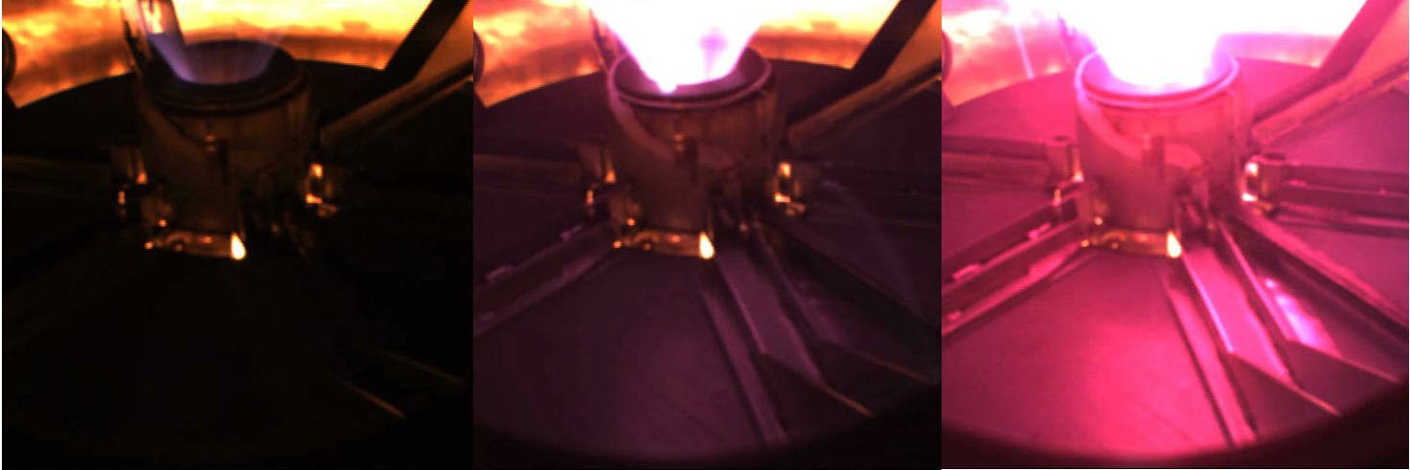
Fig. 4 Hydrogen central plasma column of MultiPinch: top row, images in the upper part of the machine; central row, main central plasma column; bottom row, plasma entering the cathode constriction coil PF2; left column, plasma break-down; central column plasma current at 500 A; right column, plasma current at 1500 A; -central main plasma images are overexposed.

Such regime was however terminated by another accidental discharge, due to the proximity of the cylindrical anode and the containing PF2 anode constriction poloidal field coil (5 mm distance from the outer surface of the cylindrical anode and the inner PF2 bore). A short circuit between the provisional anode and the enclosing PF2 coil terminated the proper plasma discharge (see Fig. 5).
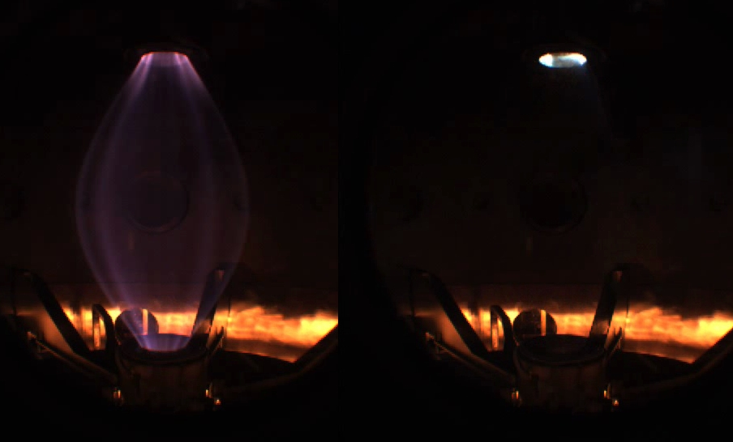
Fig. 5 Accidental switching between proper plasma central column (left, pink H_{α} light) and short circuit (metal originated white light) between provisional anode and PF2 upper constriction poloidal field coil; - central main plasma images are underexposed

The effect of such a short circuit was to close the central pinch current through the conducting vacuum vessel, from which the current reached the cathode from its outer rim, as an accidental plasma current (see the pink H_{α} light on the outer rim of the cathode in Fig. 6 b)
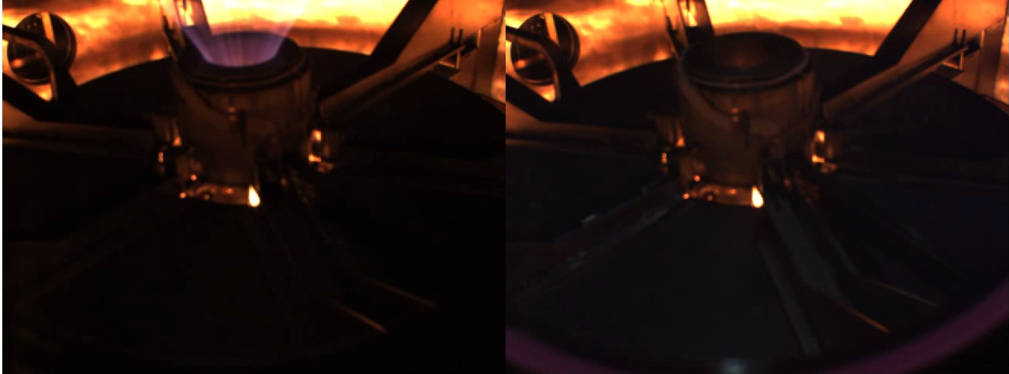
Fig. 6 Effect on the cathode of the accidental switching between proper plasma central column (left, pink H_{α} light in the proper position in the bore of the lower PF2) and current coming from the vessel (right, pink H_{α} light upon the improper outer rim of the cathode)
The effect of the short circuit between the provisional anode and the enclosing PF2 coil, which terminated the proper plasma discharge, has been also clearly observed as a sixfold slight damage on the upper vacuum vessel (see Fig. 7), once the machine was opened at the end of the provisional cylindrical anode operation in February 2015.

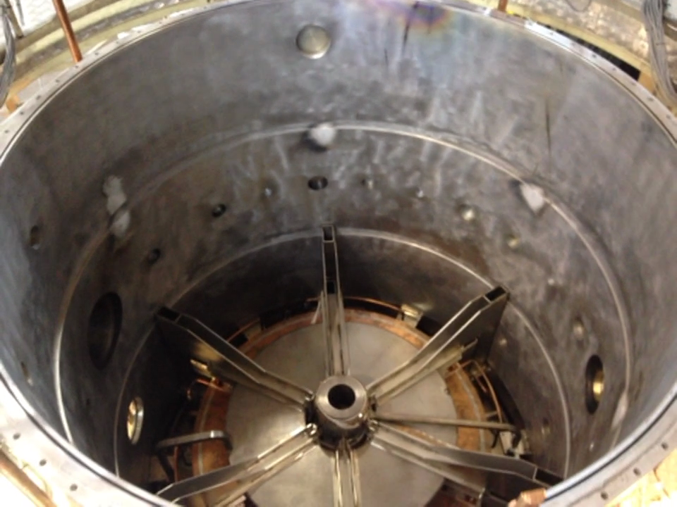
Fig. 7 Sixfold damage due to the six anode group supporting structures on the upper vacuum vessel.

The new operation of PROTO-SPHERA phase 1 (MultiPinch) which will be implemented during the year 2015 in presence the final annular anode, will presumably get rid of these accidental discharge phenomena; the hope is to achieve 8.5 kA of central plasma current for a few hundred ms.

