Scientific proposal for Enabling Research project
(max 10 pages, excluding title page)

Title | Study of a magnetically confined plasma surrounded by a dense gas blanket in Divertor Detachment condition in the PROTO-SPHERA experimental facility
Topic Area | Plasma related aspects (diagnostics)
Principal Investigator | …
Beneficiary | ENEA
Project duration | 2 years (2021-2022)

In the following text, please respect the following formatting constraints:
at least font size 11, margins (2.0 cm side and 1.5 cm top and bottom), single line spacing.
Abstract length must not exceed this front page
Proposal must start in the next page and be strictly less than 10 pages long
Formulae, tables and figures can be used.
Delete/overwrite instruction in text boxes and grey text.

Abstract
Abstract, also to be copied to online form in IMS

Introduction.
Plasma devices operating to develop magnetic fusion energy have demonstrated that the exhaust plasma can be cooled to ~few eV, orders of magnitude below core temperatures, before striking surrounding material structures. Such low temperatures give rise to "Detached Divertor Plasma" conditions, provided that strong plasma recombination into neutral gas can occur. The basic aim of the Detached Plasma concept is that the power exhaust and the particle flux from a divertor could be substantially dissipated if not almost totally extinguished in a neutral gas. The high-pressure plasma recombines before reaching the wall. If the ionization rate begins to drop significantly, plasma momentum can be effectively dissipated into recycling neutrals. This helps in reducing the target particle and energy fluxes. The detachment is characterized by dissipation of power, momentum and particle fluxes upon the open field lines from the mid plane to the divertor. A large increase in divertor radiation and peak divertor heath flux are observed. A variety of diagnostics are required to characterize the detached state and eventually to control it. Instabilities associated with the X-point and the separatrix position influence the parameters of the plasma impinging upon the targets and influence the quality of the plasma detachment.
PROTO-SPHERA is an innovative Magnetic Confinement plasma experiment for Controlled Thermonuclear Fusion research, that has formed a Spherical Torus for confining plasmas of thermonuclear interest not around a Metal Centerpost (as in Tokamaks), but around a Plasma Centerpost [here some references]. The Plasma Centerpost substitutes both the TFC (Toroidal Field Coils) by driving, through electrodes, the required plasma current along it, as well as the CT (Central Transformer) by injecting magnetic helicity inside the Spherical Torus from the inboard side. Despite being different from a conventional tokamak, PROTO-SPHERA (currently in its intermediate Phase-1.5 experiments) already produce Spherical Tori around the plasma centerpost. In the year 2018 the PROTO-SPHERA experiment has reached in Argon and in Hydrogen discharges its Phase-1 target current of 10 kA in the Plasma Centerpost, at a Tokamak-like gas filling pressure (10⁻²-10⁻¹ mbar) and with low DC voltages applied to the electrodes (80-280 Volts). The Plasma Centerpost proved to be perfectly stable, lasting for 1 sec in the Phase-1 experiments. By adding an additional group of 4 external home-built Poloidal field coils (PFExt) fed in parallel with the original 8 PFInt-GroupB coils, the first tori (albeit not spherical ones) have been produced in the experiment and sustained in 2019 for up to 1 sec. In the first half of the year 2019 in view of the intermediate Phase-1.5 (still with 10 kA plasma current in the Plasma Centerpost), the machine has been modified by substituting the original Aluminium conducting cylindrical vessel with an insulating and transparent PMMA (poly-methyl-methacrylate) cylinder. Furthermore, the presence of a transparent non-conductive vessel, together with its more conventional equatorial ports, expands the available surface for diagnostic installation.
The results already obtained in the PROTO-SPHERA experimental machine in the past 4 years (2015-2019) indicate that the plasma produced by this device is always surrounded by a thick blanket of neutral gas, which in Hydrogen discharges is evidenced by a rather thin edge layer of strong H_{α} emission. The present parameters are an electron density of ~1.5•10²⁰ m⁻³ and an estimated neutral gas density, outside the ionized plasma up to 5•10²⁰ m⁻³. Therefore this machine can act as a facility for studying Detached Plasmas and in particular Detached Divertors.
The grand challenge of the project will be achieved via a strong and young team of physicists and computer science/electronic engineers, tokamaks data acquisition and control experts together with more experienced physicists and technicians, with a strong background in plasma diagnostic and in the PROTO-SPHERA design and assembly. The interdisciplinary and motivated team will be a plus for the whole proposal. The scientific objectives and activities will be organized through interconnected yet separable activities with different degrees of complexity so as to mitigate any risk propagation and possible delays on the single tasks.
More details on these points are provided in the rest of the proposal.

Objectives and expected outcomes.
PROTO-SPHERA is an existing and operating low cost plasma producing facility, quite suitable for all kinds of interventions, repairs and corrections, like the first linear facilities that studied the gaseous divertor concept, as the Princeton QED and the UCLA\UCSD PISCES experiments. However PROTO-SPHERA is not a linear machine, but a facility that produces a confined torus around a central plasma discharge and sustains it for a duration of 1 second, in presence of a total power input to the plasma which has already achieved 3 MW and that in Phase-2 of the experiment will be increased to about 20 MW. The torus is obtained though magnetic reconnections and is endowed with X-points and magnetic separatrices. So, albeit not being a traditional Tokamak, it can study the real case of interest for Tokamaks. At the moment the magnetic divertor geometry of PROTO-SPHERA is quite similar to the so-called “Super-X Divertor”, albeit in PROTO-SPHERA only the outer leg of the divertor exists. No mechanical closure of the outer divertor leg is present at the moment but, due to the large space available in the middle section of the experiment, where the torus is located, and to the easiness in all kind of interventions, it would be quite simple to close the outer divertor leg. In the design and testing phase, the exploitation of the PROTO-SPHERA device represent a plus since its design allows to disassemble, upgrade and reassemble the machine in around three weeks.
The diagnostics that can allow for obtaining the expected outcome are here introduced:

1) (LTS) Thomson scattering from the plasma and Raman scattering from the gas blanket:
PROTO-SPHERA, whose plasma configuration is based on a self-organized plasma and in particular the phenomena of magnetic reconnection. It is therefore necessary to have at least a local electronic temperature diagnostics within plasma, on the equatorial plane of the experiment. Thomson Scattering LASER diagnostics measures the "thermal" component of the electronic plasma distribution function and allows to clearly distinguish the thermal background of the plasma from the subsequent reconnection and acceleration events (which will be measured by X-ray emission diagnostics, set up by the Italian National Institute of Astrophysics INAF, by the groups of Prof. Marco Tavani and Dr. Enrico Costa). The minimum temporal resolution required is at least 10 measurements on the duration of the plasma, of about one second, in order to study the evolution of the plasma on some resistive diffusion times of the current inside it. The system will guarantee the measurement of the electronic temperature of the plasma starting from a few tens of eV up to keV. The existing infrared lasers that were used on the Tokamak FTU can well provide the source for the Thomson Scattering on PROTO-SPHERA. [qui breve descrizione dei Laser].
The system of Thomson for PROTO-SPHERA will be a variant of the one that was used for FTU: it will introduce a frequency doubler for the infrared laser and work in green light at 532(?) nm.
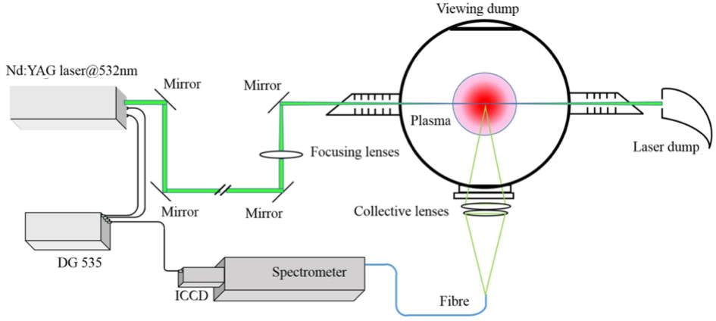
Due to the presence of the dense gas blanket in the outer half of the equatorial section of the cylinder that encloses the plasma, the LTS system will use Raman inelastic scattering from the surrounding neutral Hydrogen gas at a pressure of a few 10⁻¹ mbar. The Raman inelastic scattering was already successfully used in infrared light to calibrate the density measured on FTU at 10 mbar of Hydrogen gas pressure: the doubling of the frequency would allow (thanks to the strong f⁴ increase of the Raman scattering cross section with frequency) to have a signal sufficient to measure, at the same times the electron density is measured by Thomson scattering, the density of the neutral gas blanket. The presence of 12 optical ports on the equatorial plane of the machine will allow for up to 12 lines of observation of the scattered light distributed on 4 ports; the port most distant from the perpendicular to the laser path will observe the neutral gas blanket region; it will be viewing such region from the back of the laser path, in order to minimize the effect of stray light.
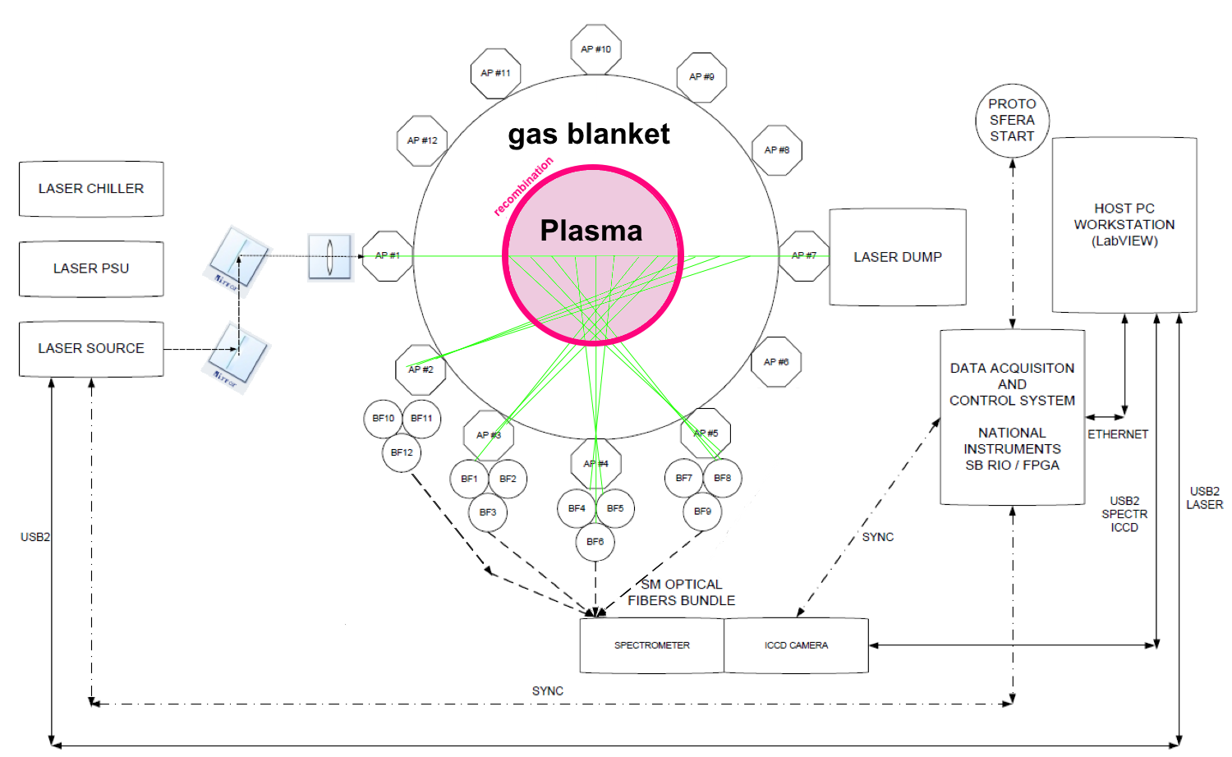

2) (IT) Imaging techniques for plasma diagnostics, reconstruction and real-time:
Imaging techniques are a relatively new path for the development of novel plasma diagnostic, analysis and control applications. Notable applications are related to the thermal imaging analysis of the vacuum vessel, with the particular focus on the limiter and divertor surfaces, and to recent attempts on the plasma boundary reconstruction. The potentialities offered by the recent advantages of the imaging techniques an computer vision to the plasma and vessel analysis remain an open and attracting opportunity yet to be maturely explored. Nowadays, the availability of strong theoretical results in computer vision applications [qui references da Davide] as well as reach and updated open projects with abundant computed vision algorithms [qui qualche riferimento] stimulates the possibility of fruitful cross-fertilization to the plasma diagnostic field, as described for the preliminary results obtained in the PROTO-SPHERA experiment and reported in the introduction.
The scientific outcome will be the both the design of imaging processing algorithms (2D tomography, 2D real-time tomography, 3D tomography, 3D reconstruction, boundary and detachment analysis, gas puffing imaging, real-time vessel diagnostic) and almost ready to use camera diagnostic systems, general enough to be installed for the majority of tokamak machines operating within the Europe. tomography represents a well established plasma analysis and diagnostic tool for its capability of “observing” within an object and reconstruct its interior. For the PROTO-SPHERA experiment, a preliminary attempt to combine imaging techniques with tomography techniques proved to be successful. However, several limitations have been left for a further and thorough research activity. First of all, vision techniques have been used to reconstruct, for each pixel of each camera, its corresponding line of view in a central reference frame (the same for all the cameras) located in the x-y plane on the equatorial plane of the vessel (which approximately corresponds to the plane cutting longitudinally the plasma torus) and the z axis corresponding with the symmetry axis of the cylindrical vacuum vessel.
For the 2D tomography, only the pixels related to the equatorial plane have been processed, and the computed lines of view have been considered as integral lines of the corresponding pixel brightness. The equatorial plane tomography has been obtained, as briefly recalled in the Introduction, through an analytical approach based on the Zernike polynomials. Despite offering good preliminary results, the approach “sticks” together an image processing approach with an analytical tomography one. Therefore, a proper integration with more advanced numeric tomography tools, such as the Simultaneous Iterative Reconstruction Technique (SIRT), the Simultaneous Algebraic Reconstruction Techniques (SART), the Ordered Subset SIRT (OS-SIRT) and the conjugated gradient based methods such as the CGLS.
All these methods appear to be particularly useful to be coupled with image analysis, since the same pixel or voxel based image discretization (or its subsampling) can be used for constructing the linear equation system for the numerical tomography problem. The implementation and validation of such an approach need to be investigated. In addition, the stereo imaging system combined with these methods can be exploited for 3D tomography and enable a 3D plasma reconstruction.
A second important limitation of the approach developed so far is that, despite computing a 2D tomography, all the pixels are acquired and processed. This results in a useless waste of bandwidth and computing power, while a goal-oriented adaptive pixels selection would allow to save computational capacity and bandwidth.
A third limitation is related to the fact that the current imaging PROTO-SPHERA setup only marginally exploits the possibility of high computing power and hardware accelerated GPUs architectures available nowadays, since its combine modern imaging techniques with more classical tomography ones, less prone to a parallel implementation.
A fourth interesting aspect is related to the vacuum vessel diagnostic. During the PROTO-SPHERA phase 1.5 campaign, a damage occurred on an internal divertor support (not leading to severe experimental campaign limitations). From the fast acquisition cameras, it has been possible to actually see the broken part falling down during the discharge. These led to the idea of developing diagnostic tools for the vacuum vessel able to analyse the status of the chamber and perform an automatic early detection of possible mechanical faults.
….

3) (SC) Spectroscopic characterization of plasma and plasma-gas blanket interface:
….

4) Two-Color Interferometer
….

5) (OFMM) Optical Fibre Magnetic Measurements:
….

6) (LP) Langmuir Probes:
….

7) (LP) Thermocamera:
….

8) (UVDD) Ultra Violet Diamond Detector:
….

Description and methodology.
Key aspects of divertor detachment are addressed by temperature and density measurements in the plasma and density measurements in the neutral gas, by bolometry, impurity spectroscopy, hydrogen spectroscopy, and measurements of divertor target heat-flux. Consequently a number of plasma diagnostics must be introduced, such as Thomson scattering inside the plasma (used also for Hydrogen Raman scattering in the blanket of neutral gas), tomographic inversion of visible and UV light, detection of soft-X ray emission from the X-point, visible and UV spectroscopy, 2 colors line of sight interferometry, Langmuir probes both on the mid plane as well as on the divertor plate, magnetic field measurements near the separatrix and near the X points, thermographic camera looking at the divertor plates. Some of these diagnostics are already existing, but all of them require additional work and some of them require additional components.
A list of necessary diagnostics is illustrated in the following:
1) (LTS) Thomson scattering from the plasma and Raman scattering from the gas blanket:
Minimization of stray light.
Lines of Hydrogen to observe in Raman scattering
….

2) (IT) Imaging techniques for plasma diagnostics, reconstruction and real-time:
Progressive technologies advancements as well as computational capacities increase poses the basis for a continuous innovation process of tokamak diagnostics, both for the plasma itself and for the chamber status. In addition to this, such technological and computational advantages allow to progressively move techniques usually adopted for off-line plasma investigation also to real-time plasma monitoring and control. A recent trend is the adoption of imaging techniques for plasma boundary reconstruction.
The proposal in hand aims at investigating and developing novel imaging techniques which have recently been introduced for the PROTO-SPHERA experiment at the ENEA research centre of Frascati (Italy).
The need for cheap diagnostics able to monitor the plasma and the presence of a totally visible light transparent camera, led to the development of a preliminary visible tomography system. Specifically, A system of six fast visible light cameras has been implemented around the PROTO-SPHERA vacuum vessel. The aim was to detect the axial symmetric brightness profile and to recognize the toroidal structures around the plasma central column via developing an optical tomography.
To do so, the six acA640-750um Basler ace USB 3.0 cameras have been placed on the equatorial plane of the vacuum vessel, separated by 60 degrees around its circular circumference and covering the whole volume of the central plasma. The cameras have been managed by two PCs, while a NANO Arduino has been exploited to trigger synchronous frames acquisition and to control the exposition time. The acquisition system has been implemented using the MARTe2 software framework [reference here]. A proper calibration/reconstruction of each line of view for all the cameras has been implemented, so as to compute a 3D representation of the vessel, via exploiting concepts of epipolar geometry and computer vision []. This has been instrumental in performing a tomography inversion of the plasma column under the consideration that the value of each pixel represents the integrated brightness along its line of sight.
Despite the adoption of a cheap cameras support system and 600 f.p.s cameras, the intuition of adopting imaging concepts for plasma tomography proved to be effective, leading to a 2D tomography of the torus on the camera equatorial plane. Such tomography has been obtained via considering, for each of the six cameras, the pixel line corresponding to the optical transformation of the torus equatorial plane onto the camera image plane. Then, a tomography has been obtained considering as integral lines the cone of lines of view departing from each camera and cutting the plasma torus. Such tomography has been performed exploiting an analysis based on the Zernike polynomials.
[IT-M1] DISTRIBUTED NUMERICAL OPTIMIZATION AND TOMOGRAPHY ALGORITHMS
This methodology aims at implementing numerical tomography algorithms based on distributed optimization techniques to be specifically designed for parallel architectures, such as parallel CPUs systems or low-cost GPUs. Note that this outcome is conceptually independent on the imaging part and provides high speed optimization routines and numerical tomography routines that can be integrated both for real-time control and for conventional X-ray tomography.
[IT-M2] OPTICAL 2D AND 3D TOMOGRPHY
Optical 2D and 3D tomography algorithms will be developed considering automatic transformation camera plane-base frame so as to automatically derive the linear systems equations and unknowns to feed the numerical tomography algorithms based on the distributed optimization developed in [M1].
[IT-M3] 3D RECONSTRUCTION
3D reconstruction algorithms will allow to exploit the plasma density values obtained from the 3D tomography performed in [IT-M2] for generating a 3D reconstruction of the plasma (or part of it). The computation of several consecutive 3D reconstructions may allow the visualization of the plasma evolution over a certain time window.
[IT-M4] PIXEL SUBSAMPLING AND SELECTION ALGORITHMS
Not the whole plasma is observable in the visible light. While in PROTO-SPHERA the whole plasma discharge is directly observable, in higher temperature tokamaks imaging techniques can be adopted for edge and divertor investigation, detached conditions and gas ionization. Therefore, only some pixel portion may be really necessarily for 2D and 3D investigation and reconstruction and proper pixels selection algorithms need to be implemented according to the specific diagnostic goal. Despite this aspect seems to be purely a technical one, it is of crucial importance if the imaging plasma analysis has to be used for real-time control. The latter, indeed, is a specific target of this research proposal and is taken into account combining the distributed computation techniques over parallel hardware developed in [IT-M1] with objective-oriented pixel selection, so as to reduce the usually huge amount of information of high resolution camera and allow, for the same channel bandwidth, higher sampling rate on only those fundamental image portions.
[IT-M5] FEATURE SELECTION AND IMAGE ANALYSIS
Feature selection algorithms specifically tailored for plasma aspects represent a huge and promising research topic. Not all the possible plasma aspects and related feature selection can be addressed in this proposal. However, limiting the focus on some relevant ones, plasma boundary, centroid and geometrical axis may be extracted through dedicate image processing algorithms. Similarly, plasma bulk movement velocity over a plane section (poloidal or toroidal) may be investigated through dedicated algorithms.
Also, algorithms for flow image analysis may be borrowed from the literature and adapted to the case of ionized gas tracking in the vacuum chamber.
[IT-M6] EXPERIMENTAL EVALUATION OF THE PROTO-SPHERA DISCHARGES
All the proposed algorithms will be used to analyse the PROTO-SPHERA hydrogen, helium and argon discharges during the phase 2 experimental campaign. Both the whole plasma bulk and the edge will be analysed in the PROTO-SPHERA Centerpost and in the torus. Furthermore, detached conditions naturally arise in the PROTO-SPHERA experiment, which present two super X divertor points. Ionization of the gas around these two points will be studied.
Since PROTO-SPHERA can be somehow seen as a spherical tokamak with no central column, a similar setup used for its imaging could turn to be immediately interesting for other spherical tokamaks, such as MAST. This aspect, together with the dissemination of the single project outcomes toward the other European machines, will be explicitly investigated during the project.

3) (SC) Spectroscopic characterization of plasma and plasma-gas blanket interface:
3a General spectroscopic UV and Vis measurements from plasma and plasma-gas blanket interface
3b Innovative Inglis-Teller spectroscopic technique to measure the plasma density from Hydrogen lines superposition.
….

4) Two-Color Interferometer
….

5) (OFMM) Optical Fibre Magnetic Measurements:
….

6) (LP) Langmuir Probes:
….
7) (LP) Thermocamera:
….

8) (UVDD) Ultra Violet Diamond Detector:
….

Work plan
The work plan must give a timeline, the project organisation including collaborations, information exchange (e.g. work progress, data sharing), the critical milestones and deliverables per year (in a table) and also indicate the effort and key individuals associated with each major activity or subproject. The plan is a critical element for the assessment of the project feasibility. Good deliverables follow the SMART principle (Specific, Measurable, Attainable, Realistic and Timely).

Templates for table of list of milestones and deliverables are provided below.

Milestones
No | Title | Description | Expected date

Deliverables
Year | Title | Description

